

|  |  |
| --- | --- |
| Name | Student_ID |
| Mohannad Reyad Albujoq | **0201263** |
| Mohammad Shaher Alabed | **0203292** |
| Abedalmajeed abedalatif Alajarmah | **0203169** |
| Adnan Samer Alkharouf | **0205413** |

 **Project 2  
  
 Second Semester 2023/2024  
  
 Supervised by:** **Dr. Mohammad Abushariah**

**Abstract**

EduAI aims to revolutionize the online learning experience for university students by incorporating advanced artificial intelligence technologies. Our project leverages a ChatGPT-powered chatbot and advance behavior tracking mechanisms to create a dynamic, personalized educational environment. By understanding and addressing the individual differences among students, EduAI facilitates tailored learning experiences that adapt to each student's unique needs and preferences. This innovative approach not only enhances engagement and interaction but also promotes more effective learning outcomes. The integration of these cutting-edge features into existing online learning platforms represents a significant step forward in the evolution of digital education, making it more responsive, inclusive, and effective for diverse student populations.

**Acknowledgment**

We begin by expressing our deep gratitude to our academic supervisor, Dr. Mohammad Abushariah for granting us the opportunity to engage in the remarkable project named "UniSwap"for the University of Jordan students. Her guidance not only steered us but also instilled in us the drive to pursue comprehensive research and broaden our horizons. Furthermore, we wish to convey our heartfelt thanks to our parents and friends, whose immense support was instrumental in completing this project within the stipulated timeframe. Our sincerest appreciation goes to everyone who contributed to the realization of this project's success. Their unwavering belief in us and their continuous encouragement have consistently fueled our motivation throughout this enriching journey.

Table of Contents

**1.** **Chapter One: Introduction** - 10 -

**1.1 Project Motivation** - 10 -

**1.2 Problem Statement** - 10 -

**1.3 Project Aim and Objectives** - 11 -

**1.4 Project Scope** - 11 -

**1.5 Software and Hardware Requirements** - 11 -

**1.6 Project Limitations** - 12 -

**1.7 Project Expected Output** - 12 -

**1.8 Project Schedule** - 13 -

**1.8.1 PERT Diagram** - 14 -

**1.8.2 GANTT Chart** - 14 -

**1.8.3 Staff Allocation Chart** - 15 -

**1.9 Report Outline** - 15 -

**2.** **Chapter Two: Related Existing System** - 18 -

**2.1 Introduction** - 18 -

**2.2 Existing Systems** - 18 -

2.2.1 Udemy - 18 -

2.2.2 Coursera - 19 -

**2.3 Overall Problems of Existing Systems** - 19 -

**2.4 Overall Solution Approach** - 20 -

**2.5 Summary** - 20 -

**3.** **Chapter Three: System Requirements Engineering and Analysis** - 21 -

**3.1 Introduction** - 21 -

**3.2 Feasibility Study** - 21 -

3.2.1 Technical Feasibility - 21 -

3.2.2 Operational Feasibility - 21 -

3.2.3 Economic Feasibility - 22 -

**3.3 Requirements Elicitation Techniques (Questionnaire)** - 23 -

**3.4 Targeted Users** - 26 -

**3.5 Functional Requirements Definition** - 27 -

**3.6 Functional Requirements Specification** - 30 -

**3.7 Non-Functional Requirements** - 46 -

**3.8 Summary** - 46 -

**4.** **Chapter Four: System Design** - 47 -

**4.1** **Introduction** - 47 -

**4.2 Context Diagram** - 47 -

**4.3 Entity Relationship Diagram (ERD)** - 48 -

**4.4 UML Use Case Diagram** - 49 -

**4.5 UML Sequence Diagram** - 53 -

**4.5.1 student sequence** - 53 -

**4.5.1 instructor sequence** - 61 -

**4.5.1 admin sequence** - 76 -

**4.6 UML Class diagram** - 98 -

**4.7 graphical user interface design / low fidelity prototype** - 99 -

**Chapter five: System Implementation** - 105 -

**5.1 database implementation** - 105 -

**5.2 Graphical user interface implementation** - 110 -

**5.3.1 Student interface** - 117 -

**5.3.1 Instructor interface** - 120 -

**5.3.1 admin interface** - 135 -

**Chapter six: Testing and installation** - 147 -

**6.1 Testing** - 147 -

**6.1.1 Heuristic Evaluation** - 147 -

**6.1.2 Cooperative Evaluation** - 154 -

**6.2 Installation** - 169 -

**6.3** **User manual** - 170 -

**7.1 Conclusions** - 227 -

**7.3 Strengths** - 227 -

**7.3 Weaknesses** - 227 -

**7.4 Future Direction** - 227 -

**References** - 228 -

Table 1:Abbreviations - 9 -

Table 2:Project Schedule - 13 -

Table 3: Staff Allocation - 15 -

Table 4: Economic Feasibility - 22 -

Table 5:Functional Requirements Definition - 27 -

Table 6: Register Tabular form - 30 -

Table 7: Non-Functional Requirements - 46 -

Table 8: Visibility of System Status - 147 -

Table 9: Match Between System and the Real World - 148 -

Table 10: User Control and Freedom - 148 -

Table 11: Consistency and Standards - 149 -

Table 12: Help Users Recognize, Diagnose, and Recover from Errors - 150 -

Table 13: Error Prevention - 150 -

Table 14: Recognition Rather Than Recall - 151 -

Table 15: Flexibility and Minimalist Design - 152 -

Table 16: Aesthetic and Minimalist Design - 152 -

Table 17: Help and Documentation - 153 -

Table 18: Participants Details - 154 -

Table 19: Cooperative Evaluation 1 - 155 -

Table 20: Cooperative Evaluation 2 - 157 -

Table 21: Cooperative Evaluation 3 - 159 -

Table 22: Cooperative Evaluation 4 - 160 -

Table 23: Cooperative Evaluation 5 - 162 -

Table 24: Cooperative Evaluation 6 - 164 -

Table 25: Task Completion Times in Minutes and Seconds - 166 -

Table 26: Participants Responses to the Post-Test Questionnaire - 167 -

Table 27: Test (Post-test Questionnaire) - 168 -

Figure 1: Pert Diagram - 14 -

Figure 2: Gantt chart - 14 -

Figure 3: Questionnaire figure 1 - 23 -

Figure 4: Questionnaire figure 2 - 23 -

Figure 5: Questionnaire figure 3 - 24 -

Figure 6: Questionnaire figure 4 - 24 -

Figure 7: Questionnaire figure 5 - 25 -

Figure 8: Questionnaire figure 6 - 25 -

Figure 9: context diagram - 47 -

Figure 10: ERD - 48 -

Figure 11: UML use case diagram: EduAI System - 49 -

Figure 12: UML use case diagram: 1 - 49 -

Figure 13: UML use case diagram: 2 - 50 -

Figure 14: UML use case diagram: 3 - 51 -

Figure 15: UML use case diagram: 4 - 52 -

Figure 16:Sequence Diagram: Student Delete Course - 53 -

Figure 17:Sequence Diagram: Sequence Diagram: Student Display Course - 54 -

Figure 18:Sequence Diagram: Sequence Diagram: Student Attempt Quiz - 55 -

Figure 19:Sequence Diagram: Sequence Diagram: Student Display Courses List - 56 -

Figure 20: Sequence Diagram: Student Dashboard - 56 -

Figure 21:Sequence Diagram: Student Display Courses Contant - 57 -

Figure 22:Sequence Diagram: Student Enroll Course - 57 -

Figure 23:Sequence Diagram: Student Display My Courses - 58 -

Figure 24::Sequence Diagram: Student Edit Profile - 59 -

Figure 25:Sequence Diagram: Student Register - 60 -

Figure 26:Sequence Diagram: Instructor Add New Section - 61 -

Figure 27::Sequence Diagram: Instructor Edit Profile - 62 -

Figure 28:Sequence Diagram: Instructor Add New YouTube Link - 63 -

Figure 29:Sequence Diagram: Instructor Chat with GPT - 63 -

Figure 30:Sequence Diagram: Instructor Display Courses - 64 -

Figure 31:Sequence Diagram: Instructor Dashboard - 64 -

Figure 32:Sequence Diagram: Instructor Delete Course - 65 -

Figure 33:Sequence Diagram: Instructor Delete Item - 66 -

Figure 34:Sequence Diagram: Instructor Delete Section - 66 -

Figure 35:Sequence Diagram: Instructor Download Material - 67 -

Figure 36:Sequence Diagram: Instructor Edit Material - 67 -

Figure 37:Sequence Diagram: Instructor Edit Course - 68 -

Figure 38:Sequence Diagram: Instructor Edit Post - 68 -

Figure 39:Sequence Diagram: Instructor Edit Question - 69 -

Figure 40:Sequence Diagram: Instructor Edit Quiz - 69 -

Figure 41:Sequence Diagram: Instructor Add New Section - 70 -

Figure 42:Sequence Diagram: Instructor Edit Item Position - 70 -

Figure 43:Sequence Diagram: Instructor Add Quiz Question - 71 -

Figure 44:Sequence Diagram: Instructor Display Quizzes List - 71 -

Figure 45:Sequence Diagram: Instructor Edit Section Position - 72 -

Figure 46:Sequence Diagram: Instructor: Display Student Quiz Result - 72 -

Figure 47: Sequence Diagram: Instructor Display Courses Content - 73 -

Figure 48:Sequence Diagram: Instructor Add Material - 73 -

Figure 49:Sequence Diagram: Instructor Add New Course - 74 -

Figure 50:Sequence Diagram: Instructor Add New Post - 74 -

Figure 51:Sequence Diagram: Instructor Add New Quiz - 75 -

Figure 52:Sequence Diagram: Admin Edit Profile - 76 -

Figure 53:Sequence Diagram: User Contact us - 77 -

Figure 54:Sequence Diagram: Admin Delete Course - 78 -

Figure 55:Sequence Diagram: Admin Delete Instructor - 79 -

Figure 56:Sequence Diagram: Admin Delete Student - 80 -

Figure 57:Sequence Diagram: Admin Display Courses List - 81 -

Figure 58:Sequence Diagram: Admin Edit Instructor - 82 -

Figure 59:Sequence Diagram: Admin Edit Student List - 83 -

Figure 60::Sequence Diagram: User Change Language - 84 -

Figure 61:Sequence Diagram: User Filter By Entity - 84 -

Figure 62:Sequence Diagram: User Login - 85 -

Figure 63::Sequence Diagram: User Logout - 86 -

Figure 64:Sequence Diagram: User Maximize Or Minimize Website - 86 -

Figure 65::Sequence Diagram: User Display privacy and policy - 87 -

Figure 66::Sequence Diagram: Admin Publish Toggle - 88 -

Figure 67::Sequence Diagram: User Reset Password - 89 -

Figure 68:Sequence Diagram: User Search - 90 -

Figure 69:Sequence Diagram: User Selection Page - 91 -

Figure 70:Sequence Diagram: User Show Password - 92 -

Figure 71:Sequence Diagram: User Term Of Use - 93 -

Figure 72:Sequence Diagram: Admin view Student - 94 -

Figure 73:Sequence Diagram: Admin Add Instructor - 95 -

Figure 74:Sequence Diagram: Admin Add Student - 96 -

Figure 75:Sequence Diagram: Admin Course Overview - 97 -

Figure 76:Sequence Diagram: Admin Dashboard - 97 -

Figure 77: UML Class Diagram - 98 -

Figure 78: low fidelity: Home Page - 99 -

Figure 79: low fidelity: Register Page - 100 -

Figure 80: low fidelity: Login Page - 101 -

Figure 81: low fidelity: Students Pages - 101 -

Figure 82:low fidelity: Admin Pages - 102 -

Figure 83: low fidelity: Instructor Pages - 103 -

Figure 84:Database Design - 104 -

Figure 85:Database Implementation 1 - 105 -

Figure 86:Database Implementation 2 - 105 -

Figure 87:Database Implementation 3 - 105 -

Figure 88:Database Implementation 4 - 105 -

Figure 89:Database Implementation 5 - 106 -

Figure 90:Database Implementation 6 - 106 -

Figure 91:Database Implementation 7 - 106 -

Figure 92:Database Implementation 8 - 106 -

Figure 93:Database Implementation 9 - 106 -

Figure 94:Database Implementation 10 - 107 -

Figure 95:Database Implementation 11 - 107 -

Figure 96:Database Implementation 12 - 107 -

Figure 97:Database Implementation 13 - 107 -

Figure 98:Database Implementation 14 - 108 -

Figure 99:Database Implementation 15 - 108 -

Figure 100:Database Implementation 16 - 108 -

Figure 101:Database Implementation 17 - 108 -

Figure 102:Database Implementation 18 - 109 -

Figure 103:Database Implementation 19 - 109 -

Figure 104:Graphical user interface implementation 1 - 110 -

Figure 105:Graphical user interface implementation 2 - 111 -

Figure 106:Graphical user interface implementation 3 - 112 -

Figure 107:Graphical user interface implementation 4 - 113 -

Figure 108:Graphical user interface implementation 5 - 114 -

Figure 109:Graphical user interface implementation 6 - 115 -

Figure 110:Graphical user interface implementation 7 - 115 -

Figure 111:Graphical user interface implementation 8 - 116 -

Figure 112: Student GUI 1 - 117 -

Figure 113: Student GUI 2 - 118 -

Figure 114: Student GUI 3 - 118 -

Figure 115: Student GUI 4 - 119 -

Figure 116: Instructor GUI 1 - 120 -

Figure 117: Instructor GUI 2 - 120 -

Figure 118: Instructor GUI 3 - 121 -

Figure 119: Instructor GUI 4 - 121 -

Figure 120: Instructor GUI 5 - 122 -

Figure 121: Instructor GUI 6 - 122 -

Figure 122: Instructor GUI 7 - 123 -

Figure 123: Instructor GUI 8 - 123 -

Figure 124: Instructor GUI 9 - 124 -

Figure 125: Instructor GUI 10 - 124 -

Figure 126: Instructor GUI 11 - 125 -

Figure 127: Instructor GUI 12 - 125 -

Figure 128: Instructor GUI 13 - 126 -

Figure 129: Instructor GUI 14 - 126 -

Figure 130: Instructor GUI 15 - 127 -

Figure 131: Instructor GUI 16 - 127 -

Figure 132: Instructor GUI 17 - 128 -

Figure 133: Instructor GUI 18 - 128 -

Figure 134: Instructor GUI 19 - 129 -

Figure 135: Instructor GUI 20 - 129 -

Figure 136: Instructor GUI 22 - 130 -

Figure 137: Instructor GUI 23 - 130 -

Figure 138: Instructor GUI 24 - 131 -

Figure 139: Instructor GUI 25 - 131 -

Figure 140: Instructor GUI 26 - 132 -

Figure 141: Instructor GUI 27 - 132 -

Figure 142: Instructor GUI 28 - 133 -

Figure 143: Instructor GUI 29 - 133 -

Figure 144: Instructor GUI 30 - 134 -

Figure 145: Instructor GUI 31 - 134 -

Figure 146: Admin GUI 1 - 135 -

Figure 147: Admin GUI 2 - 136 -

Figure 148: Admin GUI 3 - 136 -

Figure 149: Admin GUI 4 - 137 -

Figure 150: Admin GUI 5 - 137 -

Figure 151: Admin GUI 6 - 138 -

Figure 152: Admin GUI 7 - 138 -

Figure 153: Admin GUI 8 - 139 -

Figure 154: Admin GUI 9 - 139 -

Figure 155: Admin GUI 10 - 140 -

Figure 156: Admin GUI 11 - 140 -

Figure 157: Admin GUI 12 - 141 -

Figure 158: Admin GUI 13 - 141 -

Figure 159: Admin GUI 14 - 142 -

Figure 160: Admin GUI 15 - 142 -

Figure 161: Admin GUI 16 - 143 -

Figure 162: Admin GUI 17 - 143 -

Figure 163: Admin GUI 18 - 144 -

Figure 164: Admin GUI 19 - 144 -

Figure 165: Admin GUI 20 - 145 -

Figure 166: Admin GUI 21 - 145 -

Figure 167: Admin GUI 22 - 146 -

Figure 168: Admin GUI 23 - 146 -

Figure 169: User guide 1 - 170 -

Figure 170: User guide 2 - 171 -

Figure 171: User guide 3 - 172 -

Figure 172: User guide 4 - 173 -

Figure 173: User guide 7 - 174 -

Figure 174: User guide 5 - 174 -

Figure 175: User guide 6 - 174 -

Figure 176: User guide 8 - 175 -

Figure 177: User guide 9 - 176 -

Figure 178: User guide 10 - 177 -

Figure 179: User guide 11 - 178 -

Figure 180: User guide 12 - 179 -

Figure 181: User guide 13 - 180 -

Figure 182: User guide 14 - 181 -

Figure 183: User guide 15 - 182 -

Figure 184: User guide 16 - 183 -

Figure 185: User guide 17 - 184 -

Figure 186: User guide 18 - 185 -

Figure 187: User guide 19 - 186 -

Figure 188: User guide 20 - 187 -

Figure 189: User guide 21 - 188 -

Figure 190: User guide 22 - 189 -

Figure 191: User guide 23 - 190 -

Figure 192: User guide 24 - 191 -

Figure 193: User guide 25 - 192 -

Figure 194: User guide 26 - 193 -

Figure 195: User guide 27 - 194 -

Figure 196: User guide 28 - 195 -

Figure 197: User guide 29 - 196 -

Figure 198: User guide 30 - 197 -

Figure 199: User guide 31 - 198 -

Figure 200: User guide 32 - 199 -

Figure 201: User guide 33 - 200 -

Figure 202: User guide 34 - 201 -

Figure 203: User guide 35 - 202 -

Figure 204: User guide 36 - 203 -

Figure 205: User guide 37 - 204 -

Figure 206: User guide 38 - 205 -

Figure 207: User guide 39 - 206 -

Figure 208: User guide 40 - 207 -

Figure 209: User guide 41 - 208 -

Figure 210: User guide 42 - 209 -

Figure 211: : User guide 43 - 210 -

Figure 212: User guide 44 - 211 -

Figure 213: User guide 45 - 212 -

Figure 214: User guide 46 - 213 -

Figure 215: User guide 47 - 214 -

Figure 216: User guide 48 - 215 -

Figure 217: User guide 49 - 216 -

Figure 218: User guide 50 - 217 -

Figure 219: User guide 51 - 218 -

Figure 220: User guide 52 - 219 -

Figure 221: User guide 53 - 220 -

Figure 222: User guide 54 - 221 -

Figure 223: User guide 55 - 222 -

Figure 224: User guide 56 - 223 -

Figure 225: User guide 57 - 224 -

Figure 226: User guide 58 - 225 -

Figure 227: User guide 59 - 226 -

Table 1:Abbreviations

|  |  |
| --- | --- |
| Abbreviations | definition |
| HTML | HyperText Markup Language |
| CSS | Cascading Style Sheets |
| API | Application Programming Interfaces |
| GUI | Graphcal User Interface |
| ROI | Return on Investment |
| NPV | Net Present Value |

# **Chapter One: Introduction**

## **1.1 Project Motivation**

The motivation behind our project lies in addressing the individual differences among university students, acknowledging that each student learns in a distinct way. In response to the competitive and demanding nature of academic pursuits, our web-based platform seeks to provide not just courses but a holistic learning environment. The incorporation of a ChatGPT-powered chatbot aims to offer real-time support, enhancing user engagement and facilitating a more effective learning journey.

## **1.2 Problem Statement**

Many online learning websites treat all students the same, making it challenging for university students with different learning styles. This one-size-fits-all approach often leads to students feeling disconnected and struggling to stay engaged in their courses. The lack of personalized assistance and quick answers to their questions can be frustrating. Our project recognizes these issues and aims to solve the problem by adding a helpful chatbot and tracking how students use the website. This way, we want to make sure each student gets the support they need and enjoys a more personalized and effective learning experience.



## **1.3 Project Aim and Objectives**

The primary aim of our project is to enhance the online learning experience for university students by introducing a dynamic and personalized approach through the integration of a ChatGPT-powered chatbot and behavior tracking mechanisms and solving individual differences between university students.

## **1.4 Project Scope**

The scope of our project, titled "EduAI" is defined by the integration of innovative features into the online learning platform, aiming to create a more dynamic and personalized educational experience for university students.

## **1.5 Software and Hardware Requirements**

* Hardware: Any Smart Mobile Device or Computer Device.
* Software: Any Web Browser.

## **1.6 Project Limitations**

Our project, "EduAi," aims to make online learning better, but it's important to know some things we can't do. First, not everyone might want to use the new features we're adding, like the chatbot and behavior tracking. Some students might find it hard to use them. Second, while we try our best to understand how students learn, the chatbot might not always get it right, especially if students don't type their questions in a way it understands. Third, we depend on another tool called ChatGPT, and if that tool has issues or changes, it might affect how our chatbot works.

## **1.7 Project Expected Output**

What we hope to achieve is an online platform "EduAi" and it will be a friendly website where students can learn in their own way. We're adding a helpful chat friend, and the website will remember how each student likes to learn. So, every student gets a special learning experience. The website will be easy to use, with lots of interesting courses, and the chat friend will be there to help students whenever they need it. EduAi wants to make learning online easy and fun for everyone.

## **1.8 Project Schedule**

Table 2:Project Schedule

|  |  |  |  |  |  |
| --- | --- | --- | --- | --- | --- |
| Task | Description | Start Time | Duration | Dependencies | Staff |
| T1 | Introduction | 16/OCT /2023 | 7 Days | NONE | All Staff |
| T2 | Technical, Operational, and Schedule Feasibility | 23/OCT /2023 | 7 Days | T1, M1 | Abdelmajeed  Mohannad |
| T3 | Economic  Feasibility | 24/OCT /2023 | 7 Days | T1, M1 | Abdelmajeed  Mohannad |
| T4 | Identify System  Stakeholders  and  Requirements  Elicitation | 16/OCT/ 2023 | 8 Days | None | All staff |
| T5 | Specifications,  Functional, and  non-functional  Requirements,  Domain. & Wireframe | 23/OCT/ 2023 | 20 Days | T4, M2 | Abdelmajeed  Mohannad  Adnan |
| T6 | System analysis | 11/NOV/2023 | 14 Days | T2, T3, T5, M3, M4 | Mohammed  Adnan |
| T7 | Architecture  Design | 24/Nov  /2023 | 8 Days | T6, M5 | Abdelmajeed  Mohammed |
| T8 | Implementation | 20/FEB/ 2024 | 60 Days | T6, T7, M6 | All Staff |
| T9 | Documenting  User Manual | 20/APR /2024 | 10 Days | T8, M7 | All Staff |

## **1.8.1 PERT Diagram**

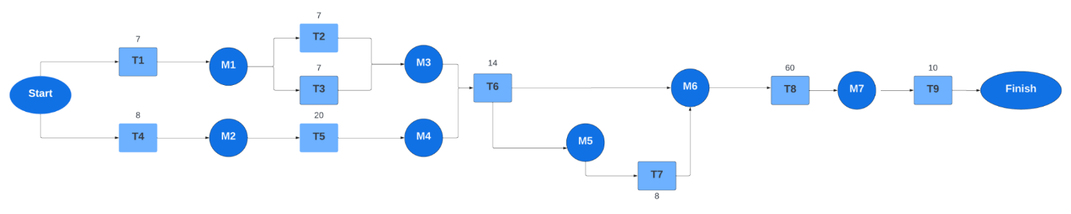Figure 1: Pert Diagram

## **A graph with blue and orange squares Description automatically generated1.8.2 GANTT Chart**

Figure 2: Gantt chart

## **1.8.3 Staff Allocation Chart**

Table 3: Staff Allocation

|  |  |  |  |  |  |  |
| --- | --- | --- | --- | --- | --- | --- |
| Weeks Interval | 0-1 | 1-2 | 2-5 | 5-7 | 7-8 | 8-19 |
| Mohannad | T1&T4 | T2&T3 | T5 |  |  | T8&T9 |
| Adnan | T1&T4 |  | T5 | T6 |  | T8&T9 |
| Mohammad | T1&T4 |  |  | T6 | T7 | T8&T9 |
| Abedalmajeed | T1&T4 | T2&T3 |  |  |  |  |

## **1.9 Report Outline**

**Chapter one:**

shows the project motivation in Section 1.1, in additional the problem statement is stated in Section 1.2, Section 1.3 list the project aim and objectives, whereas the project scope is identified in section 1.4, Section 1.5 provide the project software and hardware requirement and Section 1.6, highlights the project limitation, furthermore project expected output is addressed in Section 1.7, whereas the project is scheduled is Section 1.8, the report outline in finally present in Section 1.9.

**Chapter two:**

show an introduction in Section 2.1, the existing system is elaborated in Section 2.2, in addition the overall problems of existing system are stated in Section 2.3, Section 2.4, over-all solution approach.

**Chapter three:**

show an introduction in Section 3.1, requirements elicitation techniques are elaborated in Section 3.2, in addition the targeted users are stated in Section 3.3, Section 3.4, Functional requirements definition and functional requirement specification is identified in Section 7 3.5, Section 3.6 highlights the non-functional requirements.

**Chapter four:**

an introduction in Section 4.1, Context Diagram elaborated in Section 4.2, Section 4.3 provide the Entity Relationship Diagram, 4.4 UML Use Case Diagram, in addition the UML, Sequence Diagram is stated in Section 4.5, Section 4.6 include UML Sequence Diagram, Section, 4.7 Graphical User Interface (GUI) Design and 4.8 Summary.

**Chapter five:**

This chapter presents all aspects of the system implementation including the

database implementation, graphical user interface implementation/high fidelity

prototype, and any details pertaining to the implementation tools used.

**Chapter six:**

This chapter presents the system testing and installation aspects including the

heuristic evaluation, cooperative evaluation, system installation, and user manual.

**Chapter seven:**

This chapter presents the project conclusions and future work including the overall

weaknesses and strengths, and future directions.

# **Chapter Two: Related Existing System**

## **2.1 Introduction**

In this chapter, we embark on an exploration of existing systems in the online education landscape, drawing parallels with popular platforms like Udemy and innovative technologies such as ChatGPT. By understanding the strengths and weaknesses of these systems, we gain valuable insights to refine our project, "EduAI," and highlight the unique features it brings to the realm of online education.

## **2.2 Existing Systems**

### 2.2.1 Udemy

Udemy, a popular online learning platform, has played a main role in making education accessible globally. It offers a diverse range of courses taught by industry experts. However, Udemy mostly follows a standardized model, where courses are pre-recorded, and interactions are limited to discussion forums or messaging systems. The platform might lack the personalization required to provide individual learning preferences and address specific queries effectively.

### 2.2.2 Coursera

Coursera is a famous website for online learning. It has helped many people around the world to learn new things. It has lots of different courses taught by experts from top schools and companies. Unlike Udemy, Coursera has a more organized way of teaching with set schedules and regular homework. Many of its courses are part of bigger learning paths or degree programs, which give a more complete learning experience. But this might not be good for learners who want to learn at their own pace. Coursera tries to balance having a set way of teaching with meeting the different needs of learners, but there might still be some room to do better in meeting individual learning needs and answering questions effectively.

## **2.3 Overall Problems of Existing Systems**

The overarching issues with existing systems lie in their inability to provide to the unique learning needs of individual students. The lack of personalization, dynamic interaction, and real-time support hinders the overall effectiveness of online education platforms. Students often feel disengaged, leading to lower completion rates and decreased satisfaction.

## **2.4 Overall Solution Approach**

Our project, "EduAI" aims to address the shortcomings identified in existing systems by introducing a dynamic and personalized learning experience. The integration of a ChatGPT-powered chatbot and behavior tracking mechanisms seeks to bridge the gap between the one-size-fits-all approach and the diverse learning needs of university students. By learning from the limitations of existing systems, we strive to create an innovative solution that enhances user engagement and fosters effective learning.

## **2.5 Summary**

This chapter has provided an overview of the current state of online education systems, emphasizing their limitations in catering to individual learning styles. The subsequent chapters will delve into the detailed design and implementation of "EduAI," outlining how our project addresses these challenges and contributes to the evolution of online education.

# **Chapter Three: System Requirements Engineering and Analysis**

## **3.1 Introduction**

This chapter includes in detail the system requirements and system analysis with a full description of the system's functionality, including the definition and specification for each requirement.

## **3.2 Feasibility Study**

### 3.2.1 Technical Feasibility

Our software is developed using the following web development tools:

• Front-end: HTML, CSS, JavaScript.

• Back-end-end: PHP (Laravel).

• Database: MySQL.

The Software is developed by:

• Visual Studio code.

• XAMMP.

The software will be available to users on their web browser. These Technical resources will allow us to update and upgrade the system as required.

### 3.2.2 Operational Feasibility

The program should work for every student at the university Providing a reliable and easy-to-use program for any student. This program will help the student to minimize:

• Time.

• Money.

• Effort.

### 3.2.3 Economic Feasibility

Table 4: Economic Feasibility

|  |  |  |  |  |
| --- | --- | --- | --- | --- |
| Year | Year 0 | Year 1 | Year 2 | Year 3 |
| Hardware | 3000$ | 800$ | 1000$ | 2000$ |
| Software | 3000$ | 950$ | 800$ | 1000$ |
| DB Server | 300$ | 800$ | 2000$ | 2000$ |
| Internet Connection | 200$ | 1000$ | 1500$ | 1500$ |
| Developers | 2000$ | 2000$ | 1000$ | 1500$ |
| Maintenance cost | 5000$ | 1500$ | 2500$ | 3000$ |
| Total Cost | 13500$ | 7050$ | 8800$ | 11000$ |
| Benefits | 0$ | 7500$ | 12500$ | 26500$ |
| Discount Rate | 1 | 0.955 | 0.860 | 0.772 |
| Accumulated Cost | 13500$ | 20232.75$ | 27800.75$ | 36292.75$ |
| Accumulated Benefits | 0$ | 7162.5$ | 17912.5$ | 38370.5$ |

ROI (Return on Investment) = (Estimated Benefits – Estimated Costs) / (Estimated Costs)

= (38370.5 – 36292.75) /36292.75 = 2077.75 = 0.057 = 5%.

Annual ROI = ROI/ (Project lifetime)

Annual ROI = 0.057 / 3 = 1.9%.

NPV = Accumulated Benefits – Accumulated Costs

= 38370.5 – 36292.75 = 2077.75.

**Payback Period:** Software will start gaining profits by the end of the Third year of the software.

## **3.3 Requirements Elicitation Techniques (Questionnaire)**

The survey was sent to a group of university students and asked them about our project.

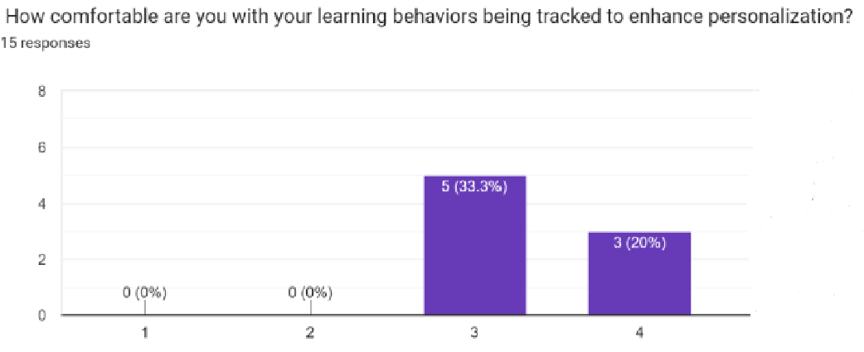

Figure 3: Questionnaire figure 1

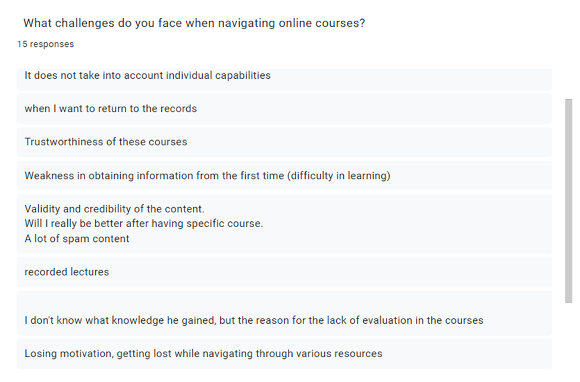

Figure 4: Questionnaire figure 2

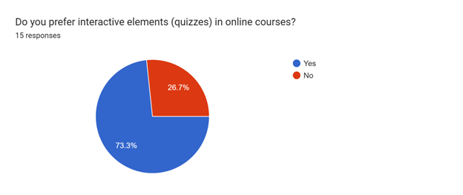

Figure 5: Questionnaire figure 3

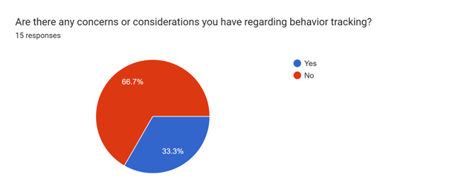

Figure 6: Questionnaire figure 4

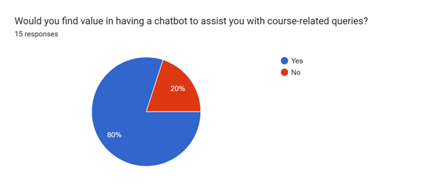

Figure 7: Questionnaire figure 5

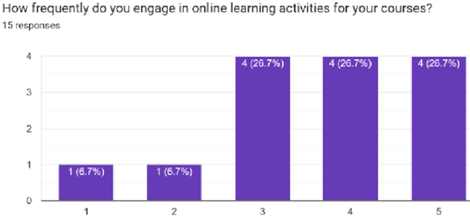

Figure 8: Questionnaire figure 6

## **3.4 Targeted Users**

University Students: Undergraduate and graduate students across various disciplines and academic levels. Those seeking personalized assistance, interactive learning experiences, and quick access to course-related information.

## **3.5 Functional Requirements Definition**

Table 5:Functional Requirements Definition

|  |  |  |
| --- | --- | --- |
| ID | Requirement Name | Description |
| 1 | Register | This feature would allow students to create a new account by providing their personal information. |
| 2 | Log in | This feature would allow users to log in to their account using the login page. |
| 3 | Forget password | A method that user can used when he/she forget the password. |
| 4 | Log out | This feature would allow users to logout of their account and end their session. |
| 5 | Greet user | short piece of text that typically displayed the name of the user on the dashboard. |
| 6 | Contact us | Feature on a website typically allows users to send a message or inquiry to the EduAi owner. |
| 7 | Log in selection | enables users to choose their login form based on their role, such as student, instructor, or admin. |
| 8 | Manage course by admin | This requirement entails granting administrators the ability to view, delete, publish, unpublish courses, and access course overviews (number of students and number of students who complete the course). |
| 9 | Manage student by admin | This requirement involves enabling administrators to view, add, edit, and delete student profiles within the system. |
| 10 | Manage instructor by admin | This requirement involves granting administrators the ability to view, add, edit, and delete instructor profiles within the system. |
| 11 | Display number of students | This feature allow admin in view the number of students within the system. |
| 12 | Display number of instructors | This feature allow admin to display number of instructors within the system. |
| 13 | manage course by instructor | allows instructors to view, edit, delete, and add courses within the system. |
| 14 | Manage lesson by instructor | Instructors can manage lessons by adding, viewing, editing, deleting sections and items, and downloading items within sections. They can also adjust the position of sections and items using drag-and-drop functionality, facilitating streamlined content organization and customization. |
| 15 | Manage course by student | Students can view all courses on the website and manage their own courses by adding them to their list, tracking ongoing progress, viewing completed courses, and filtering courses based on year, department, or title. |
| 16 | Mange item | Instructor can add material, books, YouTube links, posts and quiz. |
| 17 | Manage Lesson by student | feature allows students to mark their progress by checking boxes as they complete lessons. Additionally, students can download associated files to support their learning journey, also students can attempt quizzes. |
| 18 | Profile management | This requirement allows different user roles such as admin, instructor, and student to edit their respective profiles |
| 19 | Manage quiz by instructor | Instructor can view quiz list, quiz result, and delete, add, edit quizzes. |
| 20 | Attempt quiz | Students can take quizzes and view the result. |
| 21 | Display term of use and policy | A specific page on the website that display all term of use for our website. |
| 22 | Chat with bot | Instructor and student can chat with bot to improve the quality of learning and teaching methods. |
| 23 | Suggest material for students | The chatbot after each attempted quiz will suggest a material for students to improve their information and give a resource to study based on question fall in. |

## **3.6 Functional Requirements Specification**

**1-** **Register**

Description: Students can create a new account by providing their personal information.

Specifications:

• The system must provide a " Register " option as a designated registration page.

• Students will be prompted to enter their required personal details, including full name,

email, password, department, and current year.

• Validation checks will ensure the email address is in the correct format.

• When a successful submission comes, the system will create a new account.

• An error message will be displayed if any of the provided information is invalid or

incomplete, prompting users to correct the entries.

Table 6: Register Tabular form

|  |  |
| --- | --- |
| Condition | Action |
| Password is < 8 letters or digits | Show an error message. |
| Students email is not valid | Show a message to the user that the email is not valid. |
| Password is >= 8 letters or digits | Sign up successfully |
| Students email is valid | Sign up successfully |

Password must include at least:

* One uppercase letter (A-Z).
* One lowercase letter (a-z).
* One digit (0-9).
* One special character (e.g., !, @, #, $, etc.).

**2- Log In**

Description: Users, including students, admins, and instructors, can log in to their respective accounts using the login page. Each role has its own login form based to their specific permissions and functionalities.

Specifications:

• The system must present a "Log In" option as a login page.

• Users will be required to enter their registered email address and password.

• After submission, the system will verify the data against the database.

• When a successful authentication, users will be directed to their respective dashboard or

landing page based to their role (student dashboard, admin dashboard, instructor dashboard).

**3- Forget password**

The "Forgot Password" feature is designed to help users securely reset their passwords if they forget them. When a user clicks on the "Forgot Password" link on the login page, they are prompted to enter their registered email address. The system then sends a the new password to the user's email.

**4- Log Out**

Description: Users can log out of their account to end their current session.

Specifications:

• The system shall provide a "Log Out" option accessible within the user interface, typically

located in the header.

• When selecting the "Log Out" option, the system will terminate the user's current session

and clear any session-related data stored locally.

• After logging out, users will be redirected to the selection login page.

• The "Log Out" functionality will invalidate the current session token, ensuring that the user

cannot access restricted areas or perform actions without re-authentication.

**5- Greet User**

Description: Display a personalized greeting message, typically showing the name of the logged-in user on top of the page.

Specifications:

• The system must retrieve the name of the logged-in user when successful authentication.

• On the dashboard, a short piece of text will be displayed, incorporating the user's name,

such as "Welcome, [Full+ Name].

**6-Contact us**

Description: The "Contact Us by Email" feature enables users to send inquiries, feedback, or messages to the platform's support or customer service team through an email-based communication system. Additionally, users can also use the 'Contact Us' feature to request assistance from an administrator for creating an instructor profile."

Specifications:

• User Interface: There must be a designated "Contact Us" section or page accessible.

• The contact will be done by using the email address.

**7- Log in selection**

Specification:

• User Interface: Present a selection interface with options for roles:

Student, Instructor, Admin.

• Include a "Login" button for initiating the login process.

• Detect the selected role when user interaction.

**8- Manage course by admin:**

Allow administrators to manage courses, including view, delete, and publish, unpublish via an intuitive and secure web interface. Also display course overviews (number of students and number of students who complete the course).

**8.1 view course:**

1- User Interface:

• Display course list with search filter.

• Show course details including course name and for which department the course belongs.

**8.2 delete course:**

1- Confirmation Prompt:

• Display a confirmation prompt before proceeding with course deletion.

• Include a warning message about the irreversible action.

2- Access Control:

• Restrict deletion functionality to admin accounts only.

• Implement authentication checks to ensure authorized access.

**8.3-publish, unpublish:**

Implement "Publish" and "Unpublish" functionalities for admins to control the visibility of courses to the public.

1-Publish Course:

• Allow admins to select a course and mark it as "Published."

• Update the course status to indicate it is visible to the public.

2-Unpublish Course:

• Enable admins to choose a published course and mark it as "Unpublished."

• Update the course status to indicate it is not visible to the public.

**8.4- Display course overview:**

Including the number of enrolled students and the number of students who have completed the course.

Specification:

1- Course Overview Section:

• Include a dedicated section on the course page for the overview.

• Display key metrics such as enrollment count and completion count.

2- Enrollment Count:

• Show the total number of students currently enrolled on the course.

• Update enrollments count dynamically based on real-time data.

3- Completion Count:

• Display the number of students who have successfully completed the course.

• Update completion count dynamically based on course completion criteria.

**9- Manage student by admin**

**9.1- View Student**

• Specification: Provide administrators with a comprehensive list of all student profiles in the

system.

• Details Display: Include student names, IDs, email, department, and year.

• Filtering Options: Allow administrators to filter and search for specific student profiles

based on criteria such as name, IDs, and email.

**9.2 Add Student**

• Specification: Allow administrators to create new student profiles within the system.

• Input Fields: Include fields for student name, email, password, department, and year.

• Validation Checks: Implement validation checks to ensure data accuracy and completeness

during profile creation.

**9.3 Edit Student**

• Specification: Enable administrators to modify existing student profiles as needed.

• Editable Fields: Provide options to edit student names, email, password, year, and

department.

**9.4 Delete Student**

• Description: Provide a secure mechanism for administrators to delete student profiles with

confirmation prompts and cascading effect handling.

**9.5 Delete Student Profile**

• Specification: Allow administrators to delete student profiles when necessary.

• Confirmation Prompt: Implement a confirmation prompt to prevent accidental deletions.

• Cascading Deletion: Handle cascading effects such as removing associated records or data

linked to the deleted student profile.

**10- Manage instructor by admin**

**10.1 View Instructor**

• Specification: Provide administrators with access to a list of all instructor profiles in the

system.

• Details Display: Include instructor names, IDs and joining date.

• Filtering Options: Allow administrators to filter and search for specific instructor profiles

based on criteria such as name, ID and joining date.

**10.2 Add Instructor Profile**

• Specification: Allow administrators to create new instructor profiles within the system.

• Input Fields: Include fields for instructor name, ID, password, joining date and address.

• Validation Checks: Implement validation checks to ensure data accuracy and completeness

during profile creation.

**10.3 Edit Instructor Profile**

• Specification: Enable administrators to modify existing instructor profiles as needed.

• Editable Fields: Provide options to edit instructor names, password, email, and joining date.

• Audit Logging: Log all changes made to instructor profiles, including timestamps and

admin IDs, for audit trail purposes.

**10.4 Delete Instructor Profile**

• Specification: Allow administrators to delete instructor profiles when necessary.

• Confirmation Prompt: Implement a confirmation prompt to prevent accidental deletions.

• Cascading Deletion: Handle cascading effects such as removing associated records or data

linked to the deleted instructor profile.

**11 - Display number of students**

Specification: Add a section in the admin interface showing the total number of registered students.

• Update Frequency: Ensure the count updates periodically or upon admin request to reflect

real-time data.

• Simple Interface: Present the student count in a clear, easy-to-read format without excessive

details.

• Access Control: Limit access to this feature to authorized administrators for data security.

**12- Display number of instructors**

Specification: Add a dedicated section in the admin dashboard to display the total number of instructors in the system.

• Update Frequency: Ensure the count updates in real-time or upon admin request to reflect

current data accurately.

• Clear Presentation: Display the instructor count prominently and in a straightforward

format for easy understanding.

• Access Control: Limit access to this feature to authorized administrators to maintain data

security.

**13- manage course by instructor**

**13.1 View Courses**

Specification: Provide instructors with a list of courses they are assigned to teach.

• Details: Display key information such as course title, description, year, and department.

• Filtering: Allow instructors to filter courses based on parameters like course year or

department and title.

**13.2 Add Course**

Specification: Enable instructors to create new courses within the system.

• Input Fields: Include fields for course title, description, image, department, and year.

• Validation: Implement validation checks to ensure accurate data entry.

**13.3 Edit Course**

Specification: Allow instructors to modify existing course details.

• Editable Fields: Provide options to edit course title, description, department, year, and

image.

• Validation: Validate edited information to maintain data integrity.

**13.4 Delete Course**

Specification: Allow instructors to delete courses if necessary.

• Confirmation: Implement confirmation prompts to prevent accidental deletions.

• Cascade Deletion: Handle cascading effects, such as removing enrolled students, grades,

and related data.

**13.5 publish/ unpublish course:**

The instructor should have the ability to publish and unpublish courses.

**14. Manage lesson by instructor**

**14.1 View Lessons sections**

Specification: Provide instructors with a clear overview of all lessons they are responsible

for.

**14.2 Add Lesson sections:**

Specification: Enable instructors to create new lessons and organize them within the course

structure.

• Input Fields: Include fields for lesson title.

• Validation: Validate input data to ensure completeness and accuracy.

**14.3 Edit Lesson sections:**

Specification: Allow instructors to modify existing lesson details.

• Editable Fields: Provide options to edit lesson title.

• Validation: Validate edited information to maintain consistency and data integrity.

**14.4 Delete Lesson**

Specification: Allow instructors to delete lessons when necessary.

• Confirmation: Implement confirmation prompts to prevent accidental deletions.

• Cascade Deletion: Handle deletion of associated sections, items, and related data.

**14.5 Drag-and-Drop Functionality**

Specification: Implement drag-and-drop functionality for instructors to rearrange sections

and items within lessons.

• User Interface: Design an intuitive and responsive UI for smooth drag-and-drop

interactions.

• Feedback: Provide visual feedback (e.g., highlighting, snapping) during drag-and-drop

actions for clarity.

**15-Manage course by student**

**15.1 View All Courses**

Specification: Allow students to browse and view all available courses on the website.

• Details: Display course titles, descriptions, year, and department.

**15.2 Add Courses to List**

Specification: Enable students to add courses to their personal list or dashboard for easy

access.

• User Interface: Provide an intuitive interface with an "Add to My Courses" button or similar

functionality.

• Visibility: Ensure added courses are visible and accessible only to the respective student.

**15.3 Track Ongoing Progress**

Specification: Allow students to track their progress within enrolled courses.

• Progress Tracking: Display completion status, grades, and progress metrics for each course

unit or module.

• Visual Feedback: Provide visual cues or progress bars to indicate completed and pending

tasks.

**15.4 View Completed Courses**

Specification: Provide students with a separate section to view and access completed

courses.

• Completion Status: Display completed courses with details such as completion date, grades,

and certificates if applicable.

**15.5 Filter Courses**

Specification: Implement filtering options for students to find courses based on specific criteria.

* Filter Categories: Allow filtering by year, department, title, instructor, or other relevant attributes.
* User-Friendly Filters: Design filters that are easy to use and understand, enhancing the search experience for students.

**16-Manage Items**

**16.1 Add New Item**

Specification: Enable users to add new items within a section, such as books, YouTube

links, or posts.

• Item Types: Support multiple item types, including books (PDFs or e-books), YouTube

links (videos), and posts (text content).

• Input Fields: Include fields for item title, description, content (text or URL), file upload for

books, and YouTube video embed code.

**16.2 Book Addition**

Specification: Allow users to add new books or documents as items within a section.

• File Upload: Provide an option to upload book files in supported formats (e.g., PDF, EPUB).

• Metadata: Include fields for book title, author, publication date, and description for easy

identification and organization.

**16.3 YouTube Link**

Specification: Enable users to add YouTube video links as items within a section.

• Link Input: Provide a field to enter the YouTube video URL or embed code.

• Thumbnail Display: Automatically fetch and display video thumbnails for visual

identification.

**16.4 Post Creation**

Specification: Allow users to create new posts or articles using a WYSIWYG (What You

See Is What You Get) editor.

• Content Editor: Integrate a WYSIWYG editor with formatting options (e.g., text styles,

lists, images, hyperlinks) for content creation.

• Rich Media Support: Allow embedding of images, videos, or other multimedia content

within posts for enhanced engagement.

**16.5 Item Editing**

Specification: Enable users to edit existing items within a section.

• Edit Options: Provide options to edit item titles, descriptions, content, and associated

metadata (e.g., book details, video information).

• Version Control: Implement version control or revision history for item edits to track

changes.

**16.6 Item Deletion**

Specification: Allow users to delete items from a section when necessary.

• Confirmation Prompt: Implement a confirmation prompt to prevent accidental deletions.

• Cascade Deletion: Handle deletion of associated data (e.g., book files, YouTube links) and

update section content accordingly.

**17-Manage Lesson by Student**

**17.1 Mark Lesson Progress**

Specification: Enable students to mark their progress by checking checkboxes or indicators

as they complete lessons.

• Visual Feedback: Provide visual cues such as progress bars or completion percentages to

track lesson completion.

• Save Progress: Ensure student progress is saved and accessible across sessions for ongoing

tracking.

**17.2 Download Associated Files**

Specification: Allow students to download files associated with lessons to support their

learning.

• File Types: Support various file formats such as PDFs, documents, presentations, and

multimedia content.

• Download Options: Provide download links or buttons within lesson modules for easy

access to associated files.

**17.3 Lesson Navigation**

Specification: Design intuitive navigation within lessons for seamless progression.

• Lesson Structure: Organize lessons into sections or modules with clear titles and

descriptions.

**18-Profile management:**

**18.1 User Role Differentiation**

Specification: Clearly define and differentiate user roles such as admin, instructor, and

student within the system.

• Role-Based Access: Implement role-based access control to ensure users can only edit their

own profiles based on their assigned role.

**18.2 Profile Editing**

Specification: Provide a user-friendly interface for users to edit their profiles.

• Editable Fields: Include fields such as name, contact information, bio, profile picture, and

other relevant details based on user roles.

• Validation: Validate user input to maintain data accuracy and completeness.

**18.3 Admin Profile Editing**

Specification: Allow admins to edit their profiles with administrative information.

• Admin-specific Fields: Include fields for name and password.

**18.4 Instructor Profile Editing**

Specification: Enable instructors to update their profiles with teaching-related information.

• Instructor-specific Fields: Include fields name and password.

**18.4 Student Profile Editing**

Specification: Allow students to modify their profiles with academic and personal

information.

• Student-specific Fields: Include fields for student name, department, password, and year.

**19- Manage Quiz by Instructor**

**19.1 View Quiz List**

Specification: Provide instructors with a list of all quizzes they have created.

• Details: Display quiz titles, descriptions, creation dates, and relevant course information.

**19.2 View Quiz Results**

Specification: Enable instructors to access and view quiz results for each student.

• Individual Results: Display student names, scores, attempt dates, and detailed question-

level performance.

• Aggregate Data: Provide summary statistics such as average score, highest score, and grade

distribution.

**19.3 Add Quiz**

Specification: Allow instructors to create new quizzes within the system.

• Quiz Details: Include fields for quiz title, validity date, duration, and for which section of

course this quiz is related.

• Question Types: multiple-choice.

**19.4 Edit Quiz**

Specification: Enable instructors to modify existing quiz details and questions.

• Editable Fields: Include fields for quiz title, validity date, duration, and for which section

of course, this quiz is related.

• Question Editing: Allow instructors to add, remove, or edit individual quiz questions and

answers.

**19.5 Delete Quiz**

Specification: Allow instructors to delete quizzes when necessary.

• Confirmation: Implement confirmation prompts to prevent accidental deletions.

• Cascade Deletion: Handle deletion of associated quiz questions, student attempts, and

related data.

**20- Attempt Quiz**

Description: Enable students to attempt specific quizzes, view grades, and have the option to reattempt the quiz.

Specifications:

• The system must provide a dedicated page allowing students to access and attempt quizzes

associated with a course.

• Students will be able to select a specific quiz to attempt from the available list within the

course page.

• When completing the quiz, the system will automatically grade the quiz and display the

result to the student.

• The graded result, including the score or percentage, will be shown immediately after quiz

submission.

**21- Display term of use and policy**

The "Terms of Use and Privacy Policy" page is designed to provide users with comprehensive information about the legal terms and conditions for using the website, as well as the privacy practices regarding the collection, use, and protection of user data. The page must be easily accessible via a clearly labeled link in the footer of every page on the website, ensuring users can find it effortlessly.

**22- chat with bot**

The "Chat with Bot" feature is designed to allow instructors and students to engage with an AI bot to enhance the quality of learning and teaching methods. This feature aims to provide immediate assistance, answer questions, and offer suggestions for improving educational practices.

**Key features include:**

* Accessibility and User Interaction: Both instructors and students can access the chat bot through a designated interface within the educational platform.
* The chat bot will be available 24/7 to provide support and answer queries related to course content, teaching methods, and learning strategies.
* Functionality and Personalization: The bot will be equipped with natural language processing capabilities to understand and respond to a wide range of questions.
* It will offer personalized responses based on the user's role (instructor or student) and previous interactions.

**23- suggest material for students**

The "Suggest Material for Students" feature is designed to enhance the learning experience by providing personalized study recommendations after each quiz attempt. This feature aims to help students improve their understanding and retention of information by offering targeted resources based on their quiz performance. And after student answering questions wrong the AI will assist you addressing the problem and solve it.

## **3.7 Non-Functional Requirements**

Table 7: Non-Functional Requirements

|  |  |
| --- | --- |
| Requirement | Description |
| Performance | The system must be flexible and must be fast at executing user functions. |
| Usability | The system must be easy to use, effective and efficient and must give the user a smooth experience to satisfy him. |
| Reliability | The system should be reliable, which means it should always be available 24/7 and provide information. |
| Responsiveness | ability of a website to adapt its layout and content to different screen sizes and devices. |
| Security | The system must keep the user’s information safe and private, so it must be highly secured. |

## **3.8 Summary**

The outlined project proposes a comprehensive university platform featuring registration, course management, user interaction, and AI support. It utilizes web development tools like HTML, CSS, JavaScript, PHP (Laravel), and MySQL. The feasibility study covers technical, operational, and economic aspects, demonstrating a positive ROI of 5% and a payback period within three years. Targeting university students, the functional requirements encompass user authentication, course management, profile customization, and admin functionalities. Non-functional requirements emphasize performance, usability, reliability, responsiveness, and stringent security measures to ensure a seamless and secure user experience on the platform.

# **Chapter Four: System Design**

## **Introduction**

This chapter includes many important figures that describe our application process: it

will include a context diagram, data flow diagram (DFD), entity relation diagram (ERD),

use cases, diagrams, sequences diagrams, class diagrams.

## **4.2 Context Diagram**

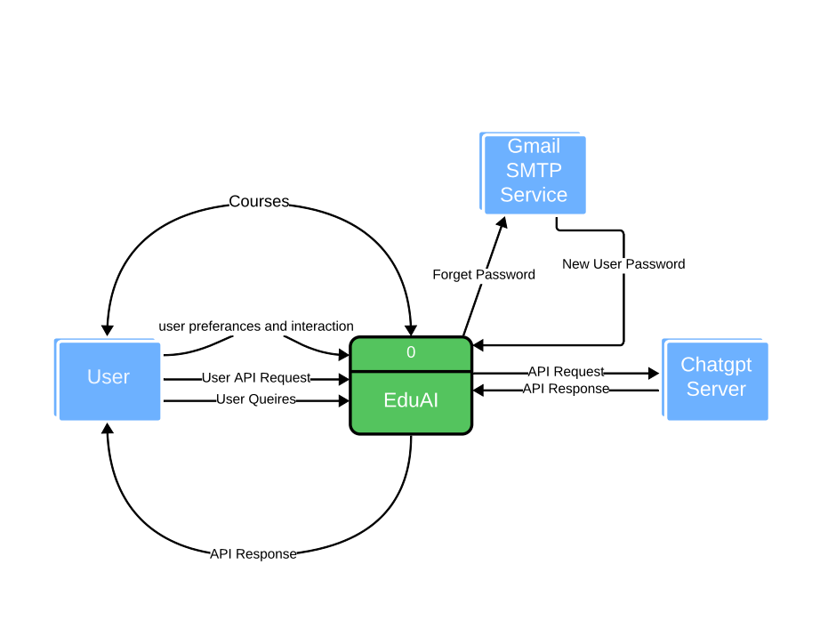

Figure 9: context diagram

**4.3 Entity Relationship Diagram (ERD)**

Figure 10: ERD

## **4.4 UML Use Case Diagram**

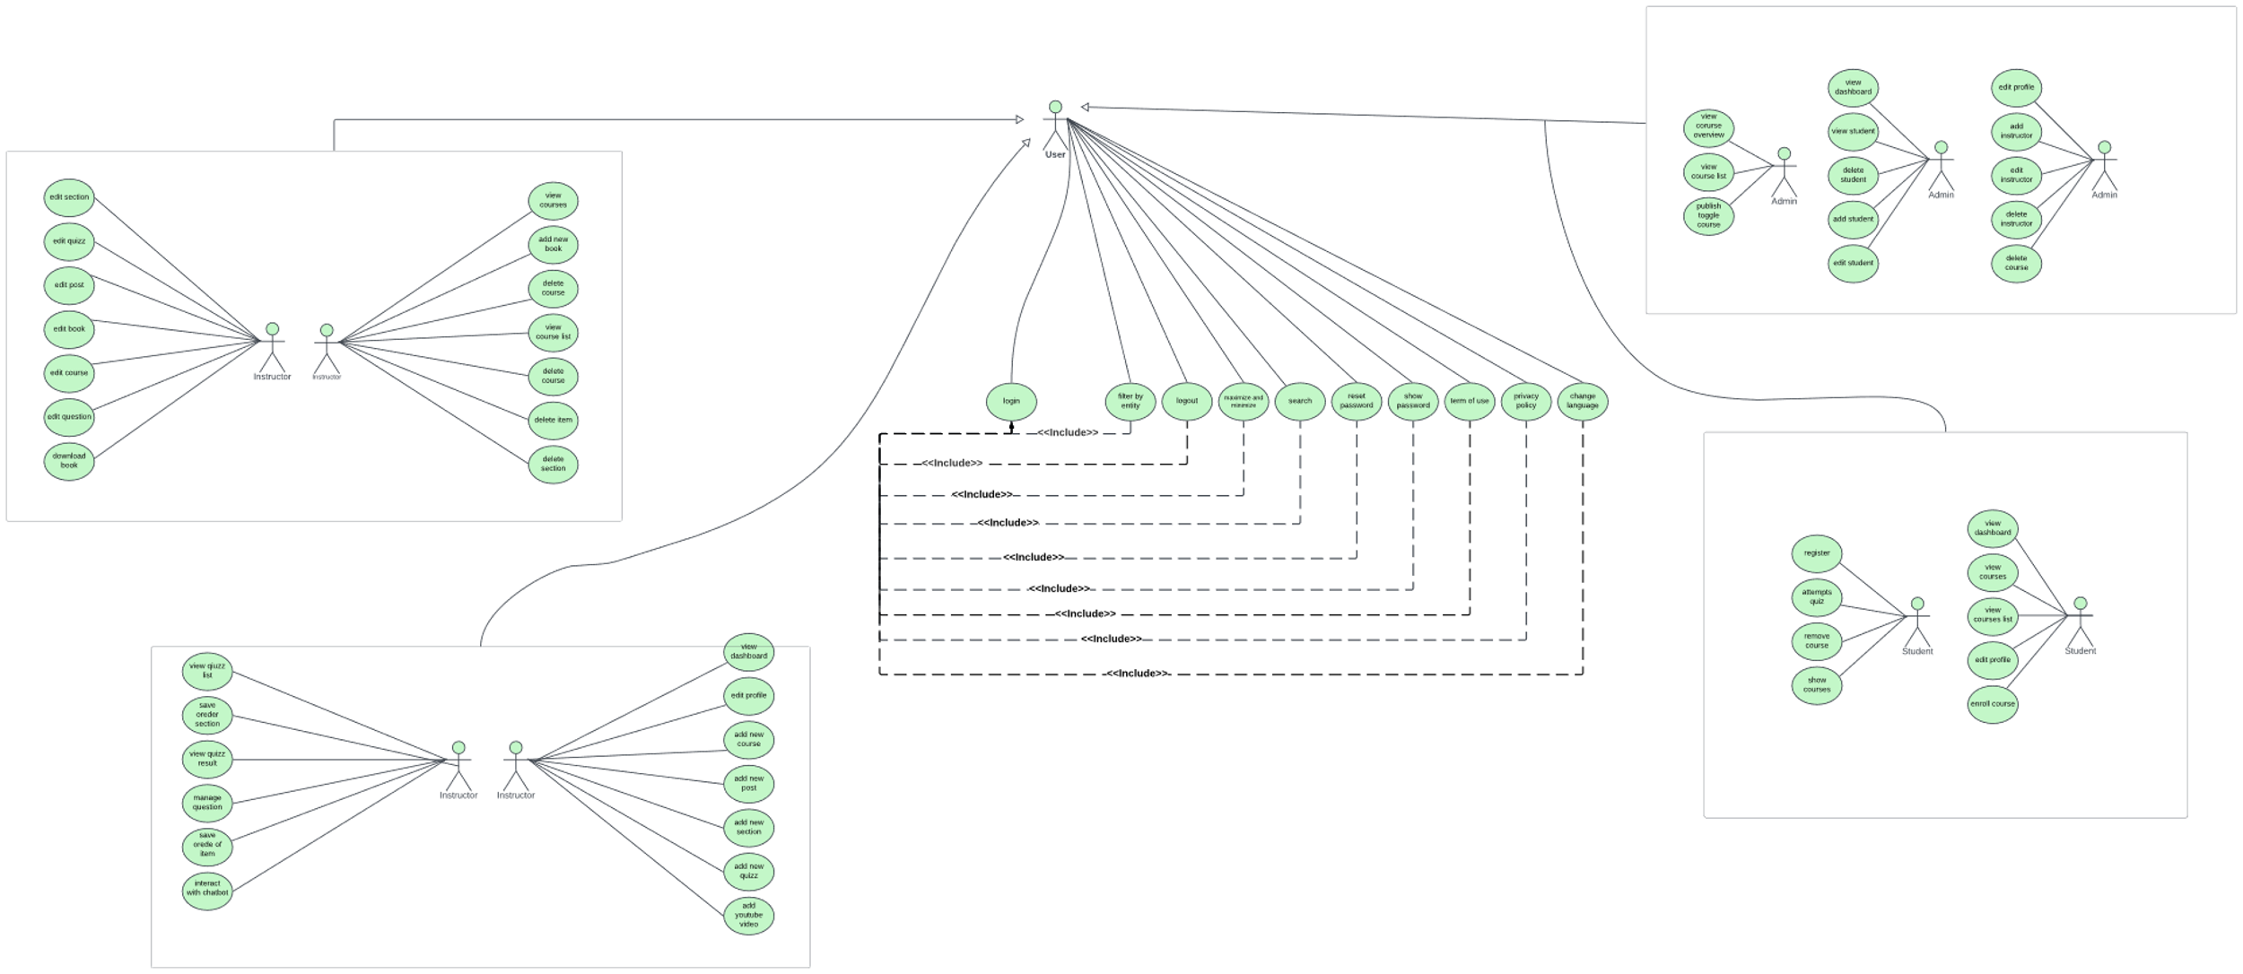

Figure 11: UML use case diagram: EduAI System

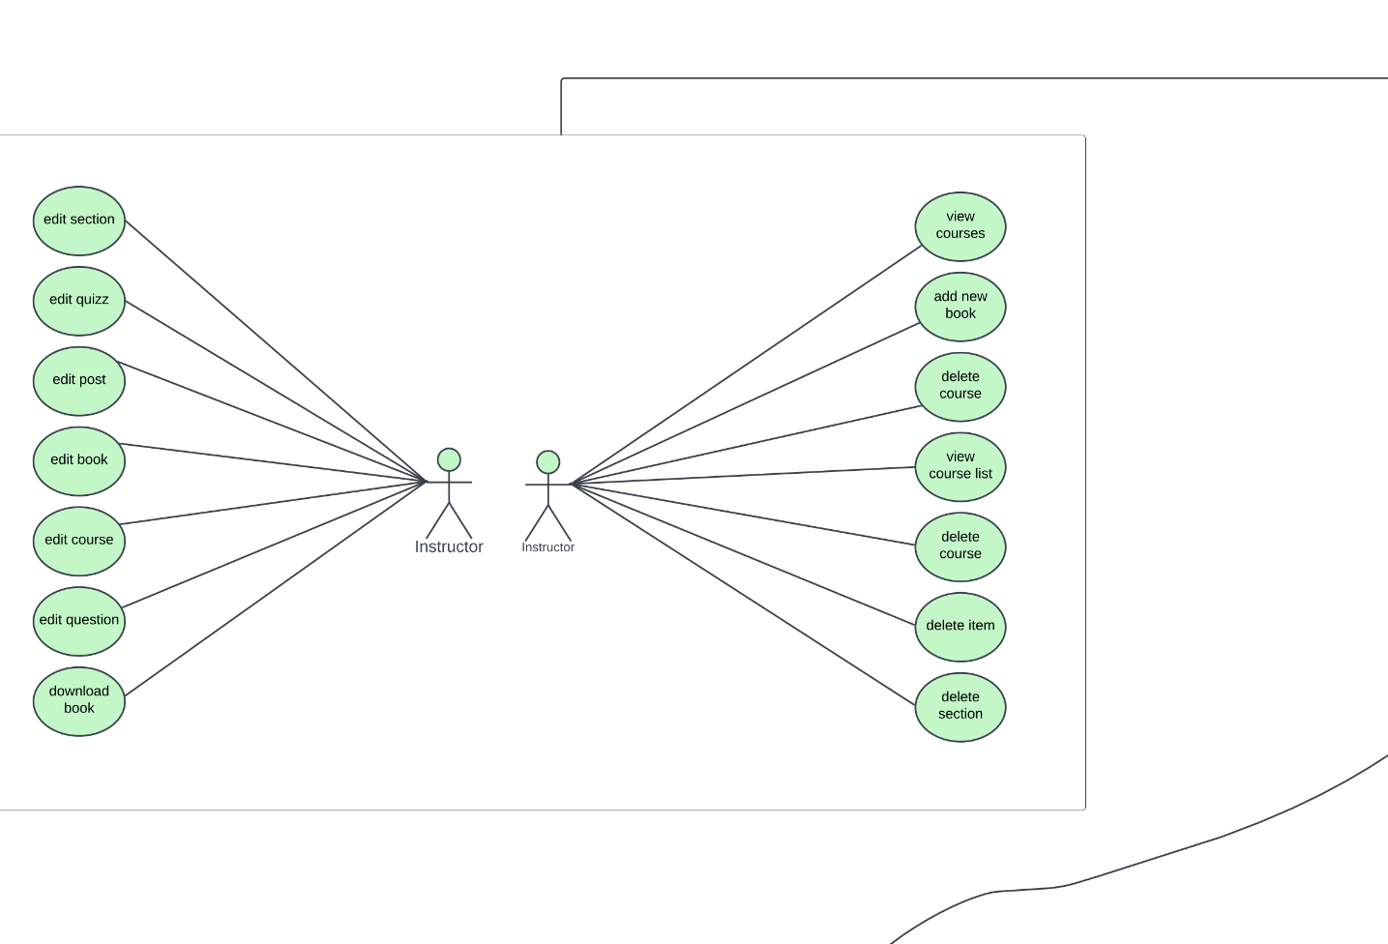

Figure 12: UML use case diagram: 1

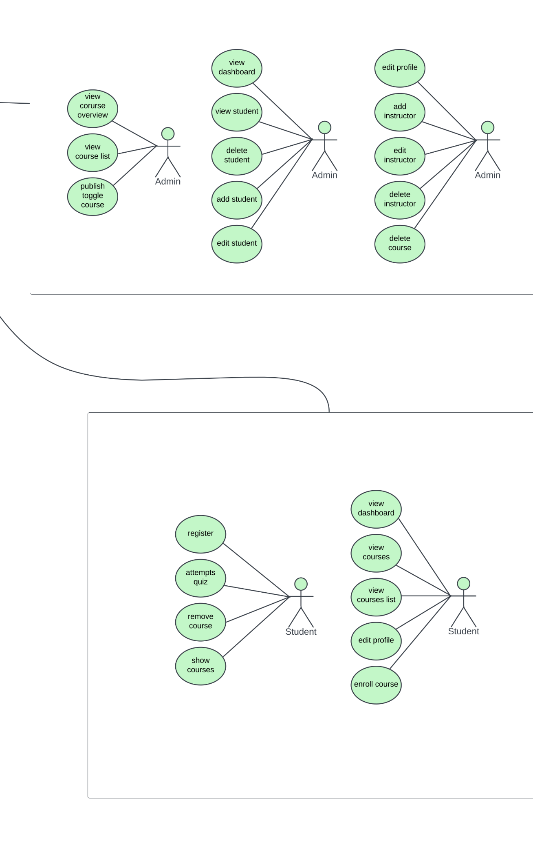

Figure 13: UML use case diagram: 2

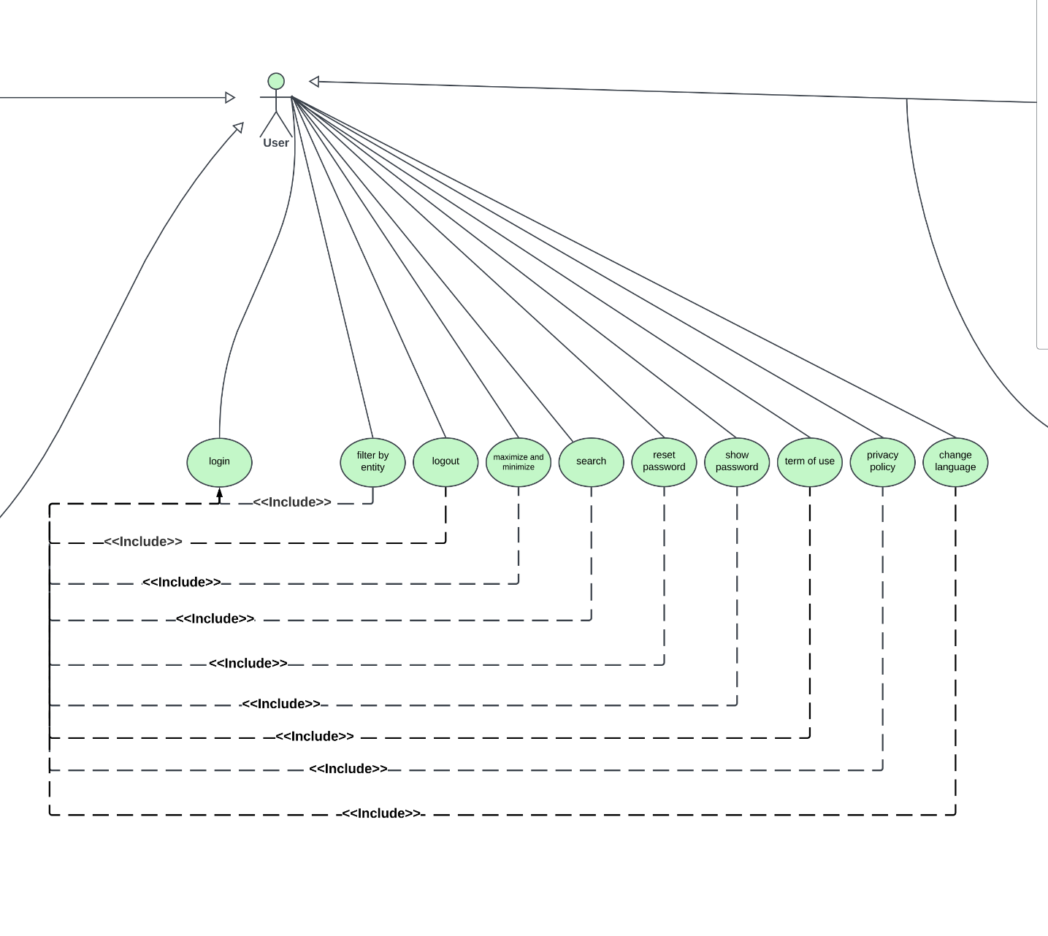

Figure 14: UML use case diagram: 3

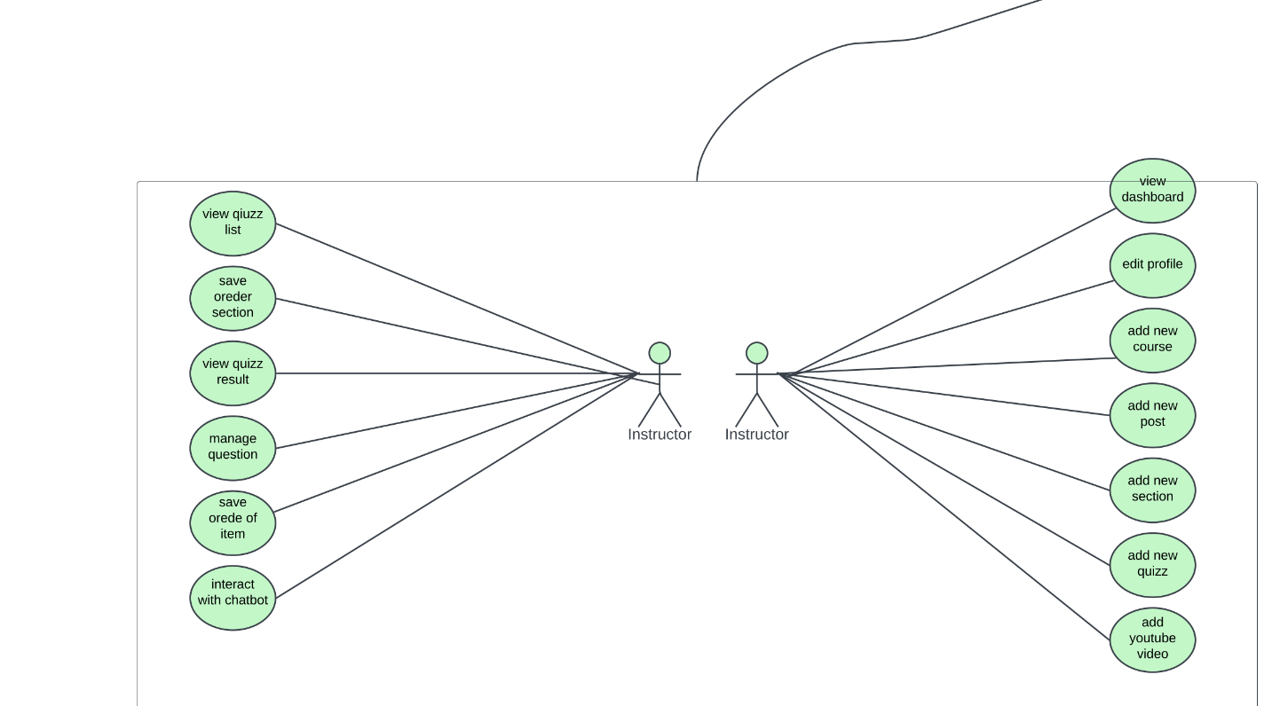

Figure 15: UML use case diagram: 4

## **4.5 UML Sequence Diagram**

## **4.5.1 student sequence**

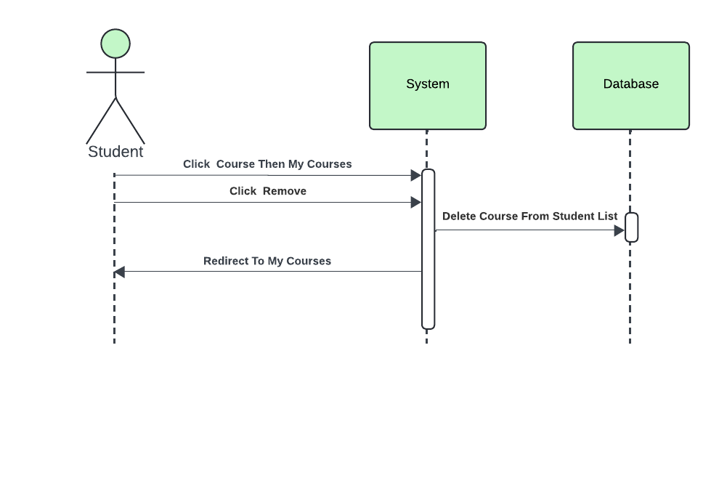

Figure 16:Sequence Diagram: Student Delete Course

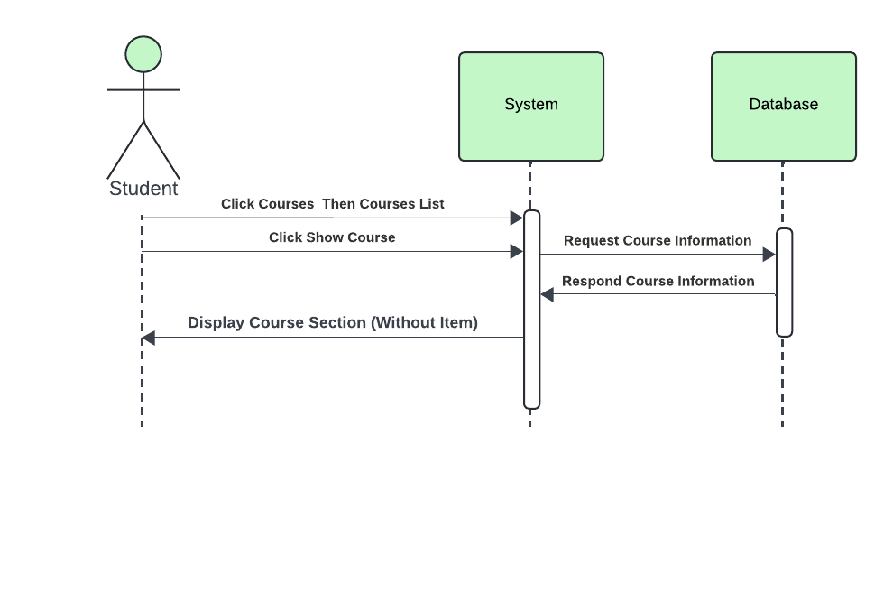

Figure 17:Sequence Diagram: Sequence Diagram: Student Display Course

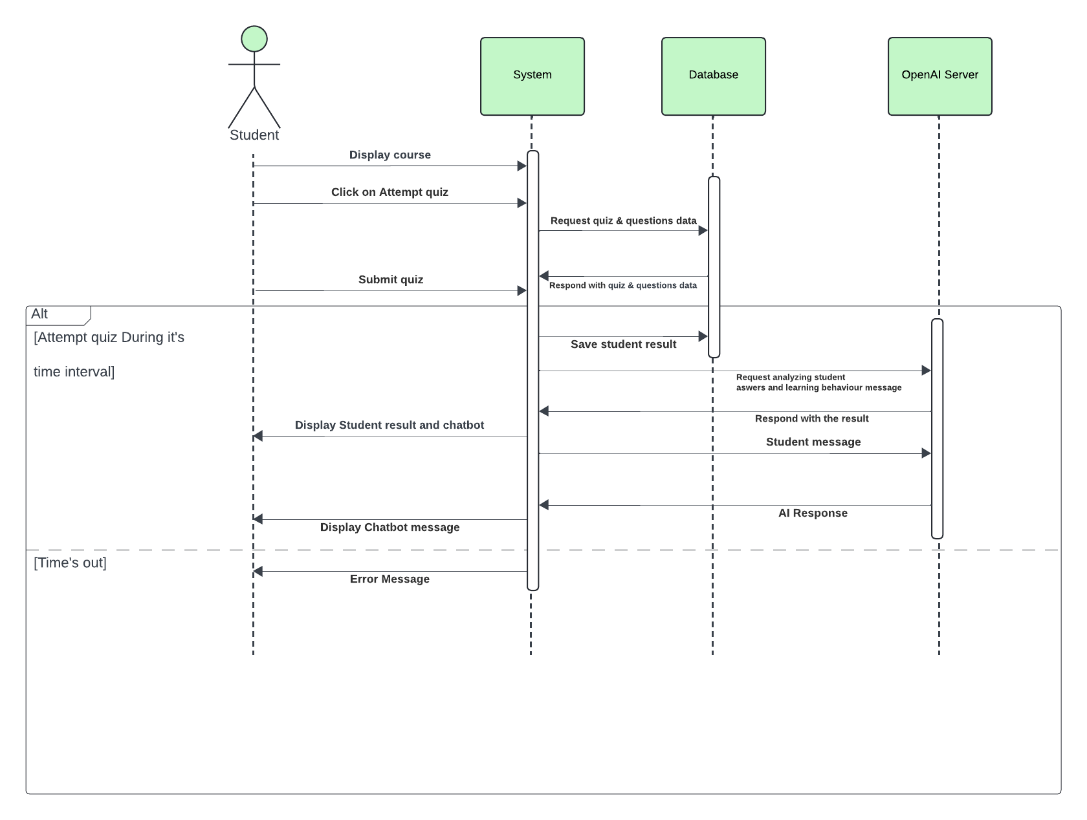

Figure 18:Sequence Diagram: Sequence Diagram: Student Attempt Quiz

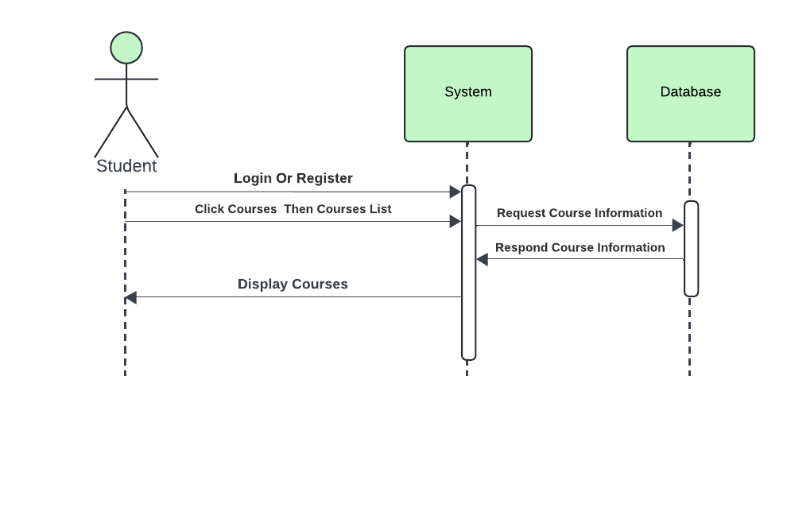

Figure 19:Sequence Diagram: Sequence Diagram: Student Display Courses List

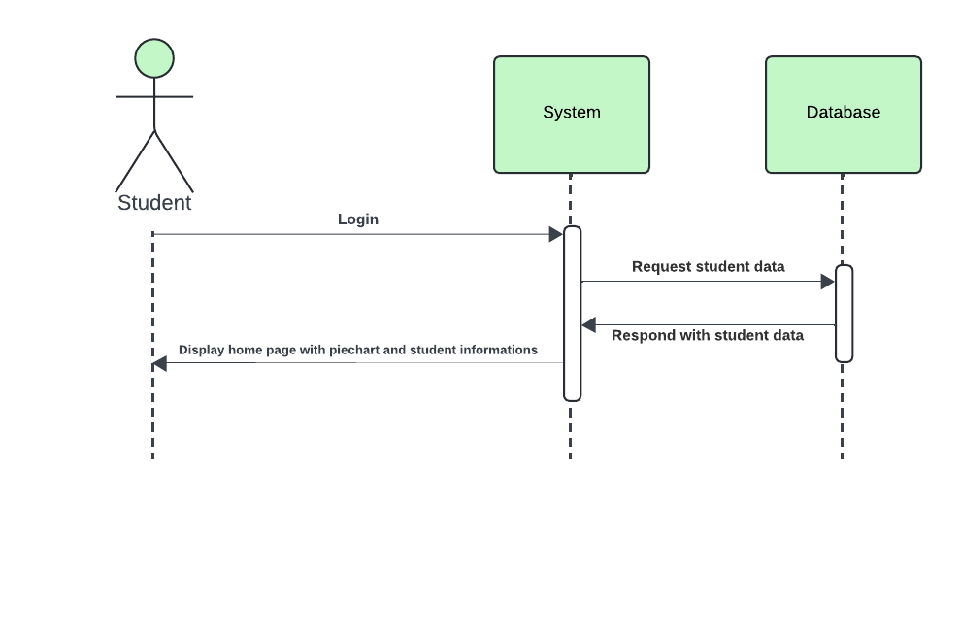

Figure 20: Sequence Diagram: Student Dashboard

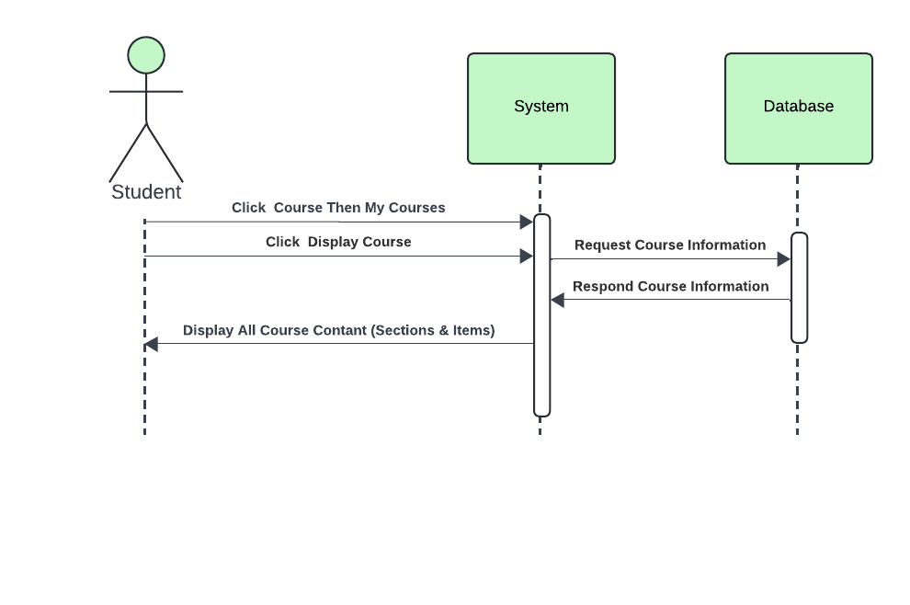

Figure 21:Sequence Diagram: Student Display Courses Contant

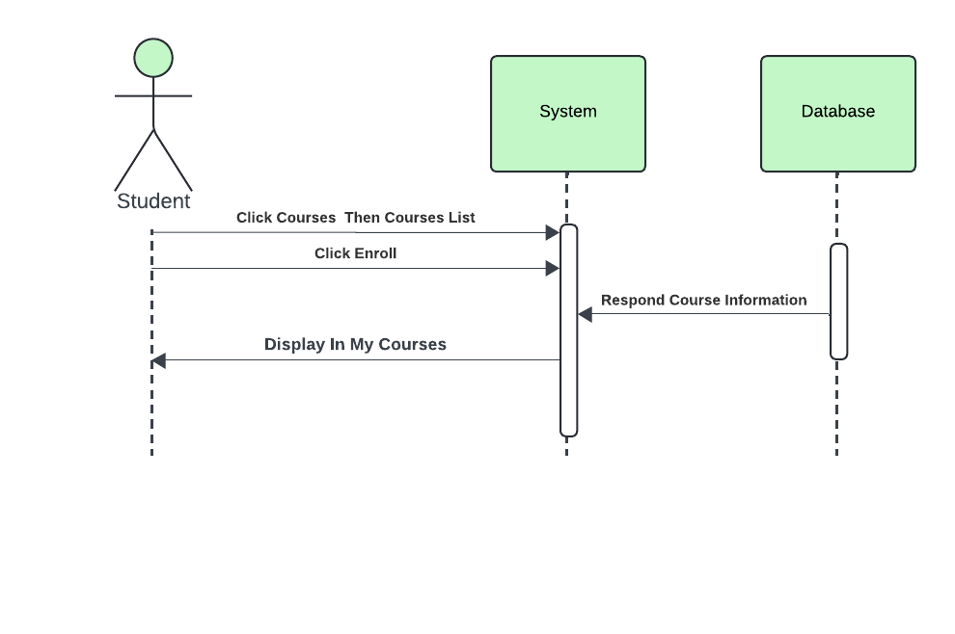

Figure 22:Sequence Diagram: Student Enroll Course

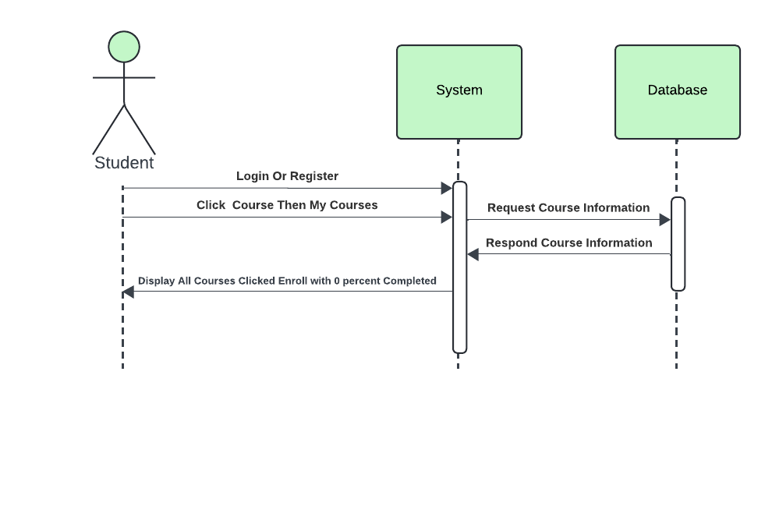

Figure 23:Sequence Diagram: Student Display My Courses

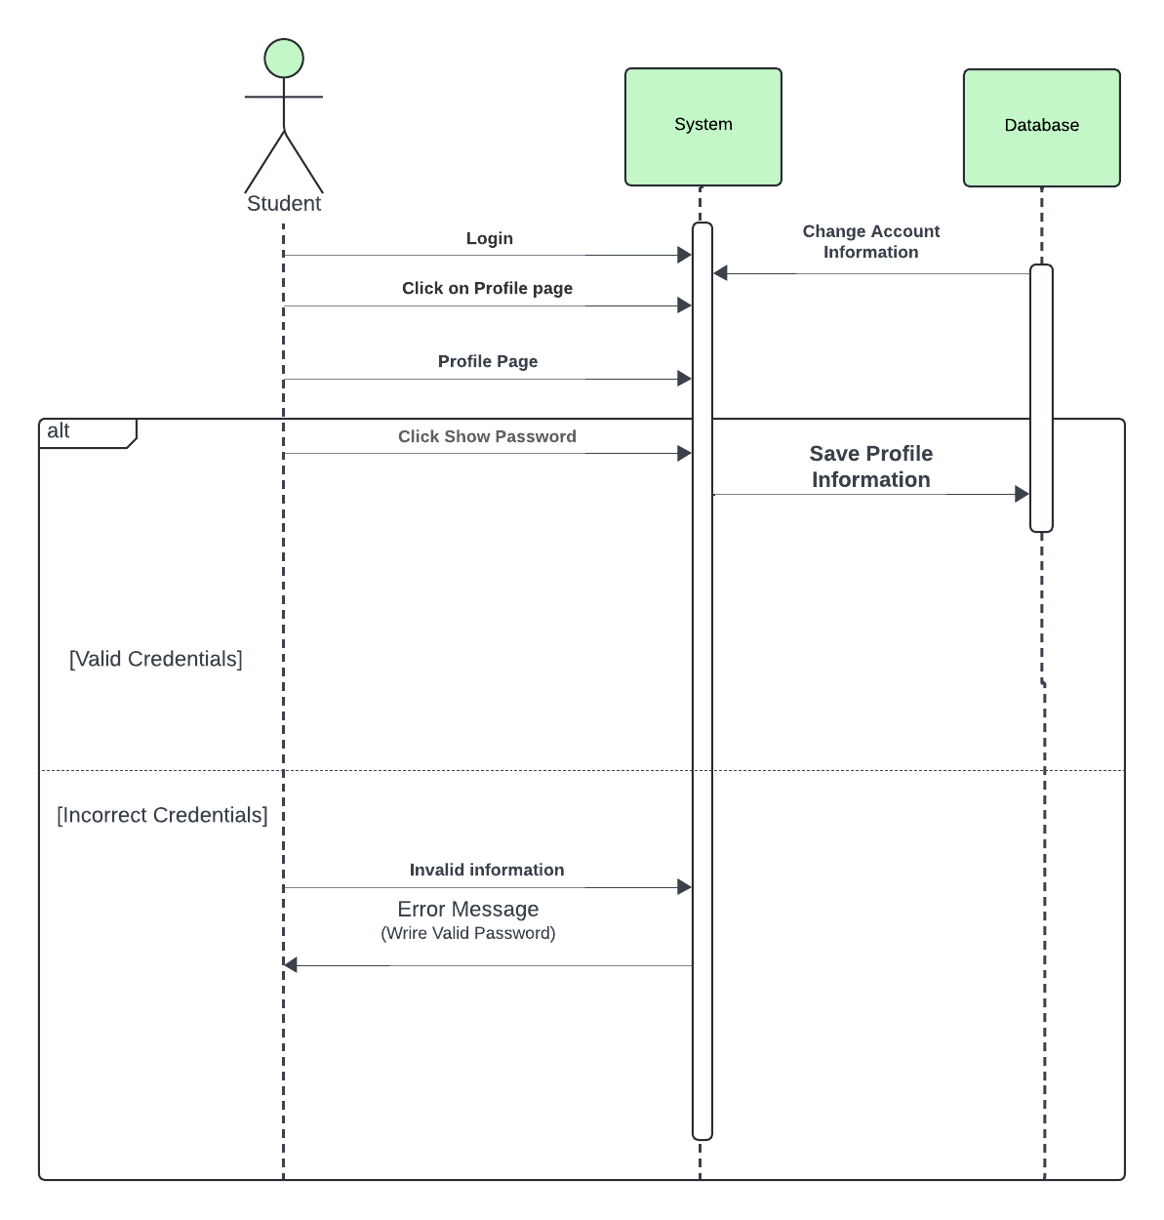

Figure 24::Sequence Diagram: Student Edit Profile

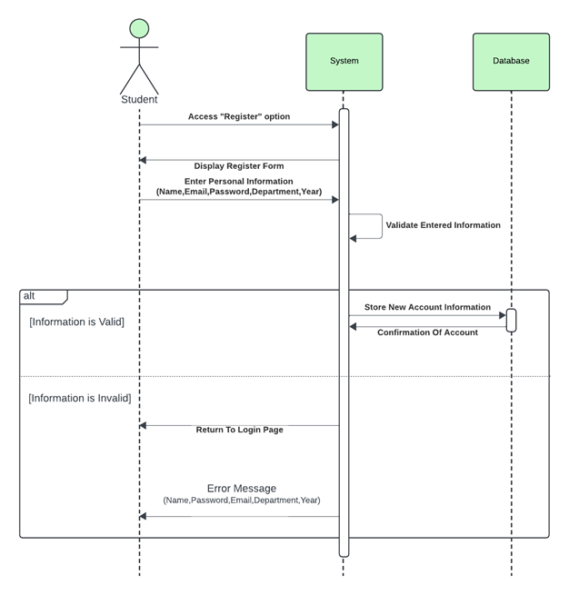

Figure 25:Sequence Diagram: Student Register

## **4.5.1 instructor sequence**

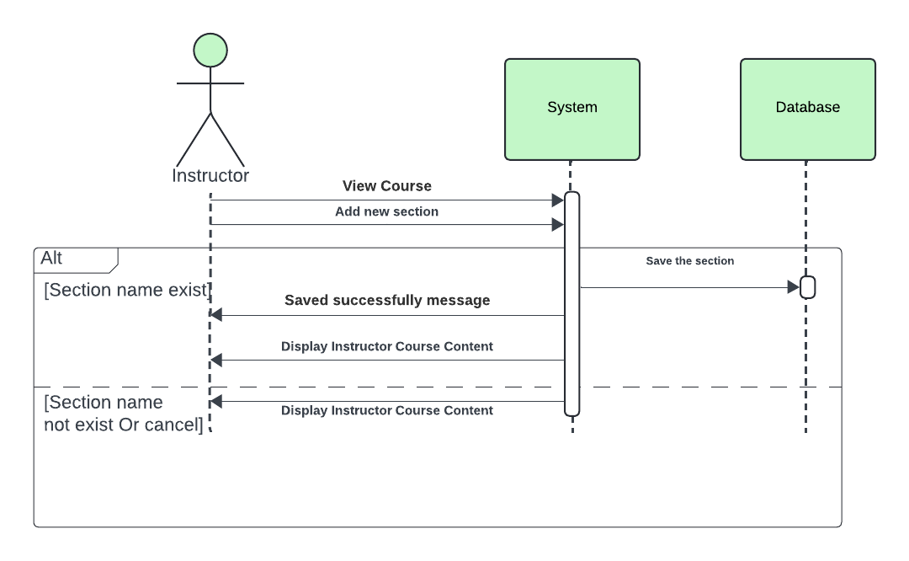

Figure 26:Sequence Diagram: Instructor Add New Section

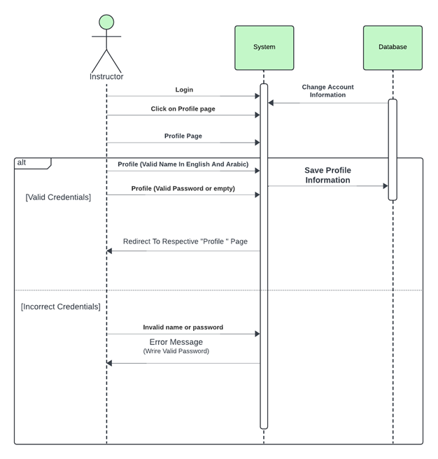

Figure 27::Sequence Diagram: Instructor Edit Profile

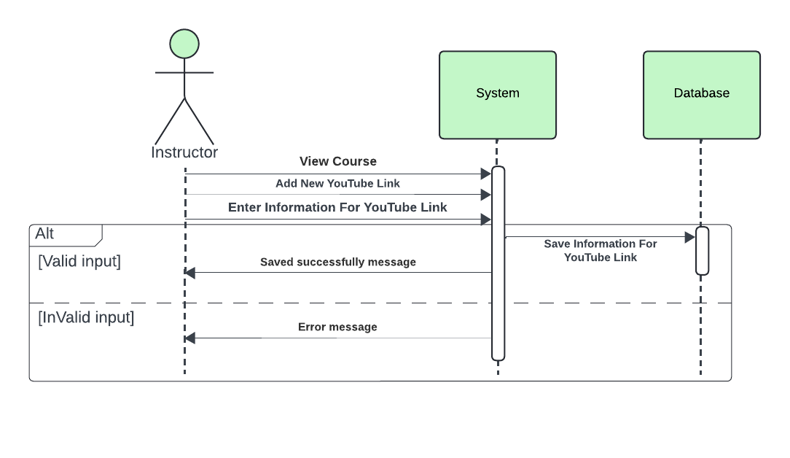

Figure 28:Sequence Diagram: Instructor Add New YouTube Link

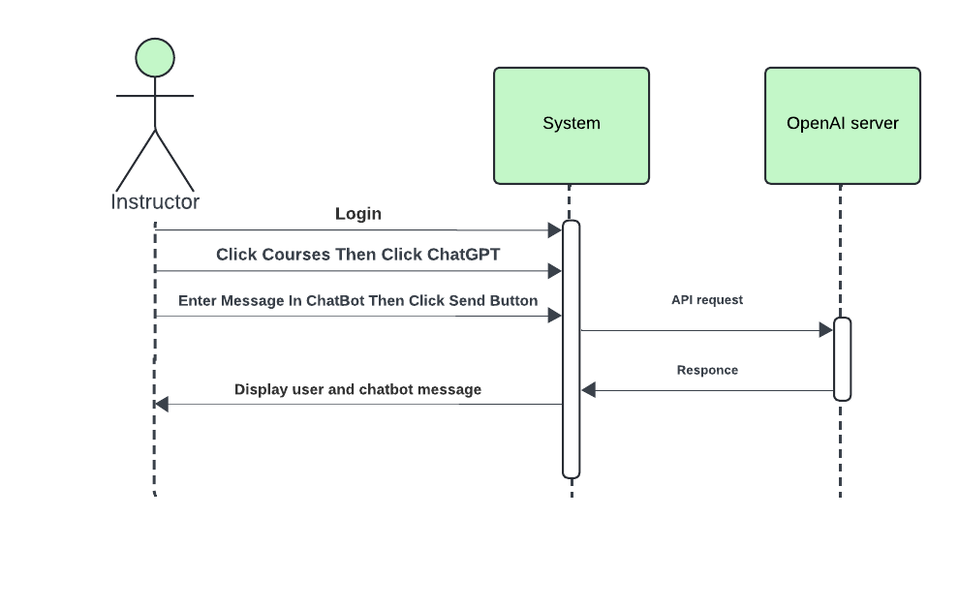

Figure 29:Sequence Diagram: Instructor Chat with GPT

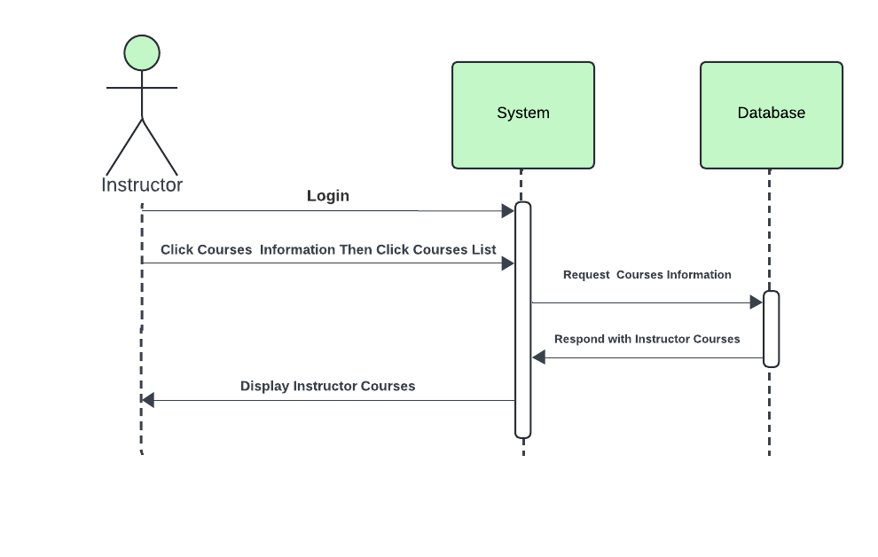

Figure 30:Sequence Diagram: Instructor Display Courses

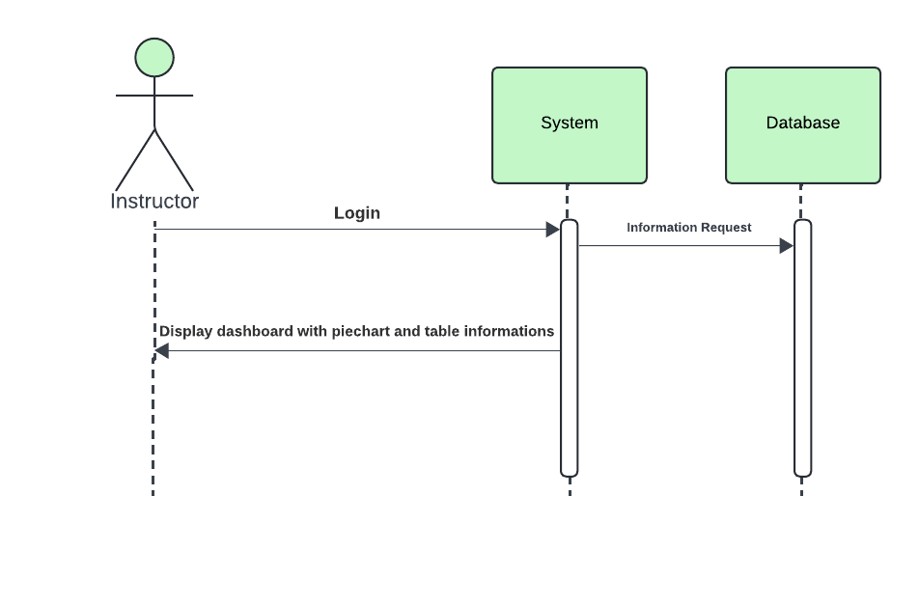

Figure 31:Sequence Diagram: Instructor Dashboard

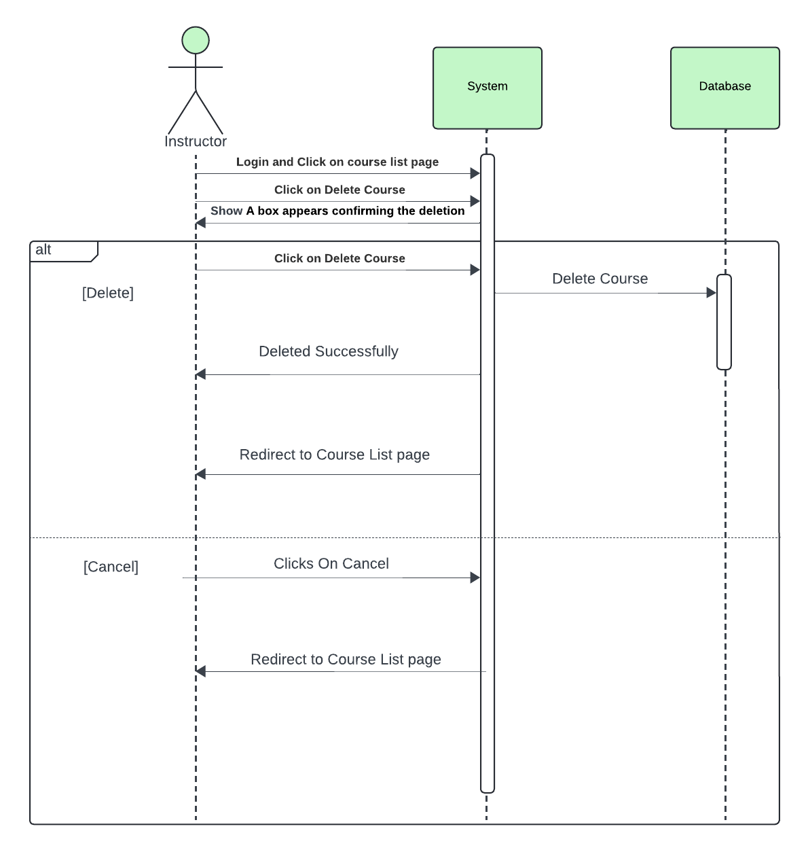

Figure 32:Sequence Diagram: Instructor Delete Course

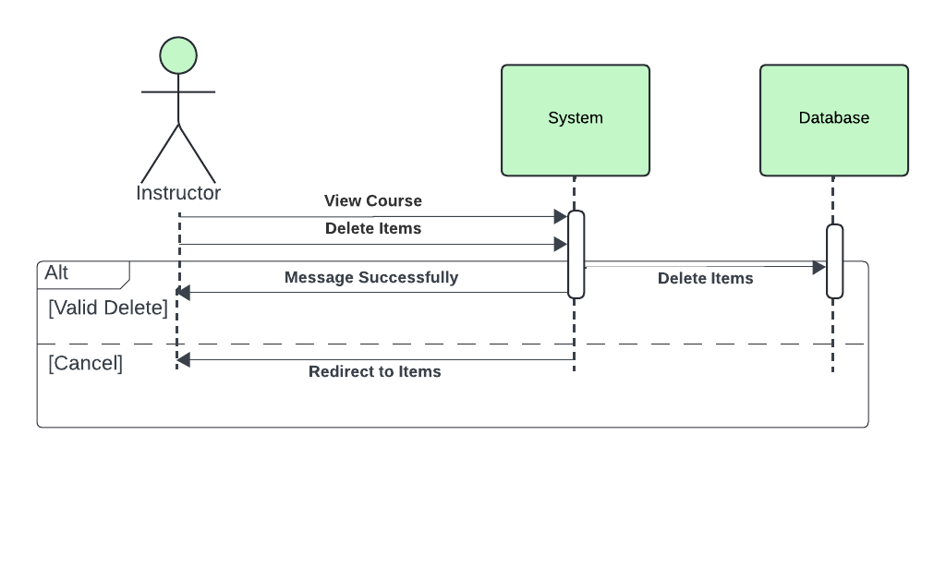

Figure 33:Sequence Diagram: Instructor Delete Item

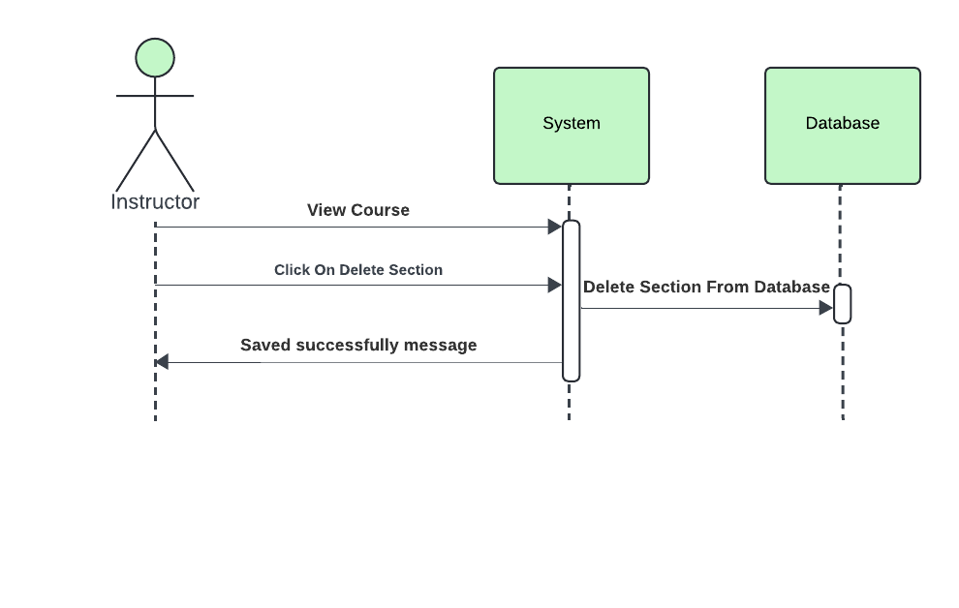

Figure 34:Sequence Diagram: Instructor Delete Section

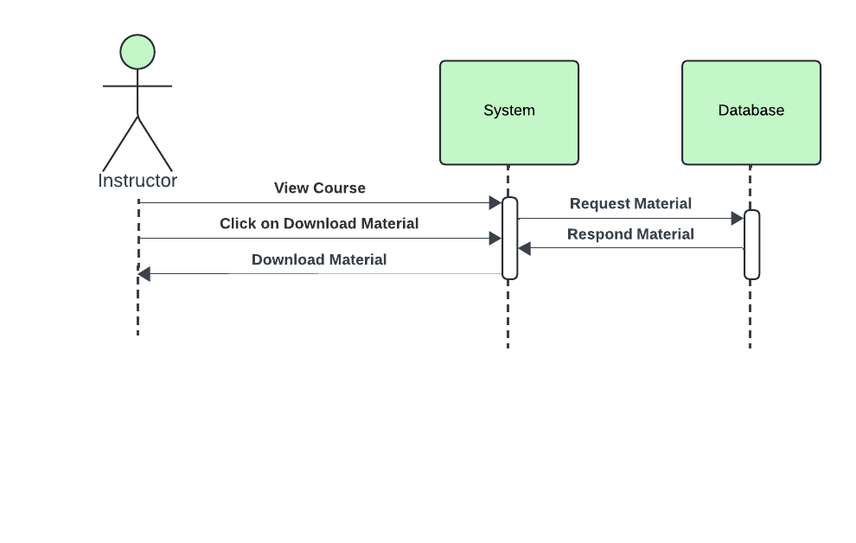

Figure 35:Sequence Diagram: Instructor Download Material

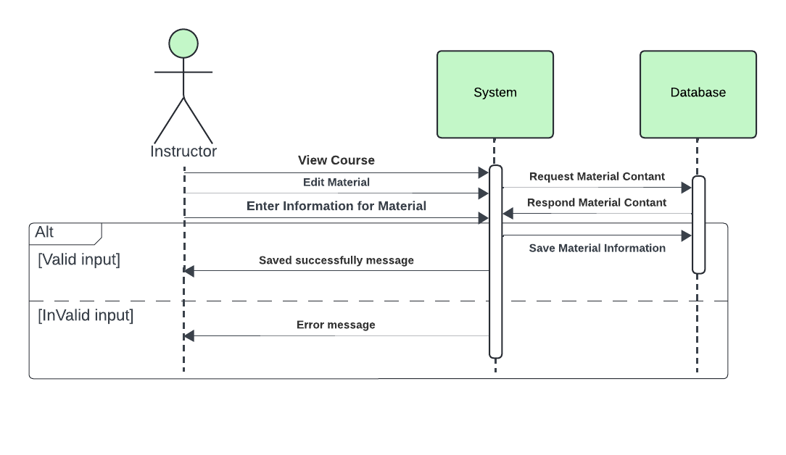

Figure 36:Sequence Diagram: Instructor Edit Material

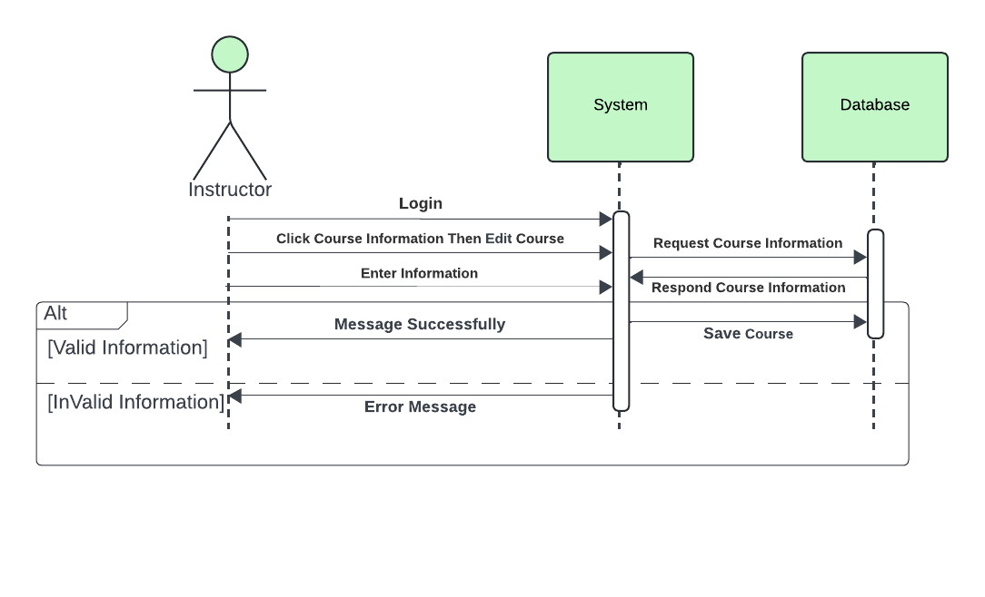

Figure 37:Sequence Diagram: Instructor Edit Course

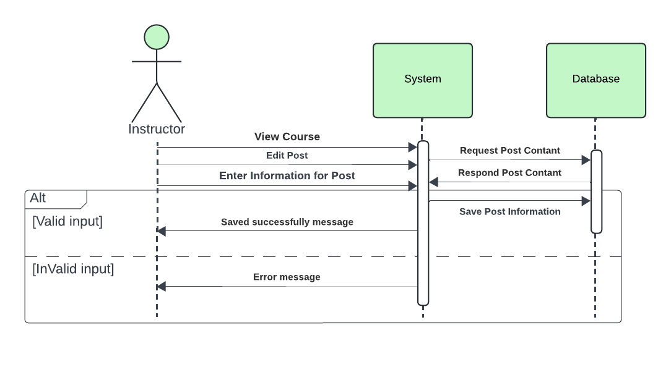

Figure 38:Sequence Diagram: Instructor Edit Post

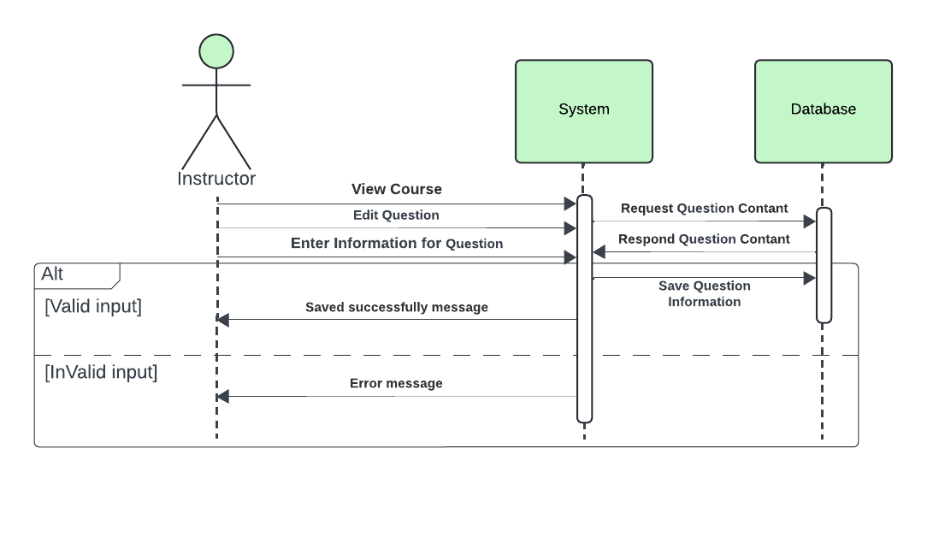

Figure 39:Sequence Diagram: Instructor Edit Question

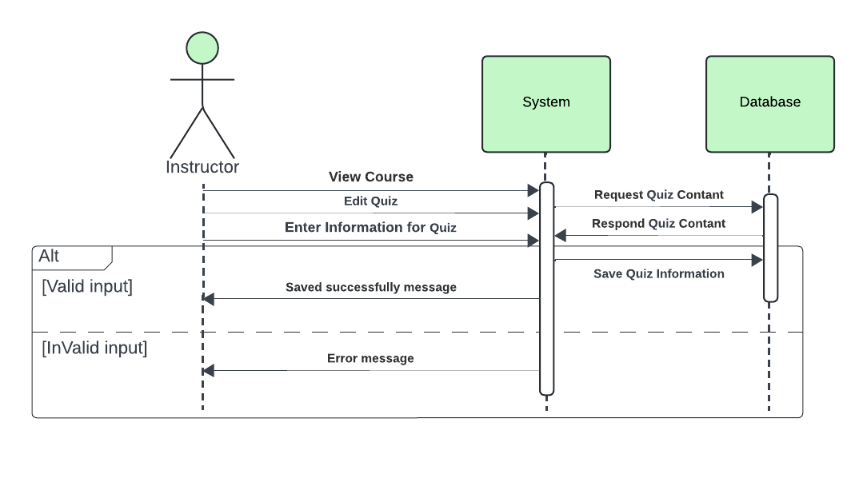

Figure 40:Sequence Diagram: Instructor Edit Quiz

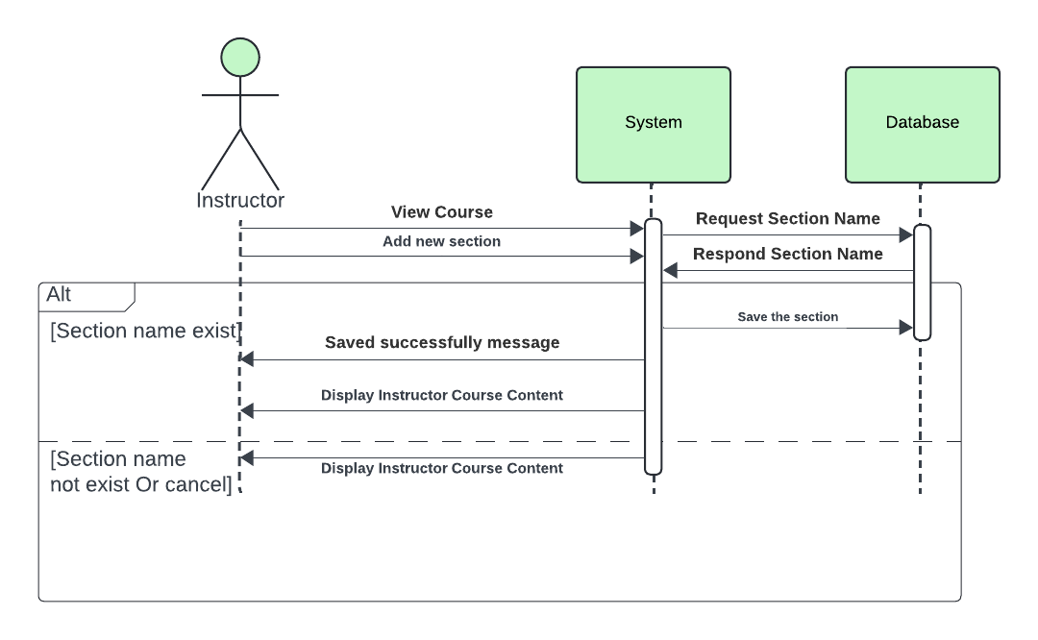

Figure 41:Sequence Diagram: Instructor Add New Section

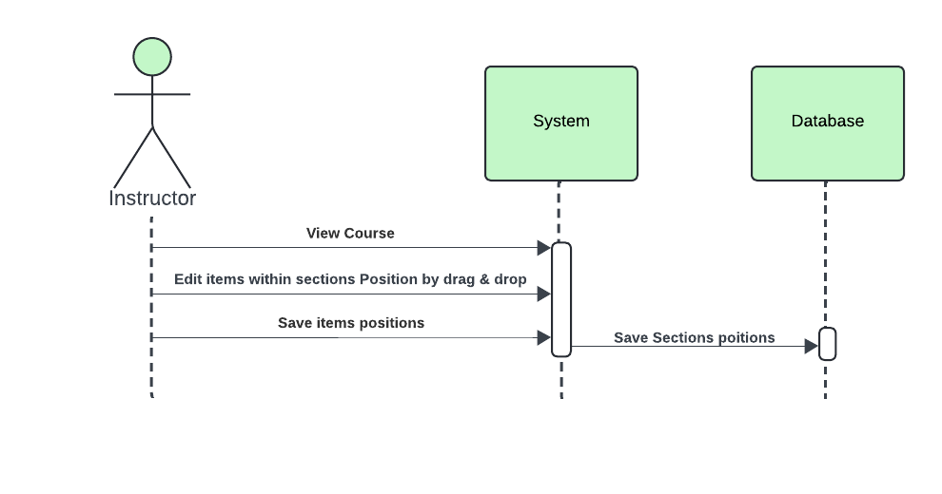

Figure 42:Sequence Diagram: Instructor Edit Item Position

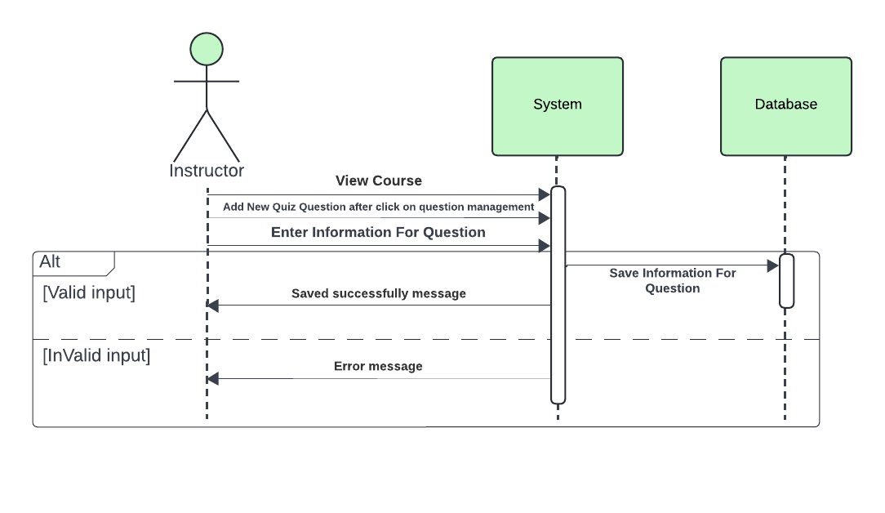

Figure 43:Sequence Diagram: Instructor Add Quiz Question

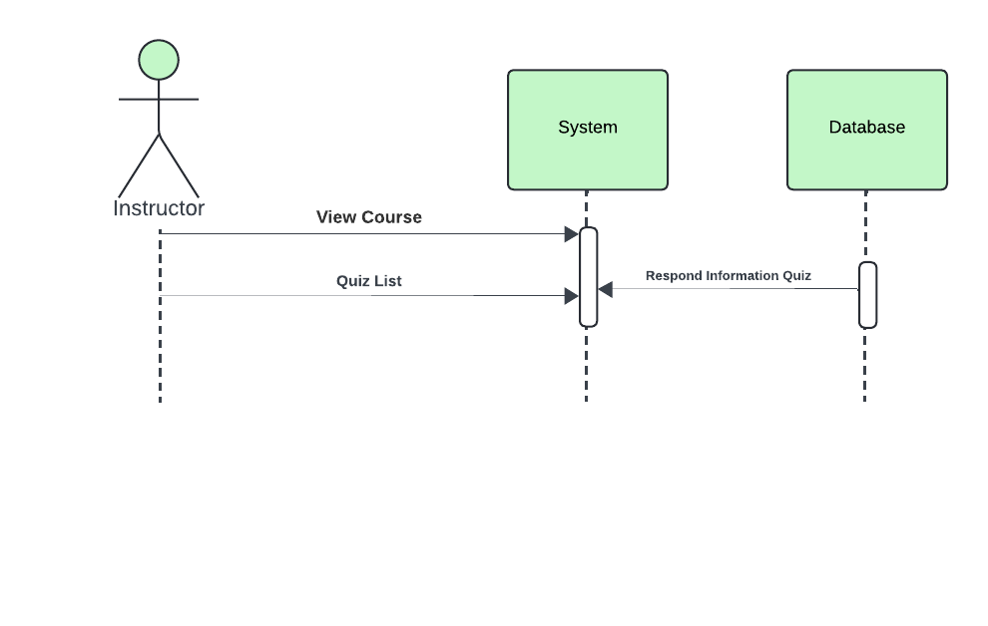

Figure 44:Sequence Diagram: Instructor Display Quizzes List

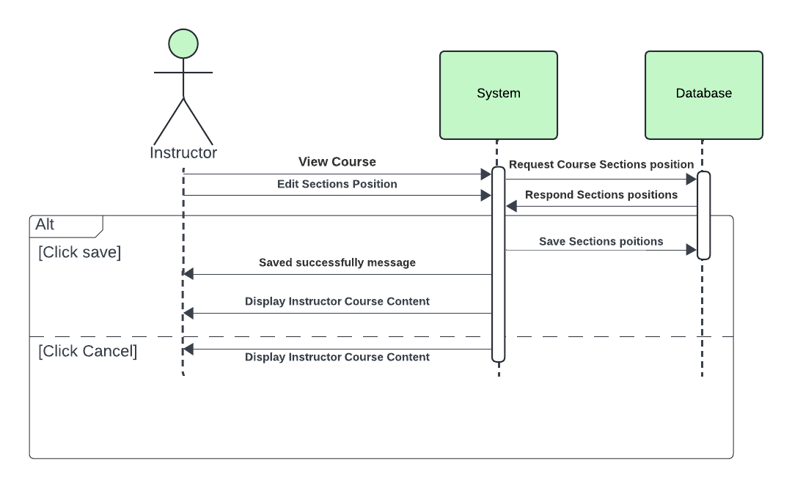

Figure 45:Sequence Diagram: Instructor Edit Section Position

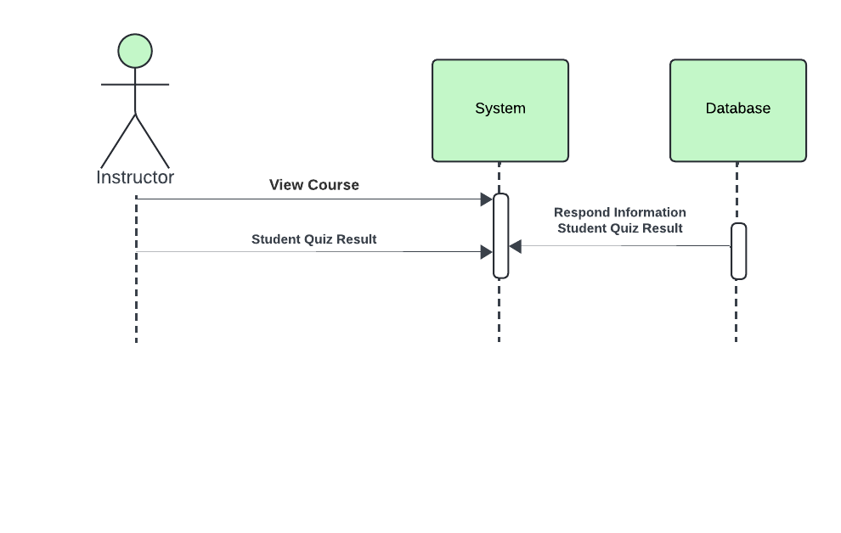

Figure 46:Sequence Diagram: Instructor: Display Student Quiz Result

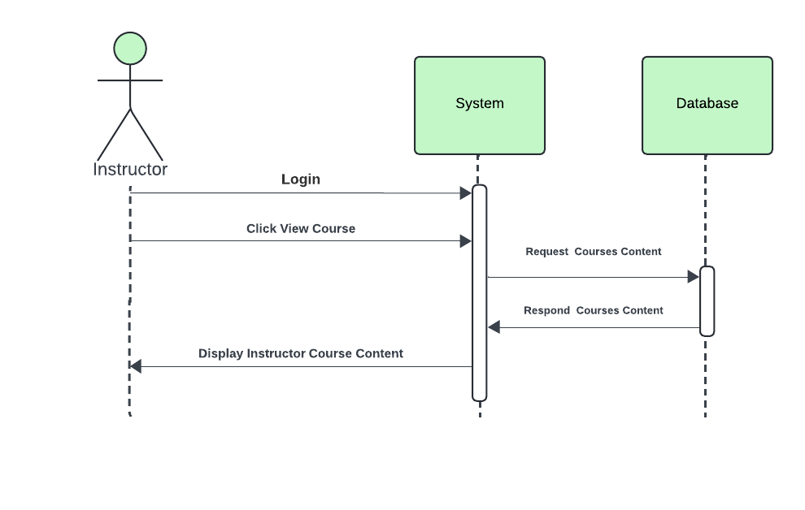

Figure 47: Sequence Diagram: Instructor Display Courses Content

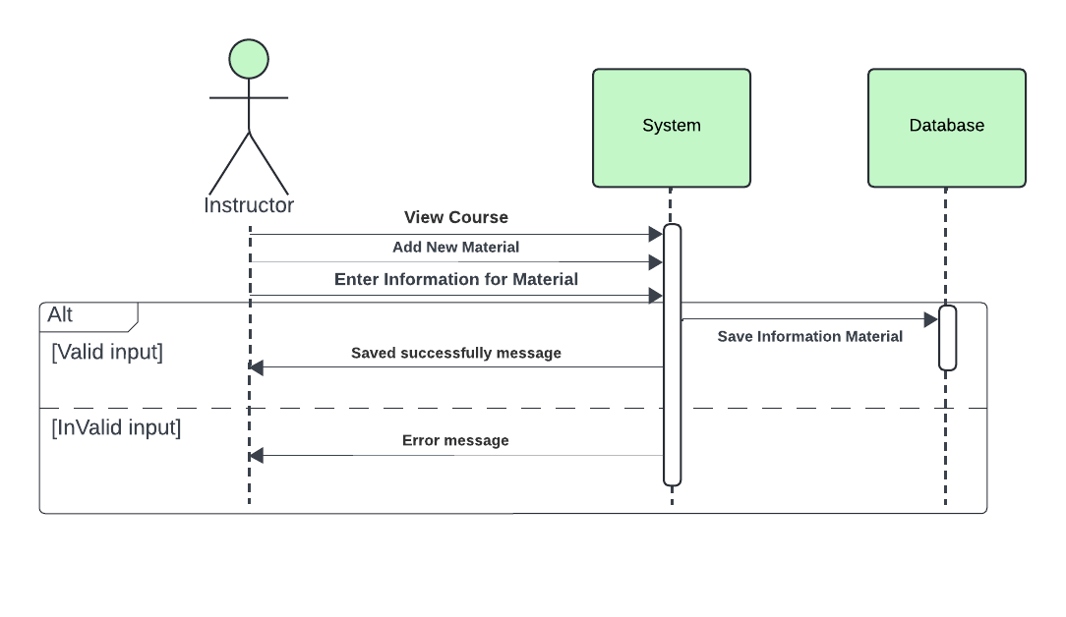

Figure 48:Sequence Diagram: Instructor Add Material

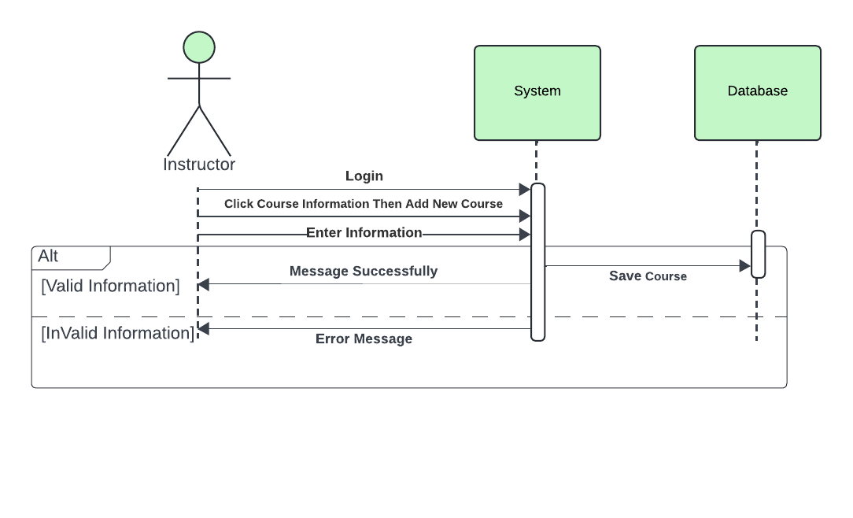

Figure 49:Sequence Diagram: Instructor Add New Course

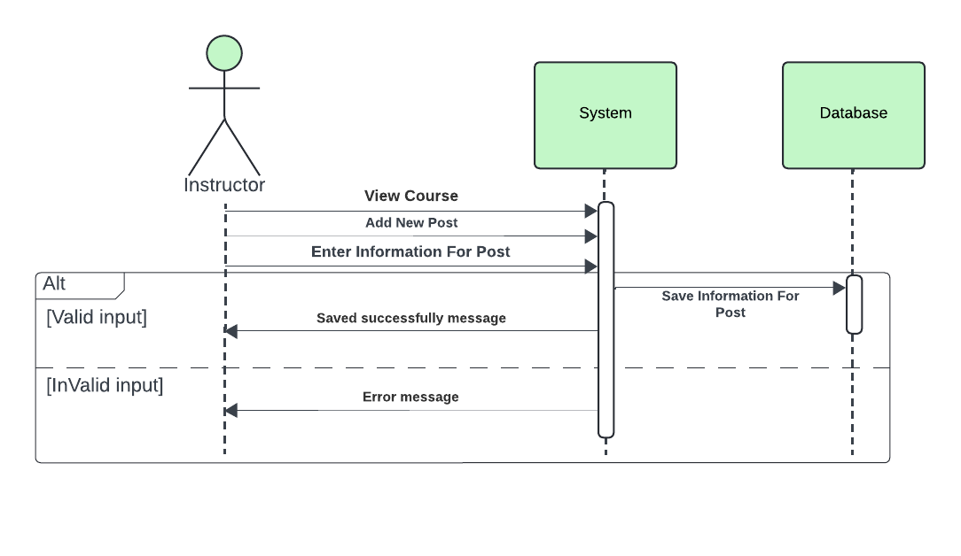



Figure 50:Sequence Diagram: Instructor Add New Post

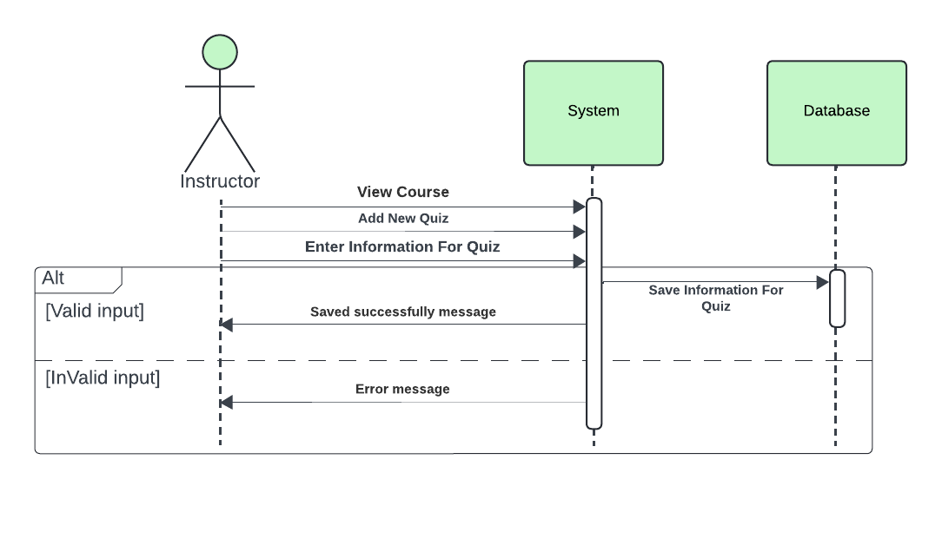

Figure 51:Sequence Diagram: Instructor Add New Quiz

## **4.5.1 admin sequence**

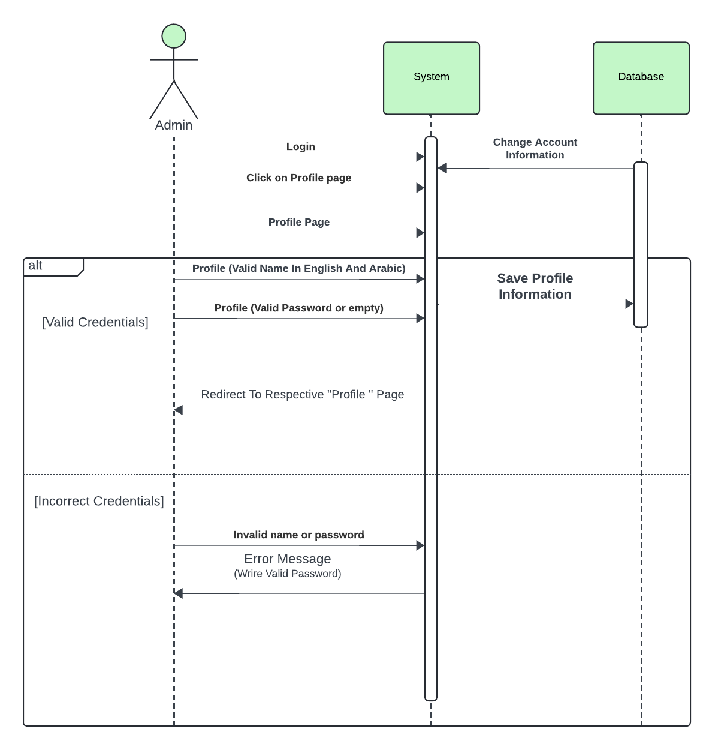

Figure 52:Sequence Diagram: Admin Edit Profile

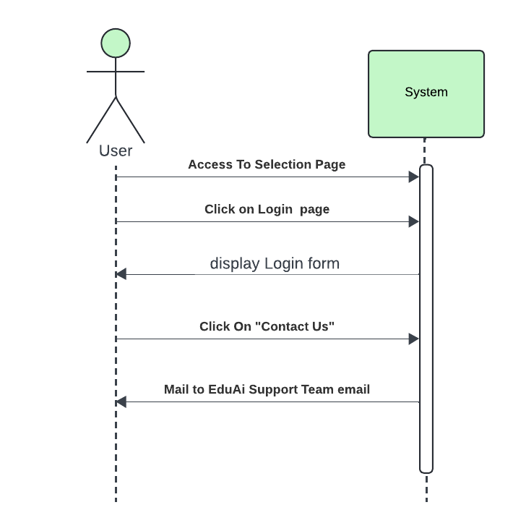

Figure 53:Sequence Diagram: User Contact us

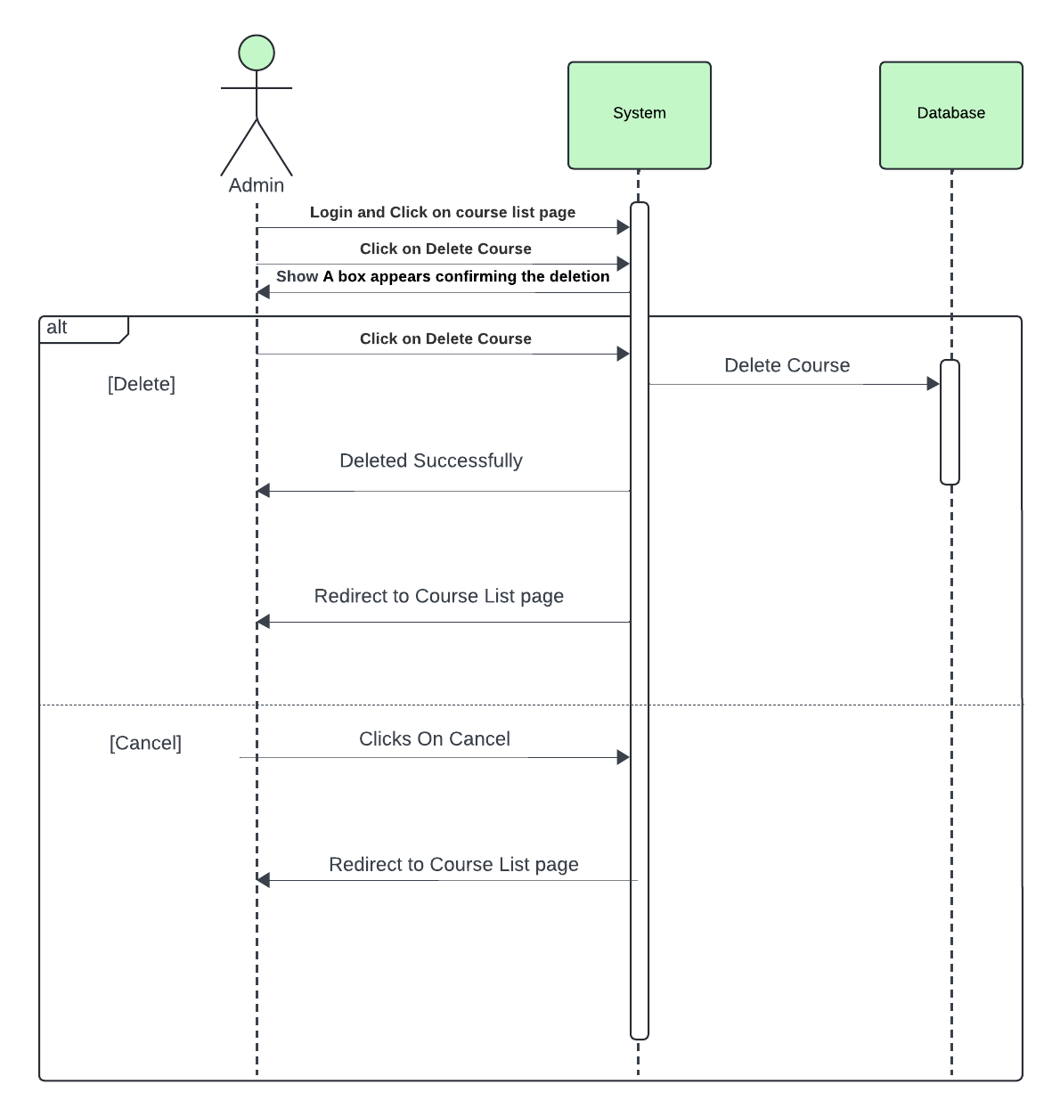

Figure 54:Sequence Diagram: Admin Delete Course

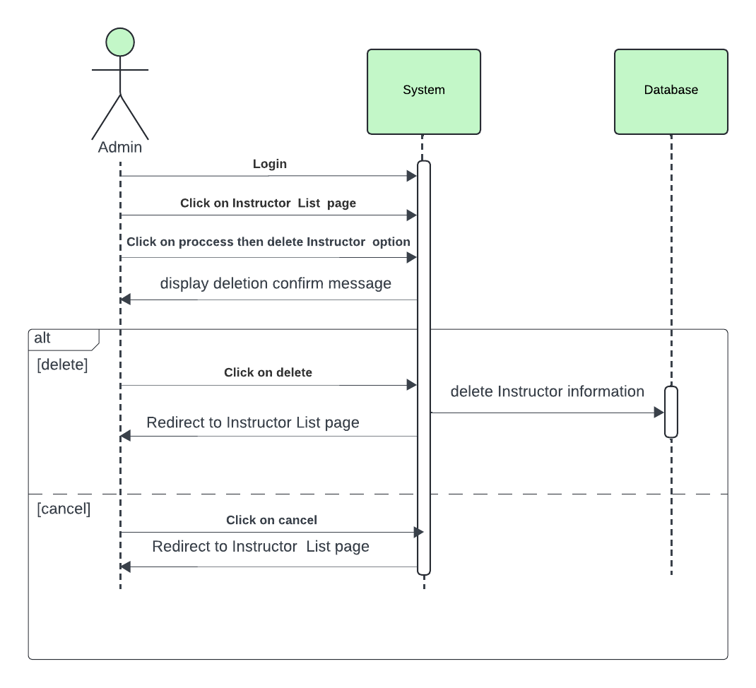

Figure 55:Sequence Diagram: Admin Delete Instructor

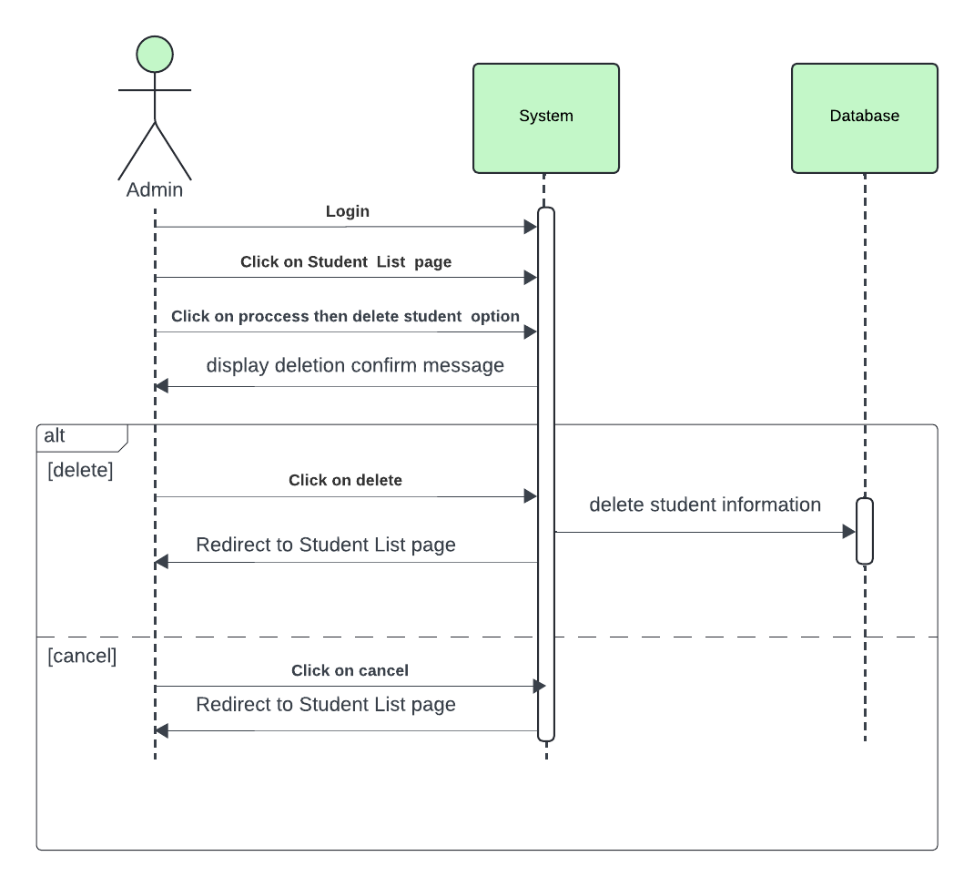

Figure 56:Sequence Diagram: Admin Delete Student

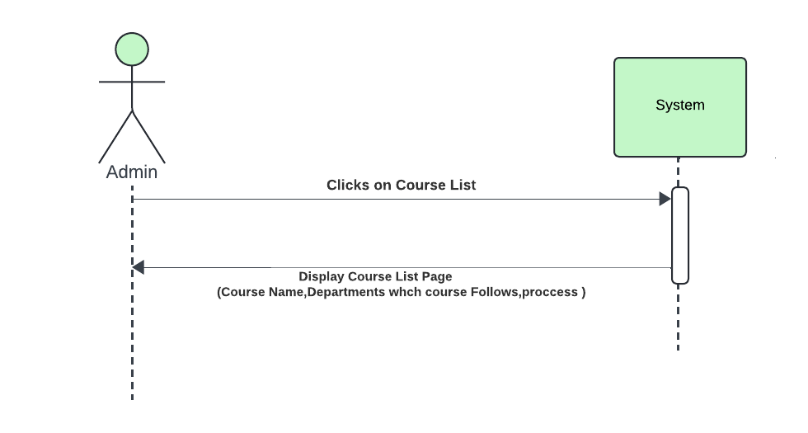

Figure 57:Sequence Diagram: Admin Display Courses List

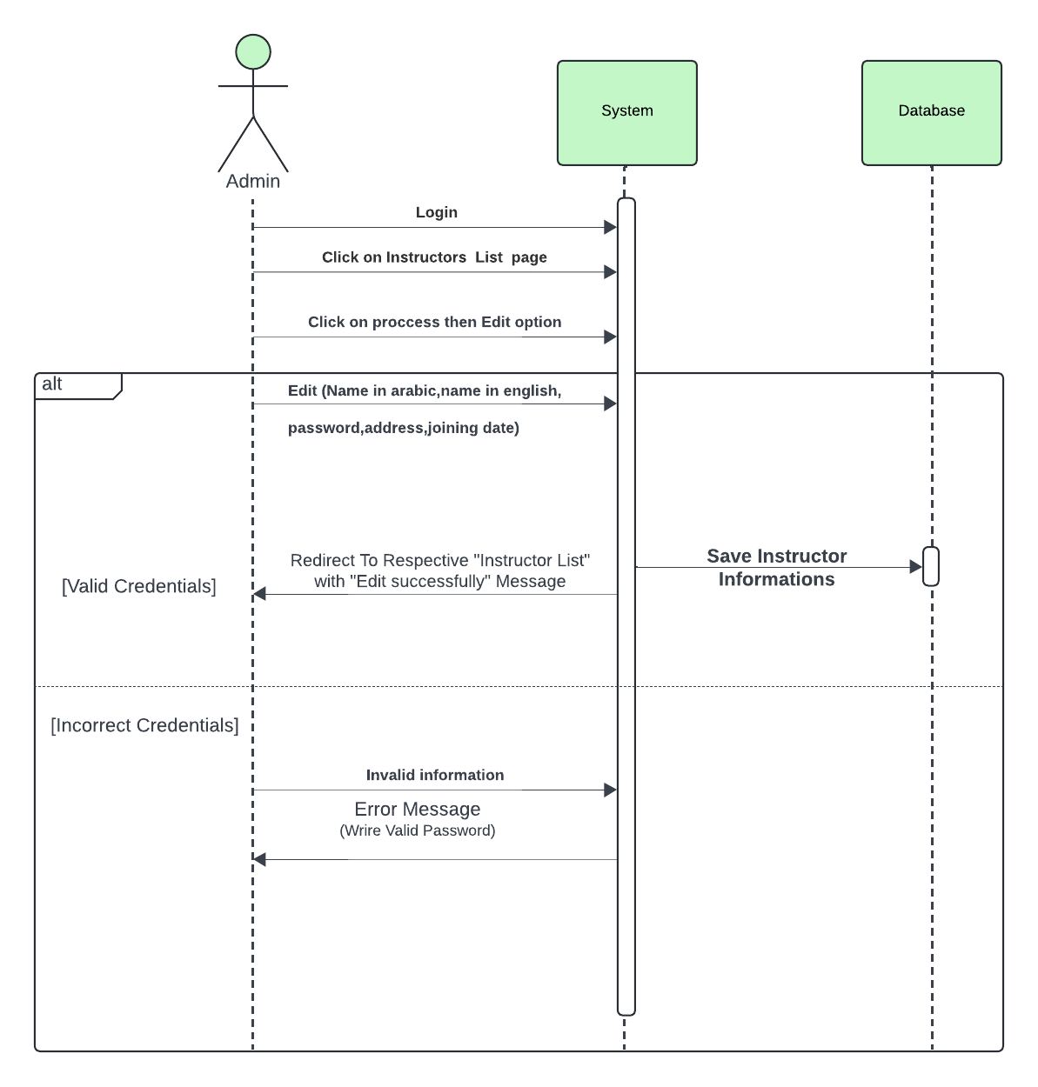

Figure 58:Sequence Diagram: Admin Edit Instructor

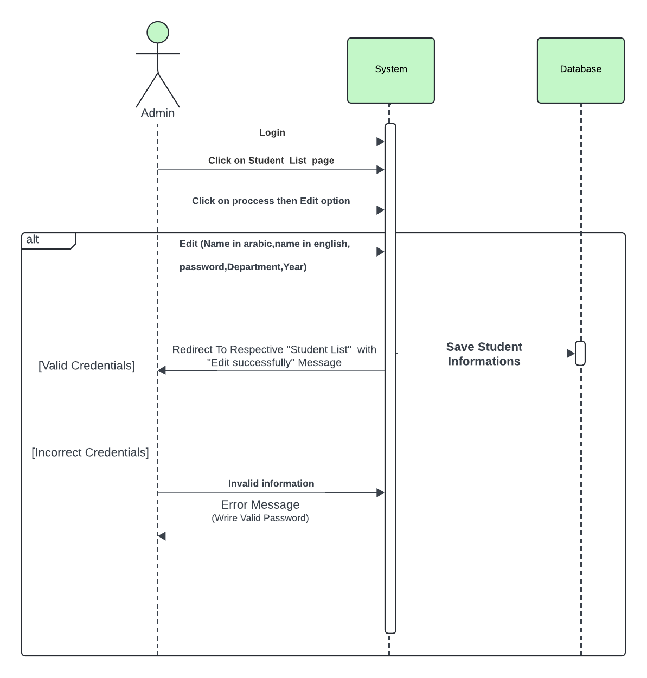

Figure 59:Sequence Diagram: Admin Edit Student List

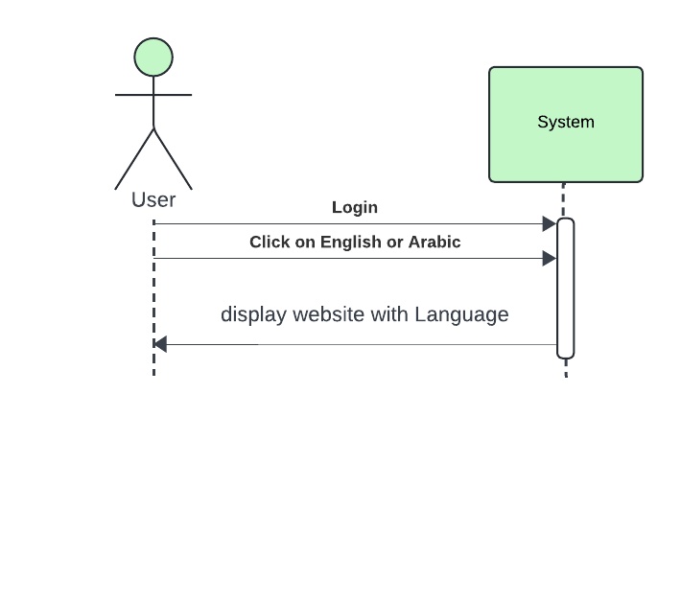

Figure 60::Sequence Diagram: User Change Language

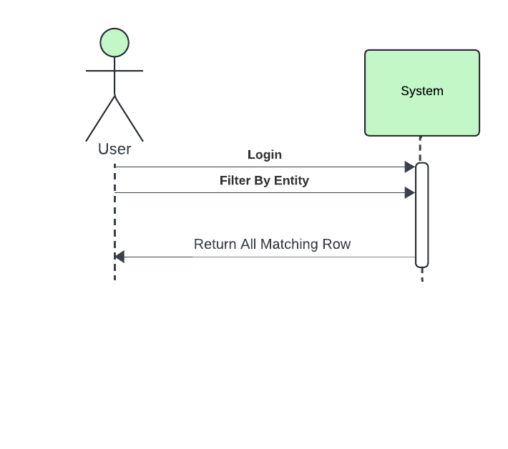

Figure 61:Sequence Diagram: User Filter By Entity

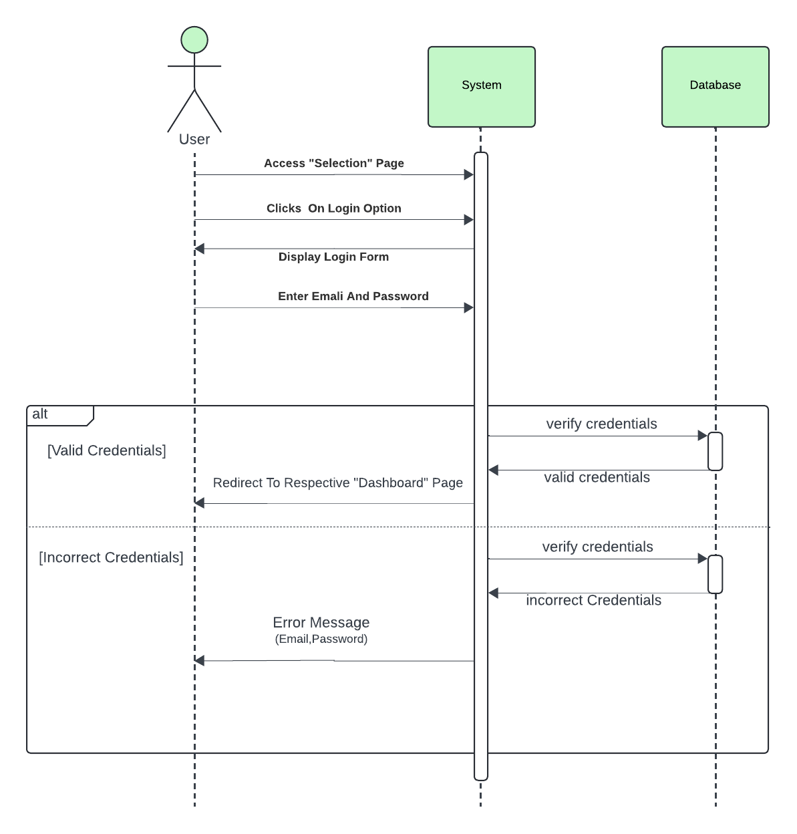

Figure 62:Sequence Diagram: User Login

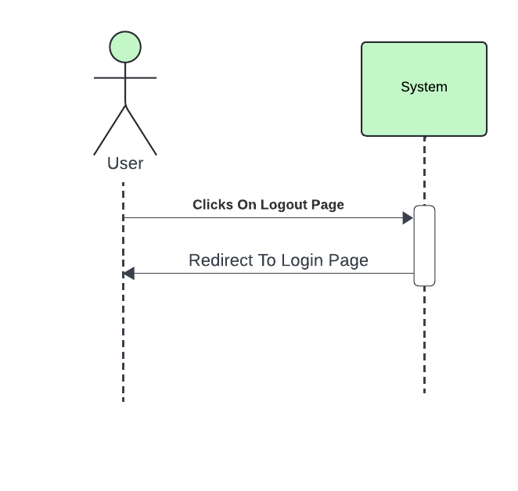

Figure 63::Sequence Diagram: User Logout

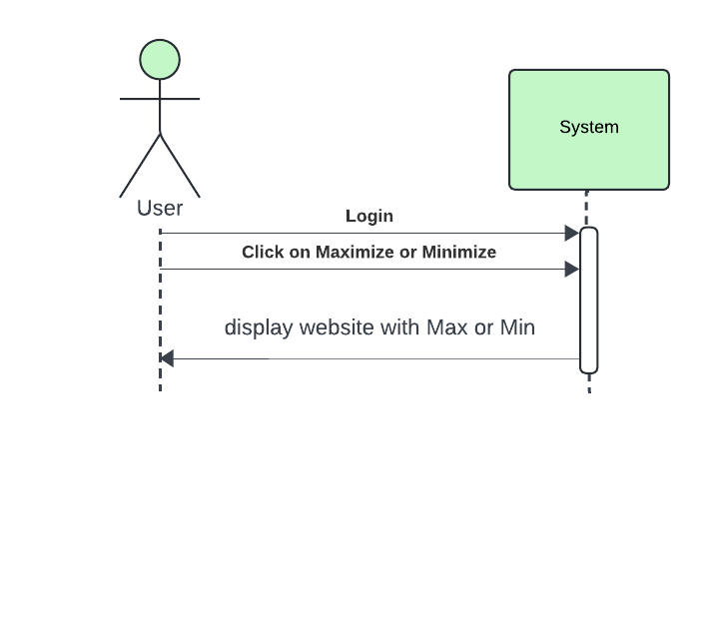

Figure 64:Sequence Diagram: User Maximize Or Minimize Website

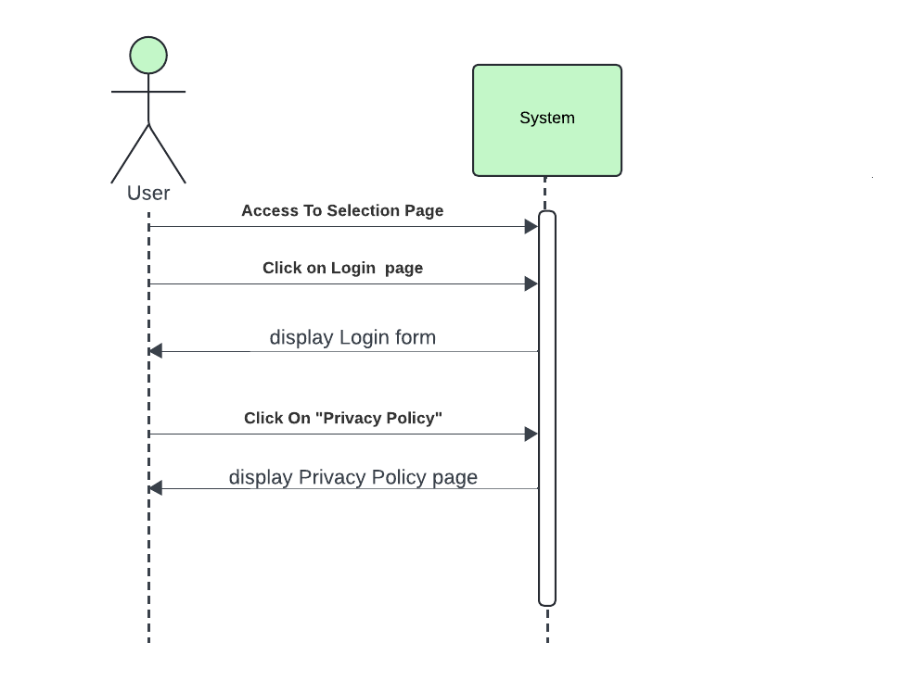

Figure 65::Sequence Diagram: User Display privacy and policy

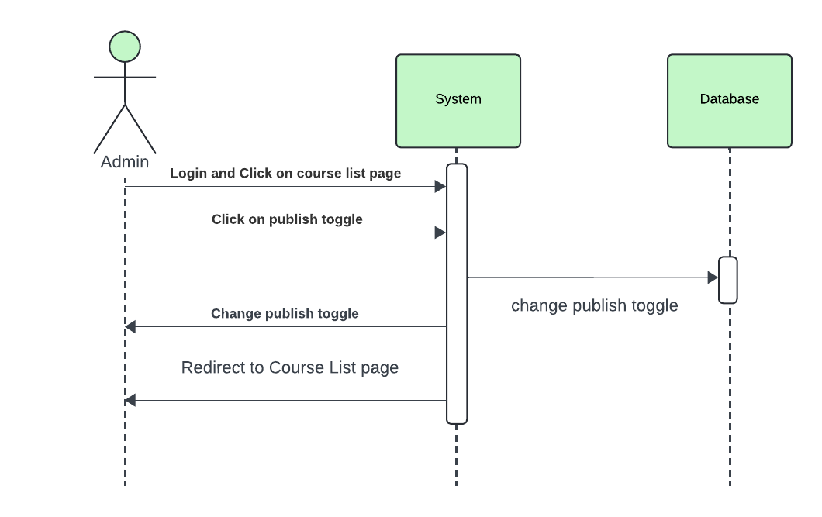

Figure 66::Sequence Diagram: Admin Publish Toggle

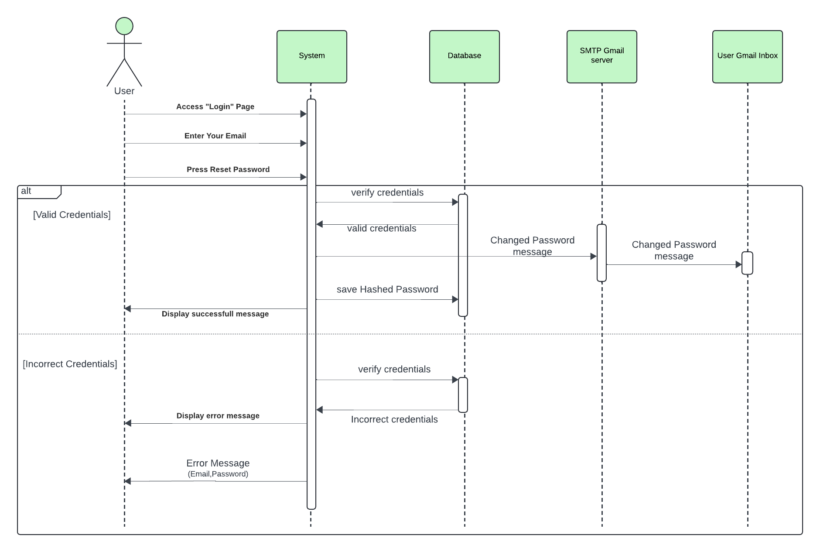

Figure 67::Sequence Diagram: User Reset Password

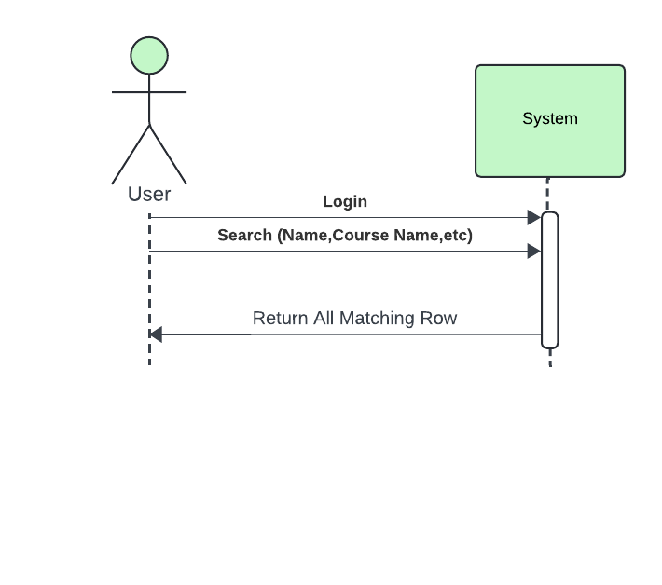

Figure 68:Sequence Diagram: User Search

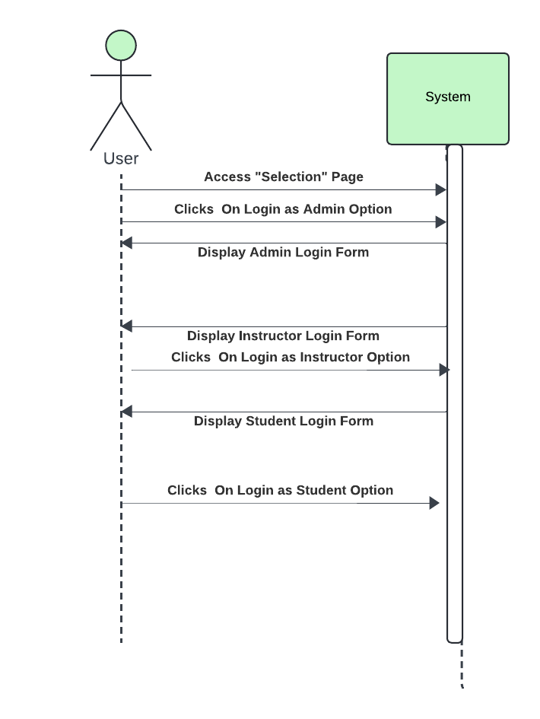

Figure 69:Sequence Diagram: User Selection Page

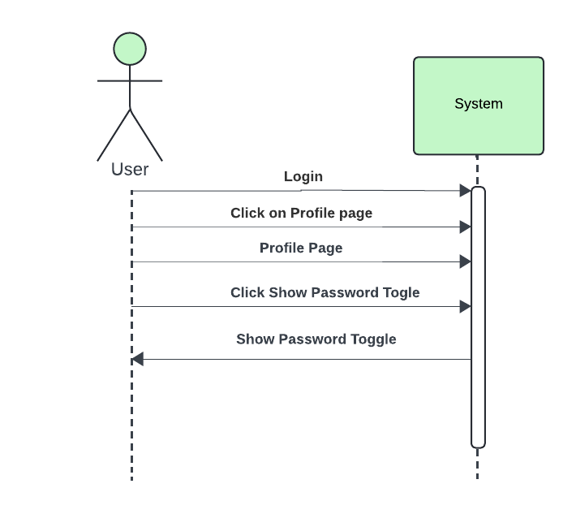

Figure 70:Sequence Diagram: User Show Password

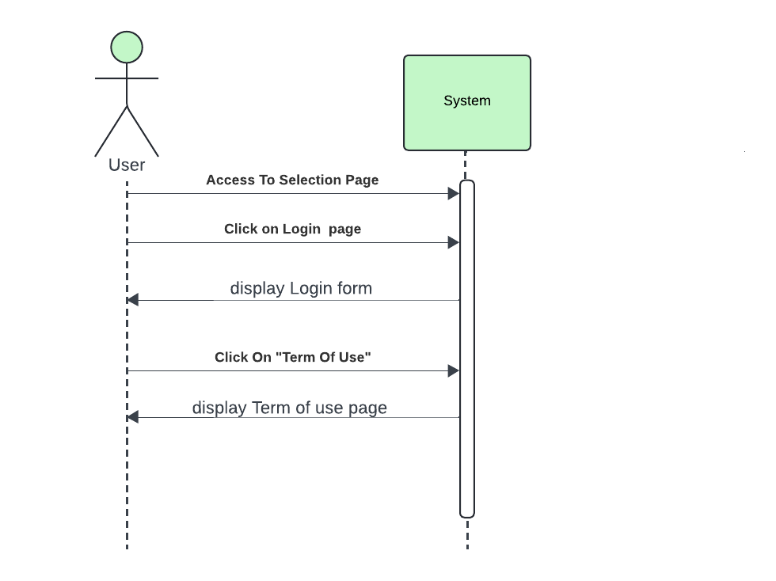

Figure 71:Sequence Diagram: User Term Of Use

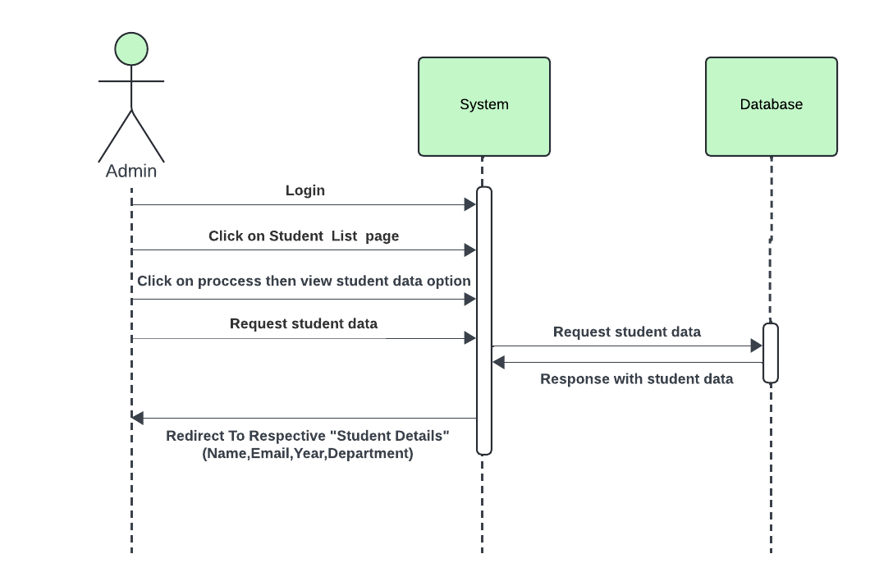

Figure 72:Sequence Diagram: Admin view Student

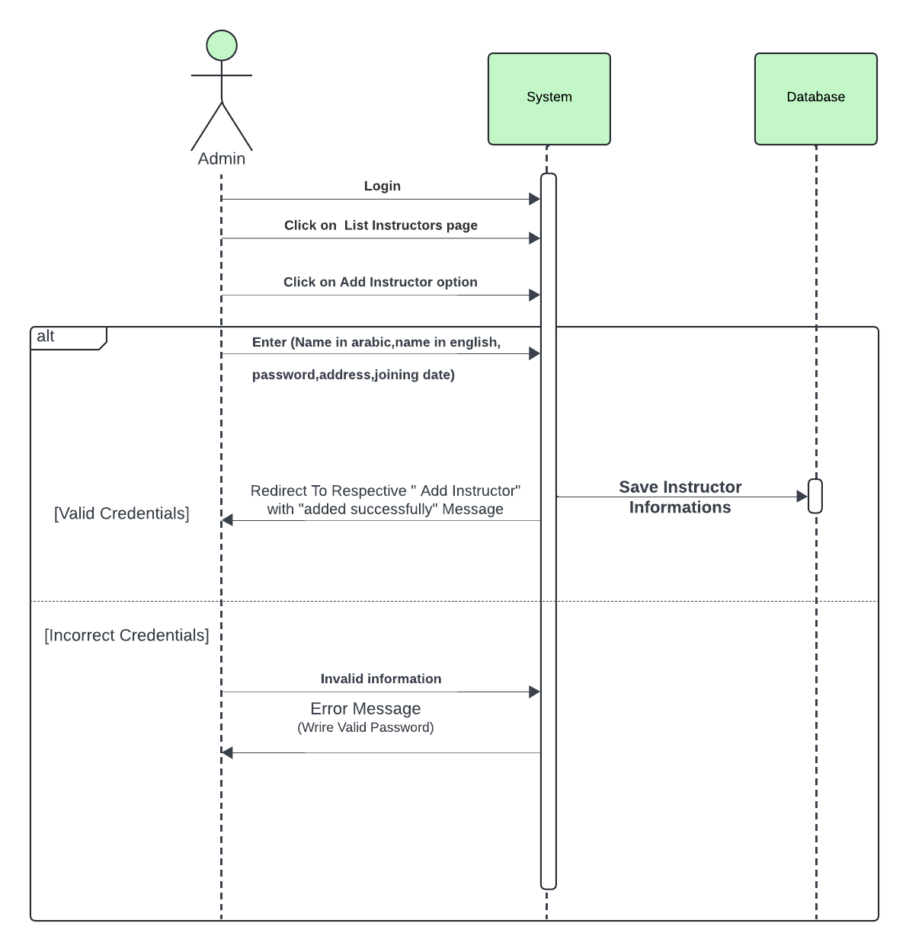

Figure 73:Sequence Diagram: Admin Add Instructor

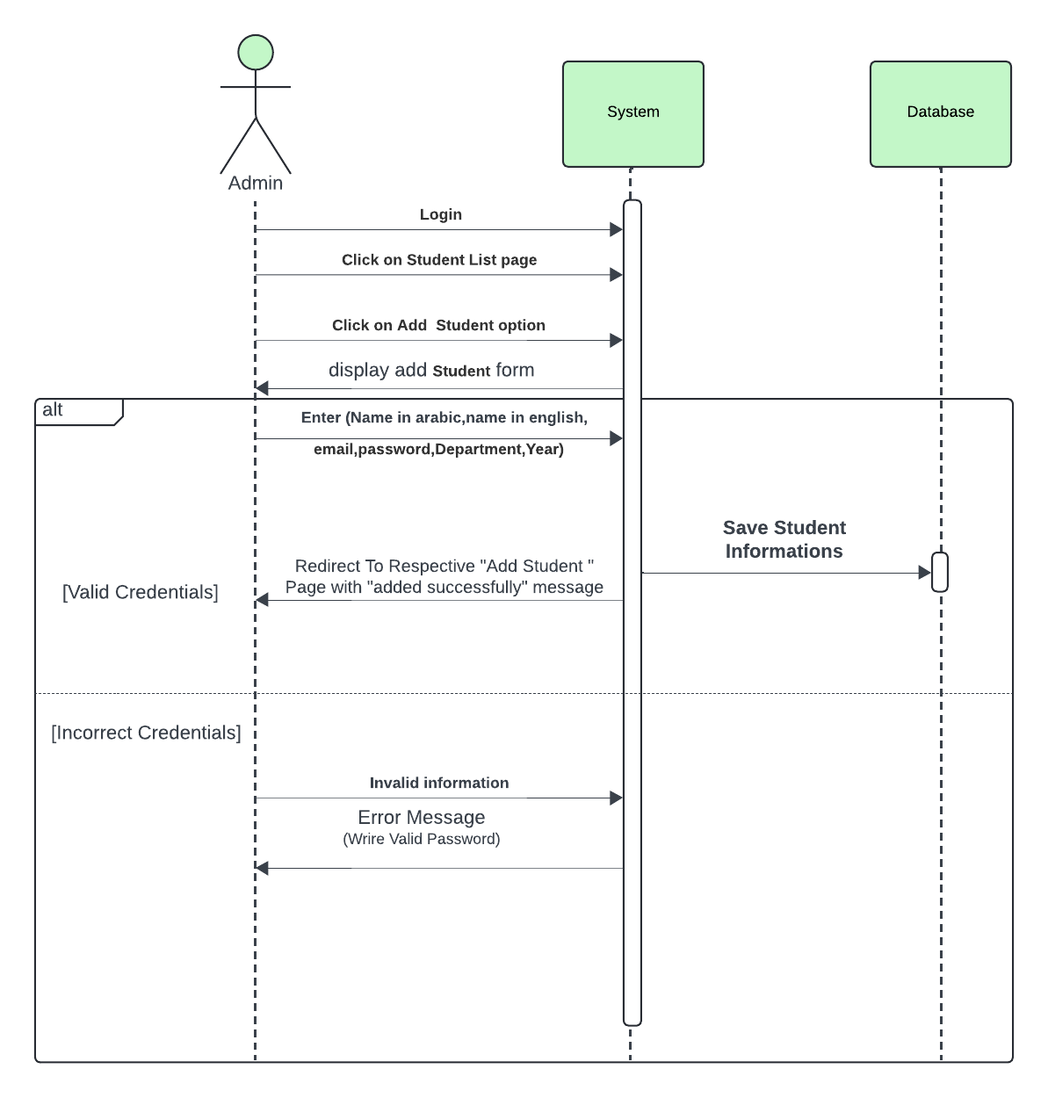

Figure 74:Sequence Diagram: Admin Add Student

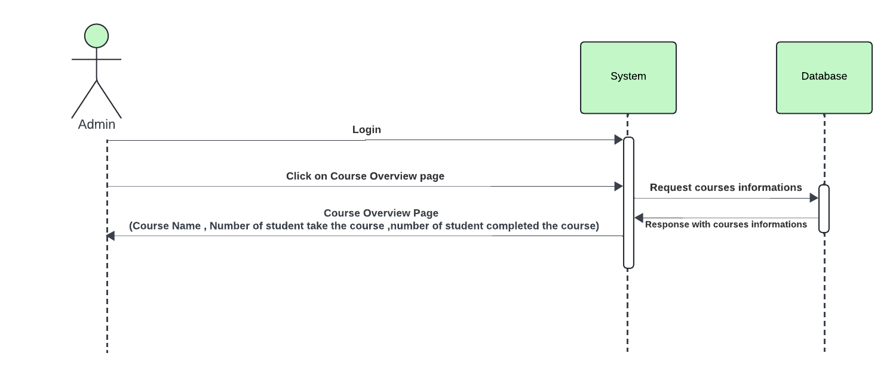

Figure 75:Sequence Diagram: Admin Course Overview

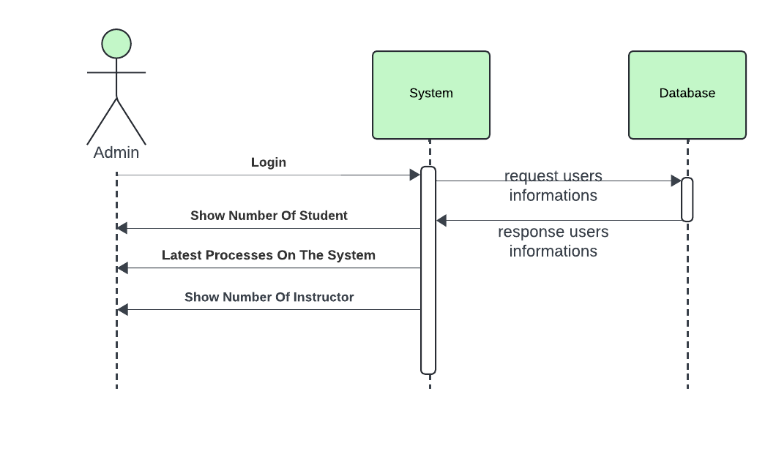

Figure 76:Sequence Diagram: Admin Dashboard

## **4.6 UML Class diagram**

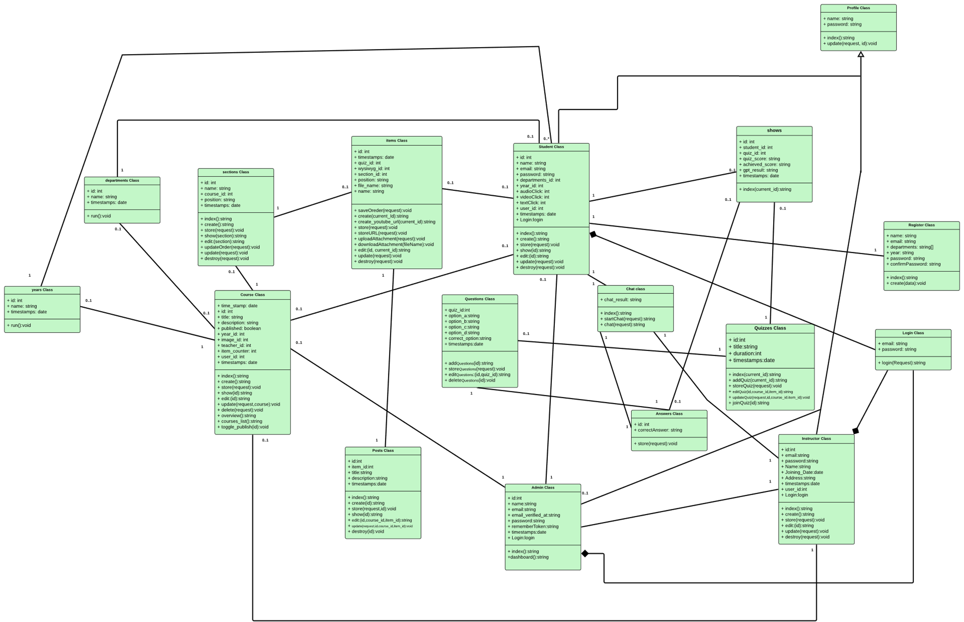

Figure 77: UML Class Diagram

## **4.7 graphical user interface design / low fidelity prototype**

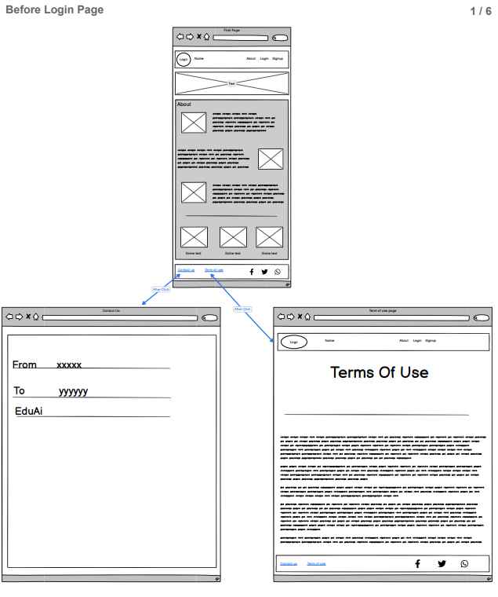

Figure 78: low fidelity: Home Page

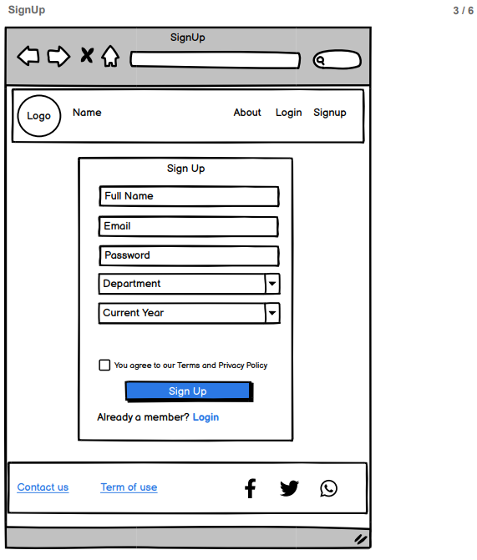

Figure 79: low fidelity: Register Page

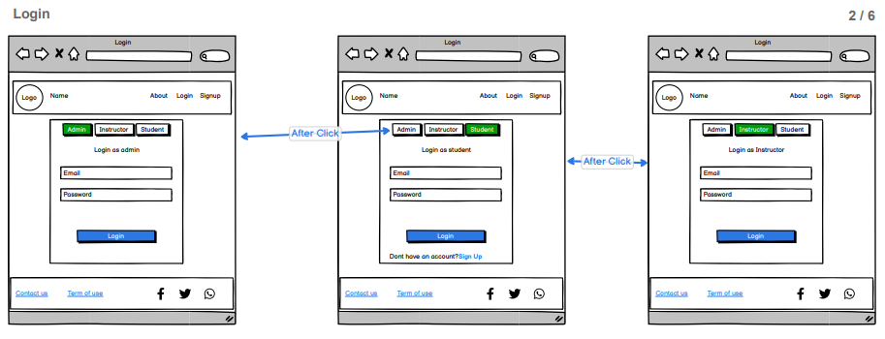

Figure 80: low fidelity: Login Page

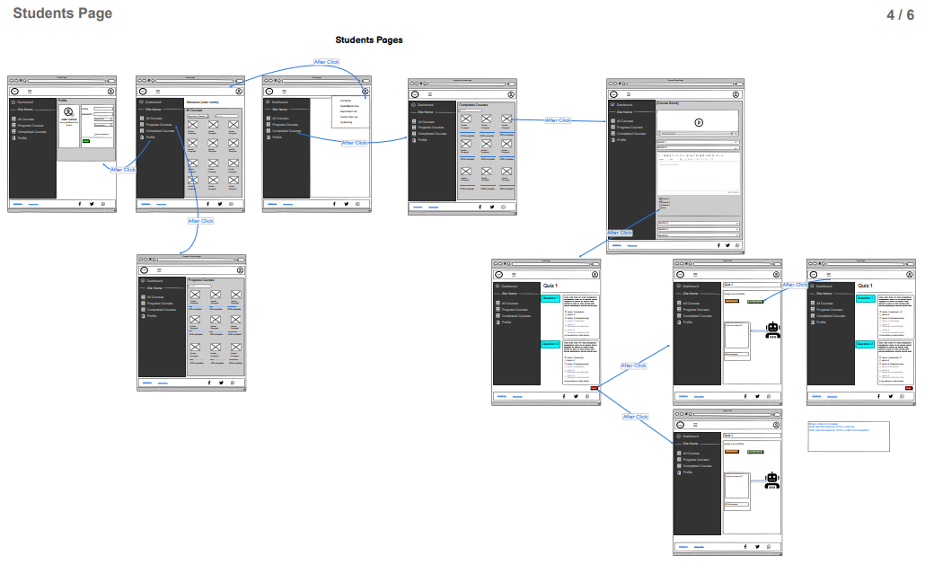

Figure 81: low fidelity: Students Pages

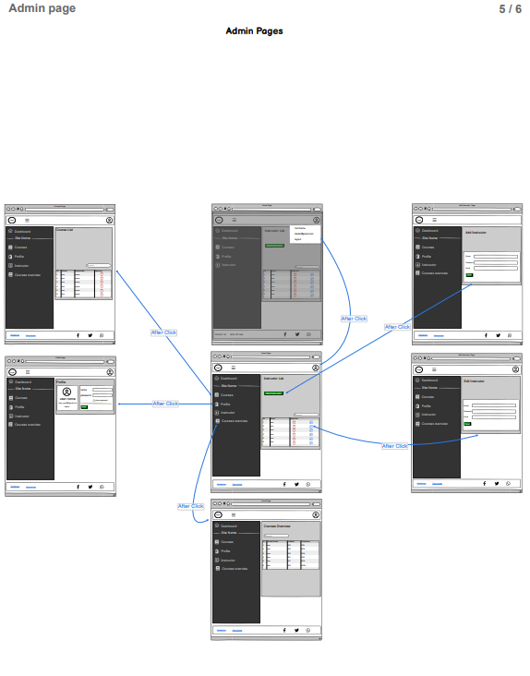

Figure 82:low fidelity: Admin Pages

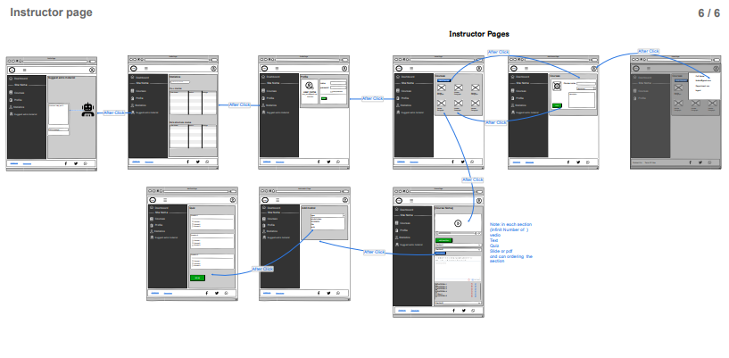

Figure 83: low fidelity: Instructor Pages

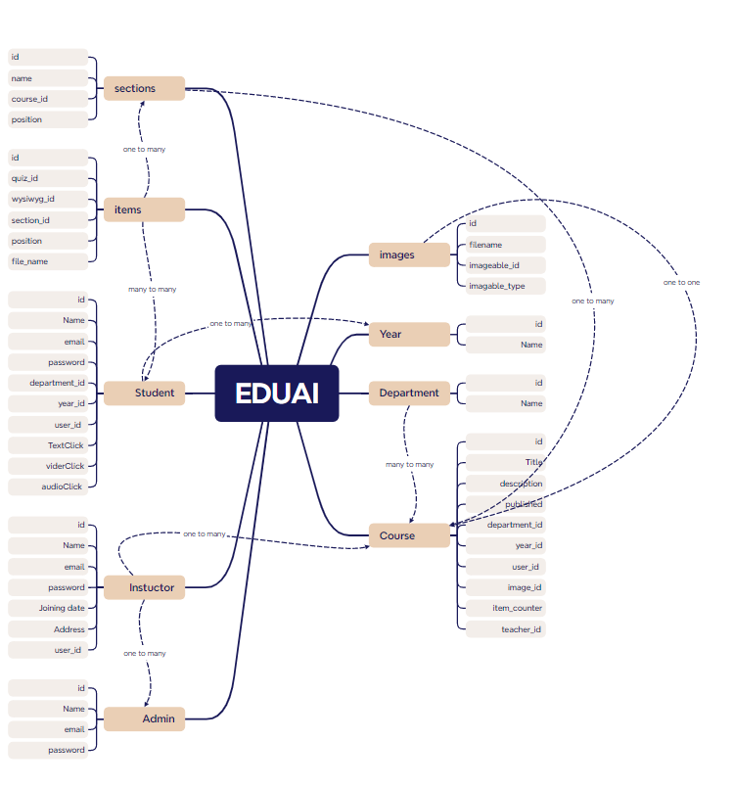

Figure 84:Database Design

# **Chapter five: System Implementation**

## **5.1 database implementation**

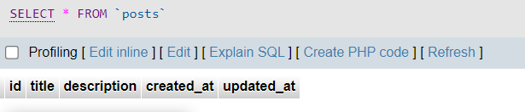

Figure 85:Database Implementation 1

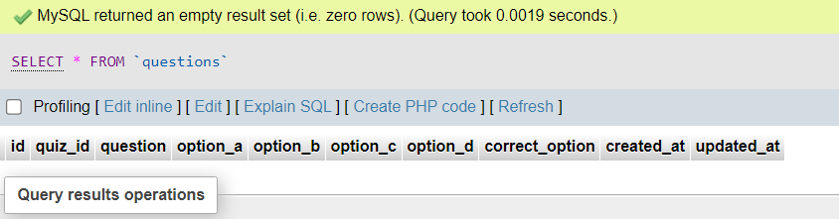

Figure 86:Database Implementation 2

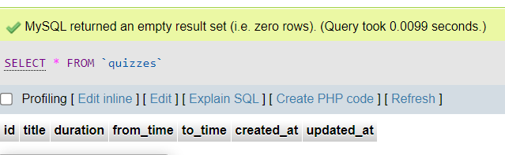

Figure 87:Database Implementation 3

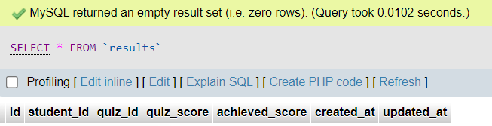

Figure 88:Database Implementation 4

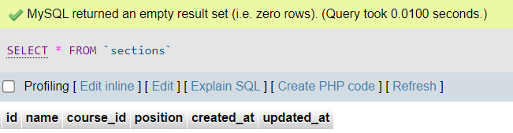

Figure 89:Database Implementation 5

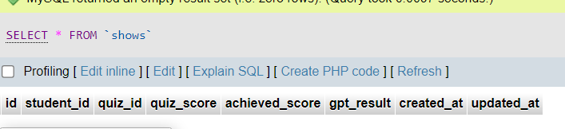

Figure 90:Database Implementation 6

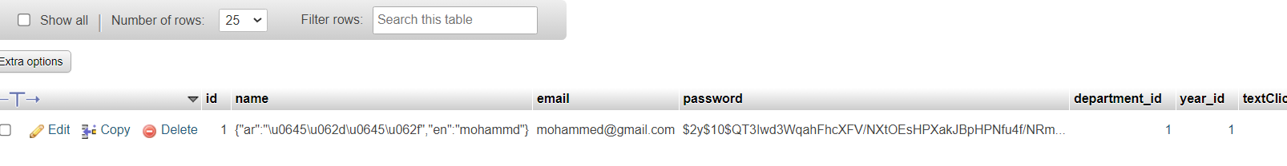

Figure 91:Database Implementation 7

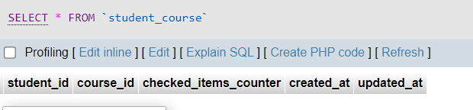

Figure 92:Database Implementation 8

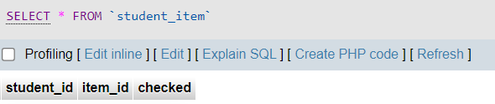

Figure 93:Database Implementation 9



Figure 94:Database Implementation 10



Figure 95:Database Implementation 11

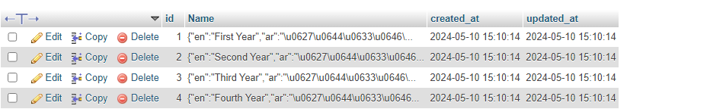

Figure 96:Database Implementation 12

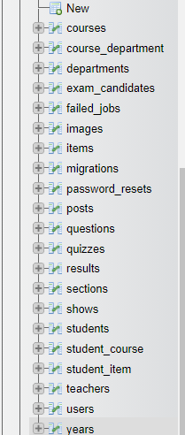

Figure 97:Database Implementation 13

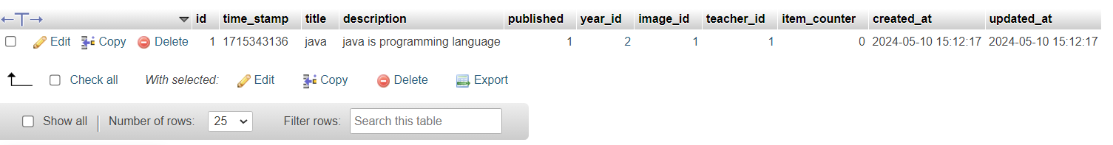

Figure 98:Database Implementation 14

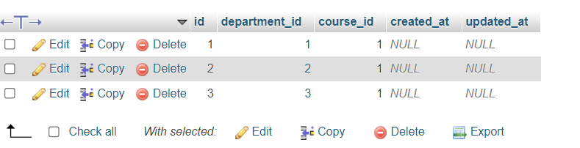

Figure 99:Database Implementation 15

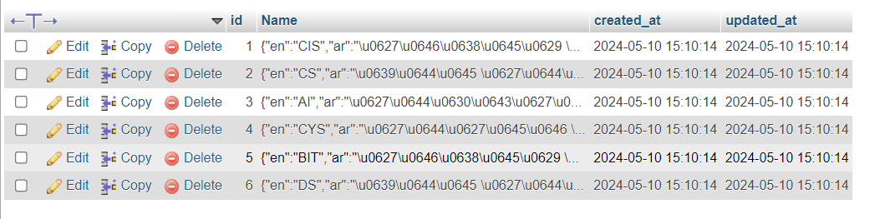

Figure 100:Database Implementation 16

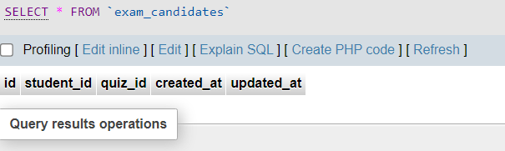

Figure 101:Database Implementation 17

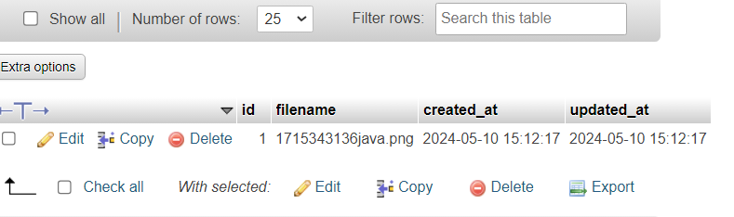

Figure 102:Database Implementation 18

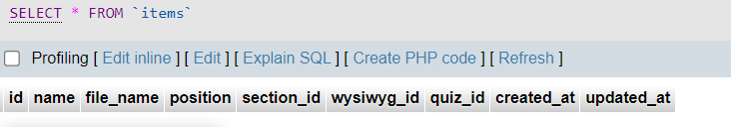

Figure 103:Database Implementation 19

## **5.2 Graphical user interface implementation**

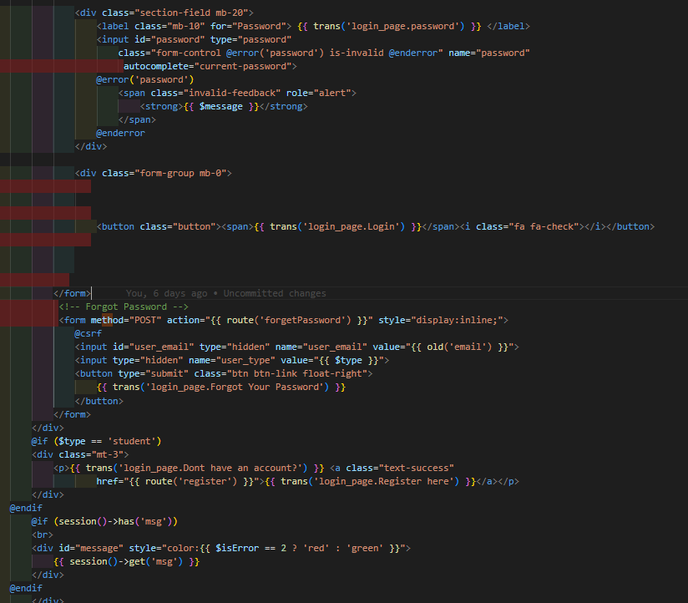

Figure 104:Graphical user interface implementation 1

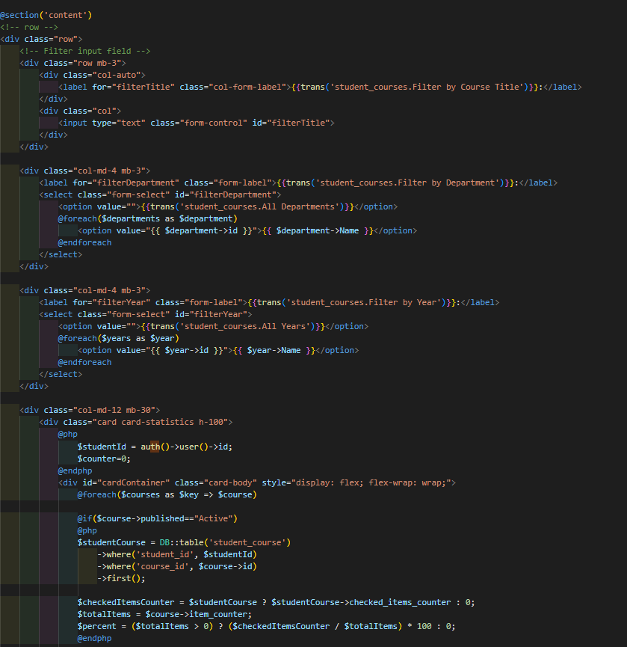

Figure 105:Graphical user interface implementation 2

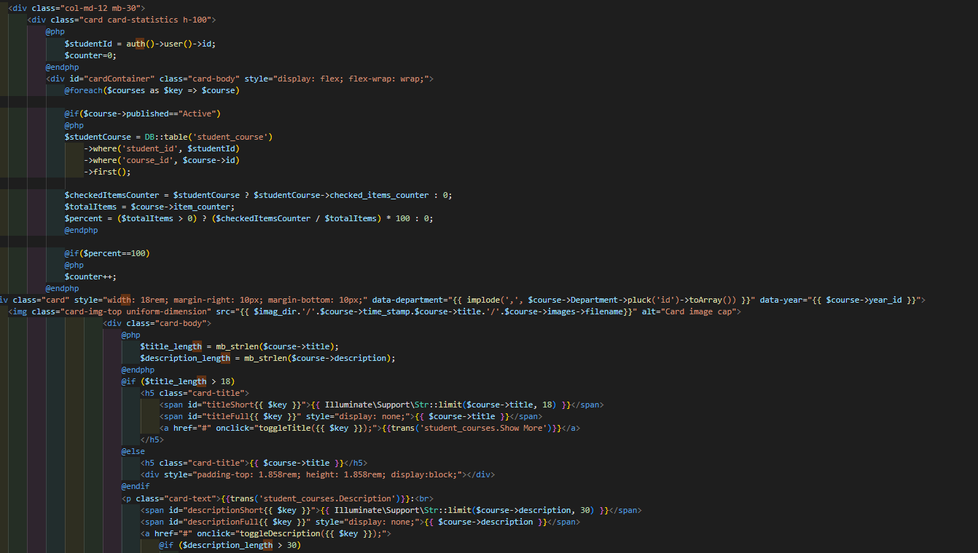

Figure 106:Graphical user interface implementation 3

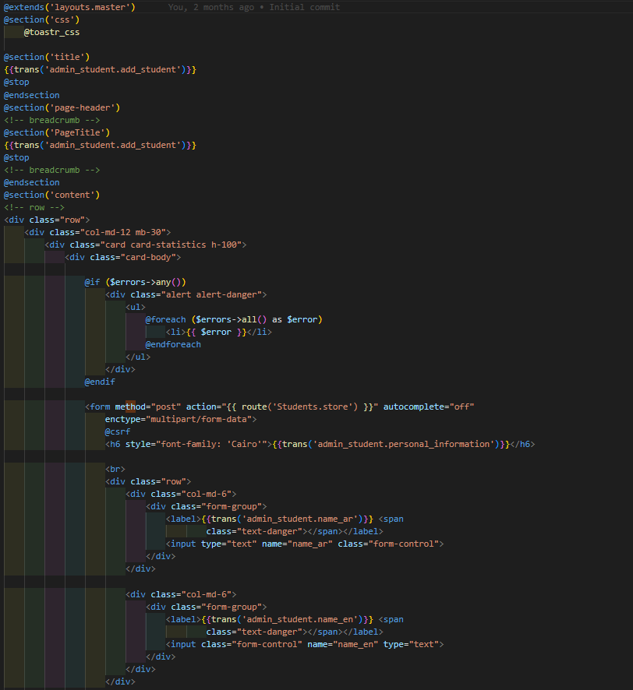

Figure 107:Graphical user interface implementation 4

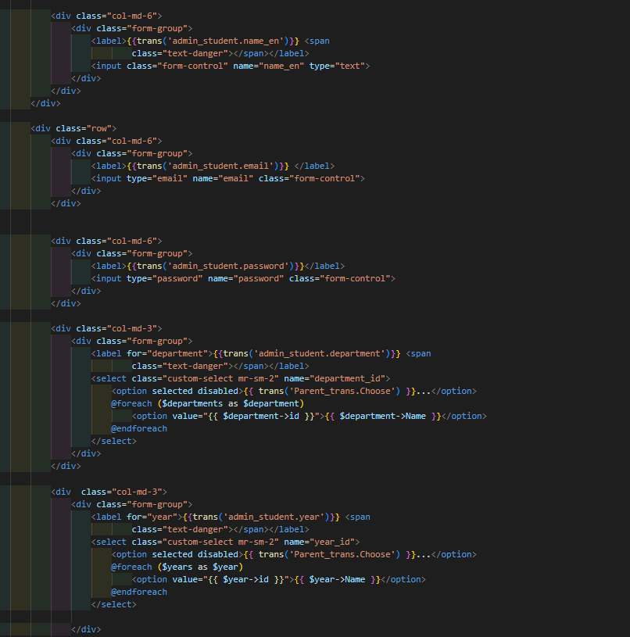

Figure 108:Graphical user interface implementation 5

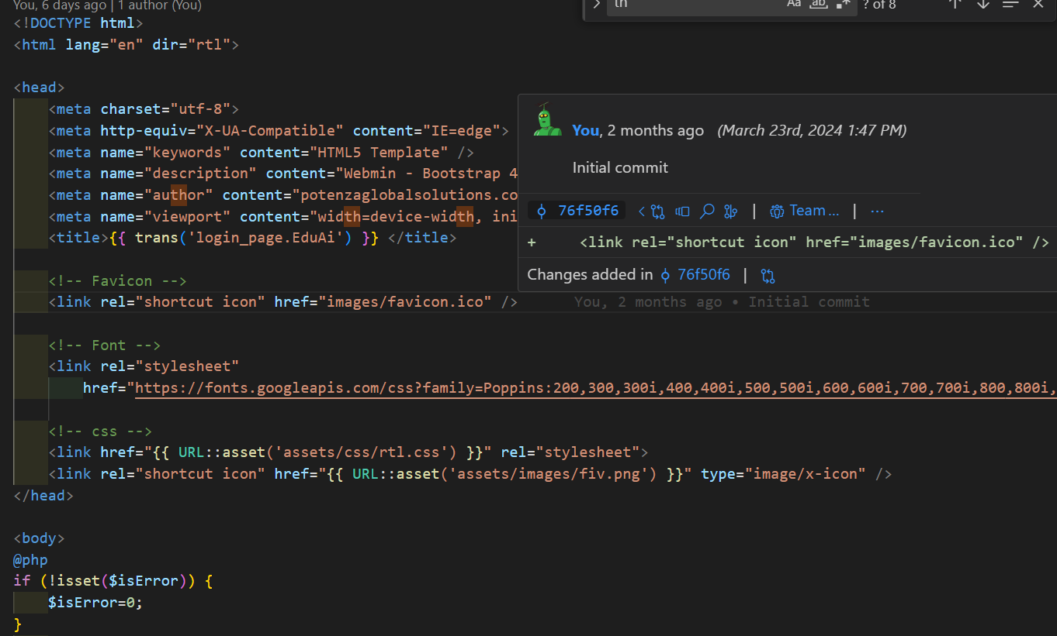

Figure 109:Graphical user interface implementation 6

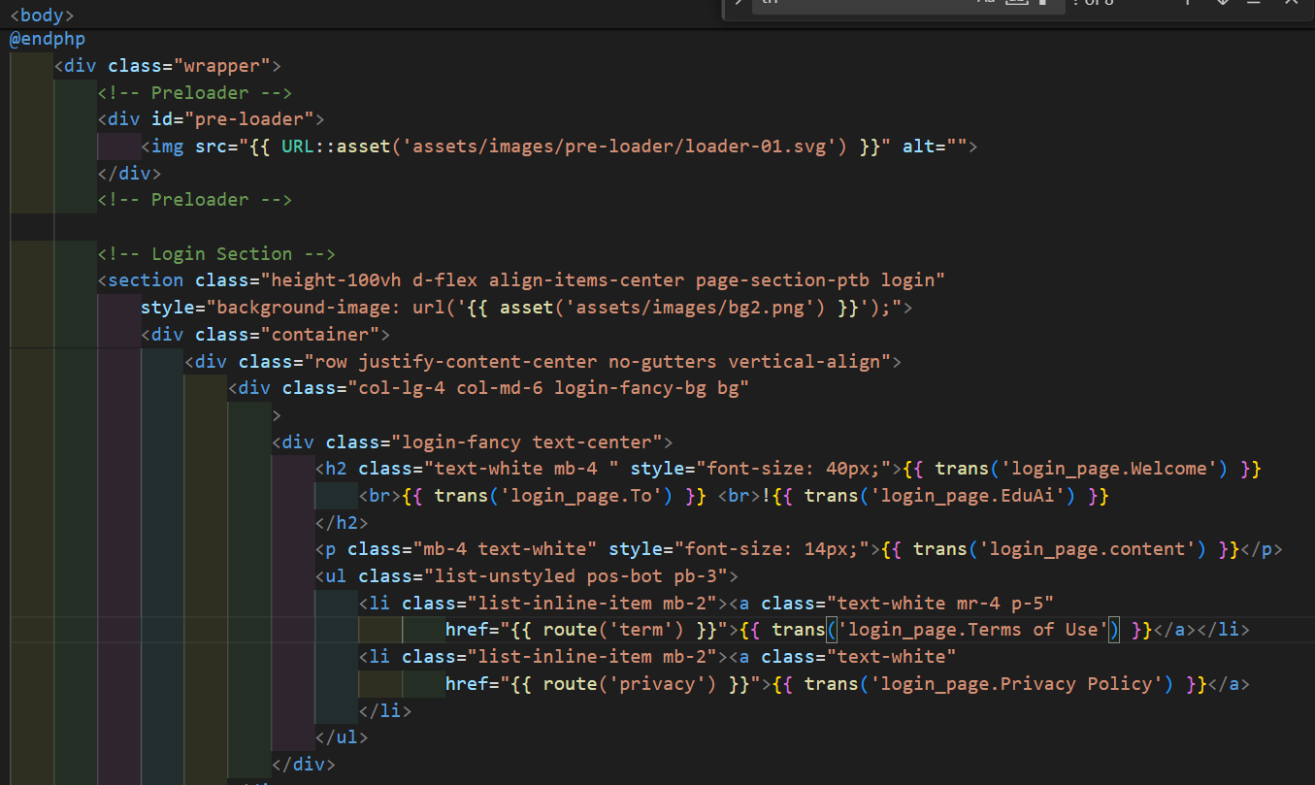

Figure 110:Graphical user interface implementation 7

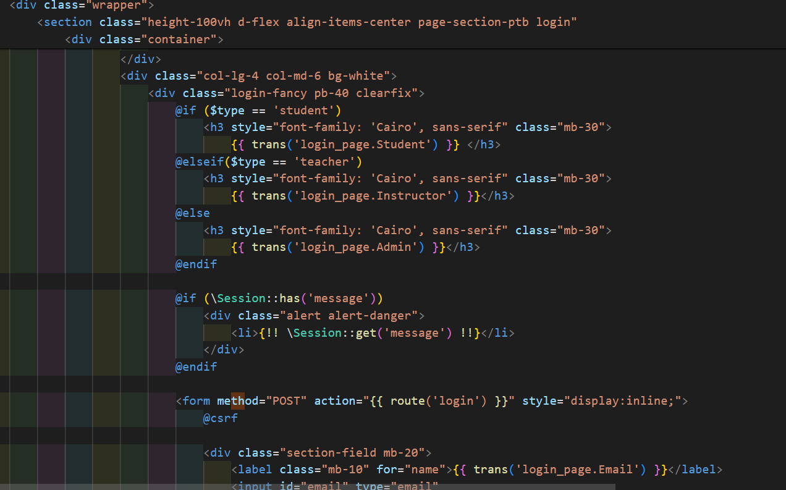

Figure 111:Graphical user interface implementation 8

**5.3 Graphical user interface high fidelity prototype**

### **5.3.1 Student interface**

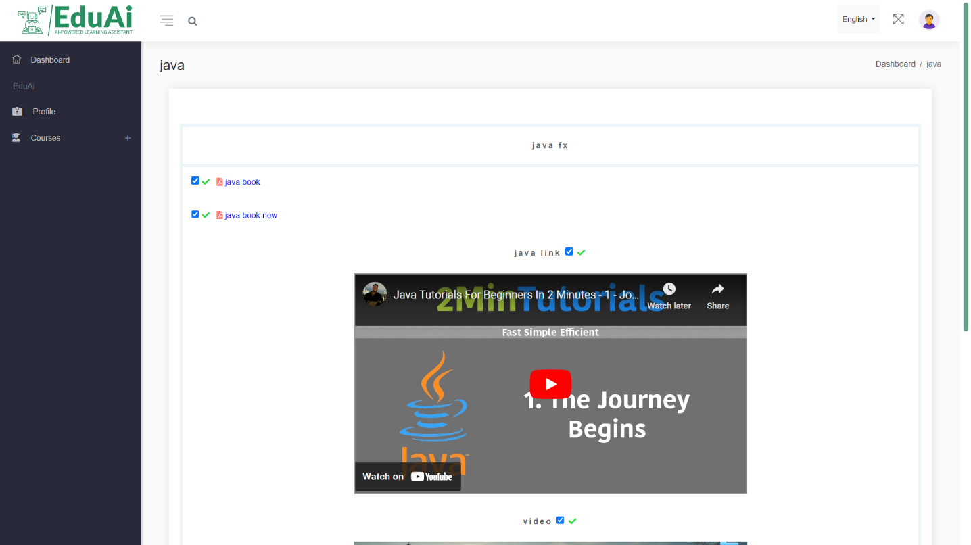

Figure 112: Student GUI 1

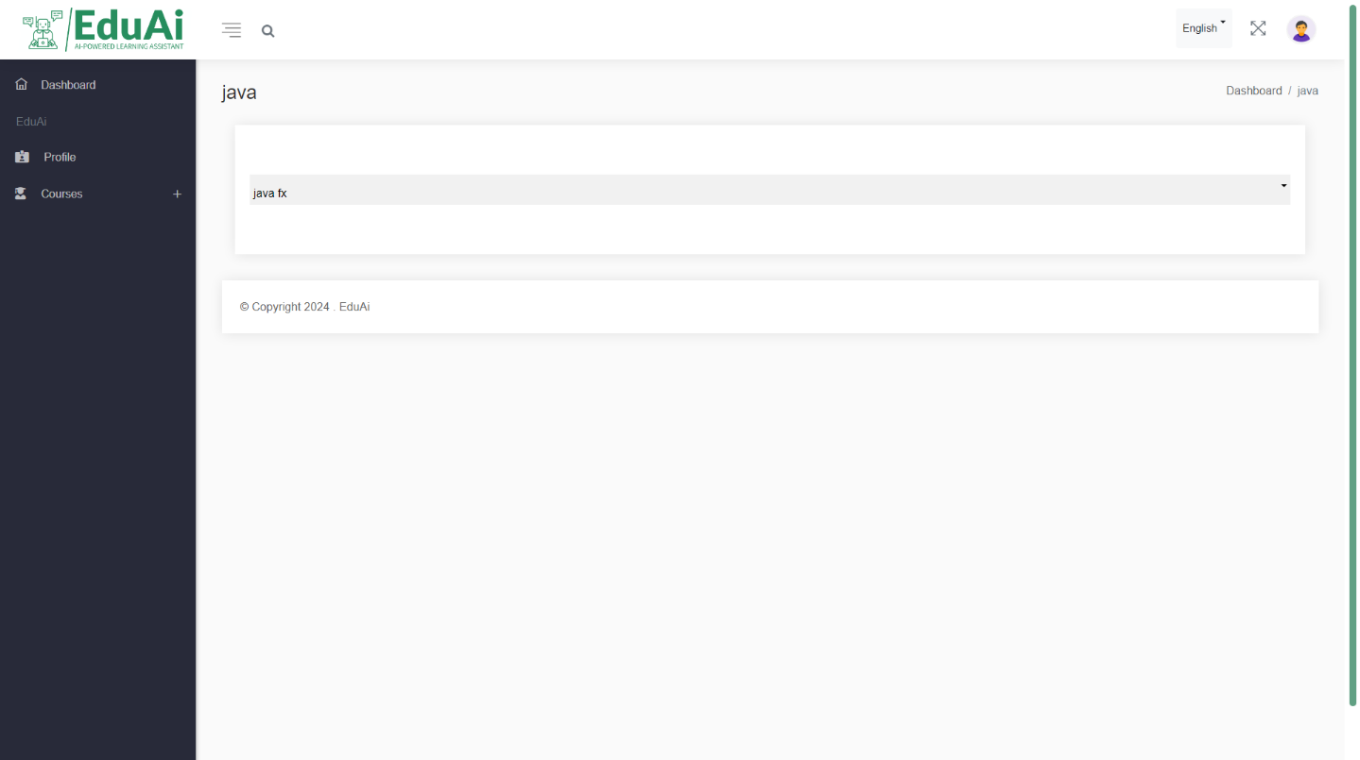

Figure 113: Student GUI 2

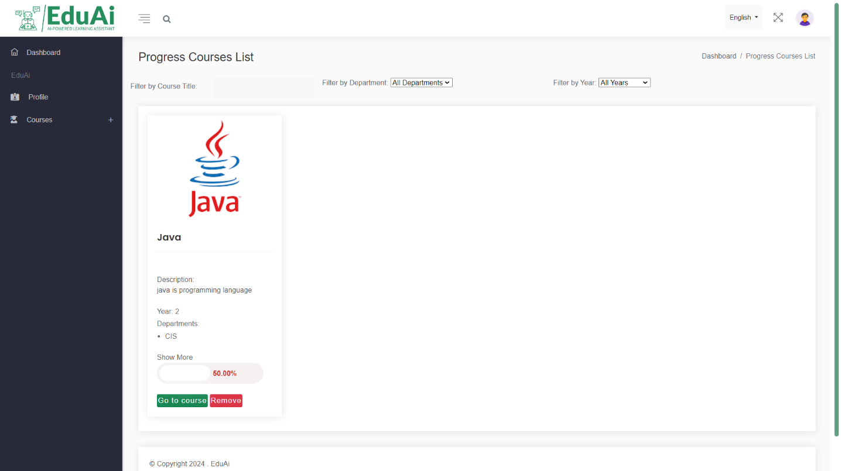

Figure 114: Student GUI 3

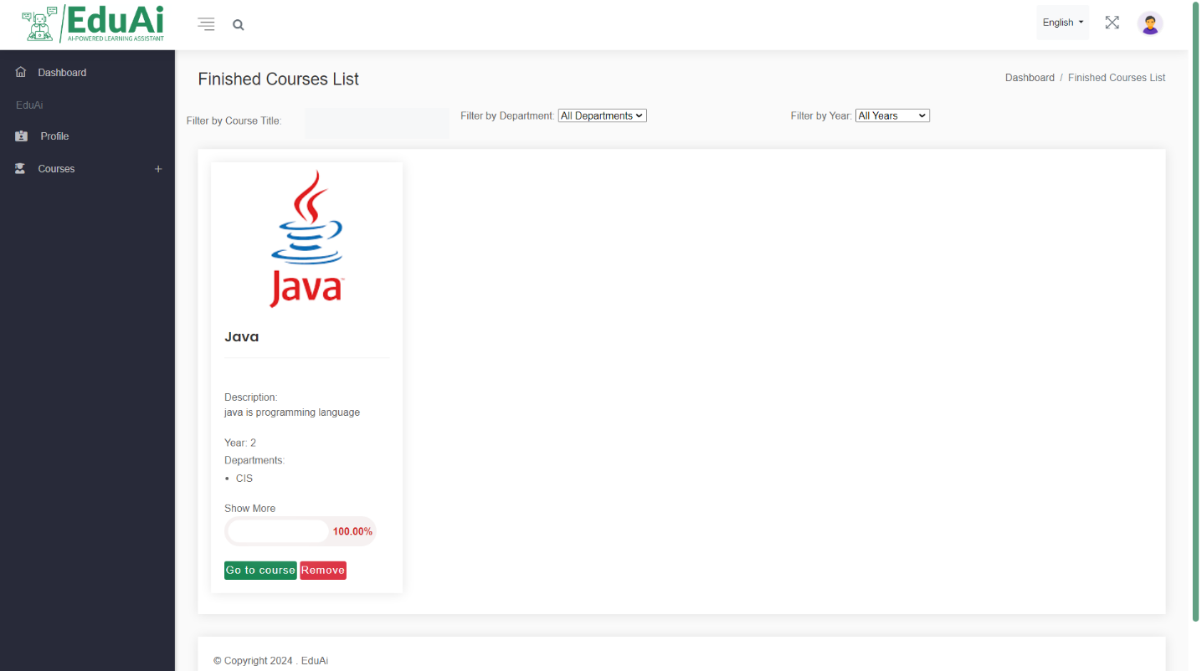

Figure 115: Student GUI 4

### **5.3.1 Instructor interface**

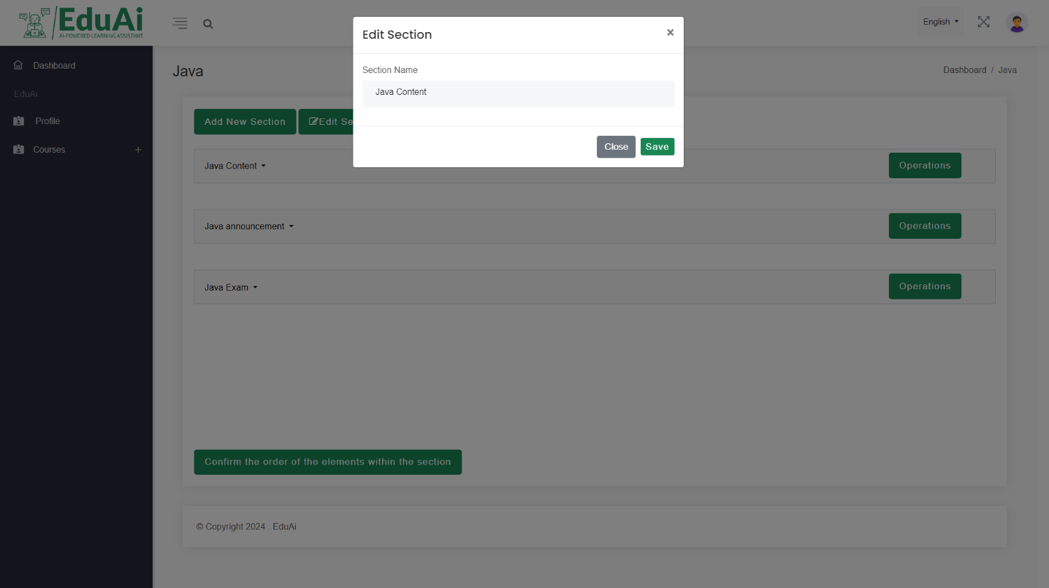

Figure 116: Instructor GUI 1

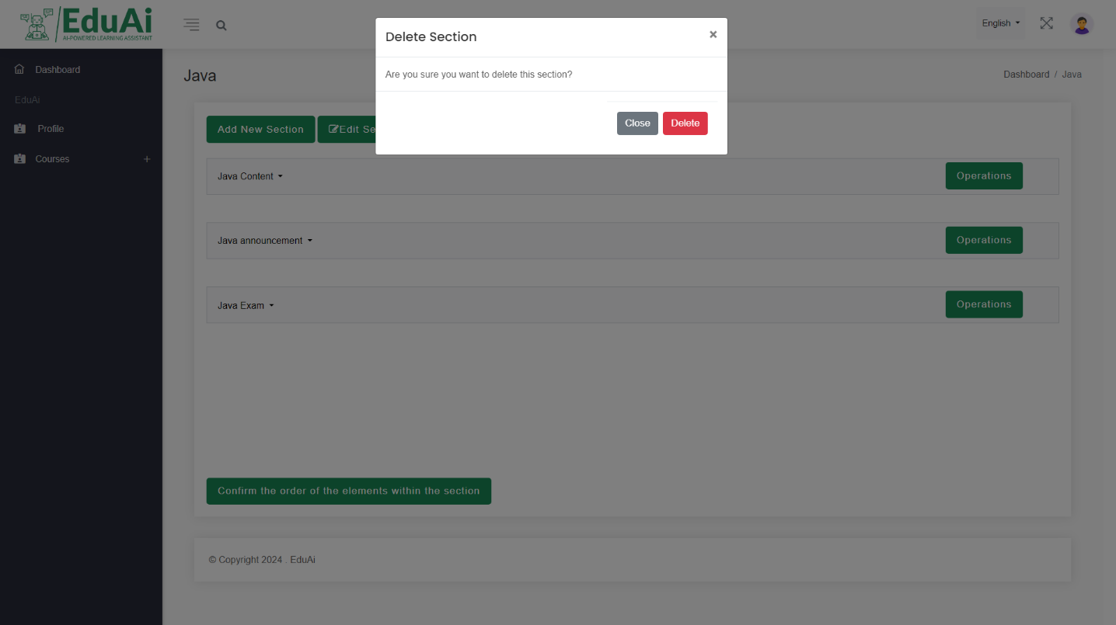

Figure 117: Instructor GUI 2

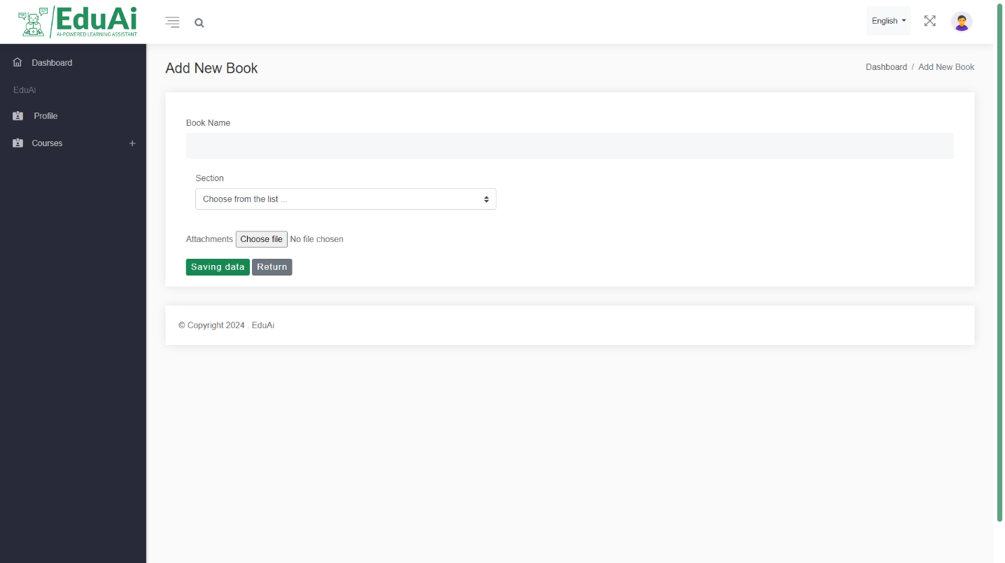

Figure 118: Instructor GUI 3

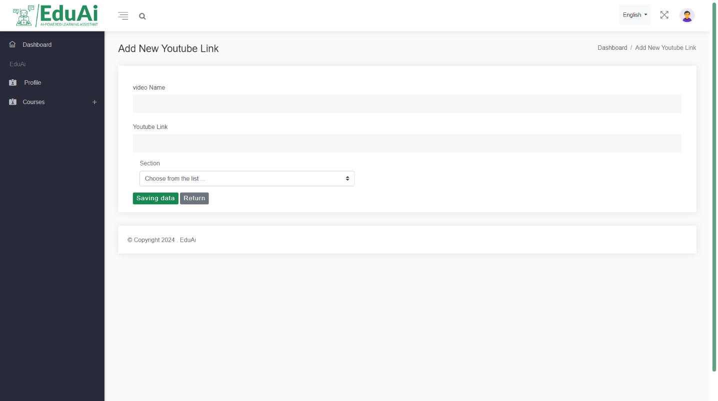

Figure 119: Instructor GUI 4

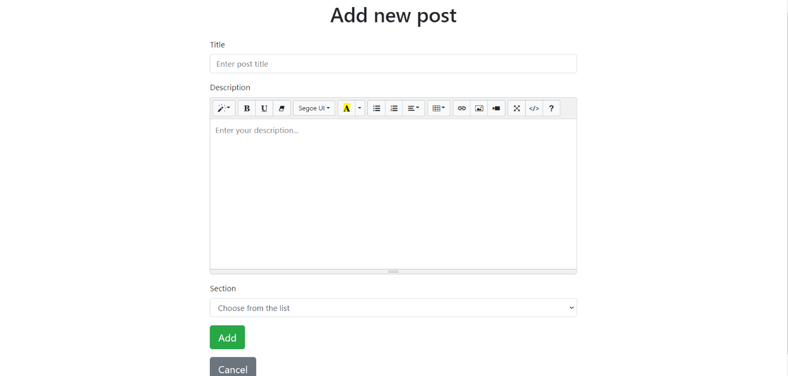

Figure 120: Instructor GUI 5

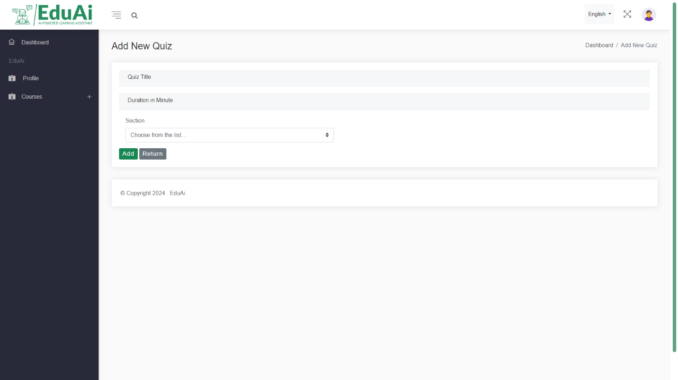

Figure 121: Instructor GUI 6

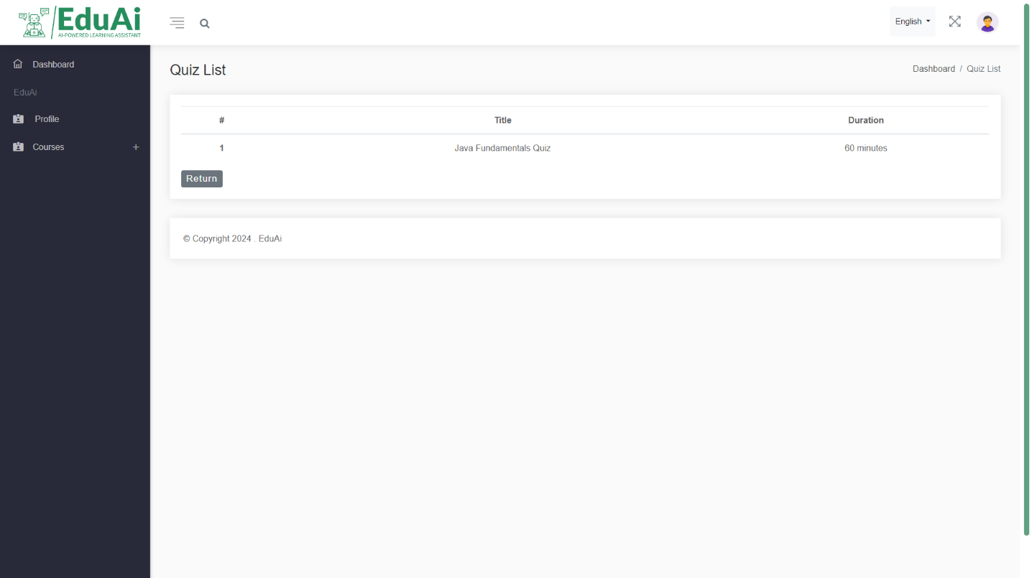

Figure 122: Instructor GUI 7

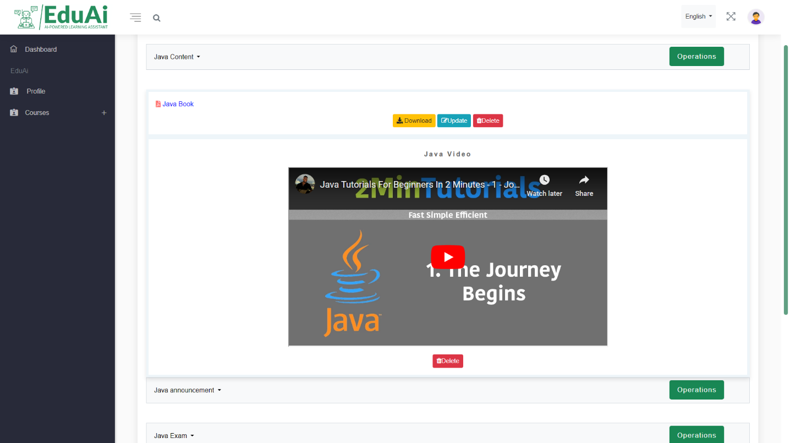

Figure 123: Instructor GUI 8

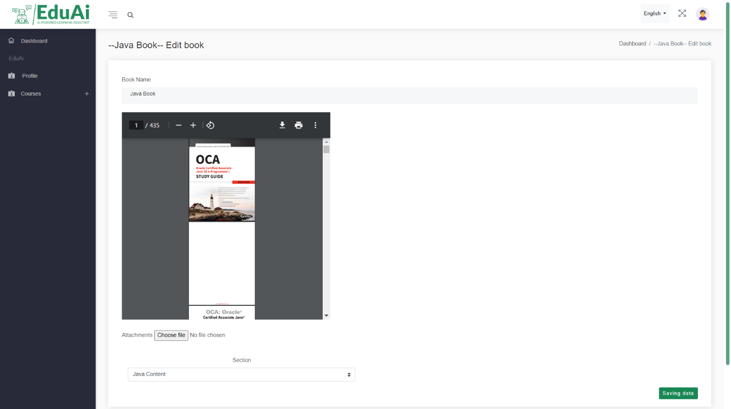

Figure 124: Instructor GUI 9

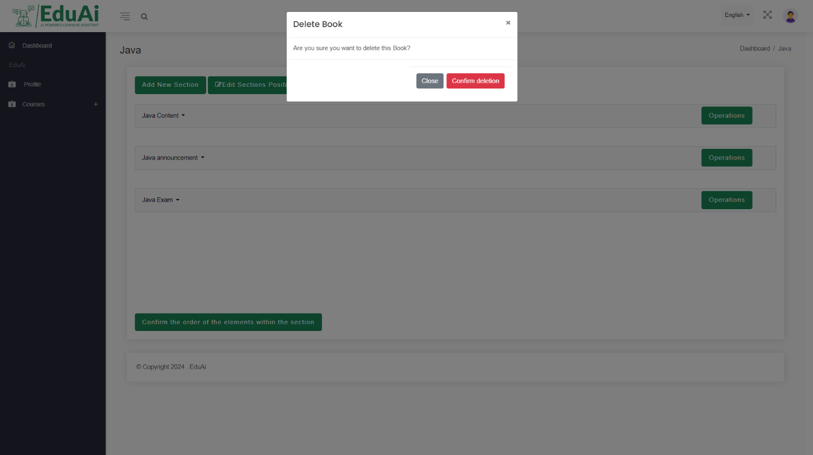

Figure 125: Instructor GUI 10

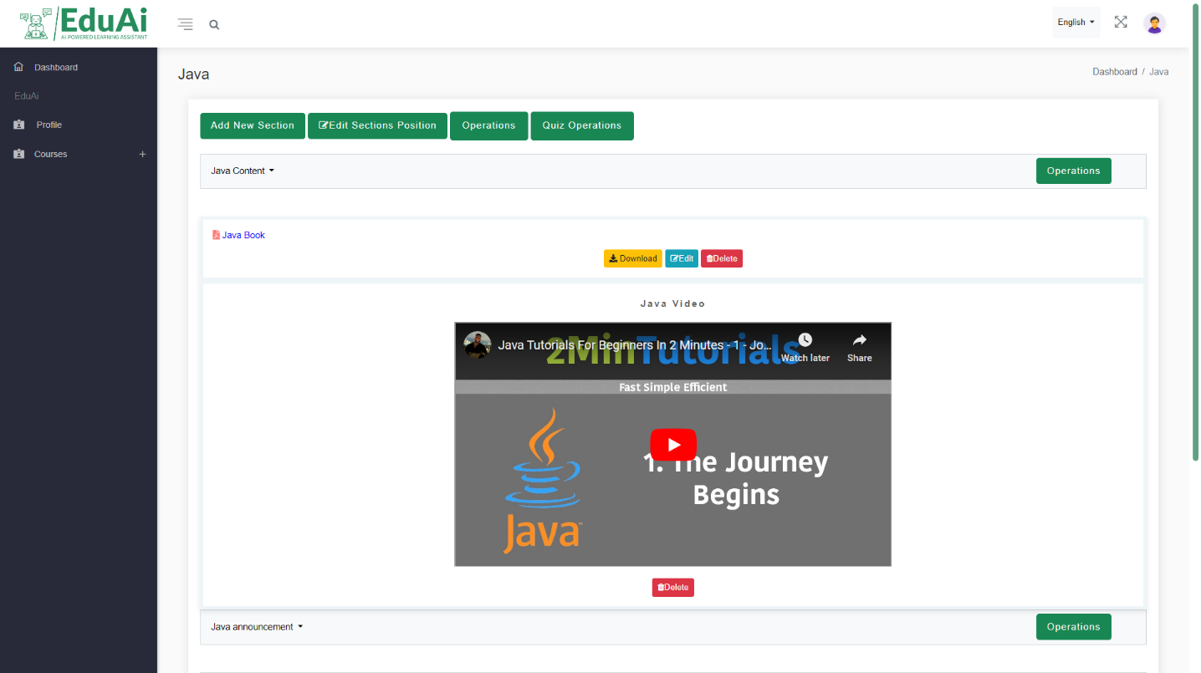

Figure 126: Instructor GUI 11

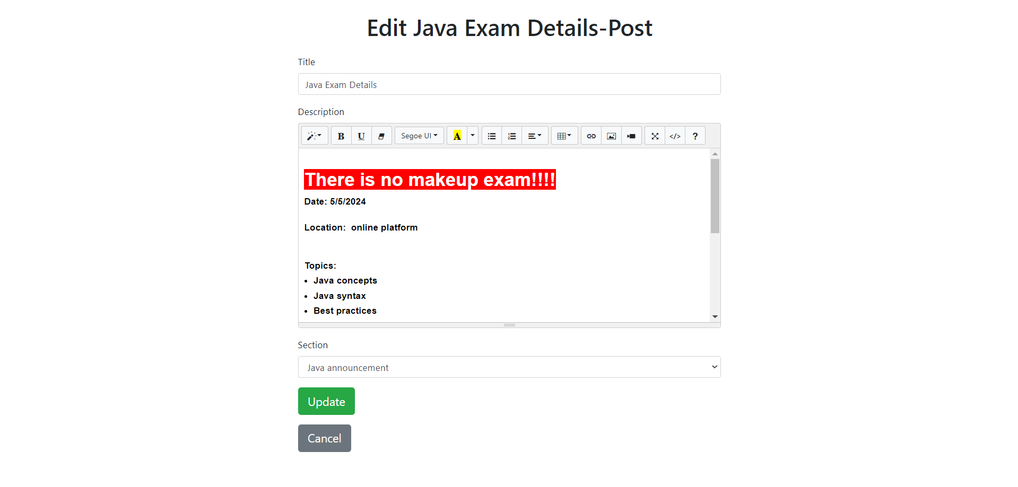

Figure 127: Instructor GUI 12

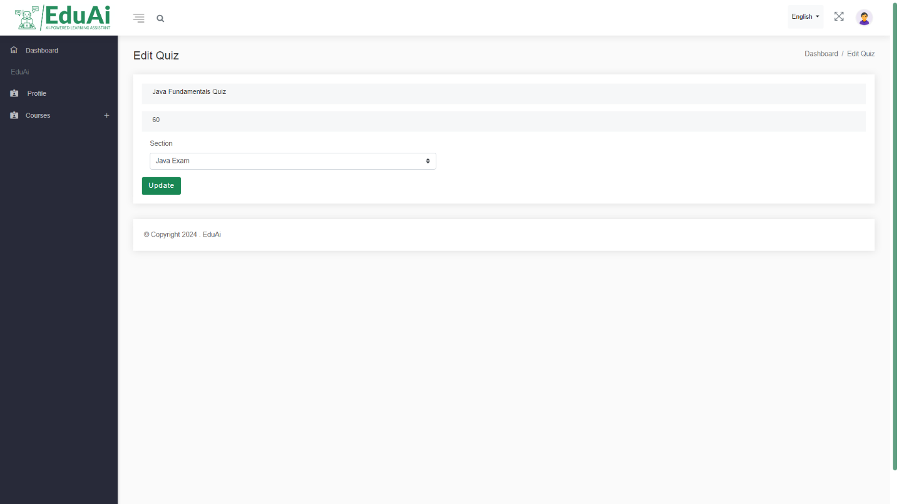

Figure 128: Instructor GUI 13

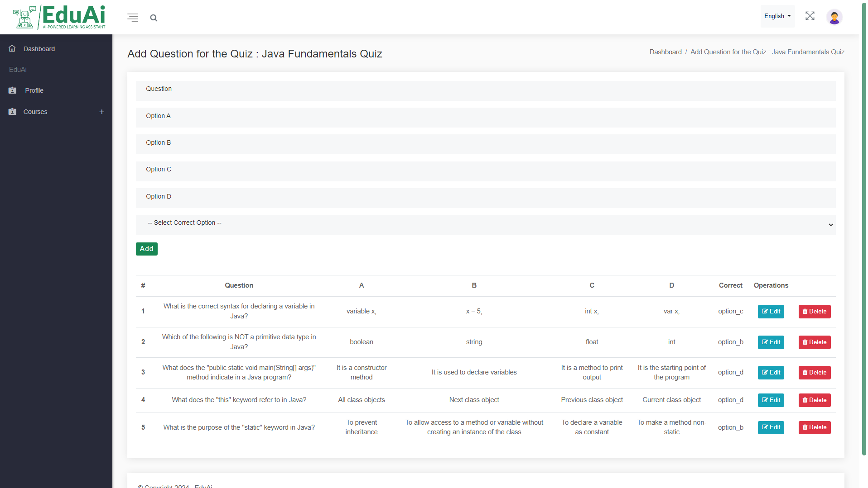

Figure 129: Instructor GUI 14

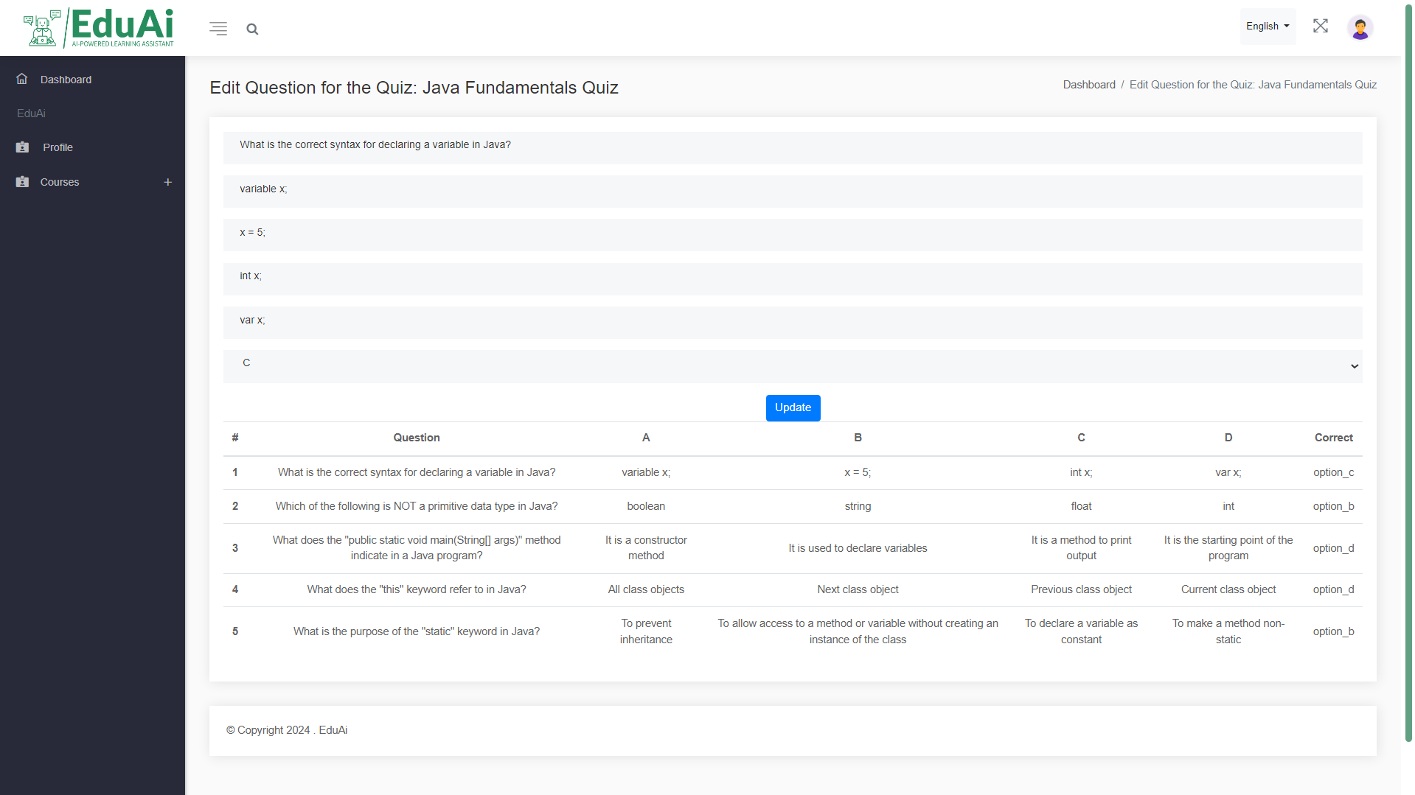

Figure 130: Instructor GUI 15

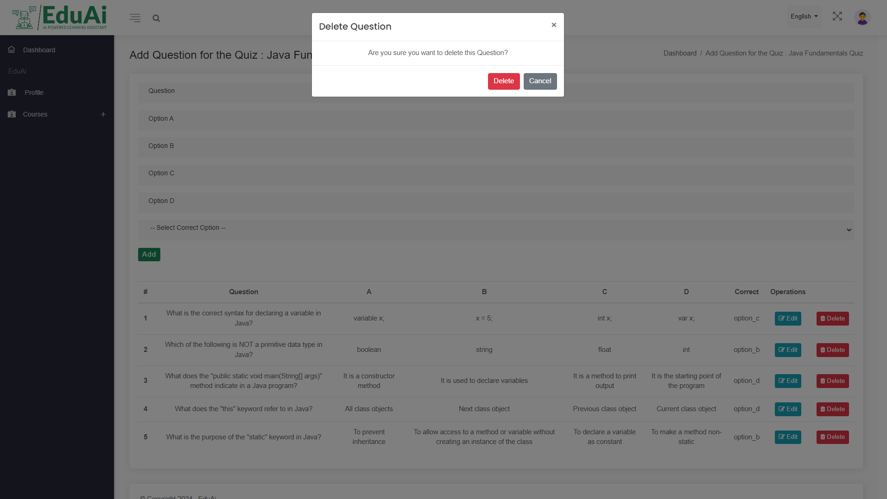

Figure 131: Instructor GUI 16

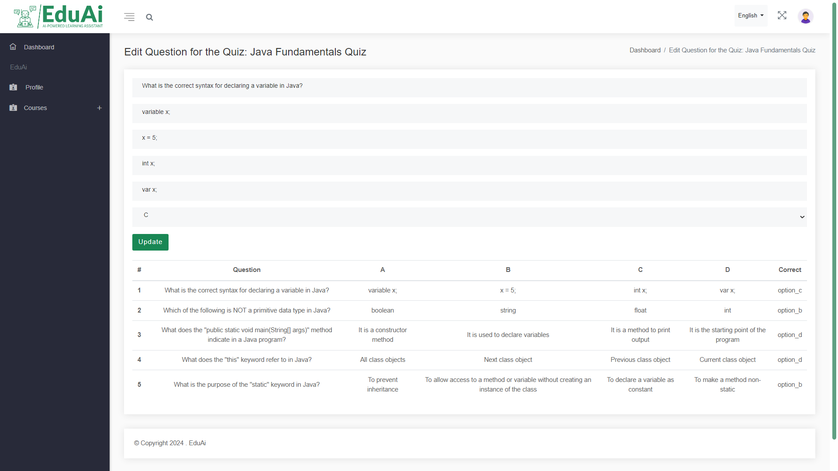

Figure 132: Instructor GUI 17

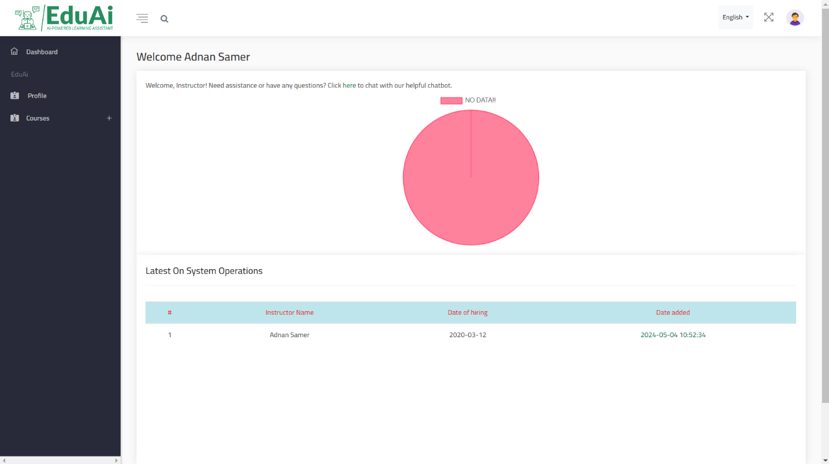

Figure 133: Instructor GUI 18

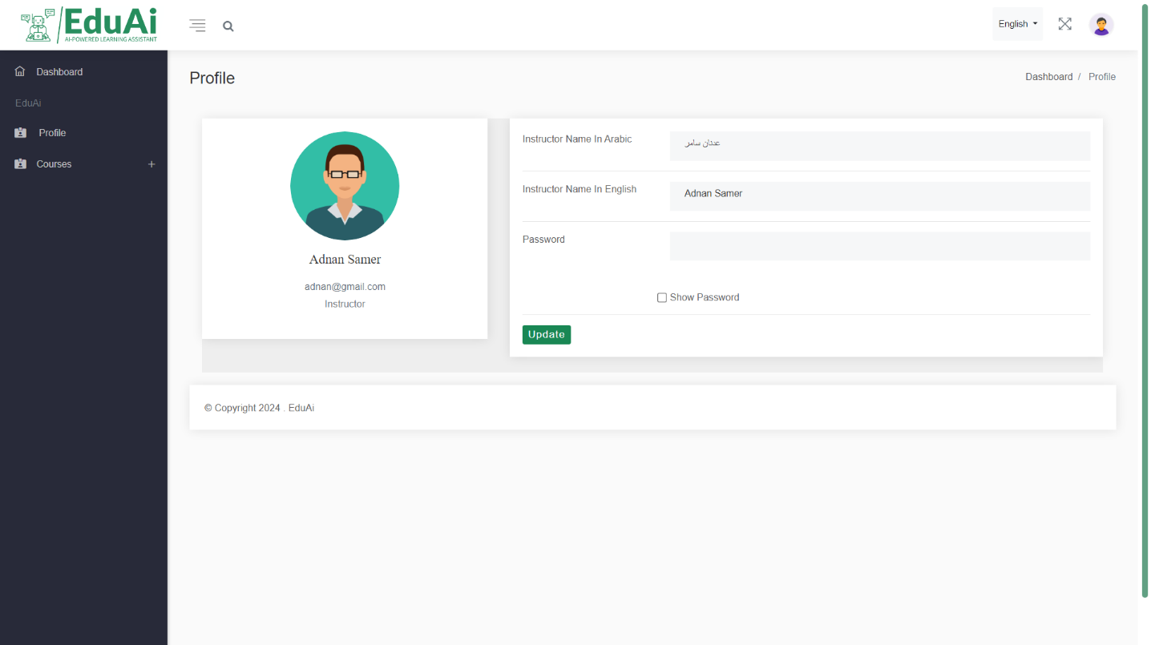

Figure 134: Instructor GUI 19

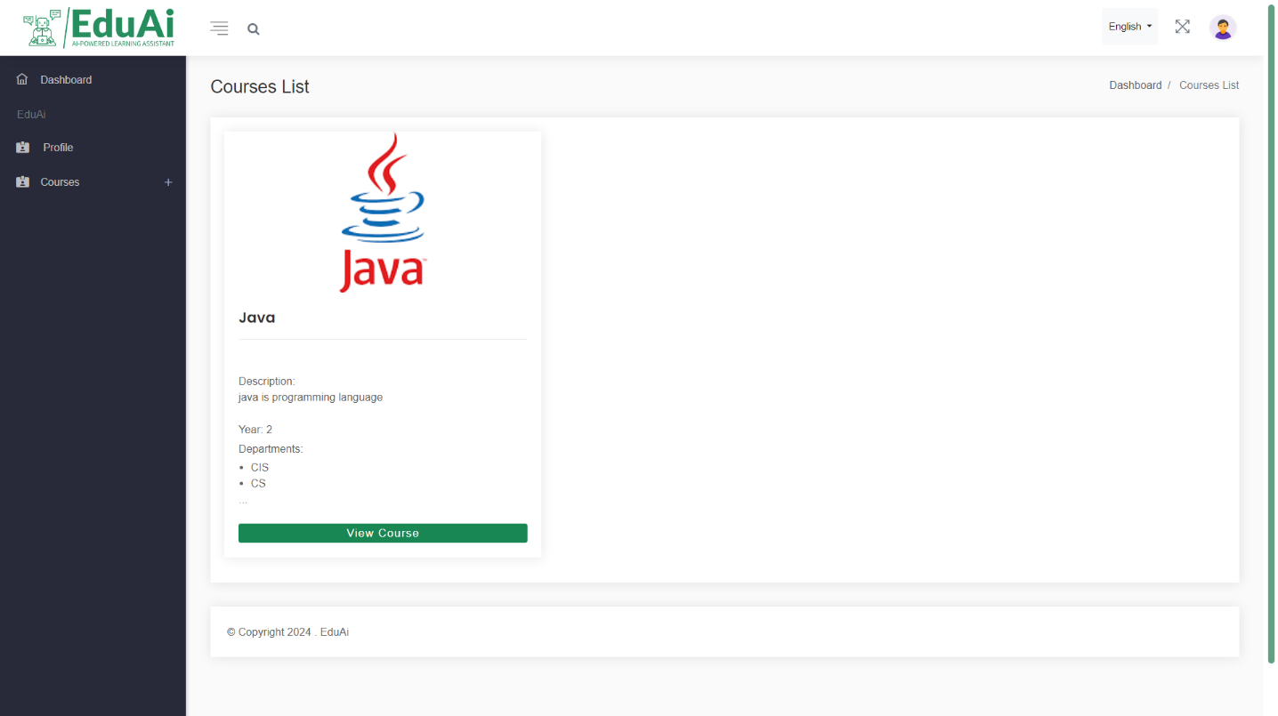

Figure 135: Instructor GUI 20

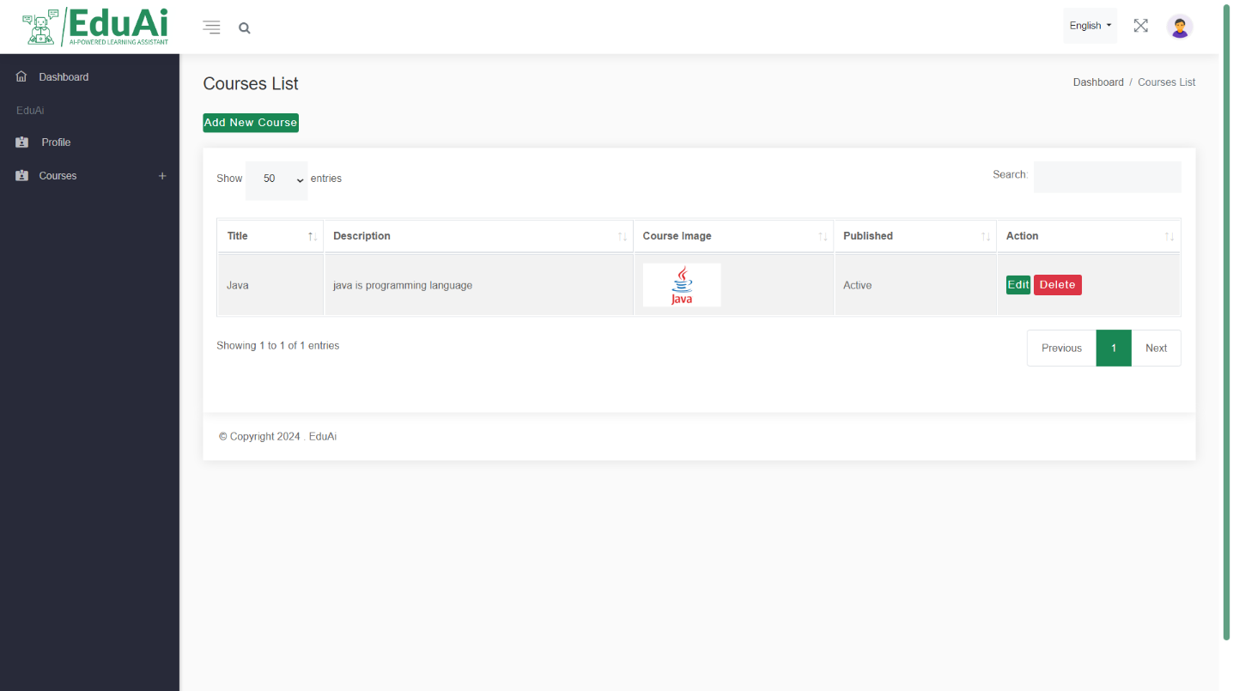

Figure 136: Instructor GUI 22

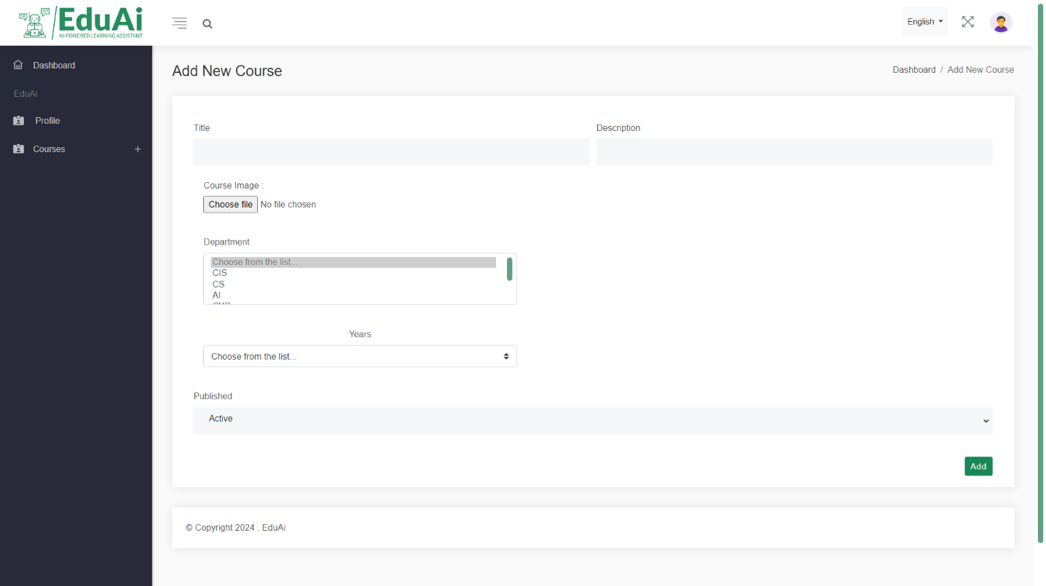

Figure 137: Instructor GUI 23

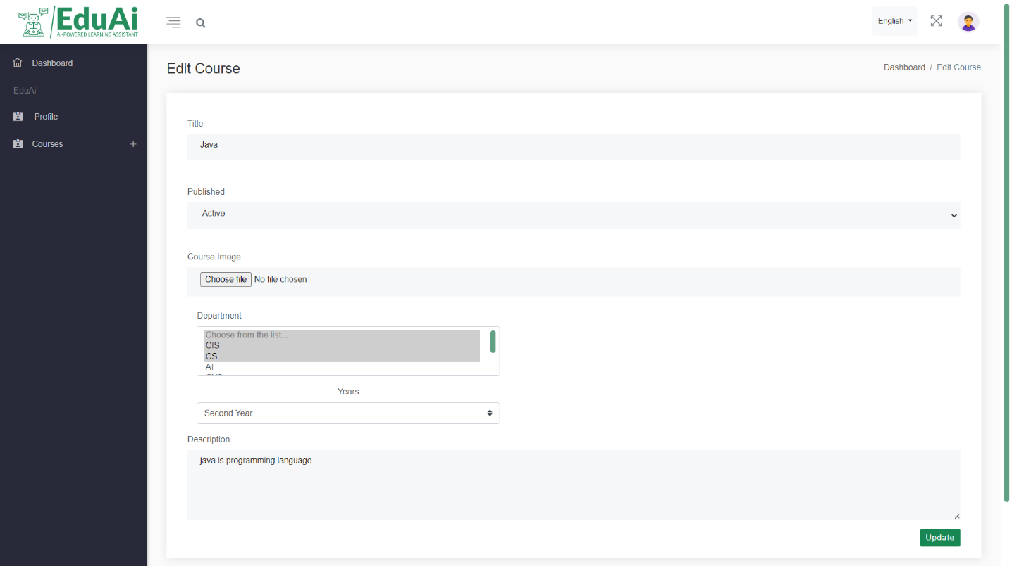

Figure 138: Instructor GUI 24

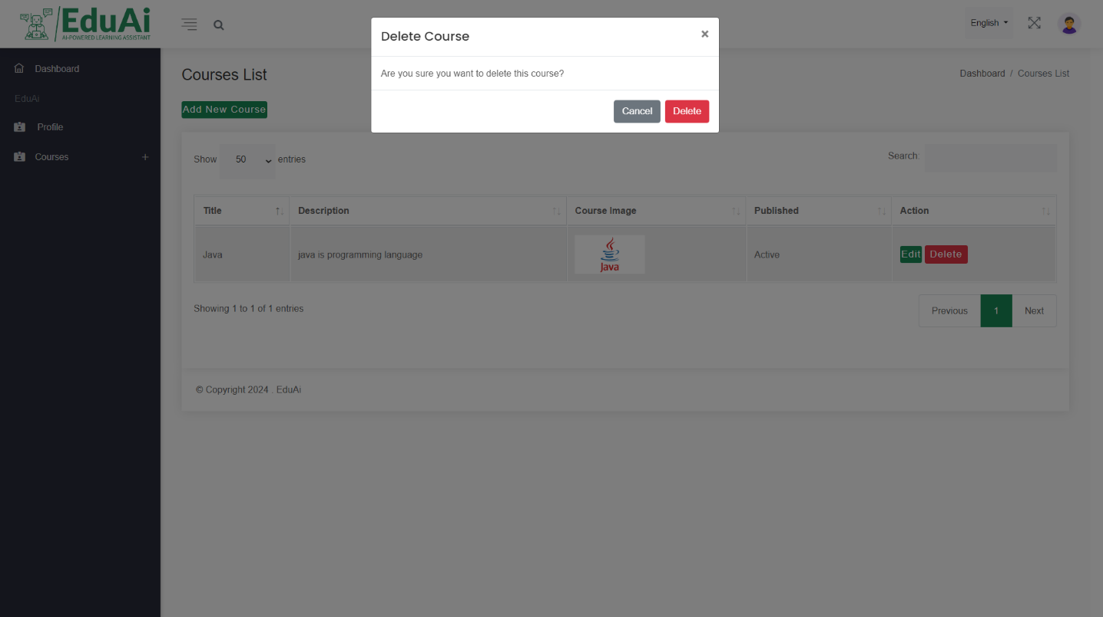

Figure 139: Instructor GUI 25

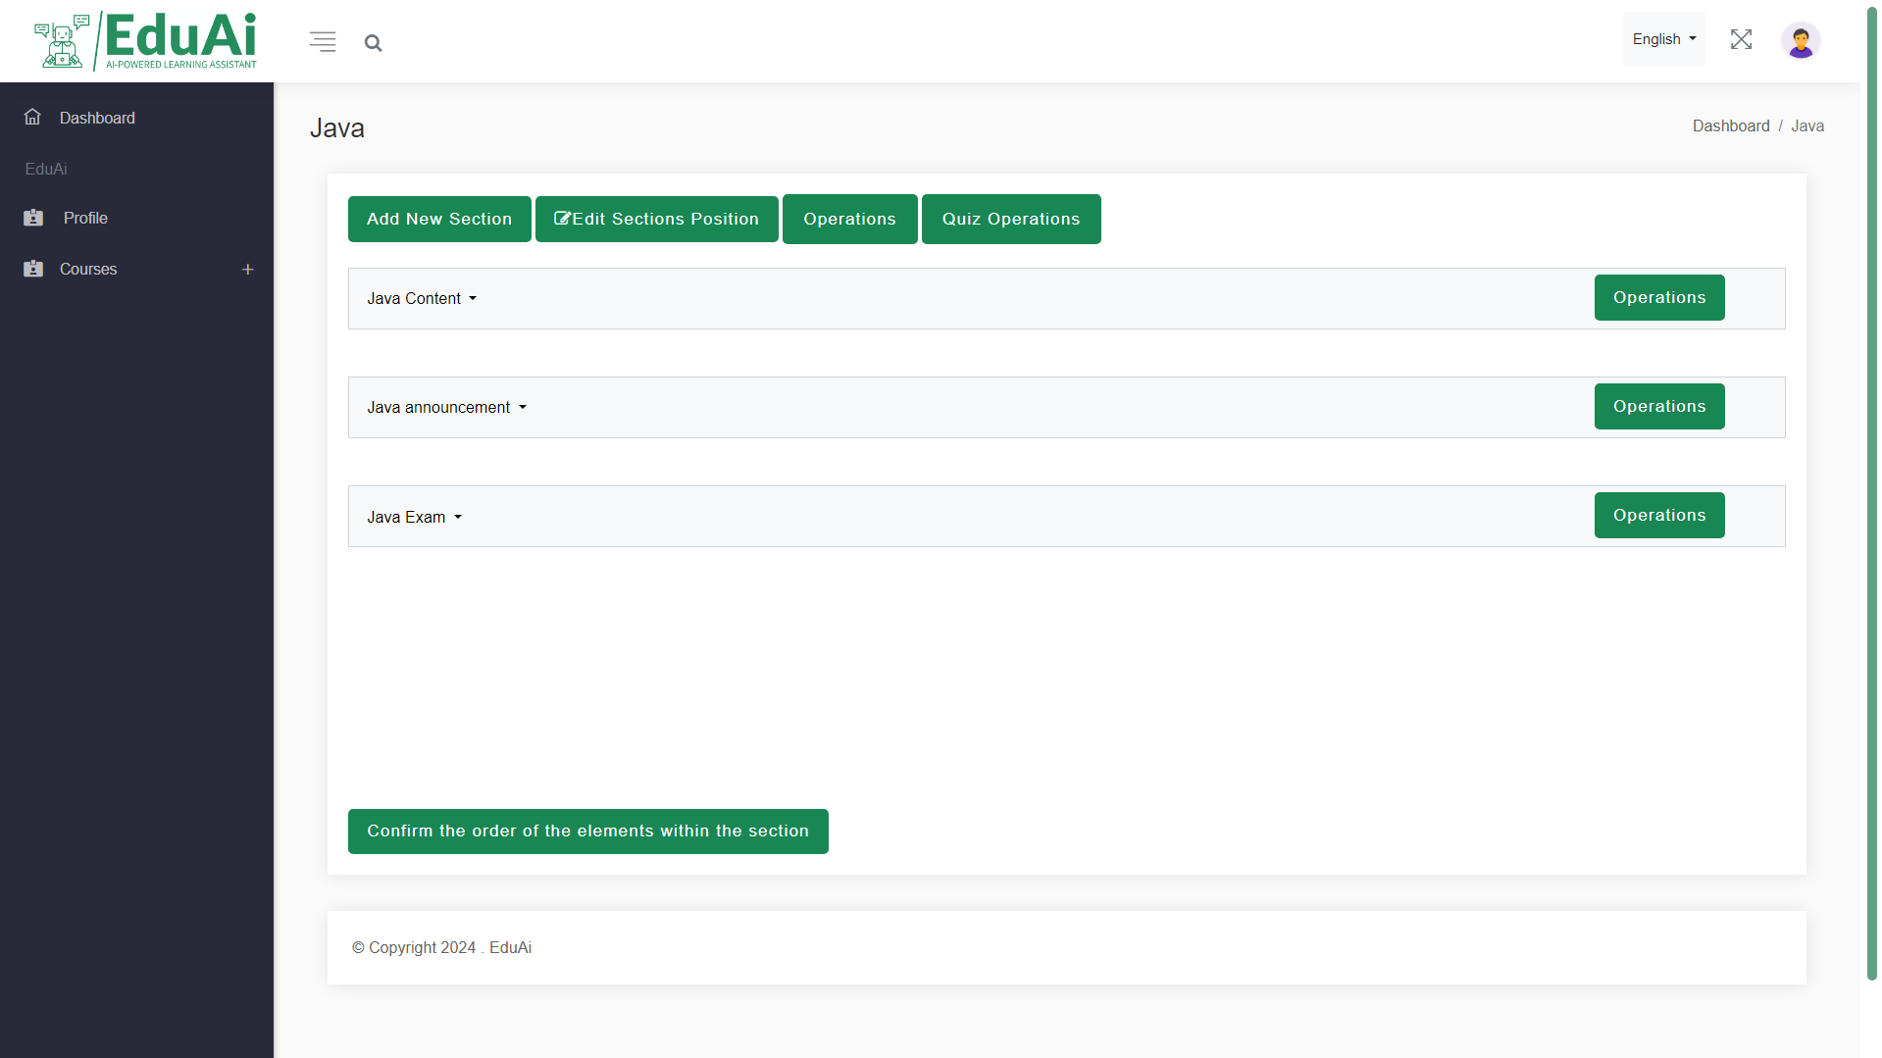

Figure 140: Instructor GUI 26

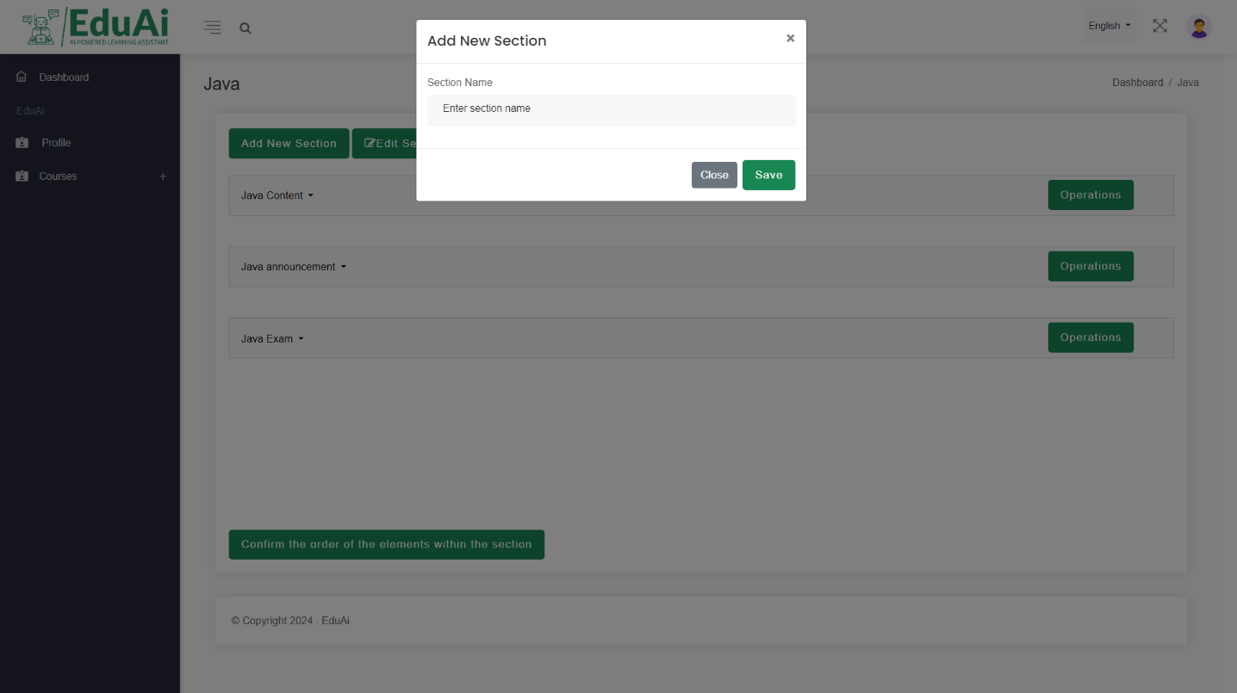

Figure 141: Instructor GUI 27

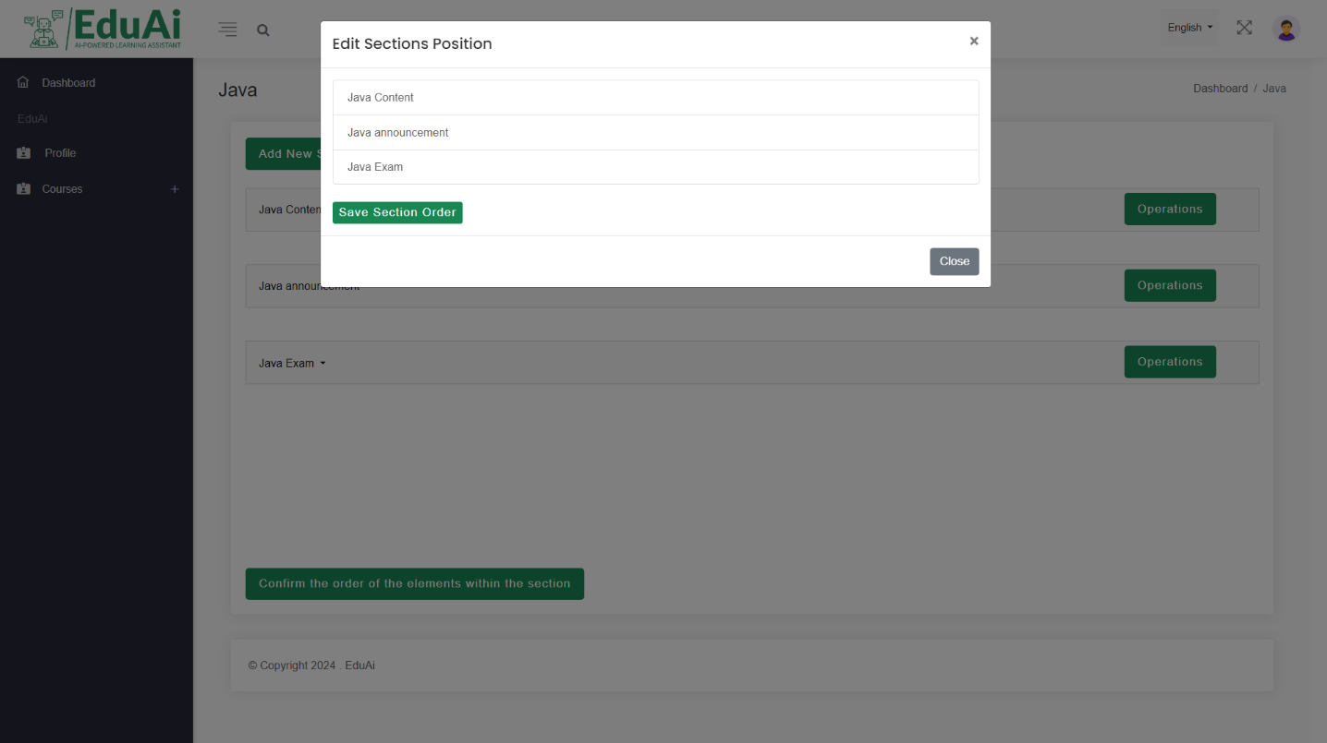

Figure 142: Instructor GUI 28

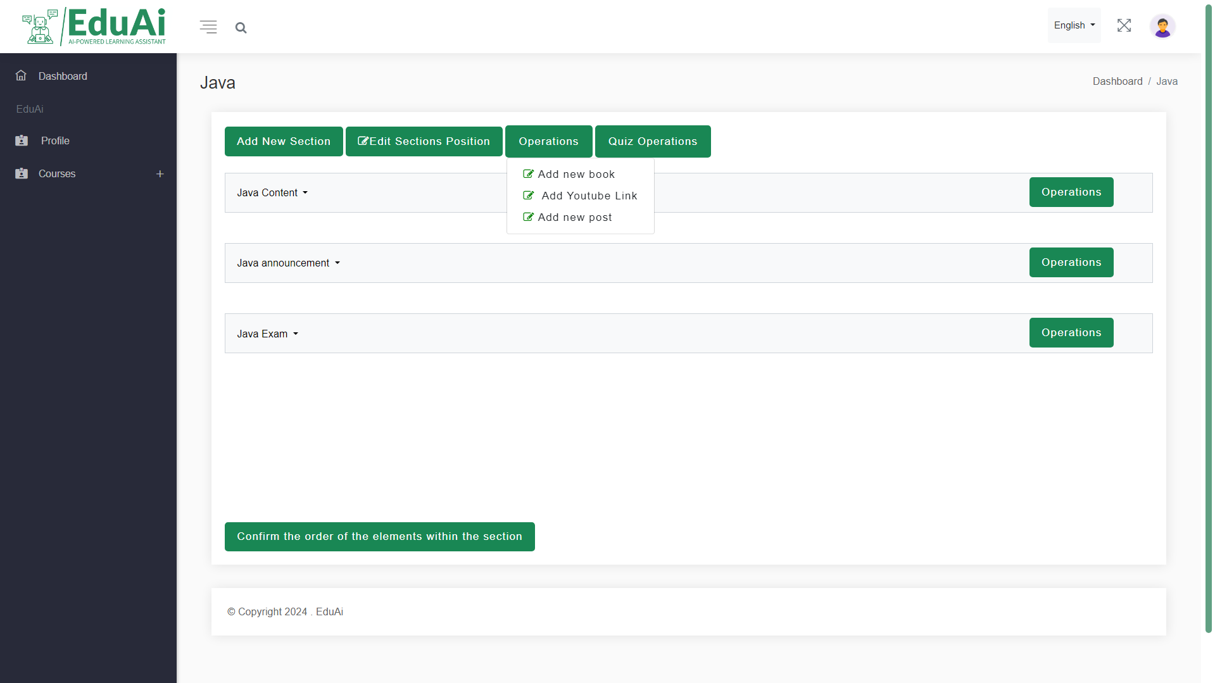

Figure 143: Instructor GUI 29

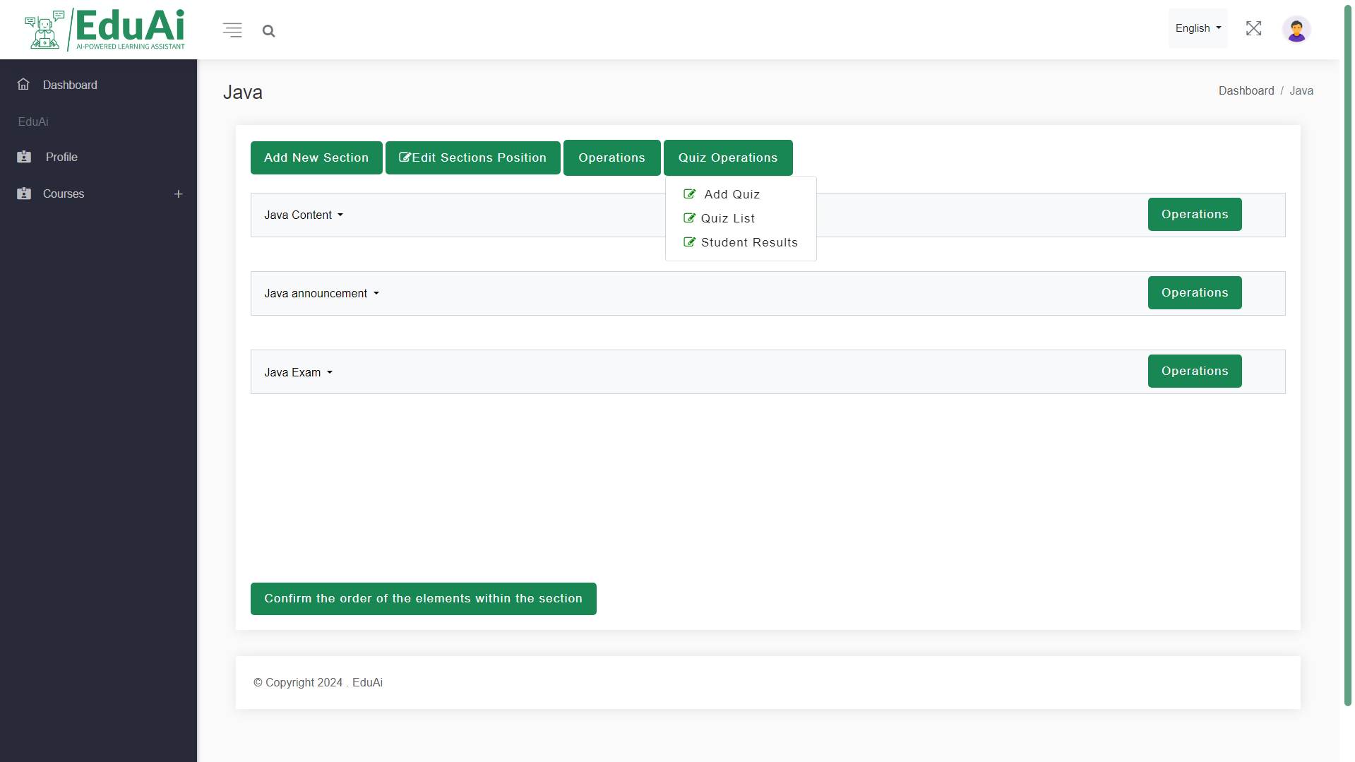

Figure 144: Instructor GUI 30

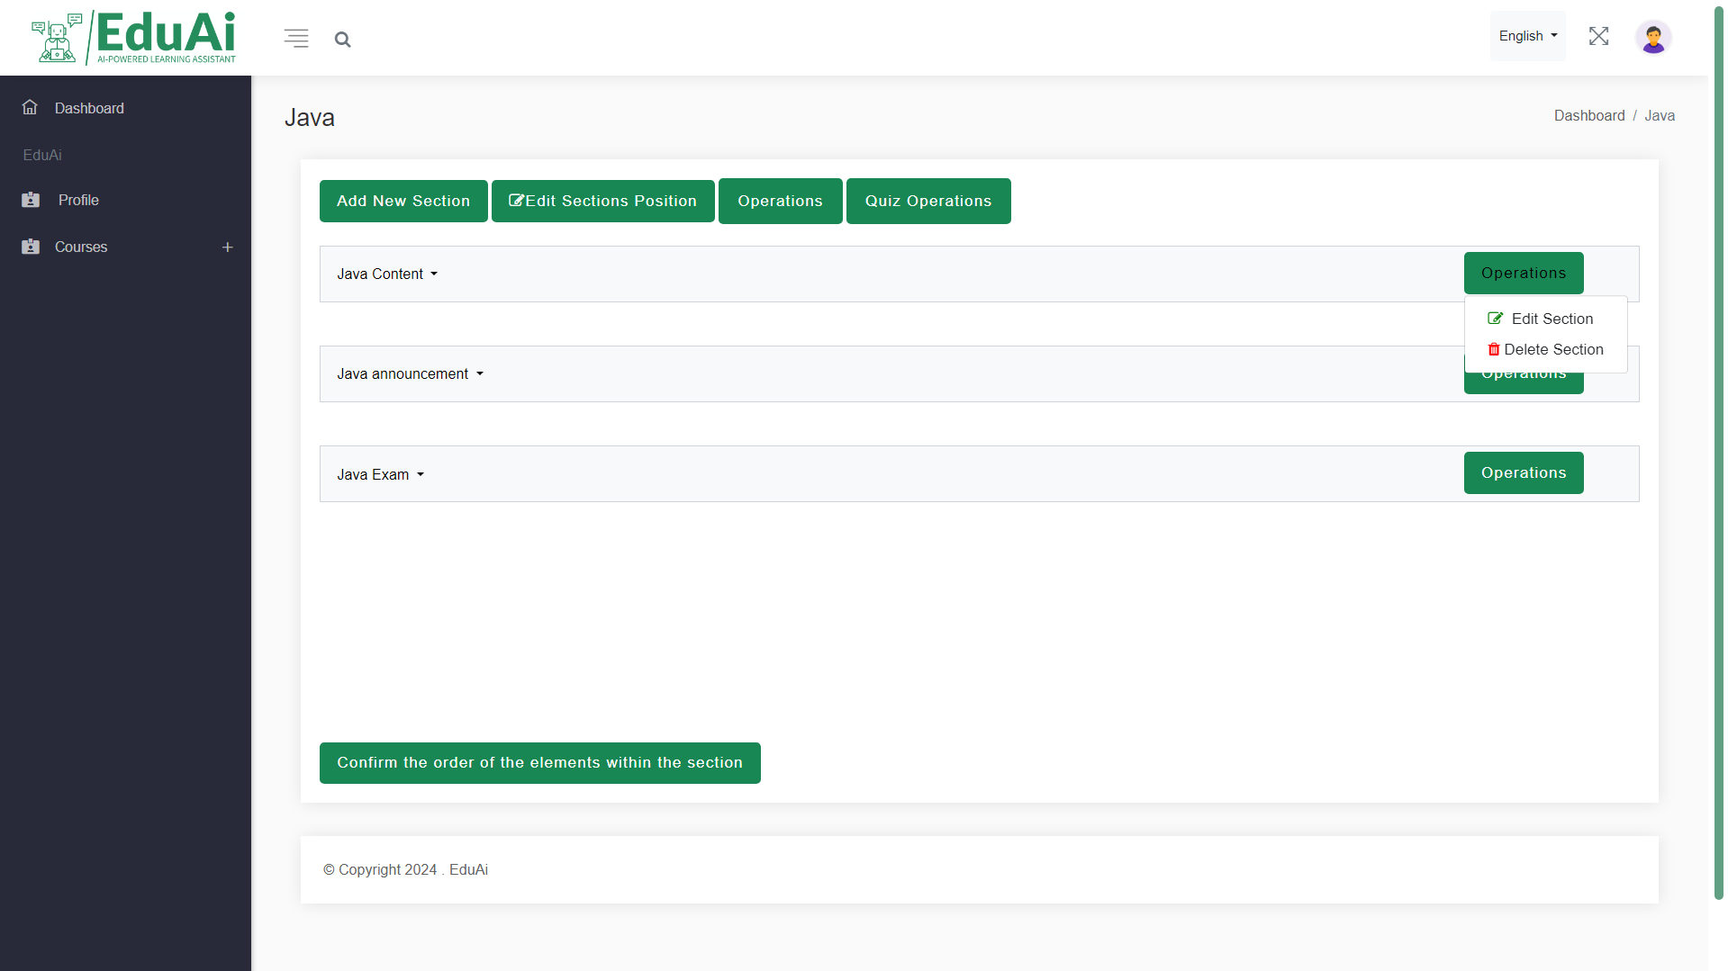

Figure 145: Instructor GUI 31

### **5.3.1 admin interface**

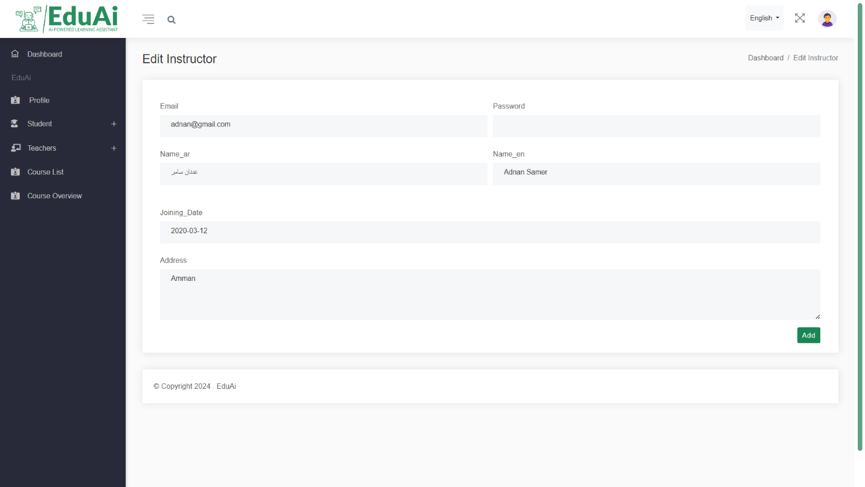

Figure 146: Admin GUI 1

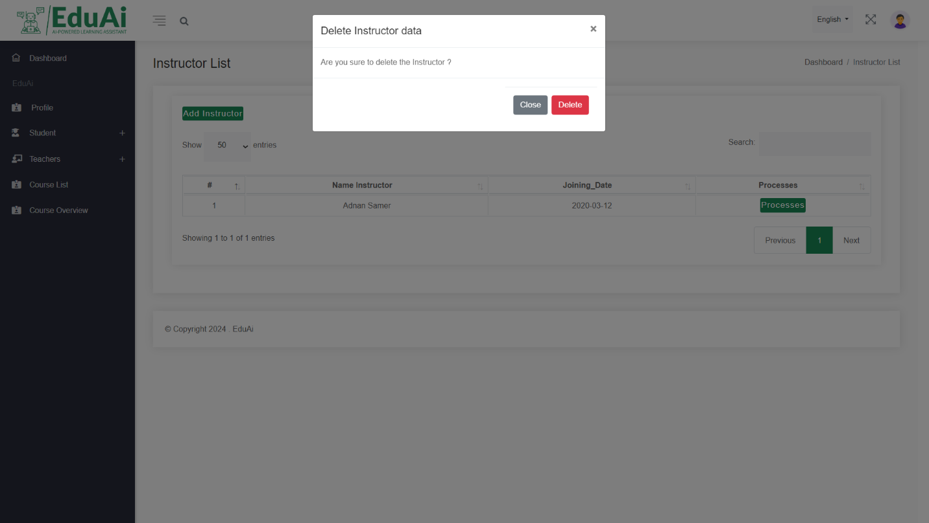

Figure 147: Admin GUI 2

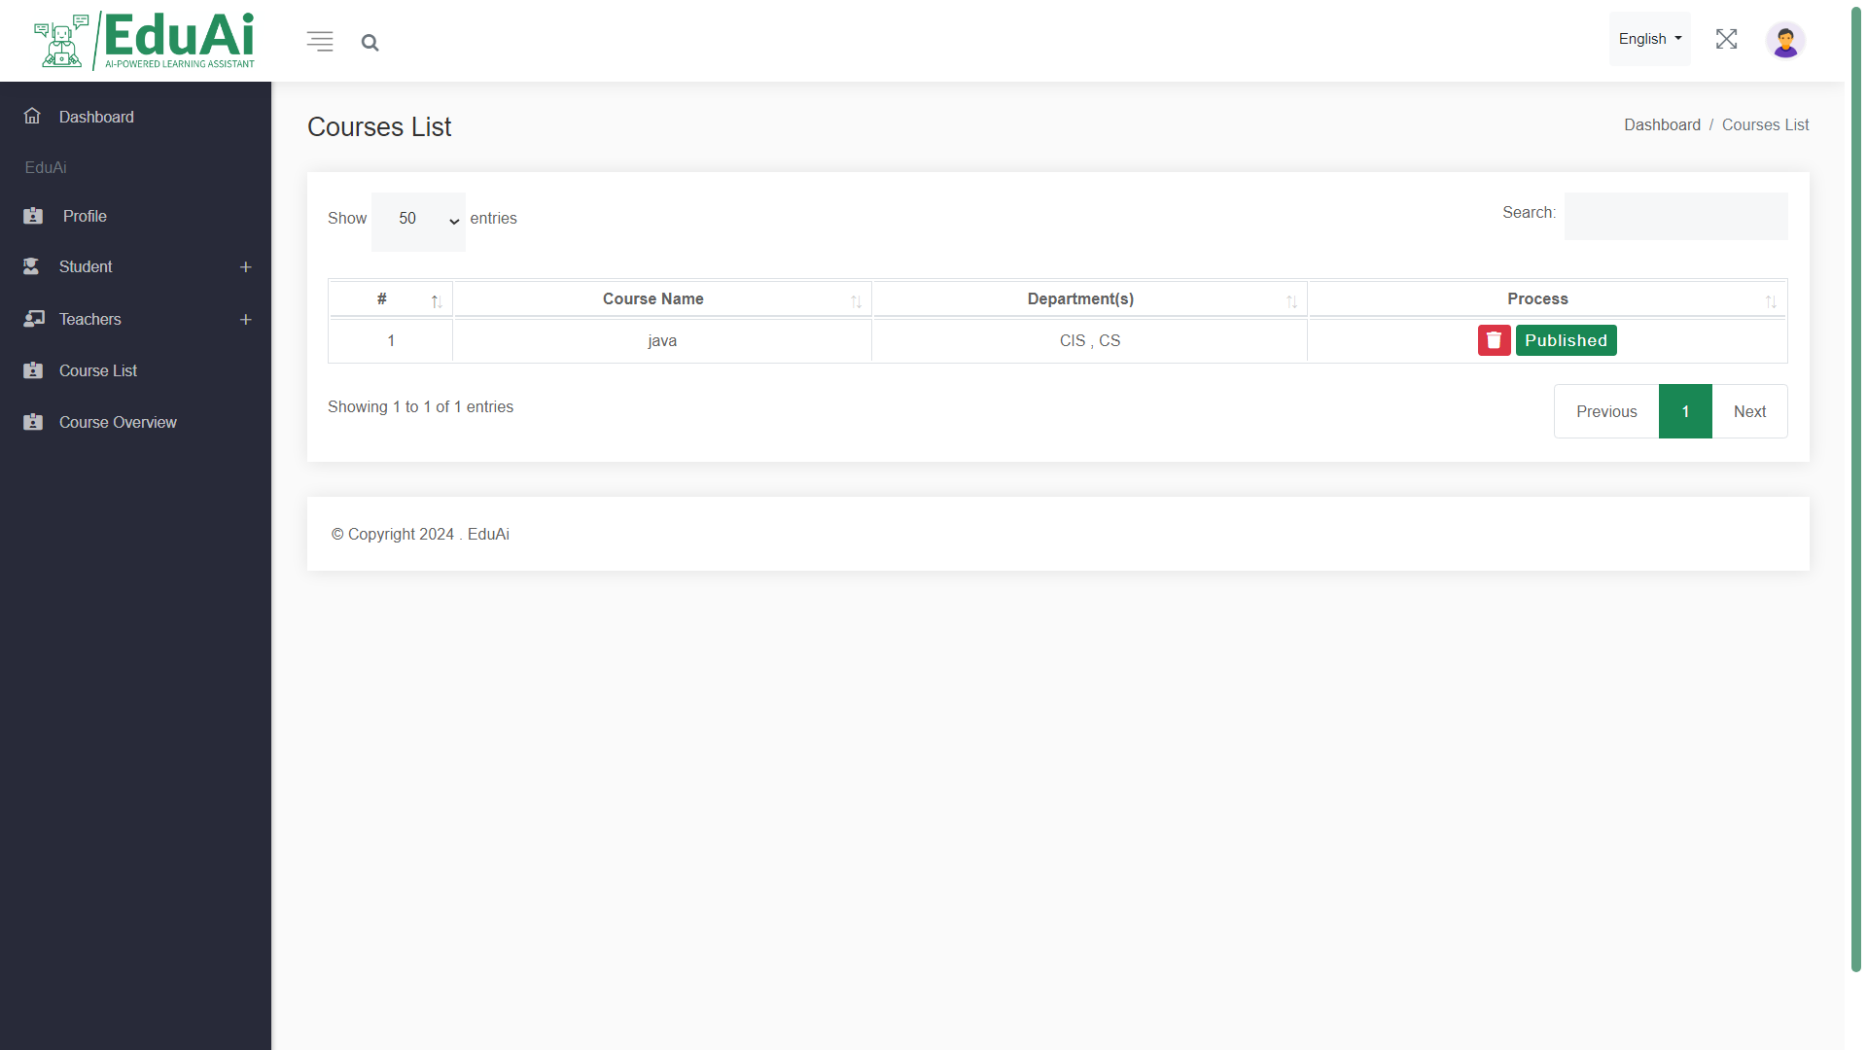

Figure 148: Admin GUI 3

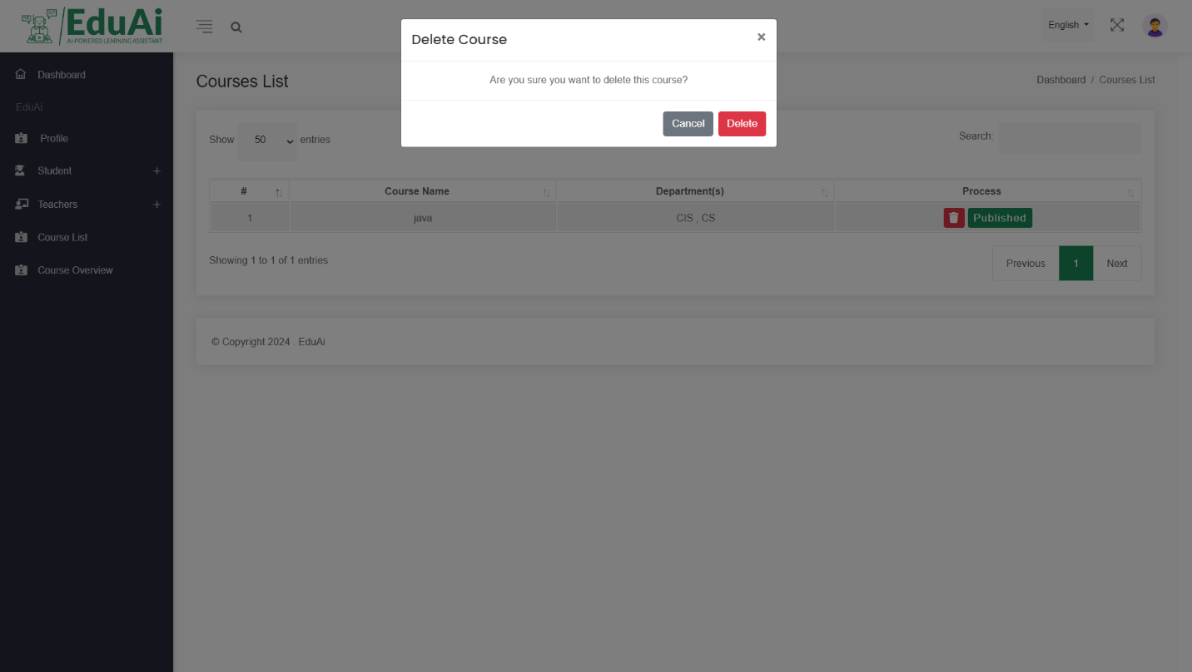

Figure 149: Admin GUI 4

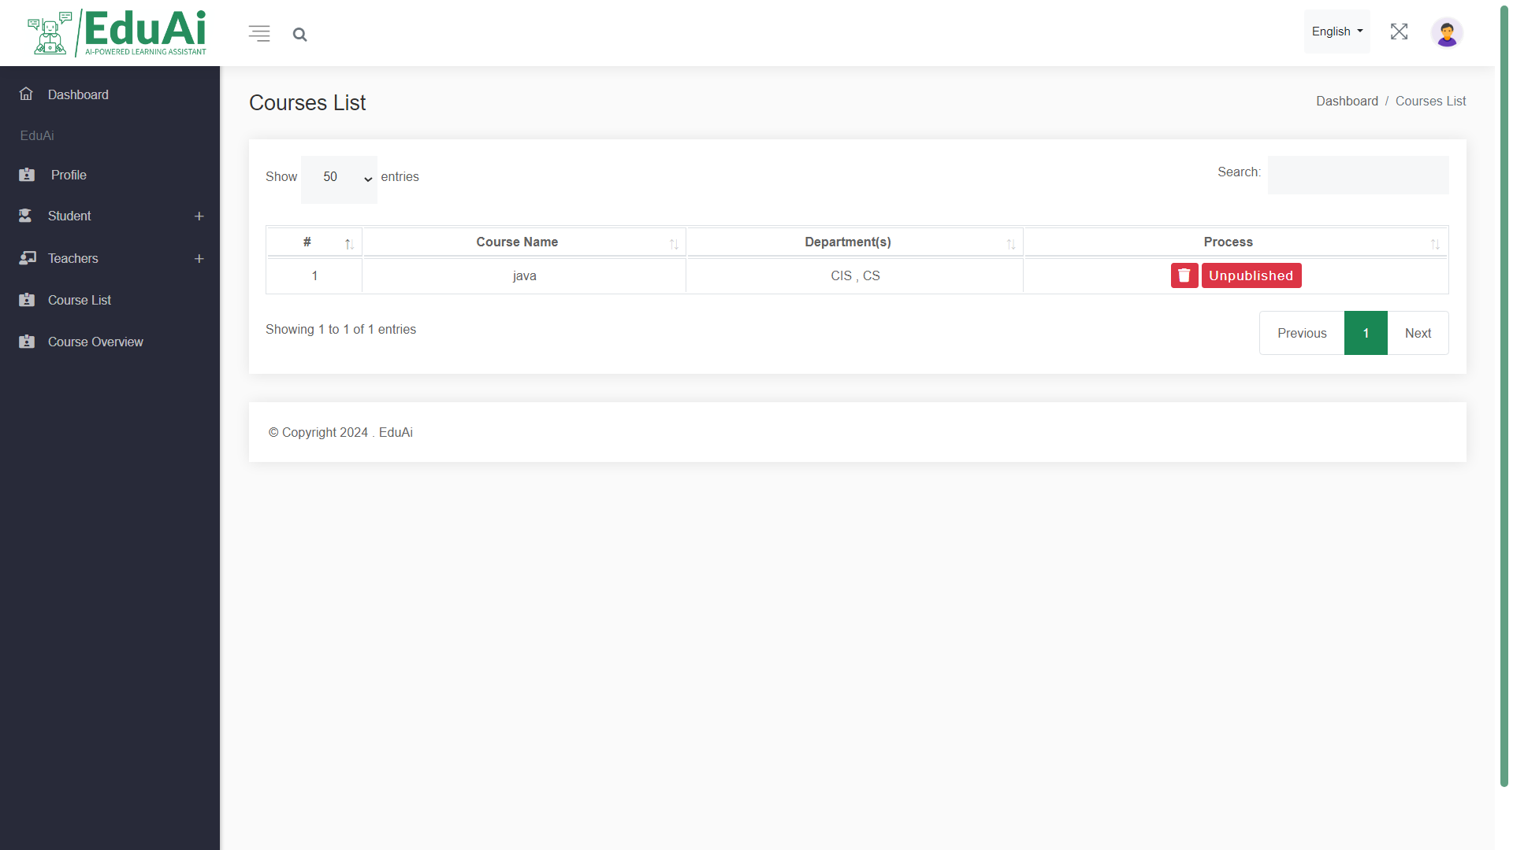

Figure 150: Admin GUI 5

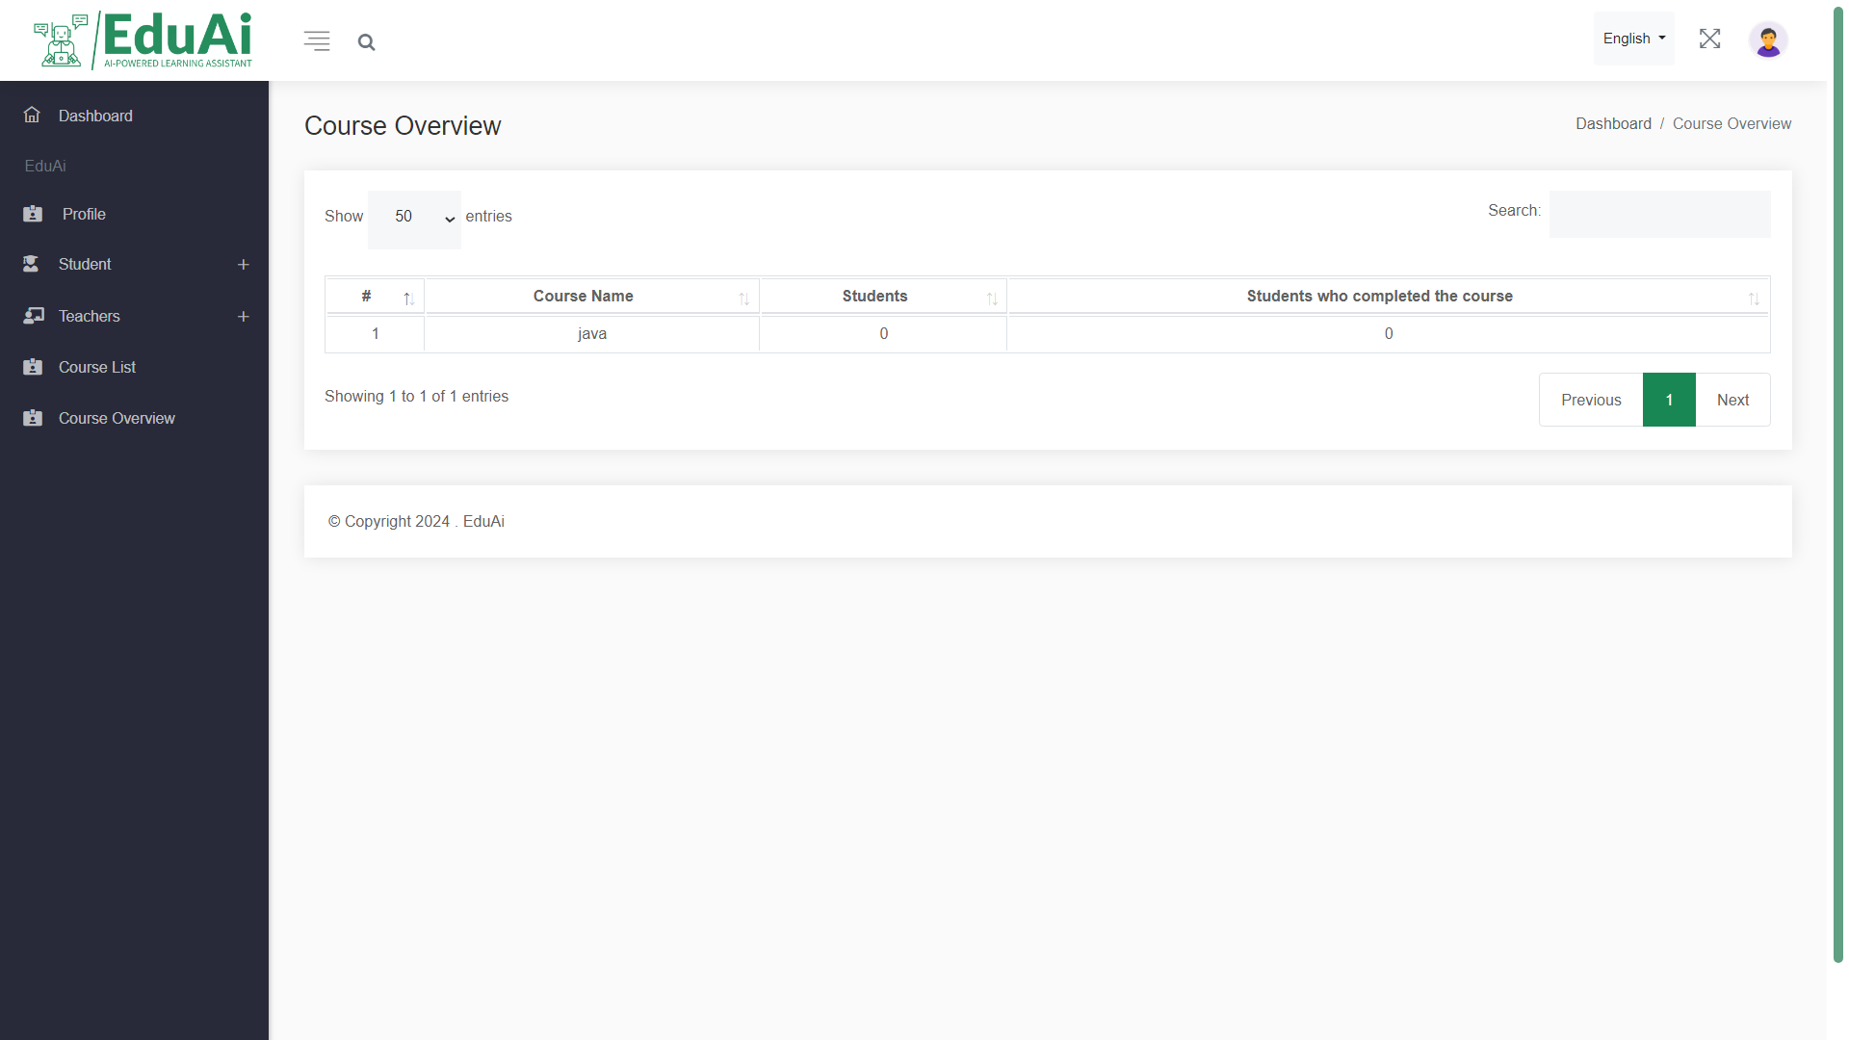

Figure 151: Admin GUI 6

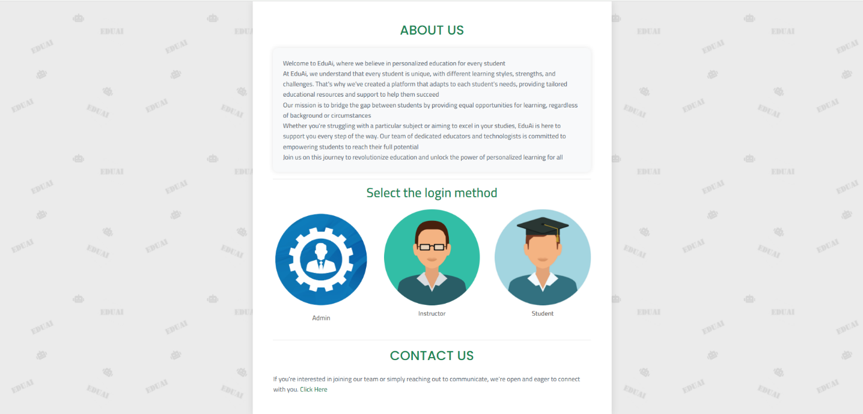

Figure 152: Admin GUI 7

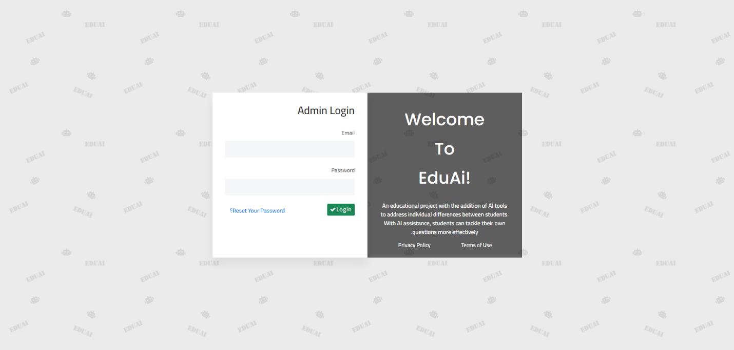

Figure 153: Admin GUI 8

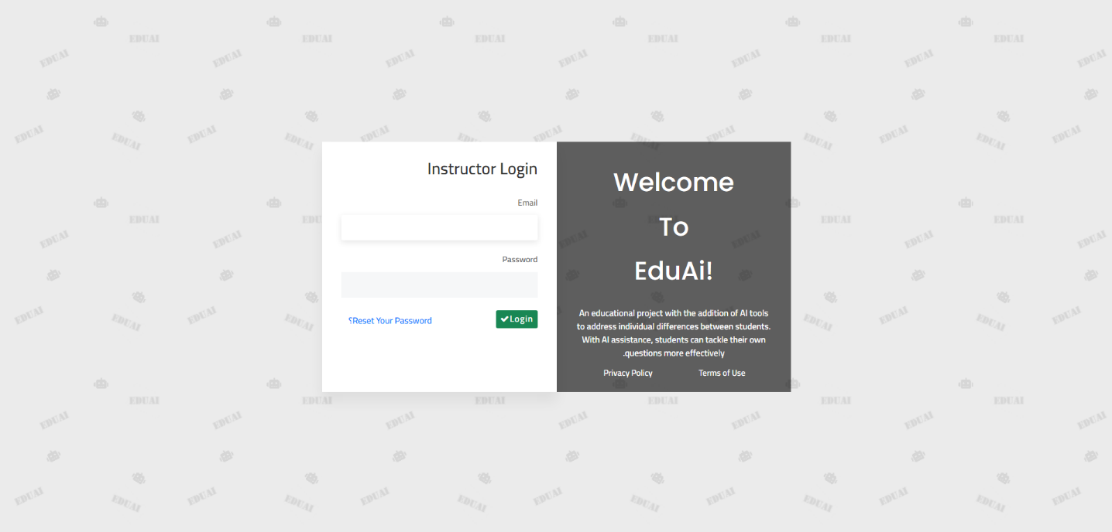

Figure 154: Admin GUI 9

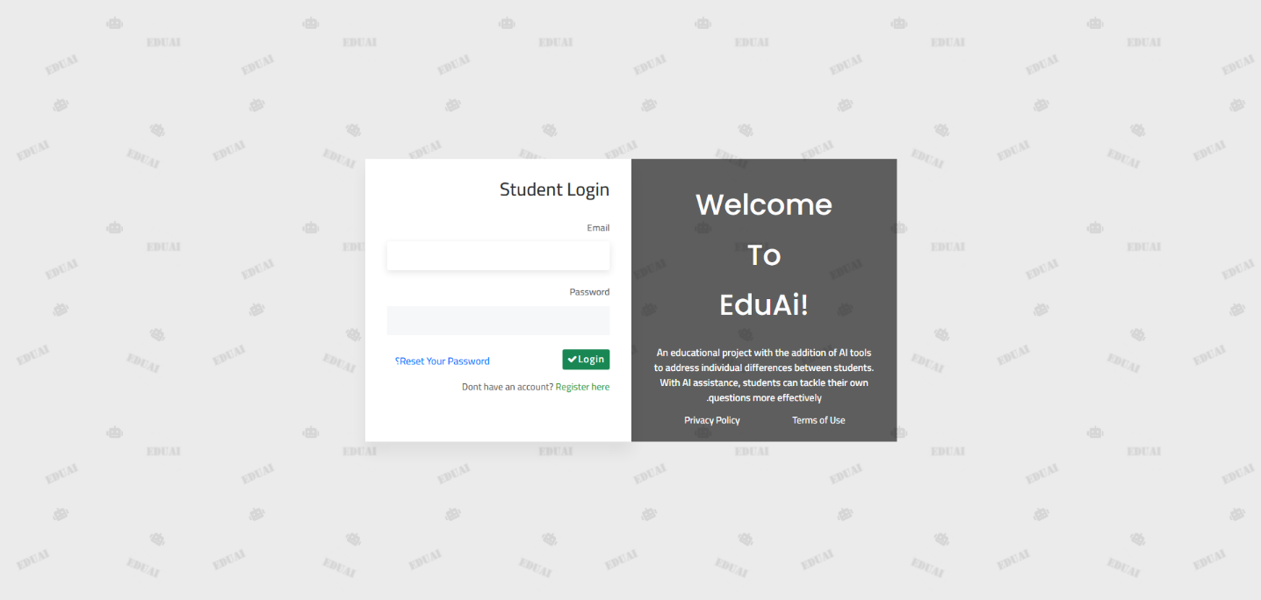

Figure 155: Admin GUI 10

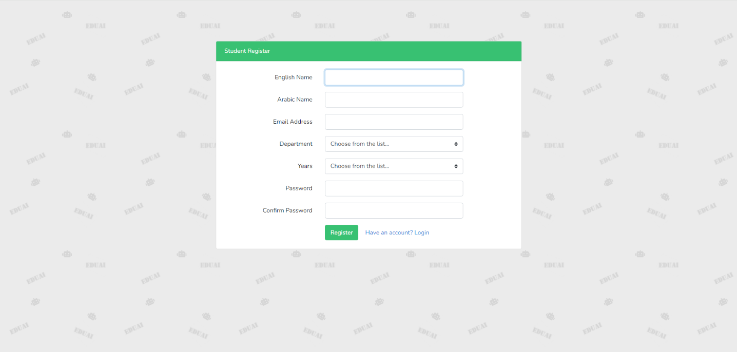

Figure 156: Admin GUI 11

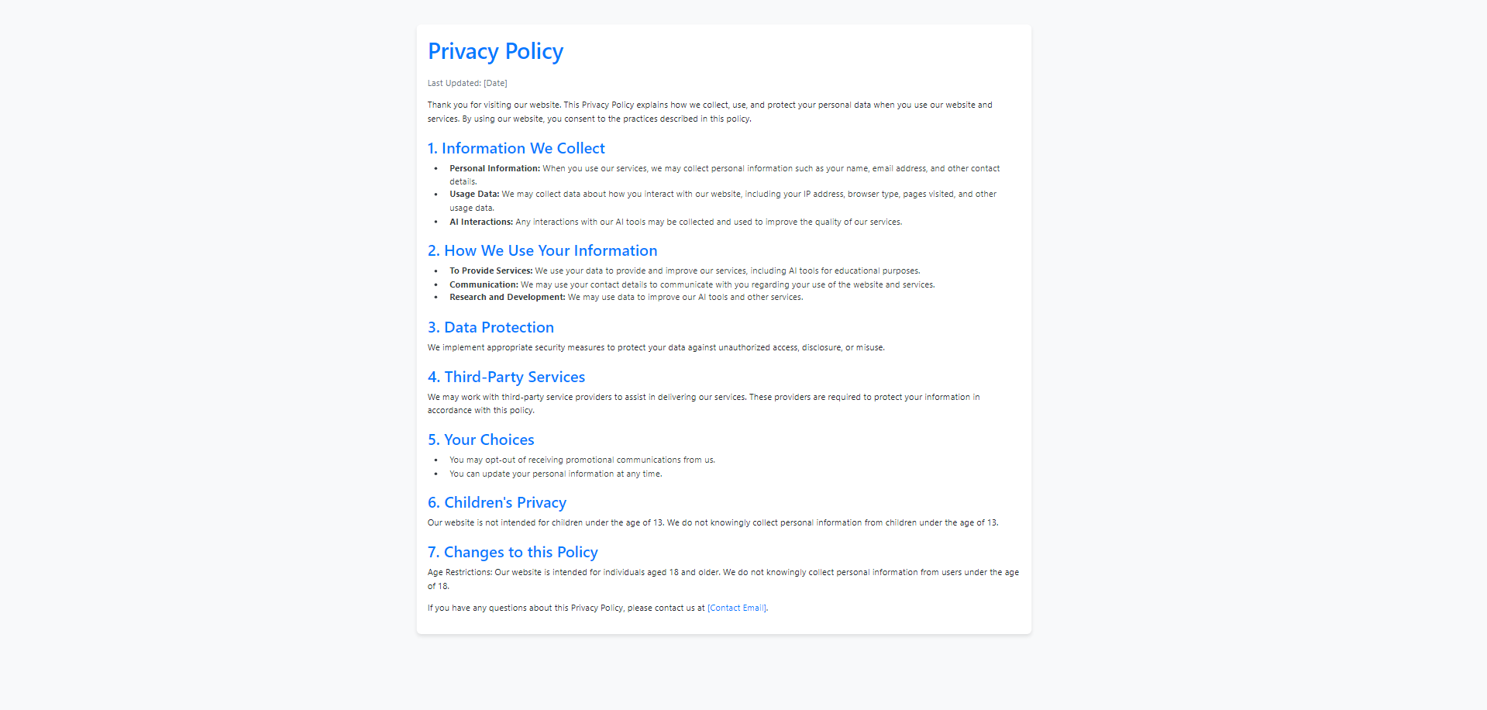

Figure 157: Admin GUI 12

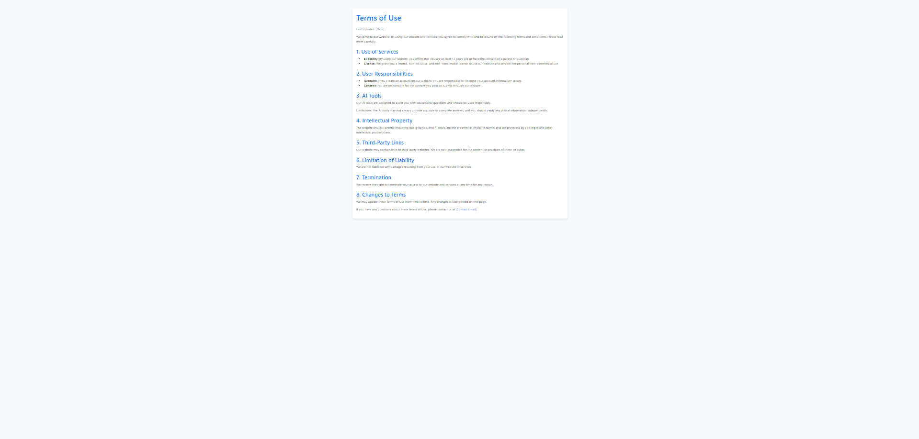

Figure 158: Admin GUI 13

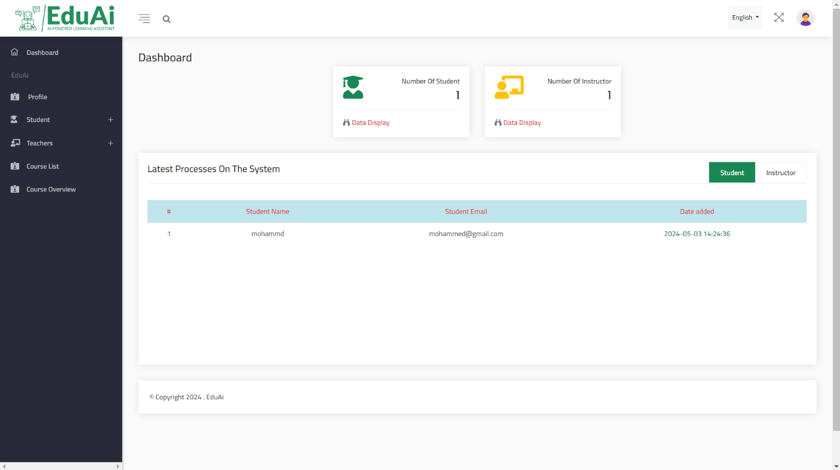

Figure 159: Admin GUI 14

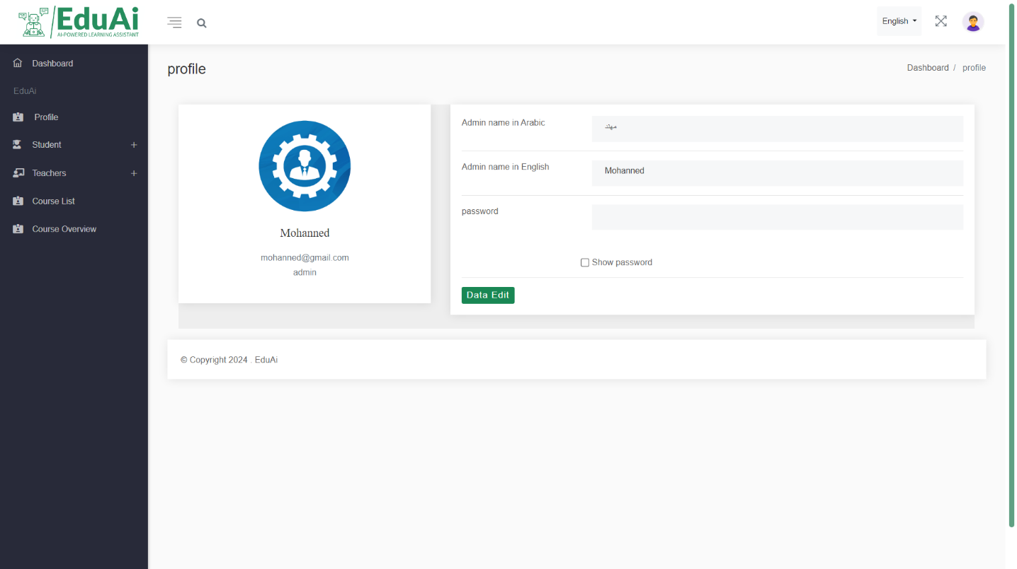

Figure 160: Admin GUI 15

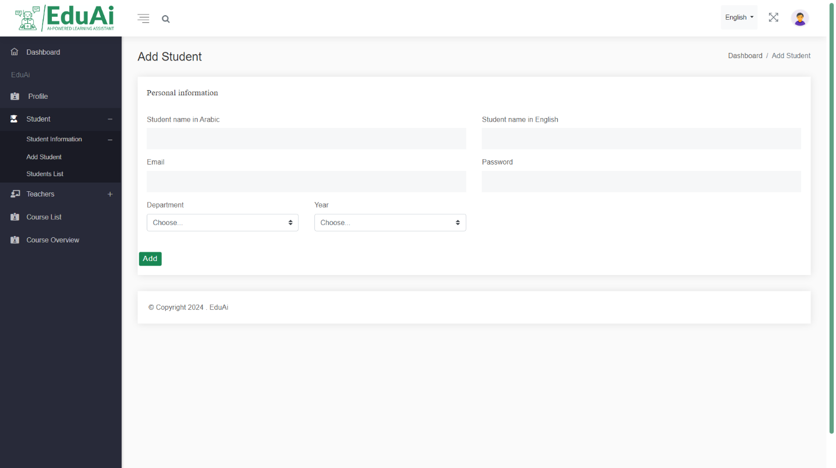

Figure 161: Admin GUI 16

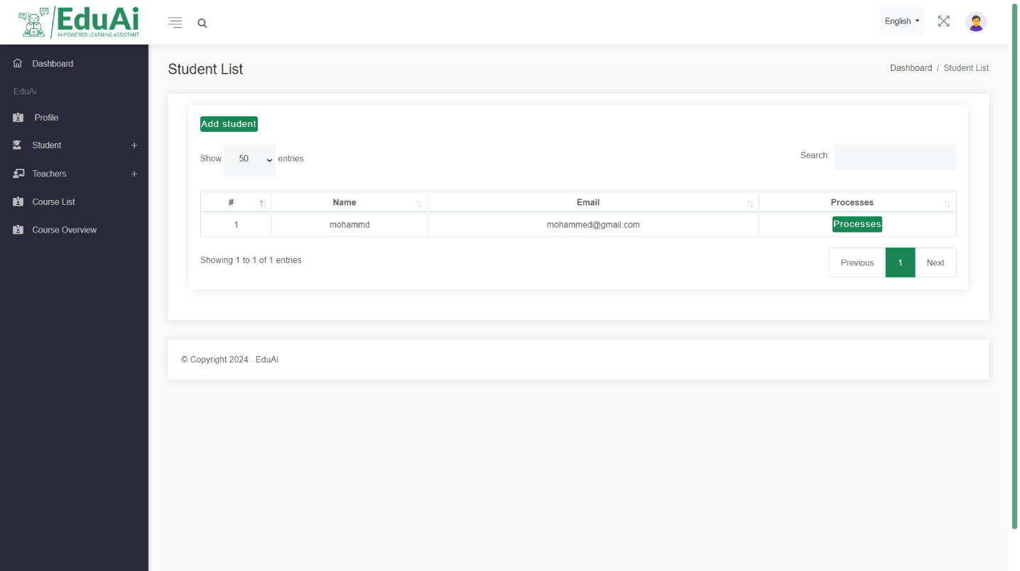

Figure 162: Admin GUI 17

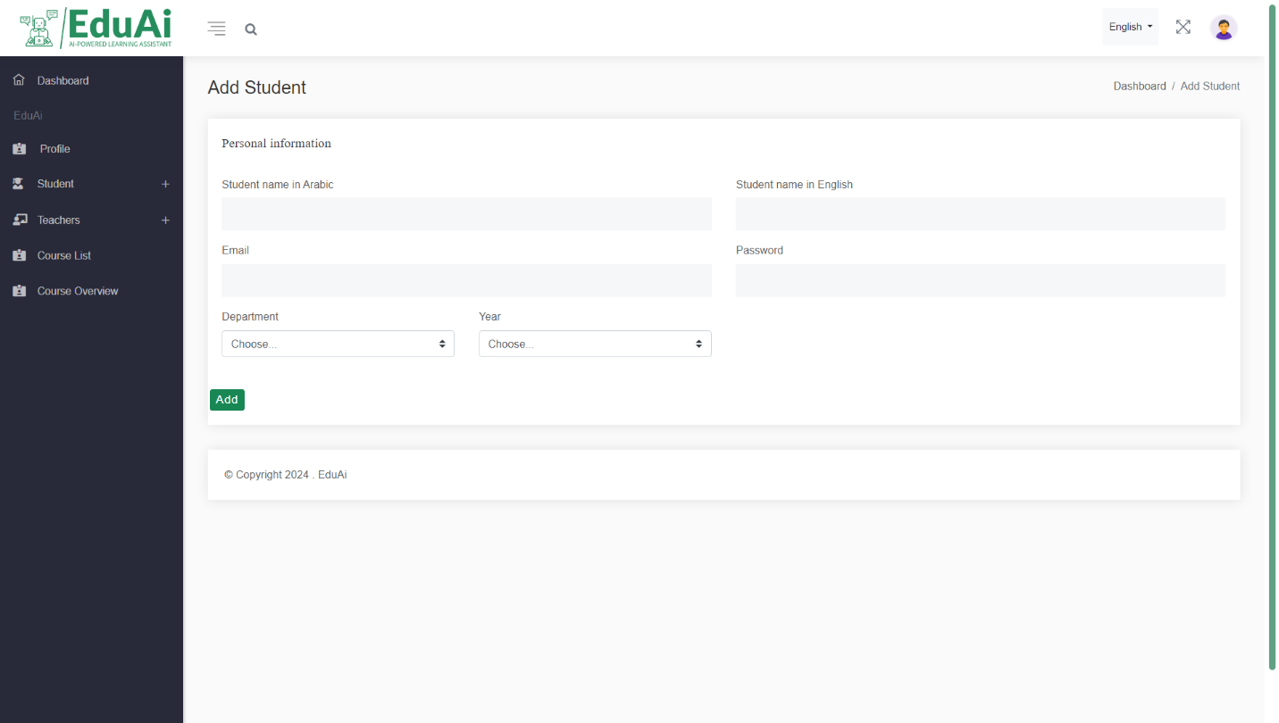

Figure 163: Admin GUI 18

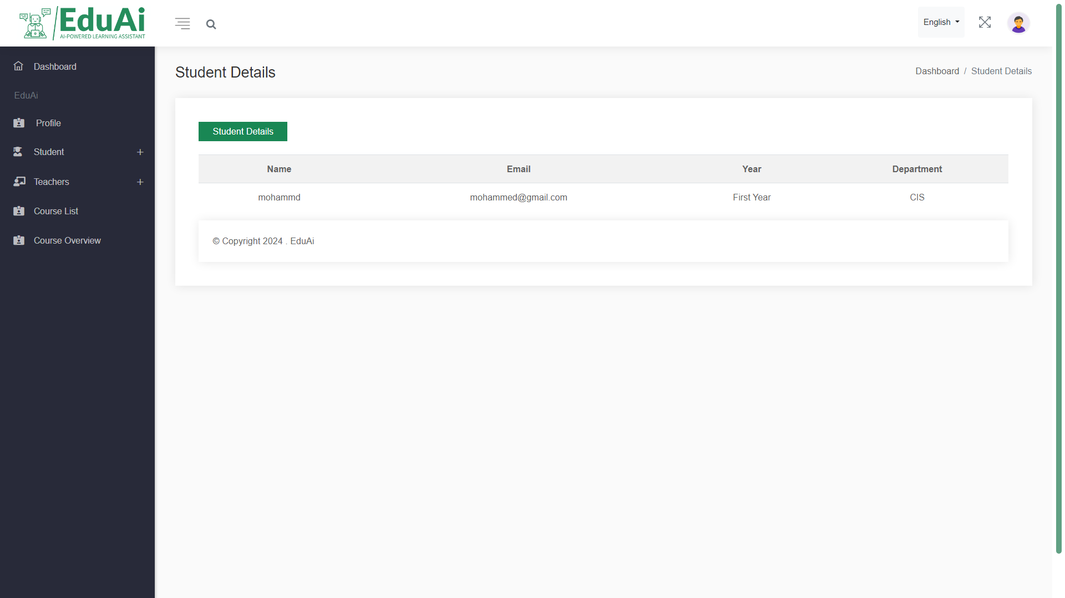

Figure 164: Admin GUI 19

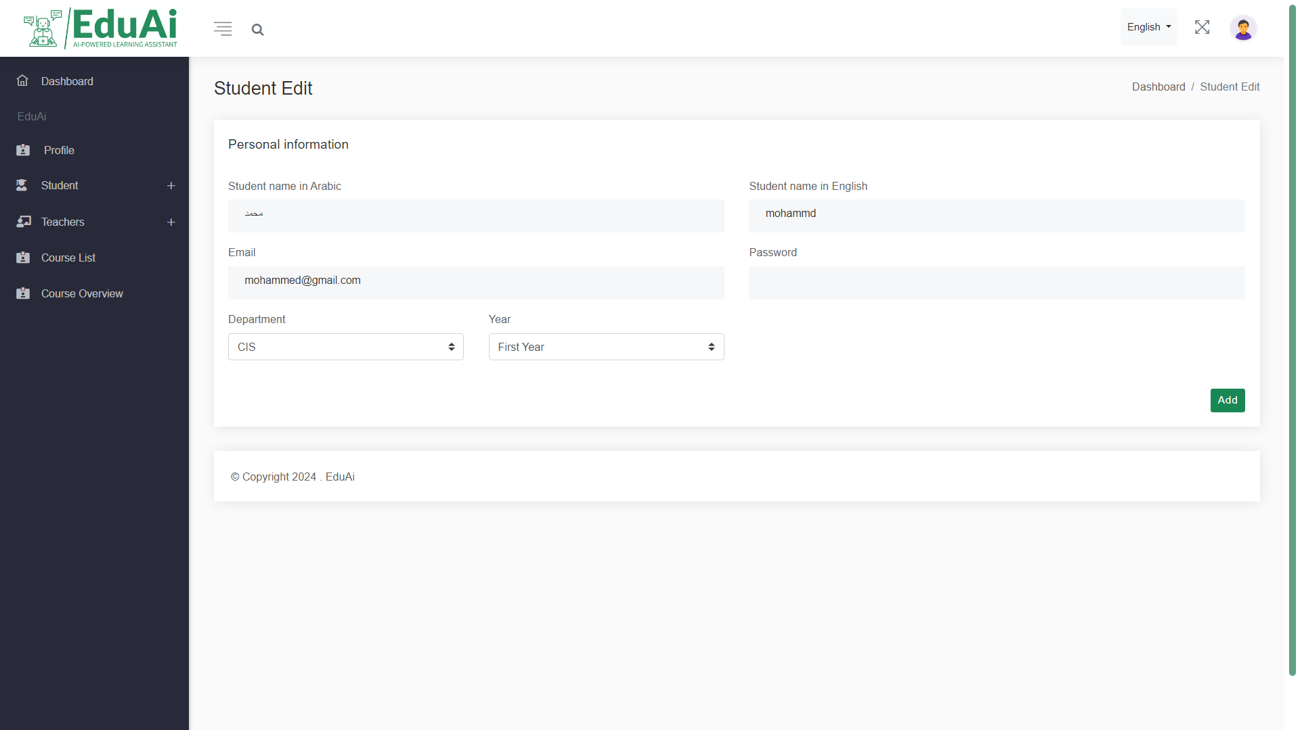

Figure 165: Admin GUI 20

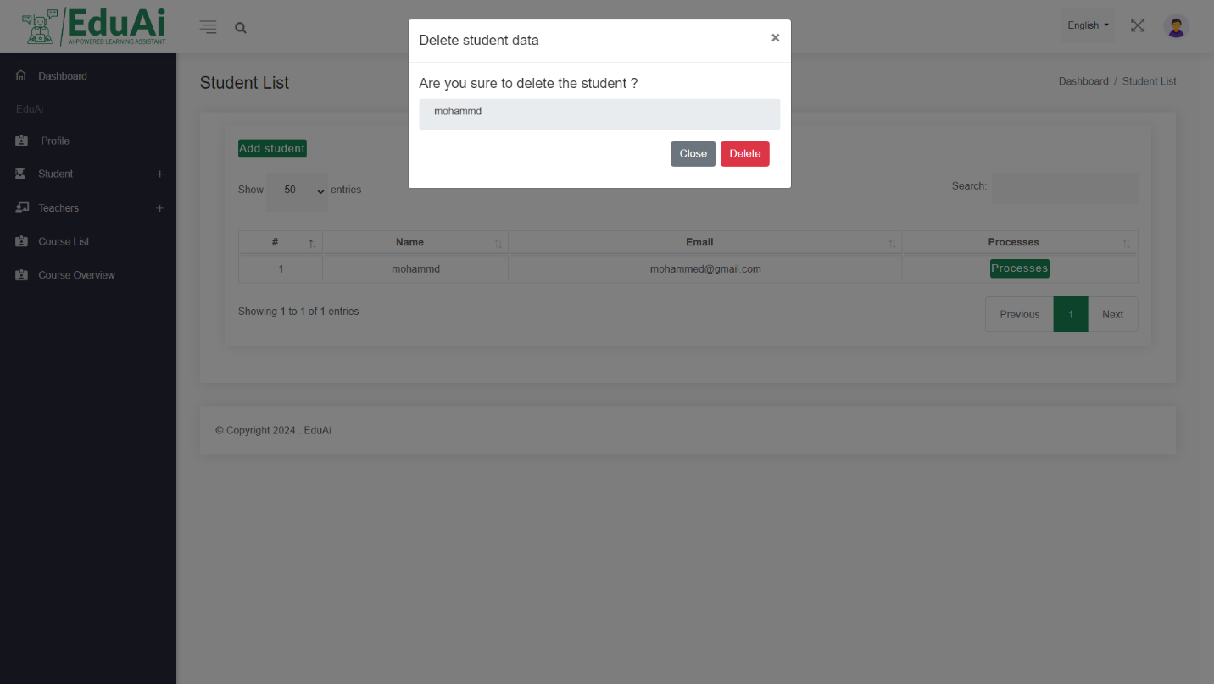

Figure 166: Admin GUI 21

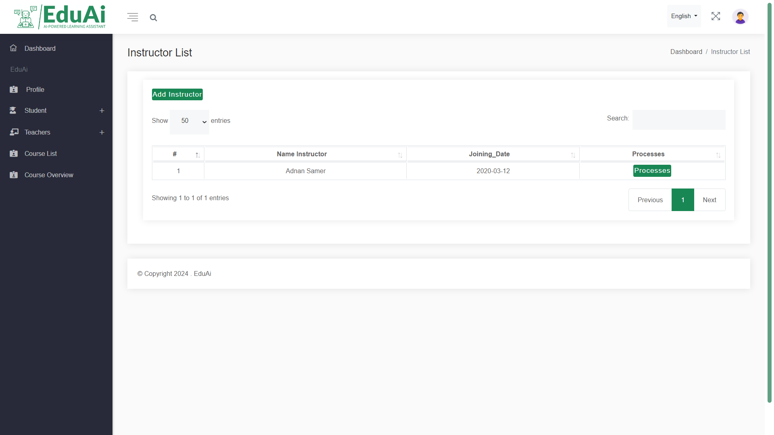

Figure 167: Admin GUI 22

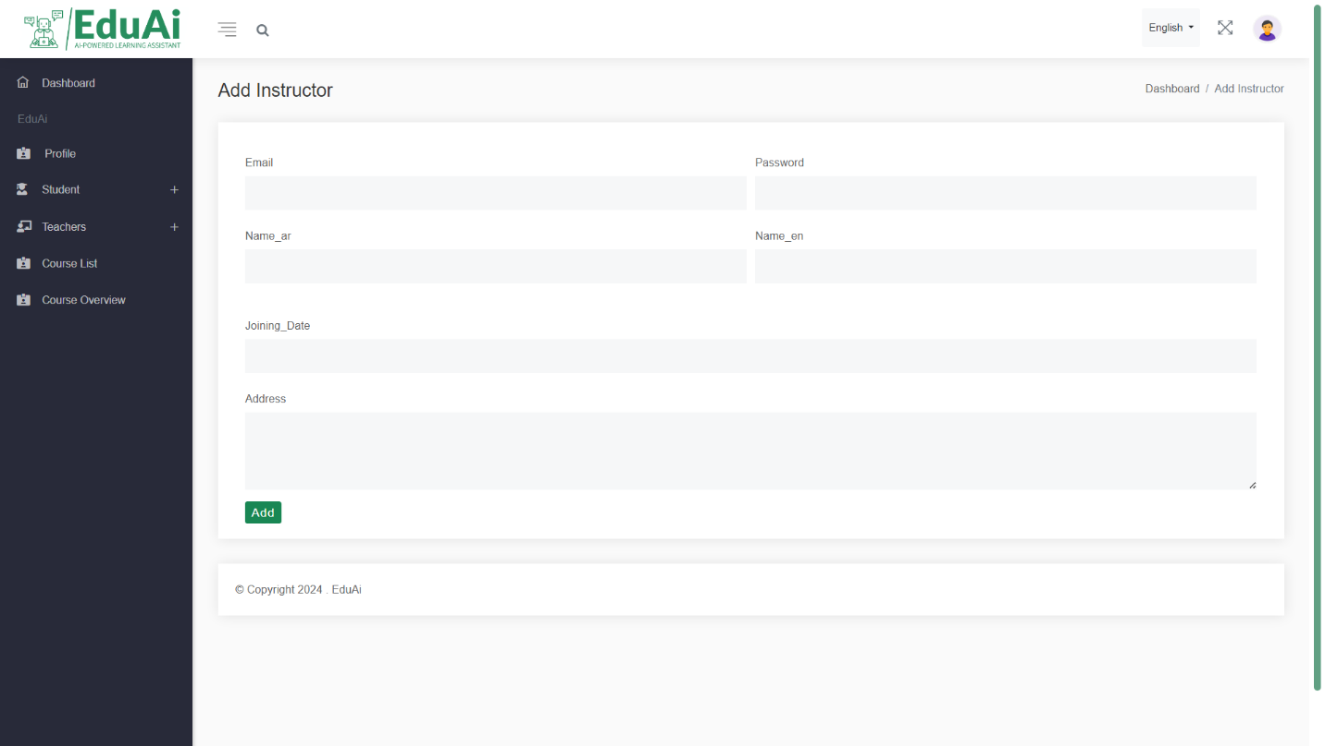

Figure 168: Admin GUI 23

# **Chapter six: Testing and installation**

## **6.1 Testing**

## **6.1.1 Heuristic Evaluation**

## 

**H1. Visibility of System Status**

The system should always keep the user informed about what is going on, through appropriate feedback within a reasonable time.

Table 8: Visibility of System Status

|  |  |  |
| --- | --- | --- |
| # | Review Checklist | 0 1 2 3 4 |
| 1.1 | Does every display begin with a title or header that describes screen contents? | ( X ) ( ) ( ) ( ) ( ) |
| 1.2 | Do menu instructions, prompts, and error messages appear in the same place(s) on each menu? | ( ) ( ) ( ) ( ) ( X ) |
| 1.3 | Is there some form of system feedback for every operator action? | ( ) ( X ) ( ) ( ) ( ) |
| 1.4 | Are response times appropriate to the user's cognitive processing? | ( ) ( ) ( X ) ( ) ( ) |
| 1.5 | Is there visual feedback in menus or dialog boxes about which choices are selectable? | ( X ) ( ) ( ) ( ) ( ) |

**H2. Match Between System and the Real World**

The system should speak the user’s language, with words, phrases, and concepts familiar to the user, rather than system-oriented terms. Follow real-world conventions, making information appear in a natural and logical order.

Table 9: Match Between System and the Real World

|  |  |  |
| --- | --- | --- |
| # | Review Checklist | 0 1 2 3 4 |
| 2.1 | Are icons concrete and familiar? | ( X ) ( ) ( ) ( ) ( ) |
| 2.2 | Are menu choices ordered in the most logical way, given the user, the item names, and the task variables? | ( ) ( X ) ( ) ( ) ( ) |
| 2.3 | Do related and interdependent fields appear on the same screen? | ( ) ( X ) ( ) ( ) ( ) |
| 2.4 | When prompts imply a necessary action, are the words in the message consistent with that action? | ( ) ( ) ( X ) ( ) ( ) |
| 2.5 | On data entry screens, are tasks described in terminology familiar to users? | ( X ) ( ) ( ) ( ) ( ) |

**H3. User Control and Freedom**

Users should be free to select and sequence tasks (when appropriate), rather than having the system do this for them. Users often choose system functions by mistake and will need a clearly marked “emergency exit” to leave the unwanted state without having to go through an extended dialogue. Users should make their own decisions (with clear information) regarding the costs of exiting current work. The system should support undo and redo.

Table 10: User Control and Freedom

|  |  |  |
| --- | --- | --- |
| # | Review Checklist | 0 1 2 3 4 |
| 3.1 | When a user's task is complete, does the system wait for a signal from the user before processing? | ( ) ( X ) ( ) ( ) ( ) |
| 3.2 | Are users prompted to confirm commands that have drastic, destructive consequences? | ( ) ( ) ( X ) ( ) ( ) |
| 3.3 | Are character edits allowed in data entry fields? | ( ) ( X ) ( ) ( ) ( ) |
| 3.4 | If menu lists are long (more than seven items), can users select an item either by moving the cursor or by typing a mnemonic code? | ( X ) ( ) ( ) ( ) ( ) |
| 3.5 | If the system uses a pointing device, do users have the option of either clicking on menu items or using a keyboard shortcut? | ( ) ( ) ( X ) ( ) ( ) |

**H4. Consistency and Standards**

Table 11: Consistency and Standards

|  |  |  |
| --- | --- | --- |
| # | Review Checklist | 0 1 2 3 4 |
| 4.1 | Has a heavy use of all uppercase letters on a screen been avoided? | ( ) ( ) ( X ) ( ) ( ) |
| 4.2 | Are icons labeled? | ( X ) ( ) ( ) ( ) ( ) |
| 4.3 | Are there no more than twelve to twenty icon types? | ( X ) ( ) ( ) ( ) ( ) |
| 4.4 | Does each window have a title? | ( ) ( X ) ( ) ( ) ( ) |
| 4.5 | Are vertical and horizontal scrolling possible in each window? | ( ) ( ) ( X ) ( ) ( ) |
| 4.6 | Are menu choice lists presented vertically? | ( X ) ( ) ( ) ( ) ( ) |
| 4.7 | Are menu titles either centered or left-justified? | ( ) ( X ) ( ) ( ) ( ) |
| 4.8 | Are menu items left-justified, with the item number or mnemonic preceding the name? | ( ) ( ) ( X ) ( ) ( ) |
| 4.9 | Do embedded field-level prompts appear to the right of the field label? | ( X ) ( ) ( ) ( ) ( ) |
| 4.10 | Are attention-getting techniques used with care? | ( ) ( ) ( X ) ( ) ( ) |

**H5. Help Users Recognize, Diagnose, and Recover from Errors**

Error messages should be expressed in plain language (NO CODES).

Table 12: Help Users Recognize, Diagnose, and Recover from Errors

|  |  |  |
| --- | --- | --- |
| # | Review Checklist | 0 1 2 3 4 |
| 5.1 | Is sound used to signal an error? | ( ) ( X ) ( ) ( ) ( ) |
| 5.2 | Are error messages worded so that the system, not the user, takes the blame? | ( ) ( ) ( ) ( X ) ( ) |
| 5.3 | Do error messages suggest the cause of the problem? | ( ) ( ) ( ) ( ) ( X ) |
| 5.4 | Do error messages indicate what action the user needs to take to correct the error? | ( ) ( ) ( ) ( X ) ( ) |
| 5.5 | If the system supports both novice and expert users, are multiple levels of error-message detail available? | ( ) ( ) ( ) ( ) ( X ) |
| 5.6 | If an error is detected in a data entry field, does the system place the cursor in that field or highlight the error? | ( ) ( ) ( ) ( X ) ( ) |
| 5.7 | Do error messages inform the user of the error's severity? | ( ) ( ) ( X ) ( ) ( ) |
|  |  |  |

**H6. Error Prevention**

Even better than good error messages is a careful design which prevents a problem from occurring in the first place.

Table 13: Error Prevention

|  |  |  |
| --- | --- | --- |
| # | Review Checklist | 0 1 2 3 4 |
| 6.1 | Are menu choices logical, distinctive, and mutually exclusive? | ( ) ( X ) ( ) ( ) ( ) |
| 6.2 | Are data inputs case-blind whenever possible? | ( ) ( X ) ( ) ( ) ( ) |
| 6.3 | Does the system prevent users from making errors whenever possible? | ( ) ( ) ( X ) ( ) ( ) |
| 6.4 | Does the system warn users if they are about to make a potentially serious error? | ( ) ( ) ( ) ( ) ( X ) |
| 6.5 | Do data entry screens and dialog boxes indicate the number of character spaces available in a field? | ( ) ( X ) ( ) ( ) ( ) |
| 6.6 | Do fields in data entry screens and dialog boxes contain default values when appropriate? | ( ) ( X ) ( ) ( ) ( ) |

**H7. Recognition Rather Than Recall**

Make objects, actions, and options visible. The user should not have to remember information from one part of the dialogue to another. Instructions for use of the system should be visible or easily retrievable whenever appropriate.

Table 14: Recognition Rather Than Recall

|  |  |  |
| --- | --- | --- |
| # | Review Checklist | 0 1 2 3 4 |
| 7.1 | For question and answer interfaces, are visual cues and white space used to distinguish questions, prompts, instructions, and user input? | ( ) ( X ) ( ) ( ) ( ) |
| 7.2 | Are inactive menu items grayed out or omitted? | ( X ) ( ) ( ) ( ) ( ) |
| 7.3 | Do data entry screens and dialog boxes indicate when fields are optional? | ( ) ( X ) ( ) ( ) ( ) |
| 7.4 | Are prompts, cues, and messages placed where the eye is likely to be looking on the screen? | ( ) ( ) ( X ) ( ) ( ) |
| 7.5 | Are field labels close to fields, but separated by at least one space? | ( X ) ( ) ( ) ( ) () |
| 7.6 | Have items been grouped into logical zones, and have headings been used to distinguish between zones? | ( ) ( X ) ( ) ( ) ( ) |
| 7.7 | Are borders used to identify meaningful groups? | ( X ) ( ) ( ) ( ) ( ) |
| 7.8 | Is color coding consistent throughout the system? | ( ) ( X ) ( ) ( ) ( ) |

**H8. Flexibility and Minimalist Design**

Accelerators-unseen by the novice user-may often speed up the interaction for the expert user such that the system can cater to both inexperienced and experienced users. Allow users to tailor frequent actions. Provide alternative means of access and operation for users who differ from the “average” user (e.g., physical or cognitive ability, culture, language, etc.)

Table 15: Flexibility and Minimalist Design

|  |  |  |
| --- | --- | --- |
| # | Review Checklist | 0 1 2 3 4 |
| 8.1 | If menu lists are short (seven items or fewer), can users select an item by moving the cursor? | ( ) ( X ) ( ) ( ) ( ) |
| 8.2 | If the system uses a pointing device, do users have the option of either clicking on fields or using a keyboard shortcut? | ( ) ( ) ( X ) ( ) ( ) |
| 8.3 | On data entry screens, do users have the option of either clicking directly on a field or using a keyboard shortcut? | ( ) ( ) ( X ) ( ) ( ) |
| 8.4 | On menus, do users have the option of either clicking directly on a menu item or using a keyboard shortcut? | ( ) ( ) ( X ) ( ) ( ) |
| 8.5 | In dialog boxes, do users have the option of either clicking directly on a dialog box option or using a keyboard shortcut? | ( ) ( ) ( ) ( X ) ( ) |

**H9. Aesthetic and Minimalist Design**

Dialogues should not contain information which is irrelevant or rarely needed. Every extra unit of information in a dialogue competes with the relevant units of information and diminishes their relative visibility.

Table 16: Aesthetic and Minimalist Design

|  |  |  |
| --- | --- | --- |
| # | Review Checklist | 0 1 2 3 4 |
| 9.1 | Are all icons in a set visually and conceptually distinct? | ( X ) ( ) ( ) ( ) ( ) |
| 9.2 | Does each icon stand out from its background? | ( ) ( X ) ( ) ( ) ( ) |
| 9.3 | Does each data entry screen have a short, simple, clear, distinctive title? | ( X ) ( ) ( ) ( ) ( ) |
| 9.4 | Are field labels brief, familiar, and descriptive? | ( X ) ( ) ( ) ( ) ( ) |
| 9.5 | Are there pop-up or pull-down menus within data entry fields that have many, but well-defined, entry options? | ( ) ( ) ( X ) ( ) ( ) |

**H10. Help and Documentation**

Even though it is better if the system can be used without documentation, it may be necessary to provide help and documentation. Any such information should be easy to search, focused on the user’s task, list concrete steps to be carried out, and not be too large.

Table 17: Help and Documentation

|  |  |  |
| --- | --- | --- |
| # | Review Checklist | 0 1 2 3 4 |
| 10.1 | Are on-line instructions visually distinct? | ( ) ( X ) ( ) ( ) ( ) |
| 10.2 | If menu choices are ambiguous, does the system provide additional explanatory information when an item is selected? | ( ) ( ) ( ) ( X ) ( ) |
| 10.3 | Is the help function visible; for example, a key labeled HELP or a special menu? | ( ) ( ) ( X ) ( ) ( ) |
| 10.4 | Navigation: Is information easy to find? | ( X ) ( ) ( ) ( ) ( ) |
| 10.5 | Presentation: Is the visual layout well designed? | ( ) ( X ) ( ) ( ) ( ) |
| 10.6 | Conversation: Is the information accurate, complete, and understandable? | ( ) ( X ) ( ) ( ) ( ) |
| 10.7 | Is the information relevant? | ( X ) ( ) ( ) ( ) ( ) |
| 10.8 | Can users easily switch between help and their work? | ( ) ( ) ( X ) ( ) ( ) |
| 10.9 | Is it easy to access and return from the help system? | ( ) ( X ) ( ) ( ) |
| 10.10 | Can users resume work where they left off after accessing help? | ( ) ( X ) ( ) ( ) |

## **6.1.2 Cooperative Evaluation**

Table 18: Participants Details

|  |  |  |  |  |  |  |  |
| --- | --- | --- | --- | --- | --- | --- | --- |
| No. | Criteria | Participant 1 | Participant 2 | Participant 3 | Participant 4 | Participant 5 | Participant 6 |
| 1. | **Gender** | Male | Female | Male | Male | Male | Male |
| 2. | **Age** | 30 | 28 | 20 | 21 | 25 | 29 |
| 3. | **Educational Level** | Bachelor's | Bachelor's | Bachelor's | Bachelor's | Bachelor's | Bachelor's |
| 4. | **Programme Taken** | Cis | Cs | Cs | Cs | Cis | Cis |
| 5. | **Institution** | University of Jordan | University of Jordan | University of Jordan | University of Jordan | University of Jordan | University of Jordan |

* 1. **Pre-Evaluation Procedures**

Participants were contacted through telephone conversations asking them about the possibility to participate in the co-operative evaluation. A brief introduction to the A system of continuous assistance and evaluation of academic processes system was given to the participants 10 minutes before they started the evaluation, and participants were asked to read that introductory document. The document also has a list of tasks, which will be performed by the participants throughout the co-operative evaluation. Users were told that they need to think aloud when facing any problem in the system. They were also told that, each task they perform is monitored and timed.

* 1. **Evaluation Procedures**

During the evaluation session, a moderator accompanied the users to do the co-operative evaluation. A comment from shown in Appendix A was used by the moderator to write down the comments of each user for each task. Users were helped when they really faced serious problems performing the tasks. The following tables show the comments from prepared by the moderator for each participant.

Table 19: Cooperative Evaluation 1

|  |  |  |  |  |  |
| --- | --- | --- | --- | --- | --- |
| Task No. | Test | Time Taken to Complete the Task | | | Comments |
| A. | **Login** | | | | |
| 1. | Log in to the A system of continuous assistance anevaluation of academic processes using the following information:  Username: Mohannad  Password:123456 | 1 minutes and 10 seconds. | | | * I can logged in fast and easily |
| B. | Register | | | | |
| 1. | Register to the A system of continuous assistance anevaluation of academic processes using the following information:  Username: Mohannad  Password:123456 | 1 minutes and 10 seconds. | | | * I need more information to Register |
| C. | **Logout** | | | | |
| 1. | Logout from A system of continuous assistance and evaluation of academic processes | 50 second | | | * I can logged out fast and easily |
| D. | Display department | | | | |
| 1. | the user can display department names and information about each department. | 1 minutes and 30 seconds. | | | * How is the information displayed? |
| E. | Display department details | | | | |
| 1. | the user can display subjects for each department and plan for each department. | 1 minutes | | | * Is the information presented clearly and organized? |
| F. | Contact us | | | | |
| 1. | contains our email to contact with us | 2 minutes and 30 seconds. | | | * **Are there any concerns about privacy or security?** |
| G. | Search | | | | |
| 1. | the user can search for a specific major to apply an action on it. | | 2 minutes and 40 seconds. | * Is the search scope clearly defined? | |

Table 20: Cooperative Evaluation 2

|  |  |  |  |  |  |
| --- | --- | --- | --- | --- | --- |
| Task No. | Test | Time Taken to Complete the Task | | | Comments |
| A. | **Login** | | | | |
| 1. | Log in to the A system of continuous assistance anevaluation of academic processes using the following information:  Username: Mohannad  Password:123456 | 2 minutes | | | * I can logged in fast and easily |
| B. | Register | | | | |
| 1. | Register to the A system of continuous assistance anevaluation of academic processes using the following information:  Username: Mohannad  Password:123456 | 50 seconds. | | | * I need more information to Register |
| C. | **Logout** | | | | |
| 1. | Logout from A system of continuous assistance and evaluation of academic processes | 2 minutes and 22 seconds. | | | * I can logged out fast and easily |
| D. | Display department | | | | |
| 1. | the user can display department names and information about each department. | 2 minutes | | | * How is the information displayed? |
| E. | Display department details | | | | |
| 1. | the user can display subjects for each department and plan for each department. | 1 minutes | | | * Is the information presented clearly and organized? |
| F. | Contact us | | | | |
| 1. | contains our email to contact with us | 2 minutes and 50 seconds. | | | * **Are there any concerns about privacy or security?** |
| G. | Search | | | | |
| 1. | the user can search for a specific major to apply an action on it. | | 2 minutes and 40 seconds. | * Is the search scope clearly defined? | |

Table 21: Cooperative Evaluation 3

|  |  |  |  |  |  |
| --- | --- | --- | --- | --- | --- |
| Task No. | Test | Time Taken to Complete the Task | | | Comments |
| A. | **Login** | | | | |
| 1. | Log in to the A system of continuous assistance anevaluation of academic processes using the following information:  Username: Mohannad  Password:123456 | 1 minutes and 20 seconds. | | | * I can logged in fast and easily |
| B. | Register | | | | |
| 1. | Register to the A system of continuous assistance anevaluation of academic processes using the following information:  Username: Mohannad  Password:123456 | 2 minutes and 10 seconds.. | | | * I need more information to Register |
| C. | **Logout** | | | | |
| 1. | Logout from A system of continuous assistance and evaluation of academic processes | 2 minutes and 3 seconds. | | | * I can logged out fast and easily |
| D. | Display department | | | | |
| 1. | the user can display department names and information about each department. | 3 minutes | | | * How is the information displayed? |
| E. | Display department details | | | | |
| 1. | the user can display subjects for each department and plan for each department. | 2 minutes | | | * Is the information presented clearly and organized? |
| F. | Contact us | | | | |
| 1. | contains our email to contact with us | 2 minutes and 45 seconds. | | | * **Are there any concerns about privacy or security?** |
| G. | Search | | | | |
| 1. | the user can search for a specific major to apply an action on it. | | 2 minutes and 50 seconds. | * Is the search scope clearly defined? | |

Table 22: Cooperative Evaluation 4

|  |  |  |  |  |  |
| --- | --- | --- | --- | --- | --- |
| Task No. | Test | Time Taken to Complete the Task | | | Comments |
| A. | **Login** | | | | |
| 1. | Log in to the A system of continuous assistance anevaluation of academic processes using the following information:  Username: Mohannad  Password:123456 | 1 minutes and 15 seconds. | | | * I can logged in fast and easily |
| B. | Register | | | | |
| 1. | Register to the A system of continuous assistance anevaluation of academic processes using the following information:  Username: Mohannad  Password:123456 | 55 seconds.. | | | * I need more information to Register |
| C. | **Logout** | | | | |
| 1. | Logout from A system of continuous assistance and evaluation of academic processes | 1 minutes | | | * I can logged out fast and easily |
| D. | Display department | | | | |
| 1. | the user can display department names and information about each department. | 2 minutes and 20 seconds. | | | * How is the information displayed? |
| E. | Display department details | | | | |
| 1. | the user can display subjects for each department and plan for each department. | 3 minutes | | | * Is the information presented clearly and organized? |
| F. | Contact us | | | | |
| 1. | contains our email to contact with us | 2 minutes and 30 seconds. | | | * **Are there any concerns about privacy or security?** |
| G. | Search | | | | |
| 1. | the user can search for a specific major to apply an action on it. | | 2 minutes and 20 seconds. | * Is the search scope clearly defined? | |

Table 23: Cooperative Evaluation 5

|  |  |  |  |  |  |
| --- | --- | --- | --- | --- | --- |
| Task No. | Test | Time Taken to Complete the Task | | | Comments |
| A. | **Login** | | | | |
| 1. | Log in to the A system of continuous assistance anevaluation of academic processes using the following information:  Username: Mohannad  Password:123456 | 50 seconds.. | | | * I can logged in fast and easily |
| B. | Register | | | | |
| 1. | Register to the A system of continuous assistance anevaluation of academic processes using the following information:  Username: Mohannad  Password:123456 | 2 minutes | | | * I need more information to Register |
| C. | **Logout** | | | | |
| 1. | Logout from A system of continuous assistance and evaluation of academic processes | 2 minutes | | | * I can logged out fast and easily |
| D. | Display department | | | | |
| 1. | the user can display department names and information about each department. | 2 minutes and 10 seconds. | | | * How is the information displayed? |
| E. | Display department details | | | | |
| 1. | the user can display subjects for each department and plan for each department. | 1 minutes and 30 seconds. | | | * Is the information presented clearly and organized? |
| F. | Contact us | | | | |
| 1. | contains our email to contact with us | 2 minutes and 50 seconds. | | | * **Are there any concerns about privacy or security?** |
| G. | Search | | | | |
| 1. | the user can search for a specific major to apply an action on it. | | 2 minutes and 22 seconds. | * Is the search scope clearly defined? | |

Table 24: Cooperative Evaluation 6

|  |  |  |  |  |  |
| --- | --- | --- | --- | --- | --- |
| Task No. | Test | Time Taken to Complete the Task | | | Comments |
| A. | **Login** | | | | |
| 1. | Log in to the A system of continuous assistance anevaluation of academic processes using the following information:  Username: Mohannad  Password:123456 | 30 seconds | | | * I can logged in fast and easily |
| B. | Register | | | | |
| 1. | Register to the A system of continuous assistance anevaluation of academic processes using the following information:  Username: Mohannad  Password:123456 | 2 minutes and 50 seconds. | | | * I need more information to Register |
| C. | **Logout** | | | | |
| 1. | Logout from A system of continuous assistance and evaluation of academic processes | 1 minutes | | | * I can logged out fast and easily |
| D. | Display department | | | | |
| 1. | the user can display department names and information about each department. | 1 minutes and 45 seconds. | | | * How is the information displayed? |
| E. | Display department details | | | | |
| 1. | the user can display subjects for each department and plan for each department. | 1 minutes and 40 seconds. | | | * Is the information presented clearly and organized? |
| F. | Contact us | | | | |
| 1. | contains our email to contact with us | 3 minutes and 30 seconds. | | | * **Are there any concerns about privacy or security?** |
| G. | Search | | | | |
| 1. | the user can search for a specific major to apply an action on it. | | 2 minutes and 45 seconds. | * Is the search scope clearly defined? | |

Table 25: Task Completion Times in Minutes and Seconds

|  |  |  |  |  |  |  |  |
| --- | --- | --- | --- | --- | --- | --- | --- |
| Task No. | Default | Participant 1 | Participant 2 | Participant 3 | Participant 4 | Participant 5 | Participant 6 |
| A. Login |  | | | | | | |
| 1. | 00:20 | 01:10 | 02:00 | 01:20 | 01:15 | 00:50 | 00:30 |
| B. Register |  | | | | | | |
| 1. | 01:00 | 01:10 | 00:50 | 02:10 | 00:55 | 02:00 | 02:50 |
| C. Logout |  | | | | | | |
| 1. | 00:30 | 00:50 | 02:22 | 02:03 | 01:00 | 02:00 | 01:00 |
| D.Display department |  | | | | | | |
| 1. | 01:20 | 01:30 | 02:00 | 03:00 | 02:20 | 02:10 | 01:45 |
| E. Display department details |  | | | | | | |
| 1. | 00:50 | 01:00 | 01:20 | 02:00 | 03:00 | 01:30 | 01:40 |
| F. Contact us |  | | | | | | |
| 1. | 01:50 | 02:30 | 02:50 | 02:45 | 02:30 | 02:50 | 03:30 |
| G. Search |  | | | | | | |
| 1. | 02.00 | 02.30 | 02.40 | 02.50 | 02.20 | 02.22 | 02.45 |
| Total Completion Time | **07:50** | **10:40** | **14:02** | **16:08** | **13:20** | **13:42** | **14:00** |

* 1. **Post-Evaluation Procedures**

After completing the co-operative evaluation, participants were given a post-test questionnaire to fill in, which is shown in Appendix B. This questionnaire was important to capture their thoughts and feelings and the system of continuous assistance and evaluation of academic processes while they were still fresh. The questionnaire was then followed by a short interview and discussion, which mainly focused on the initial modified design of the the system of continuous assistance and evaluation of academic processes. Table 23 shows the responses of the 6 participants to the post-test questionnaire

Table 26: Participants Responses to the Post-Test Questionnaire

|  |  |  |  |  |  |  |  |  |
| --- | --- | --- | --- | --- | --- | --- | --- | --- |
| No. | Statement | Participant 1 | Participant 2 | Participant 3 | Participant 4 | Participant 5 | Participant 6 | Average |
| 1 | A system of continuous assistance and evaluation of academic processesis easy to use. | 4 | 2 | 1 | 3 | 4 | 1 | **2.50** |
| 2 | A system of continuous assistance and evaluation of academic processeshas accomplished its goals. | 2 | 3 | 3 | 4 | 3 | 2 | **2.83** |
| 3 | A system of continuous assistance and evaluation of academic processes interface is interactive. | 4 | 3 | 3 | 2 | 3 | 1 | **2.66** |
| 4 | A system of continuous assistance and evaluation of academic processes is easy to understand and easy to follow. | 4 | 2 | 2 | 3 | 1 | 3 | **2.50** |
| 5 | It is easy to understand the functionality of the system without prior experience. | 4 | 4 | 1 | 4 | 3 | 3 | **3.16** |
| 6 | A system of continuous assistance and evaluation of academic processes is enjoyable website. | 3 | 4 | 1 | 4 | 4 | 4 | **3.33** |
| 7 | Interactions tap provides clear and easy to understand information. | 4 | 3 | 3 | 2 | 3 | 4 | **3.17** |
| 8 | The concept of A system of continuous assistance and evaluation of academic processes was difficult to understand. | 1 | 4 | 4 | 4 | 2 | 2 | **2.83** |
| 9 | I liked the look and feel of the Website. | 3 | 3 | 3 | 2 | 4 | 3 | **3.00** |
| 10 | A system of continuous assistance and evaluation of academic processes felt complete. | 4 | 2 | 3 | 3 | 3 | 2 | **2.83** |
| 11 | I felt that the tasks were difficult to complete using the Website. | 1 | 2 | 3 | 2 | 1 | 2 | **1.83** |
| Average | | **3.09** | **2.9** | **2.18** | **3.00** | **2.81** | **2.45** | **2.78** |

**Test (Post-test Questionnaire)**

After using the tool and answering the system of continuous assistance and evaluation of academic processes test, please indicate the extent to which you agree or disagree with each of the following statements regarding to your experience with the tool.

Table 27: Test (Post-test Questionnaire)

|  |  |  |  |  |  |  |
| --- | --- | --- | --- | --- | --- | --- |
| No. | Statements | Strongly Disagree | Disagree | Neutral | Agree | Strongly Agree |
| **1** | **2** | **3** | **4** | **5** |
| 1. | the system of continuous assistance and evaluation of academic processes is easy to use. |  | ✓ |  |  |  |
| 2. | the system of continuous assistance and evaluation of academic processes has accomplished its goals. |  |  | ✓ |  |  |
| 3. | the system of continuous assistance and evaluation of academic processes interface is interactive. |  |  | ✓ |  |  |
| 4. | the system of continuous assistance and evaluation of academic processes is easy to understand and easy to follow. |  | ✓ |  |  |  |
| 5. | It is easy to understand the functionality of the system without prior experience. |  |  | ✓ |  |  |
| 6. | the system of continuous assistance and evaluation of academic processes is enjoyable Website. |  |  | ✓ |  |  |
| 7. | Interactions tap provides clear and easy to understand information. |  |  | ✓ |  |  |
| 8. | The concept of the system of continuous assistance and evaluation of academic processes was difficult to understand. |  |  | ✓ |  |  |
| 9. | I liked the look and feel of the Website. |  |  | ✓ |  |  |
| 10. | the system of continuous assistance and evaluation of academic processes felt complete. |  |  | ✓ |  |  |
| 11. | I felt that the tasks were difficult to complete using the website. |  | ✓ |  |  |  |

## **6.2 Installation**

1. Visual studio code.
2. Xampp.
3. Composer.
4. Git.
5. Node.js.
6. Xmind.

## **User manual**

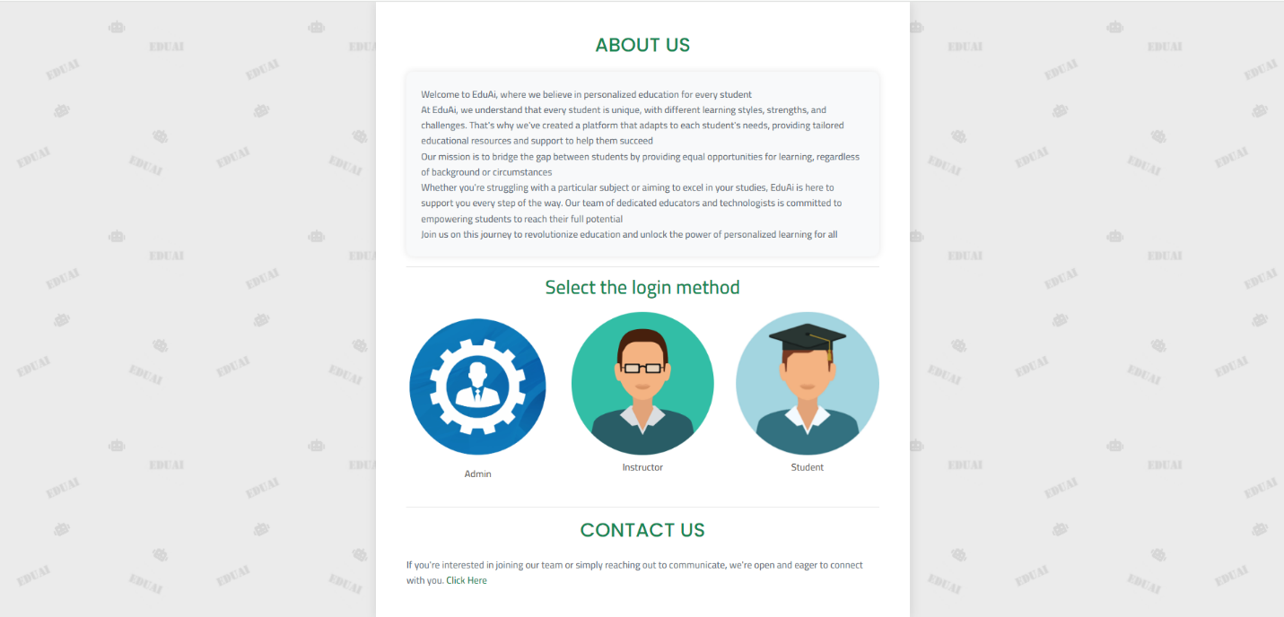

Contact us section

About us section

Choosing the login role

Figure 169: User guide 1

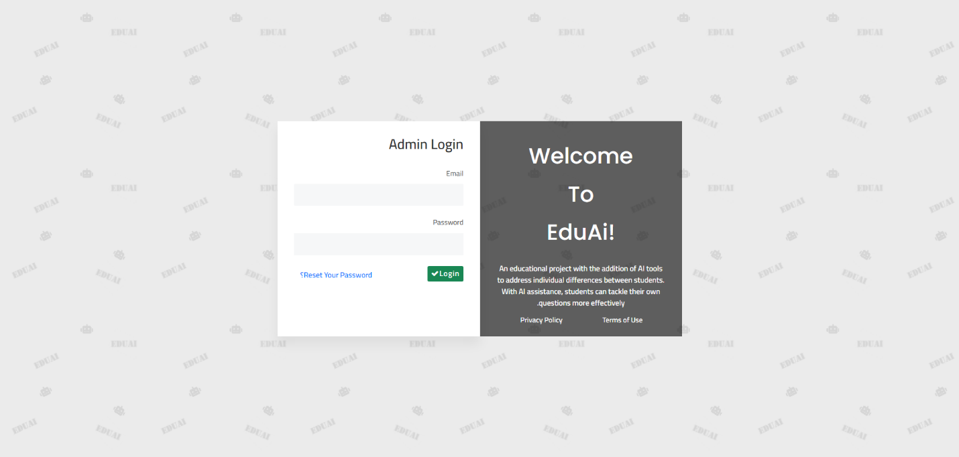

Enter the password

Enter the email

Rest password link

Login in button after filling required data

Figure 170: User guide 2

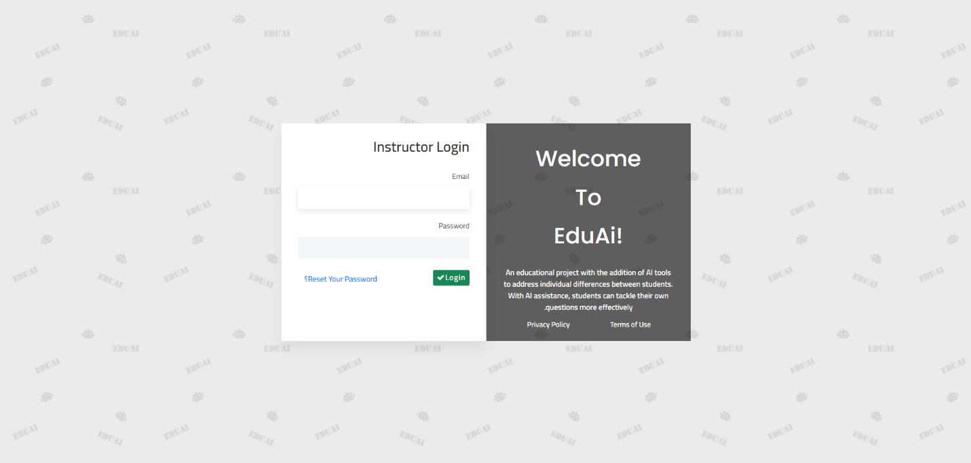

Enter the password

Enter the email

Rest password link

Login in button after filling required data

Figure 171: User guide 3

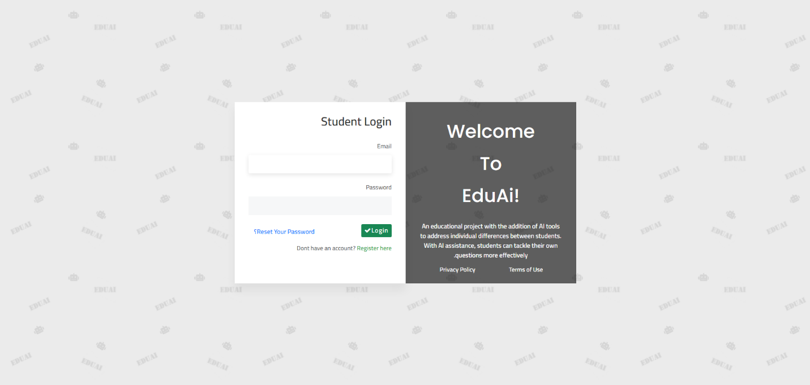

Enter the password

Enter the email

Rest password link

Login in button after filling required data

Register Link

Figure 172: User guide 4

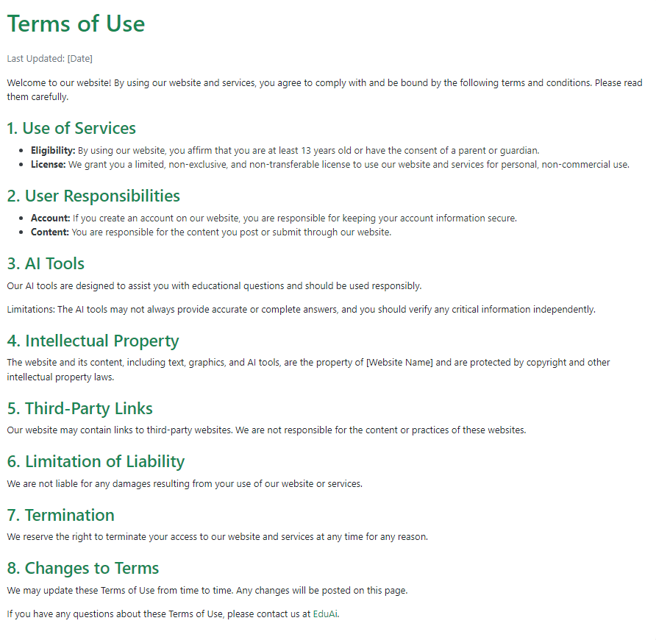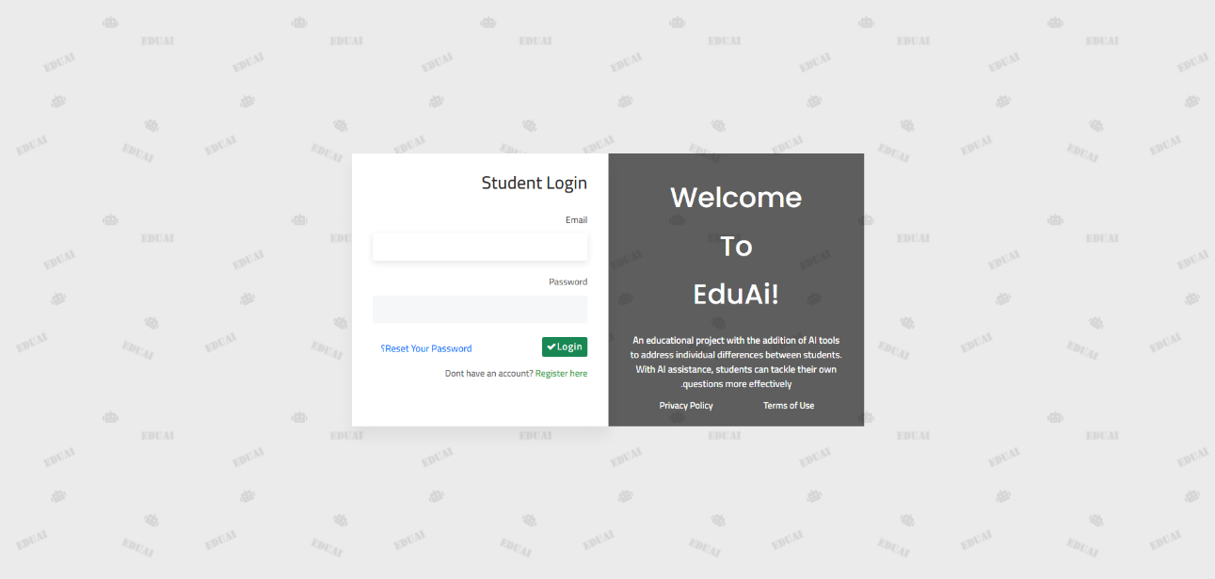

Figure 173: User guide 7

Figure 174: User guide 5

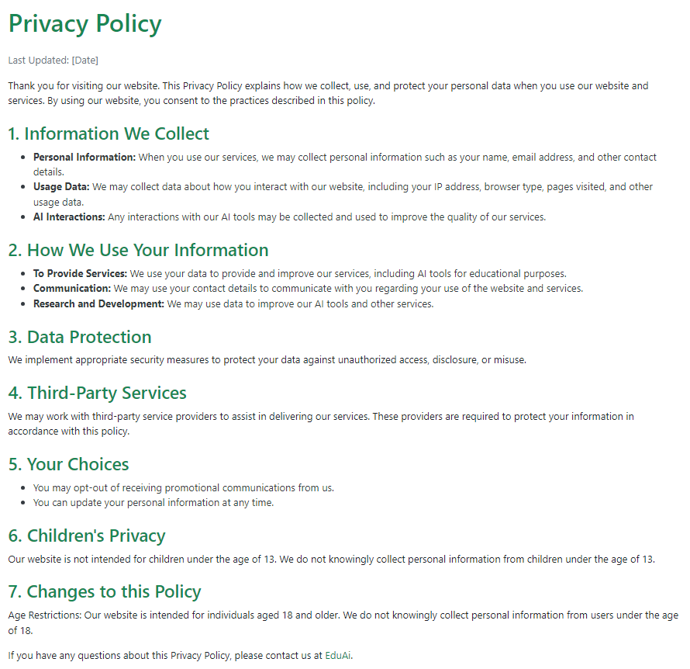

Figure 175: User guide 6

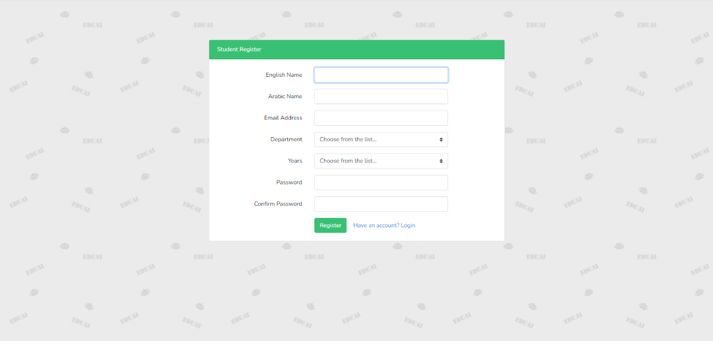

Go to login page link

Register button after filling required data

Enter student data for registration process

Figure 176: User guide 8

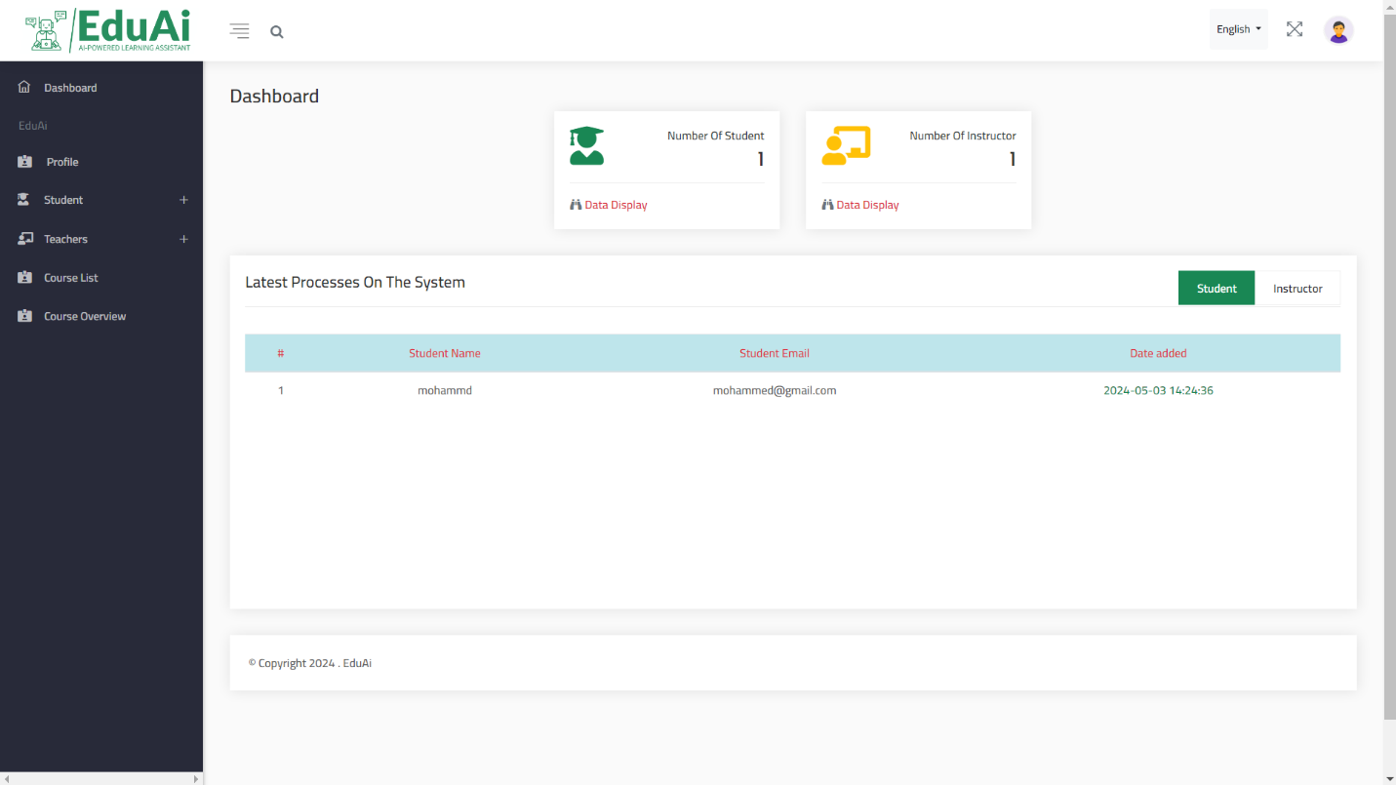

Instructors and students counter

Instructors and students info

Switch between students and instructors

Figure 177: User guide 9

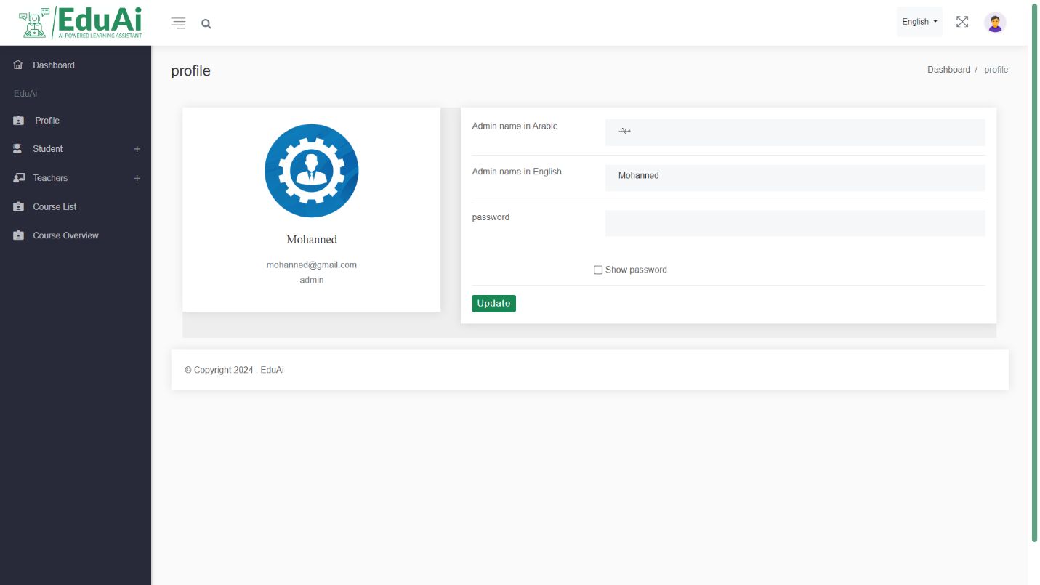

Update admin data section choose your field and edit the data

Update data button click it after finish data editing

Figure 178: User guide 10

Student details list

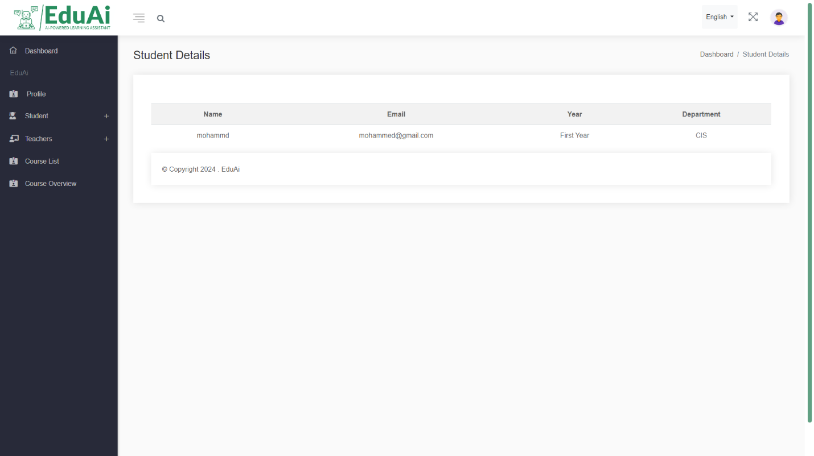

Figure 179: User guide 11

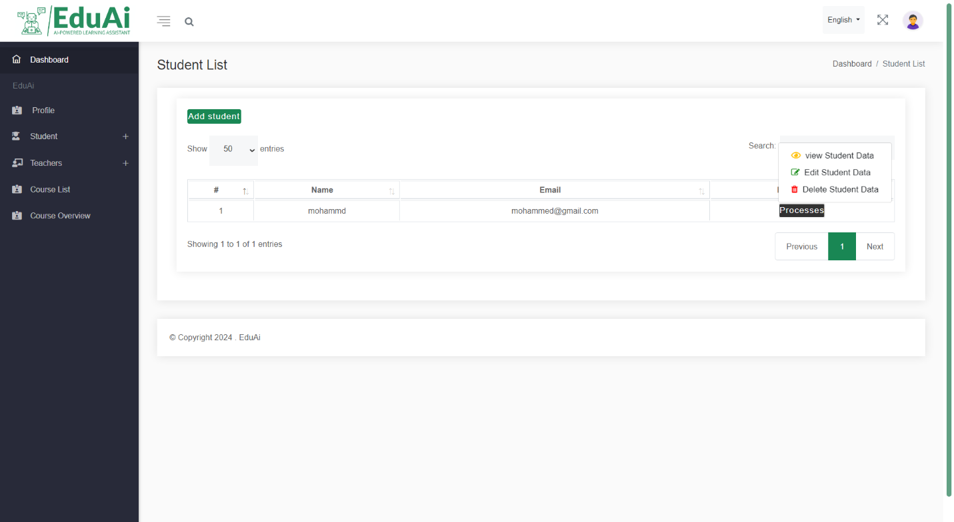

Add student button

Admin can edit, delete and view student

Figure 180: User guide 12

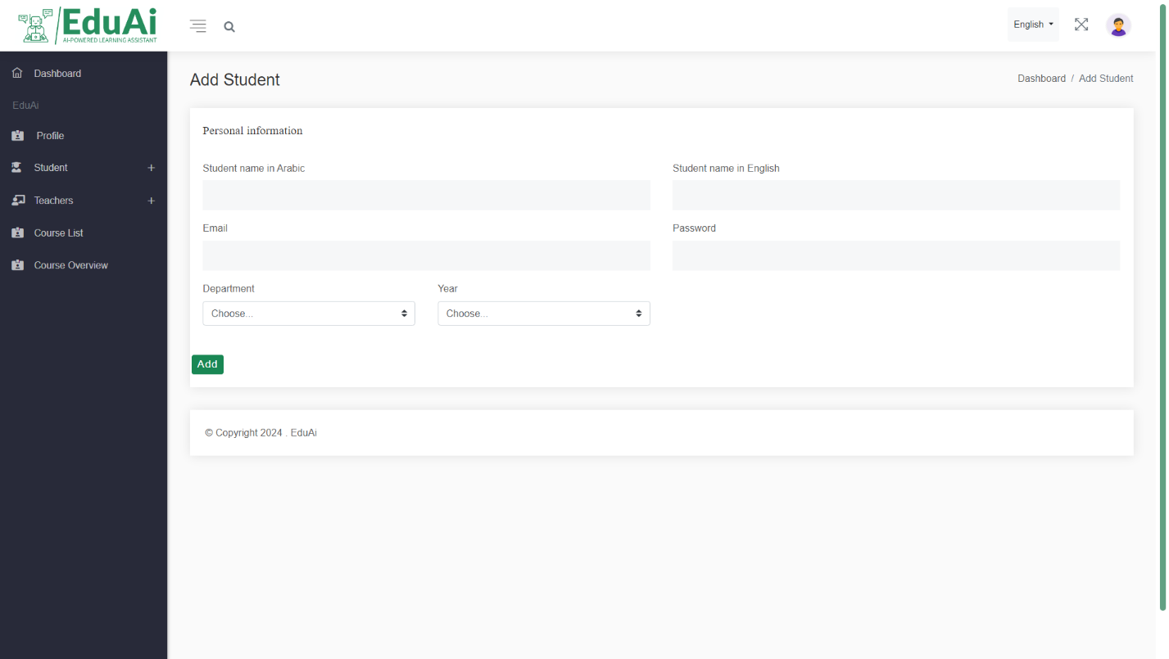

Add button click it after finishing student data

Insert student data

Figure 181: User guide 13

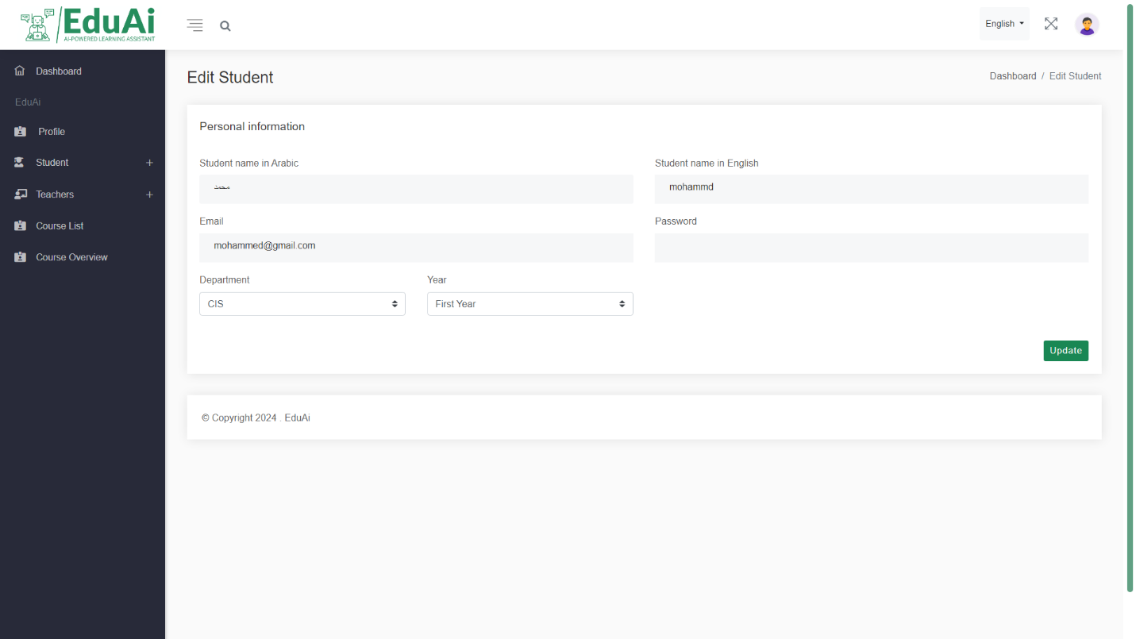

Update button click it after you finish student data edit

Change student data that you want

Figure 182: User guide 14

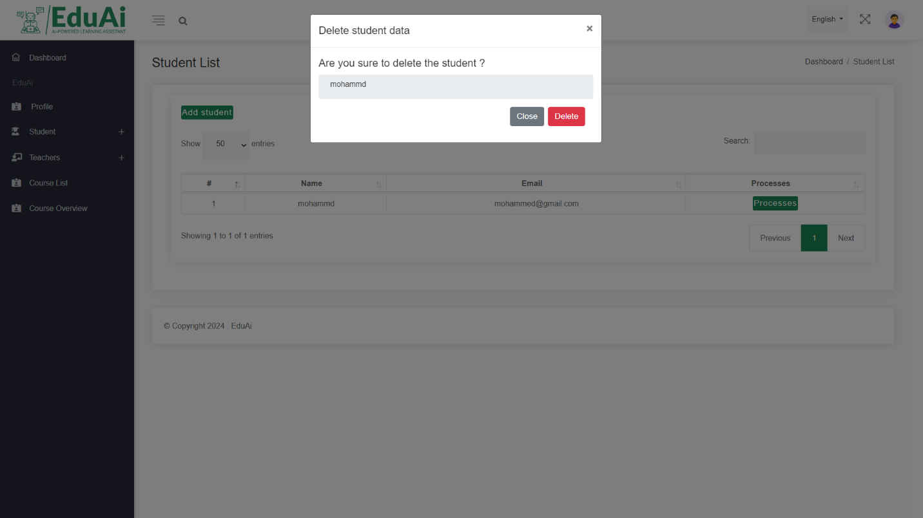

Choosing correct action

Alert box

Figure 183: User guide 15

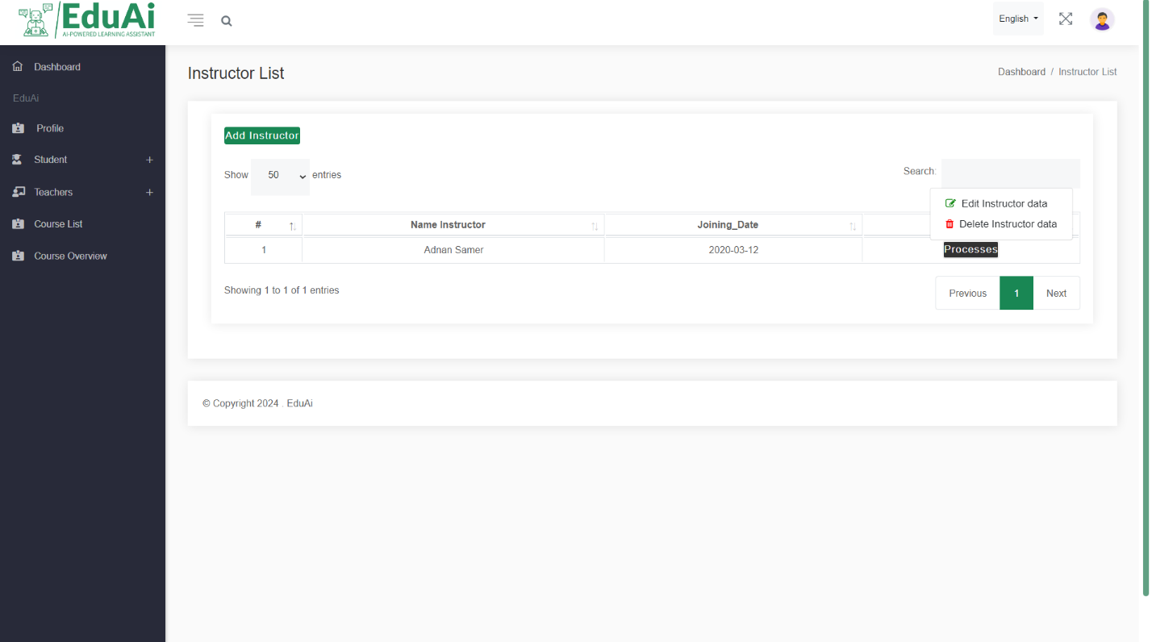

Add instructor button

Admin can edit, delete instructor

Figure 184: User guide 16

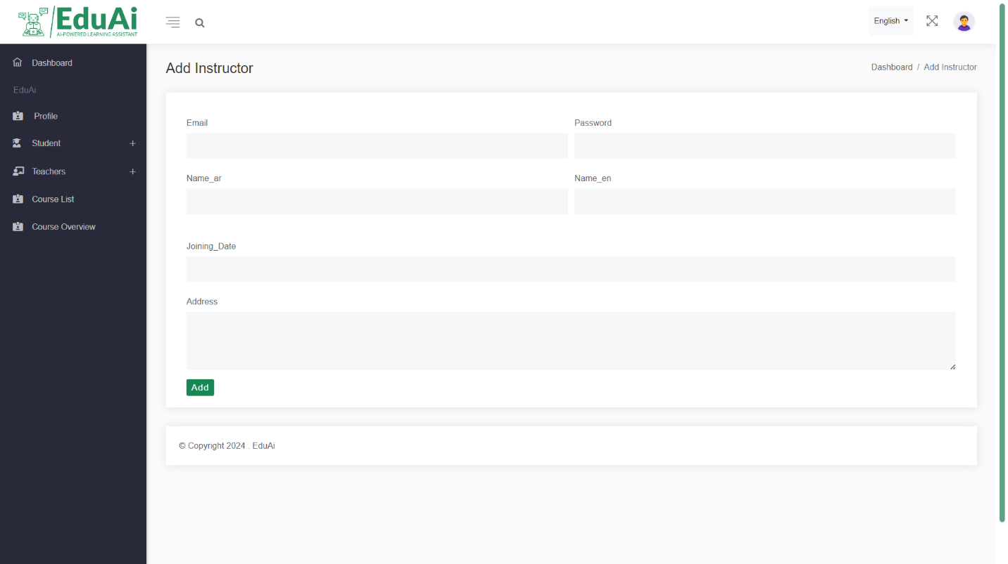

Add button click it after finishing instructor data

Insert instructor data

Figure 185: User guide 17

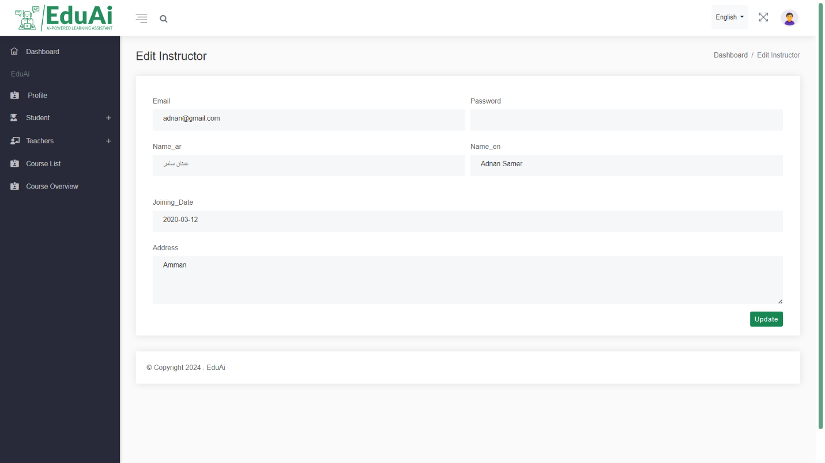

Change student data that you want

Update button click it after you finish student data edit

Figure 186: User guide 18

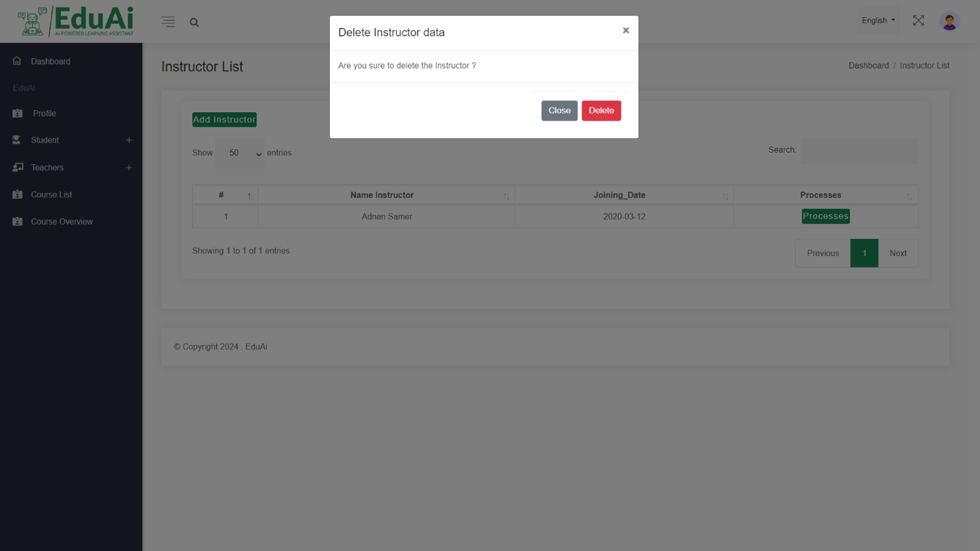

Choosing correct action

Alert box

Figure 187: User guide 19

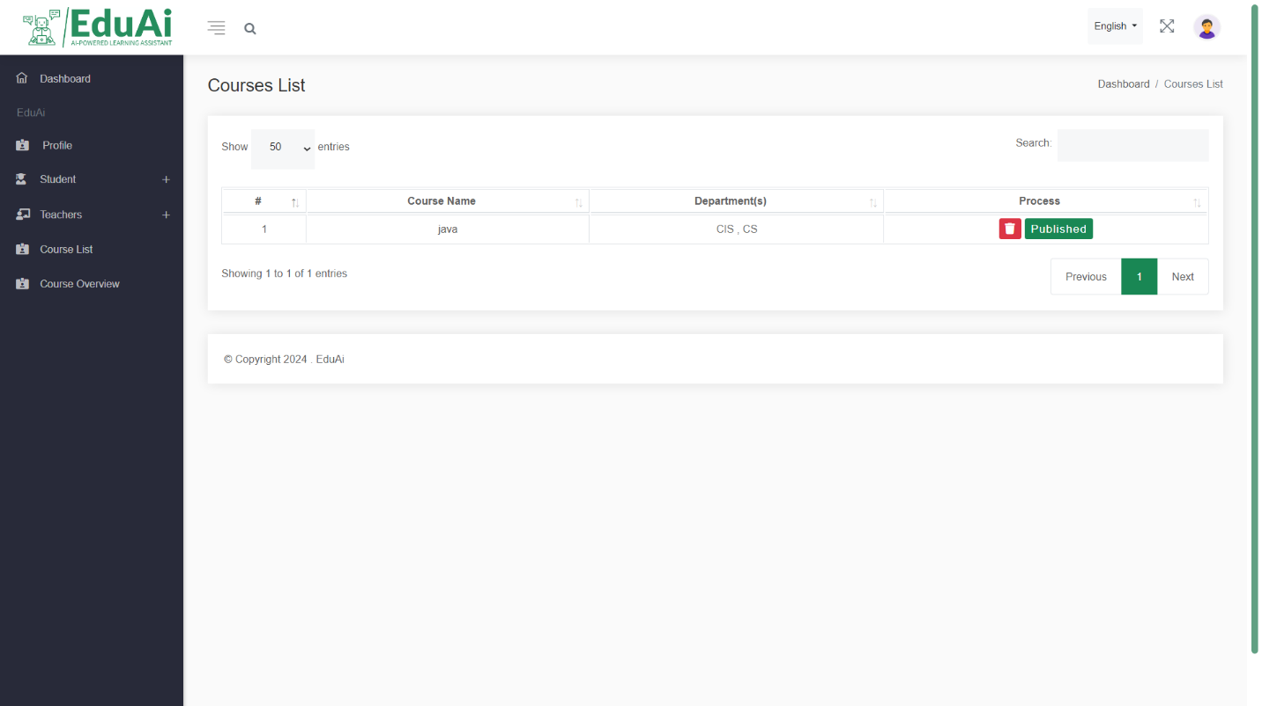

Delete and (publish / unpublish) button

Figure 188: User guide 20

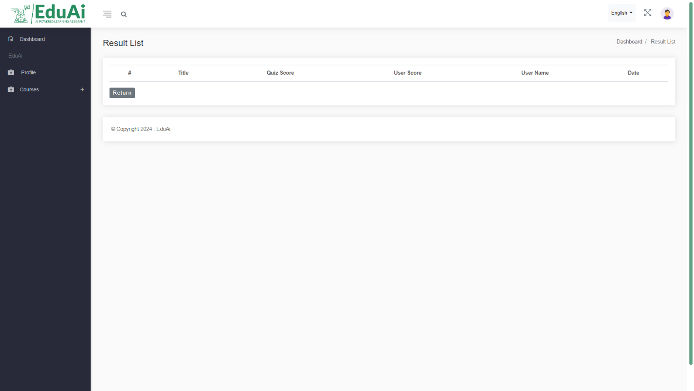

List of all student result in specific quiz

Figure 189: User guide 21

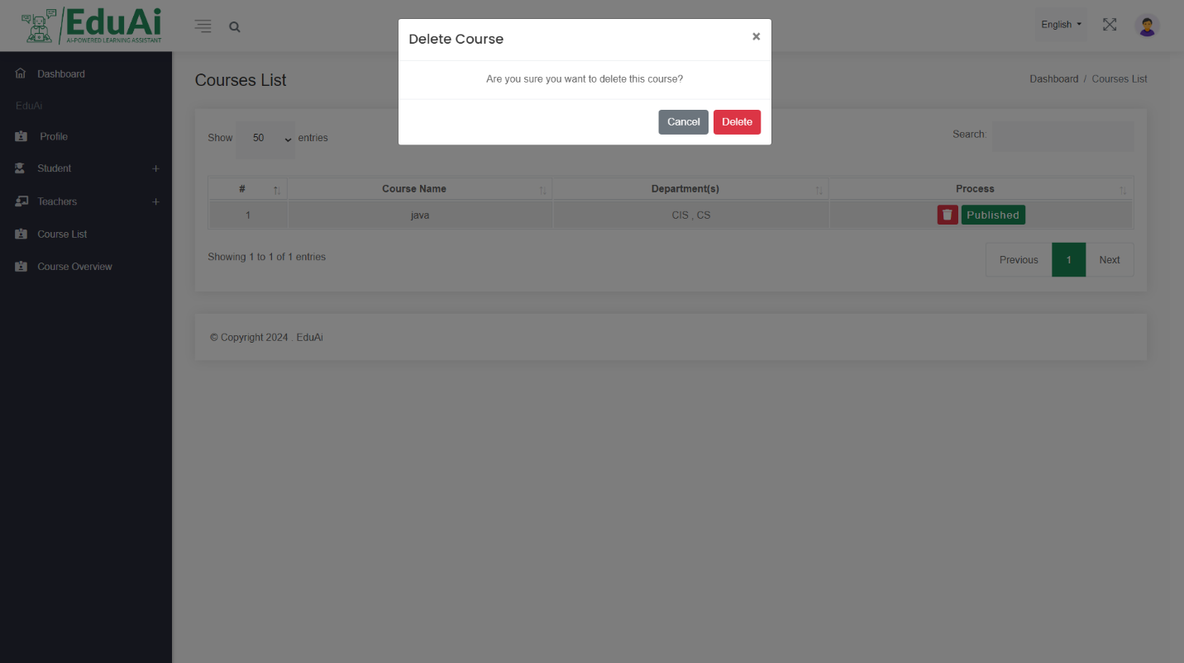

Alert box

Choosing correct action

Figure 190: User guide 22



Search box by name or id

Figure 191: User guide 23

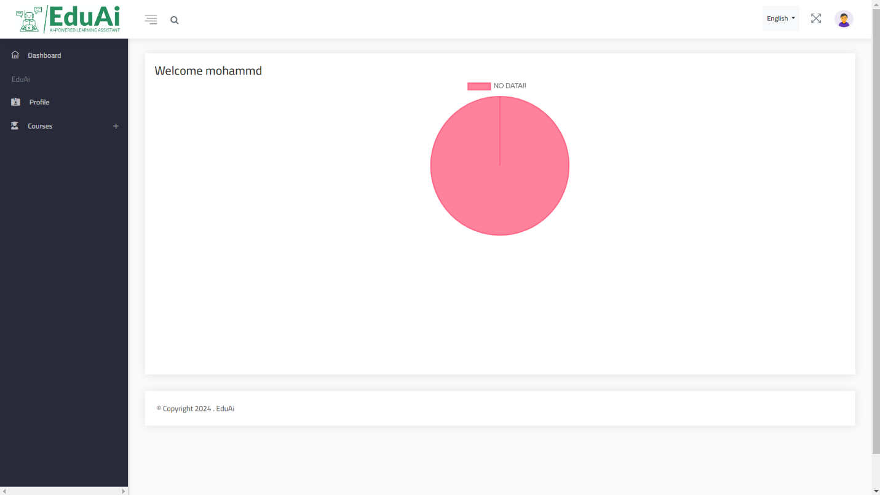

Courses Progress Chart

Figure 192: User guide 24

|  |
| --- |
|  |
|  |  |

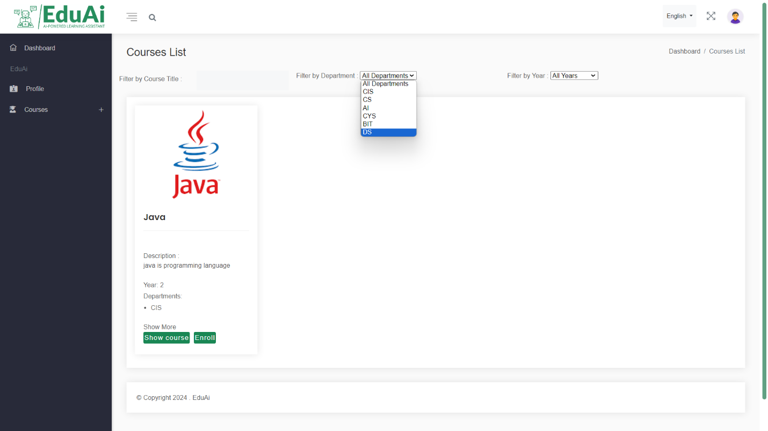

Filter courses by department using drop list

Figure 193: User guide 25

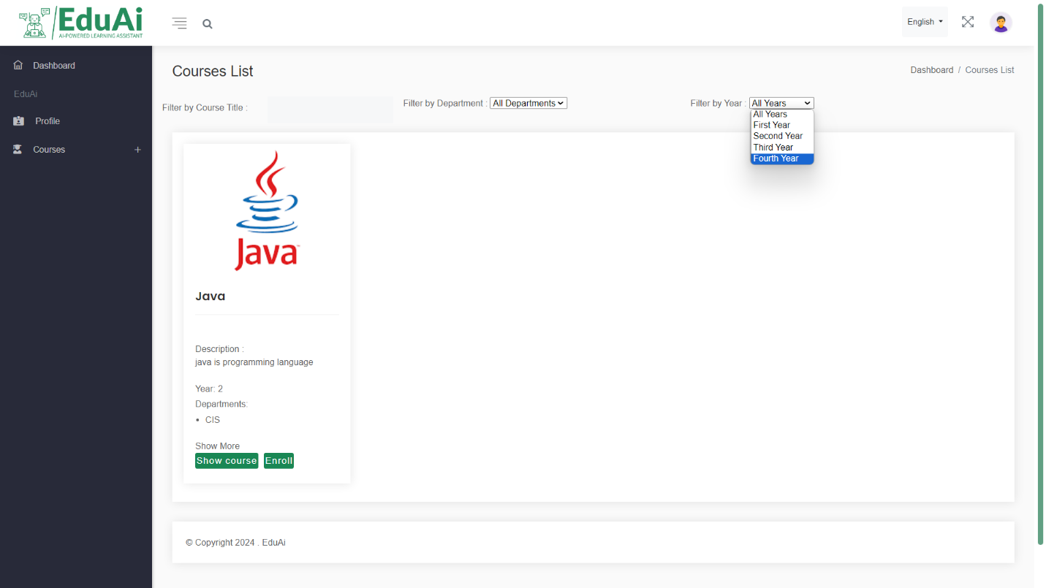

Filter courses by year using drop list

Filter courses by year using drop list

Figure 194: User guide 26

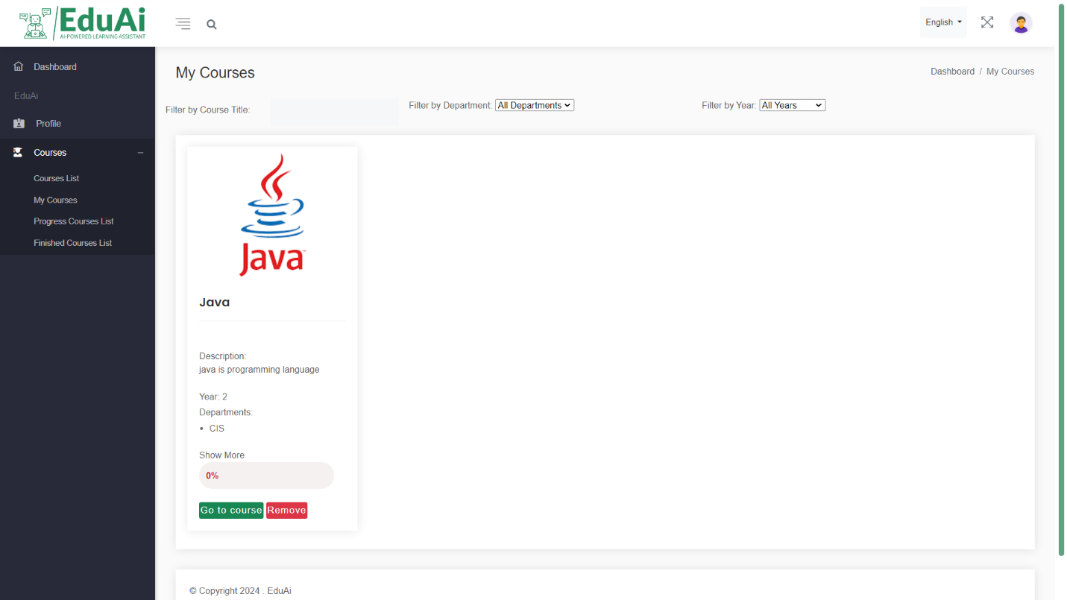

Student courses details after enrolling to the course

Figure 195: User guide 27

Remove or enter specific course content

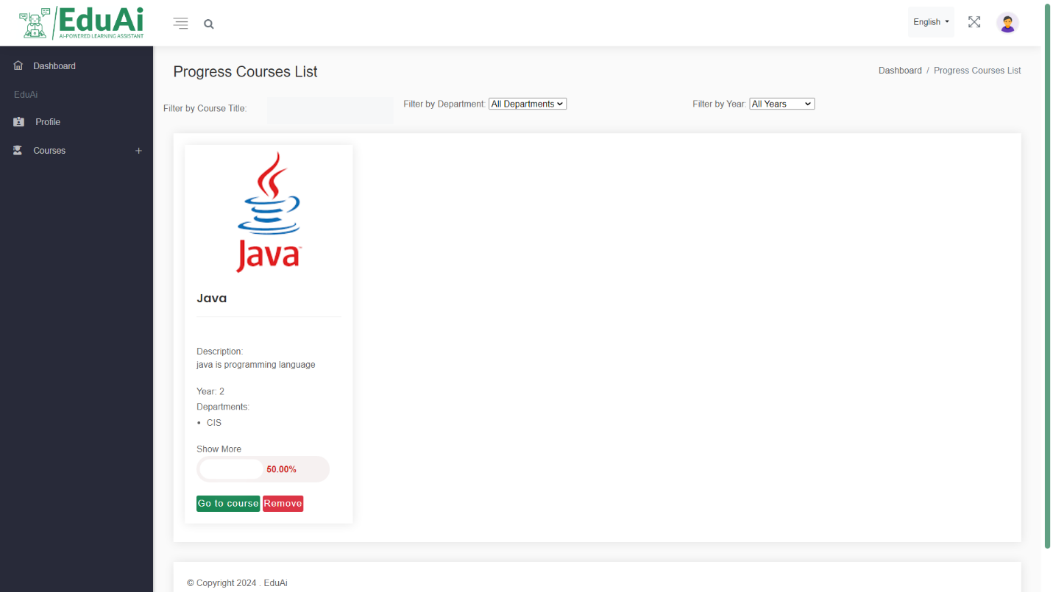

Student progress courses details

Figure 196: User guide 28

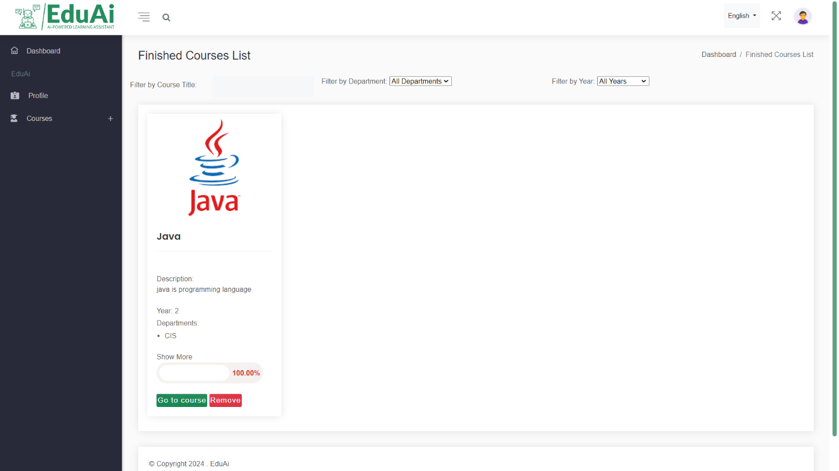

Student finished courses details

Figure 197: User guide 29

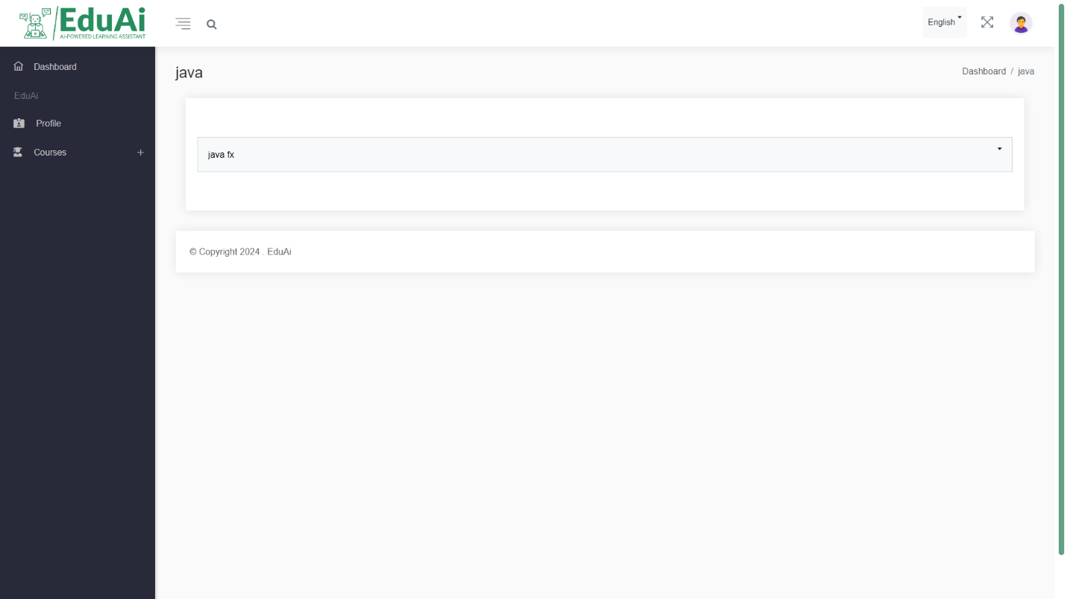

After click (show) button display all section name without any item related to the course

Figure 198: User guide 30

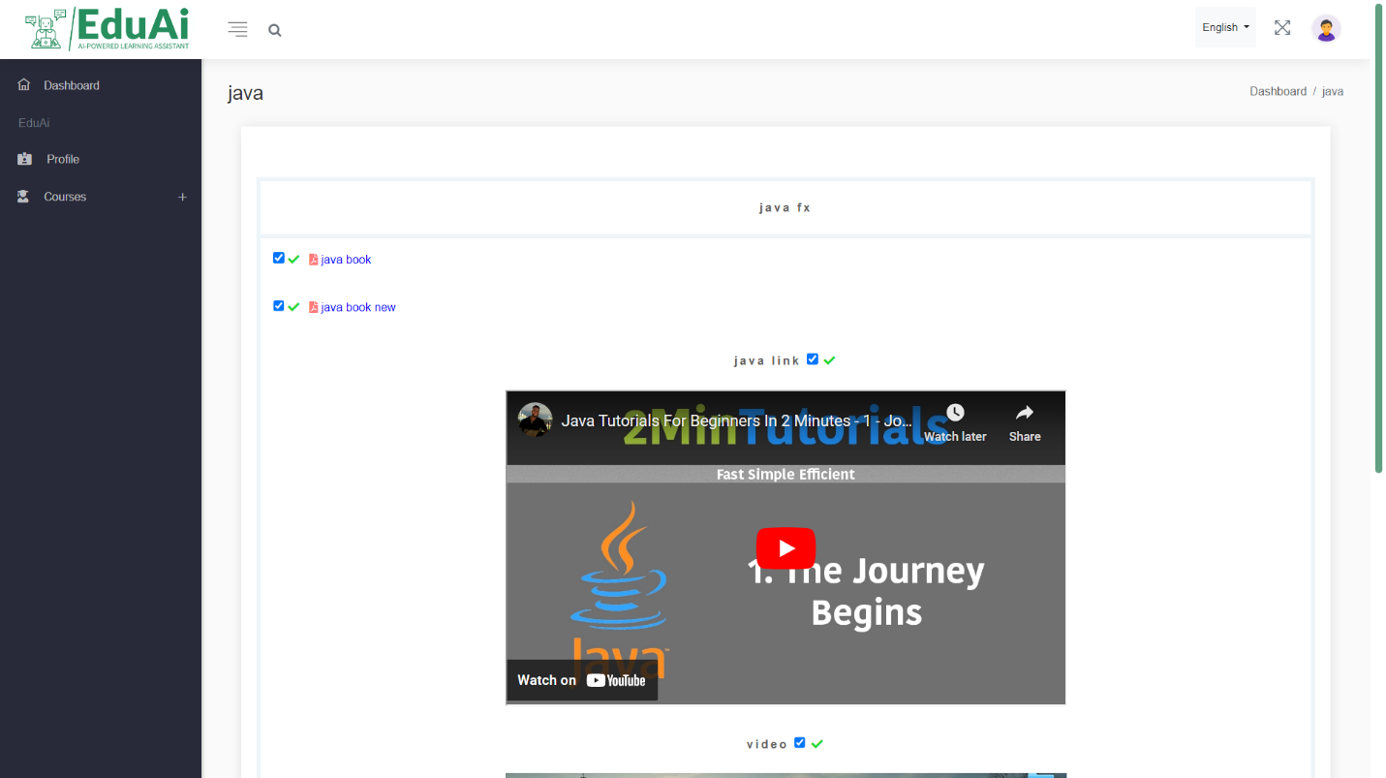

Figure 199: User guide 31

After click (go to course) button display all section name with item related to the course

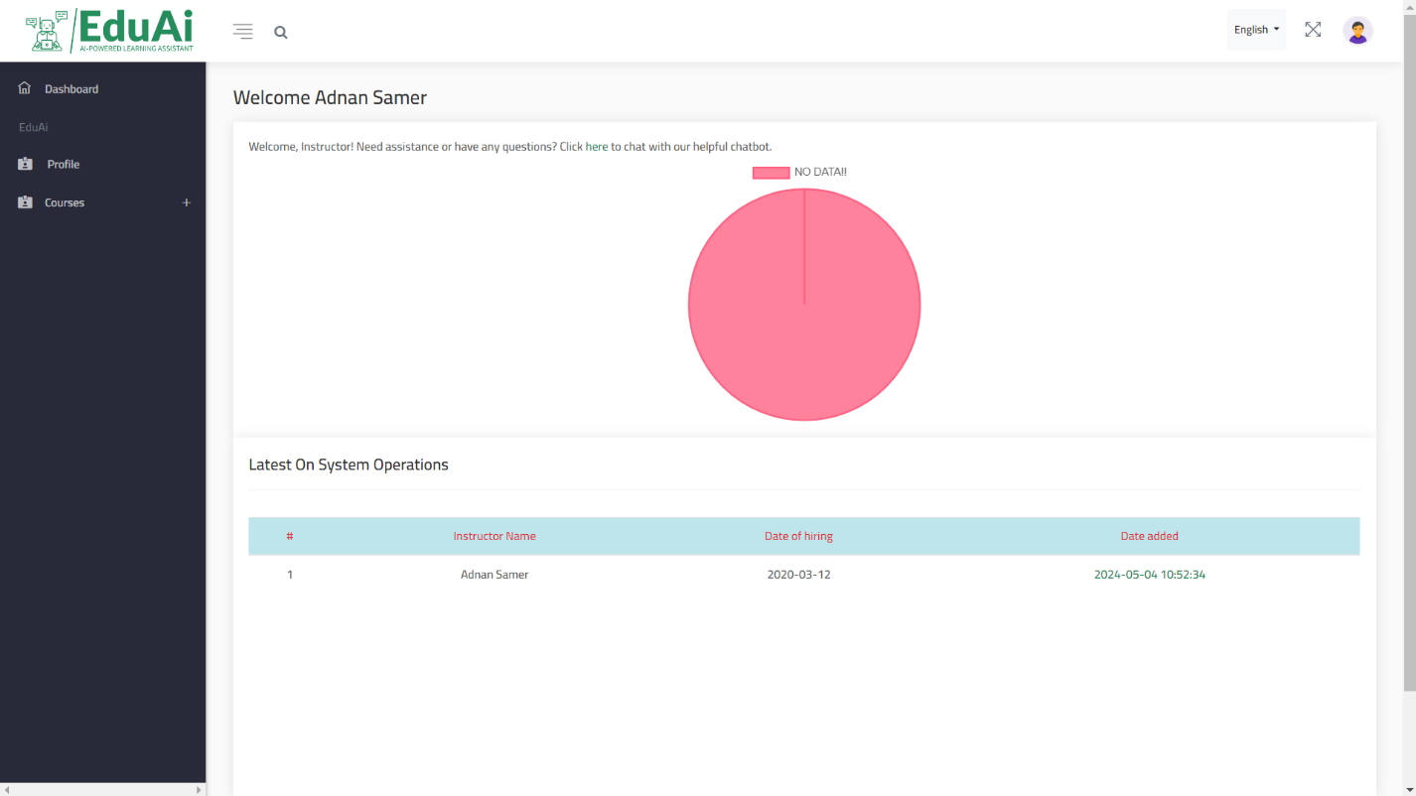

Chat with bot link

Student Progress Courses Chart

Instructor adding log

Figure 200: User guide 32

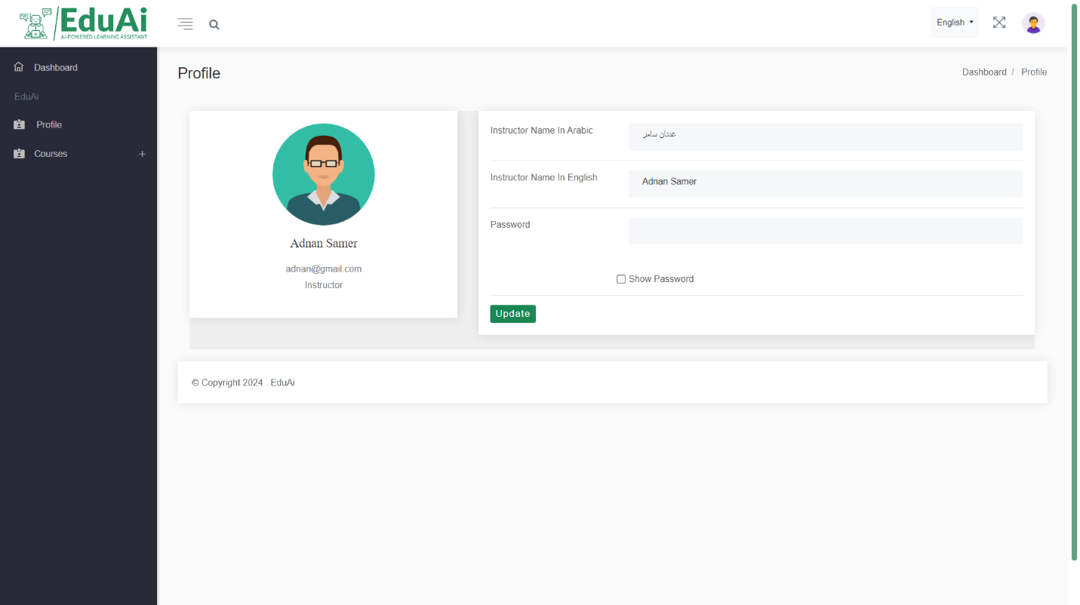

Update button click it after you finish instructo data edit

Change instructor data that you want

Figure 201: User guide 33

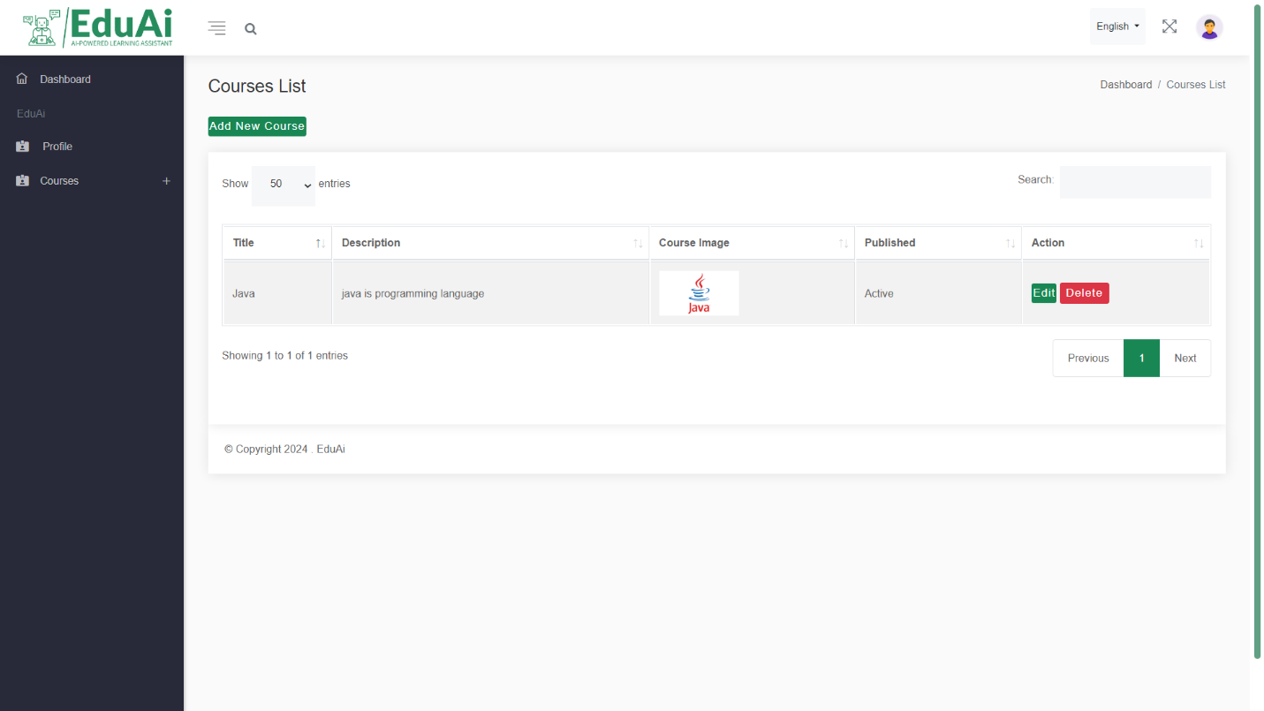

All added courses will display here

All added courses will display here

Click here to add new course

Figure 202: User guide 34

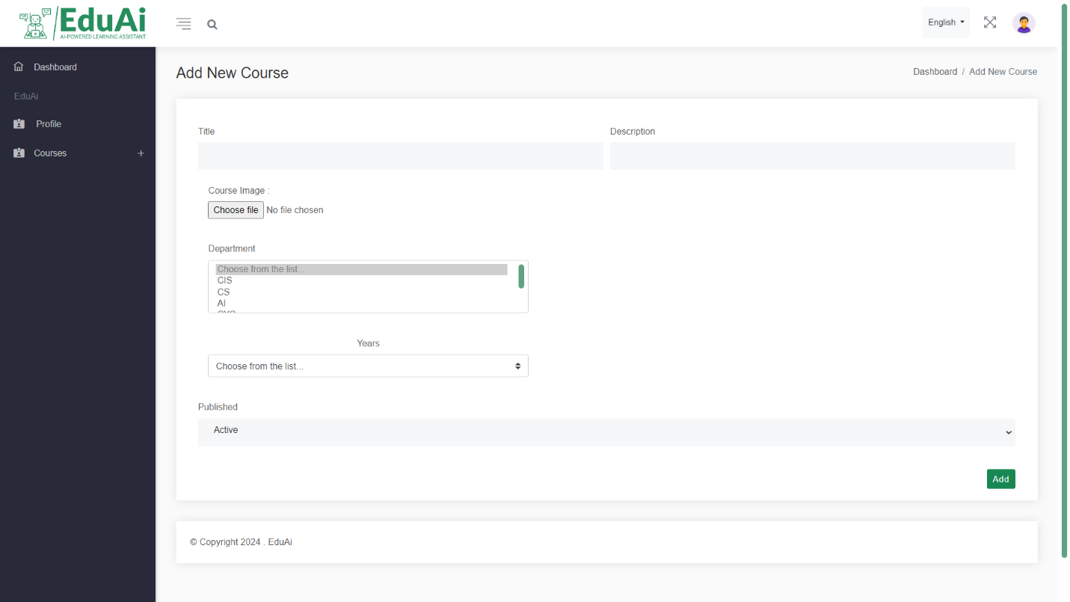

Add course button click it after you finished insert course data

Fill all required course data to add one

Figure 203: User guide 35

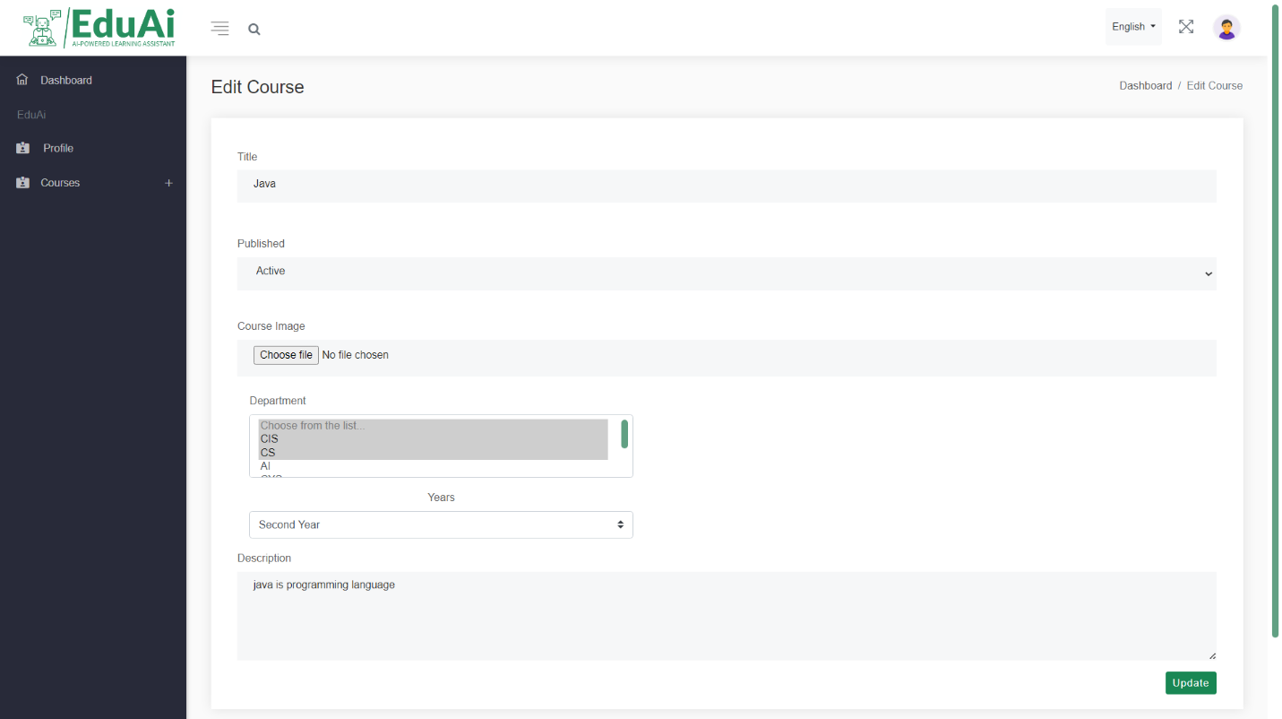

Fill all required course data you want to edit

Figure 204: User guide 36

update course button click it after you finished editing course data

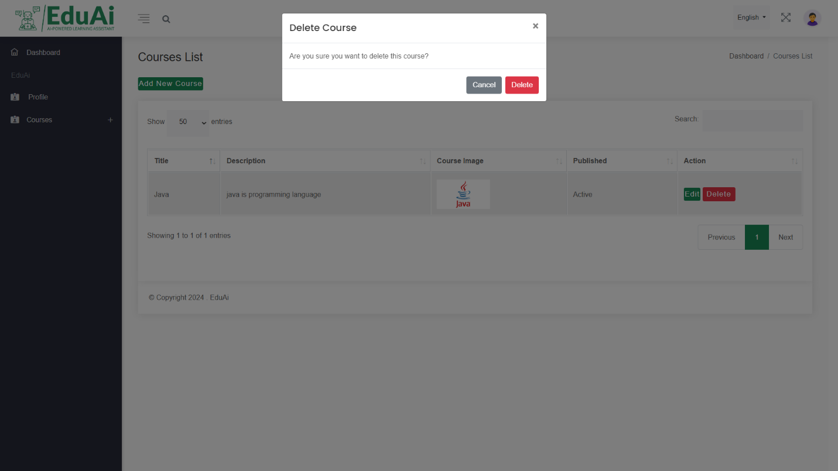

Choose correct action

Delete course Alert message

Figure 205: User guide 37

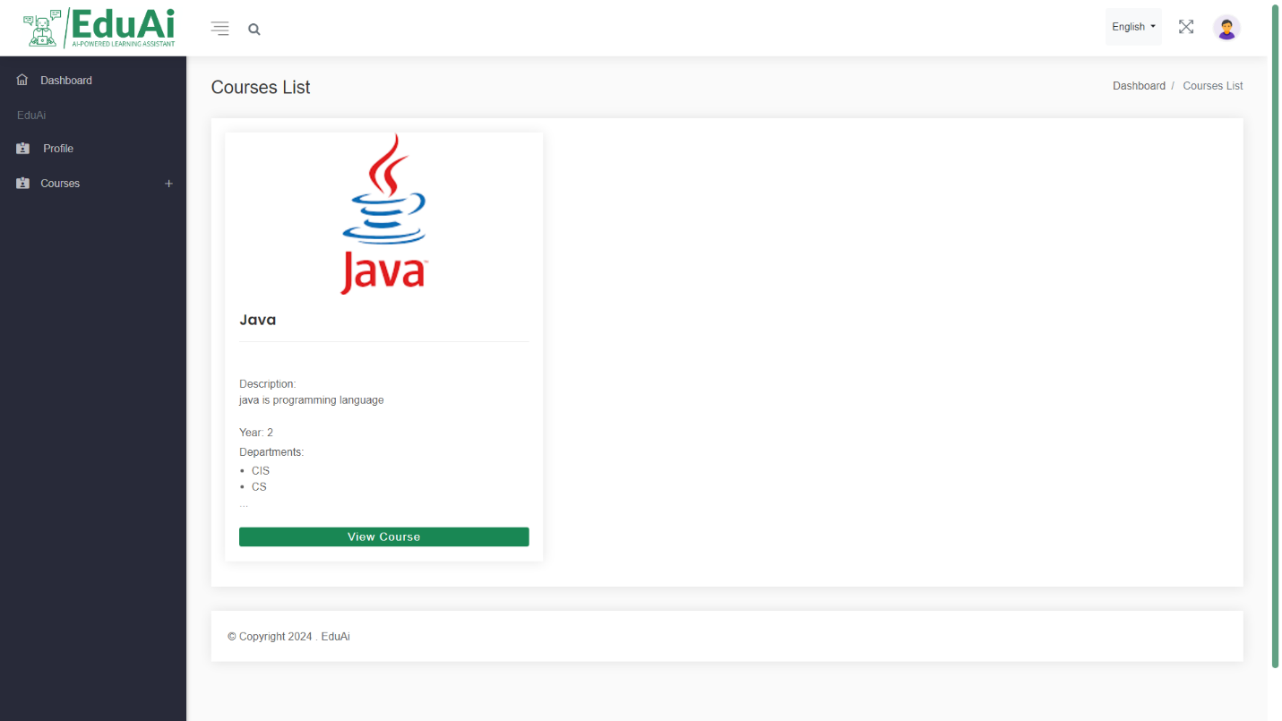

All instructor courses will display here

Figure 206: User guide 38

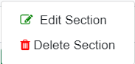

Add or edit item and quiz at specific section

Different operations on section (add/edit section)

Click here after editing the position of element within the section to save

Edit or delete section

Figure 207: User guide 39

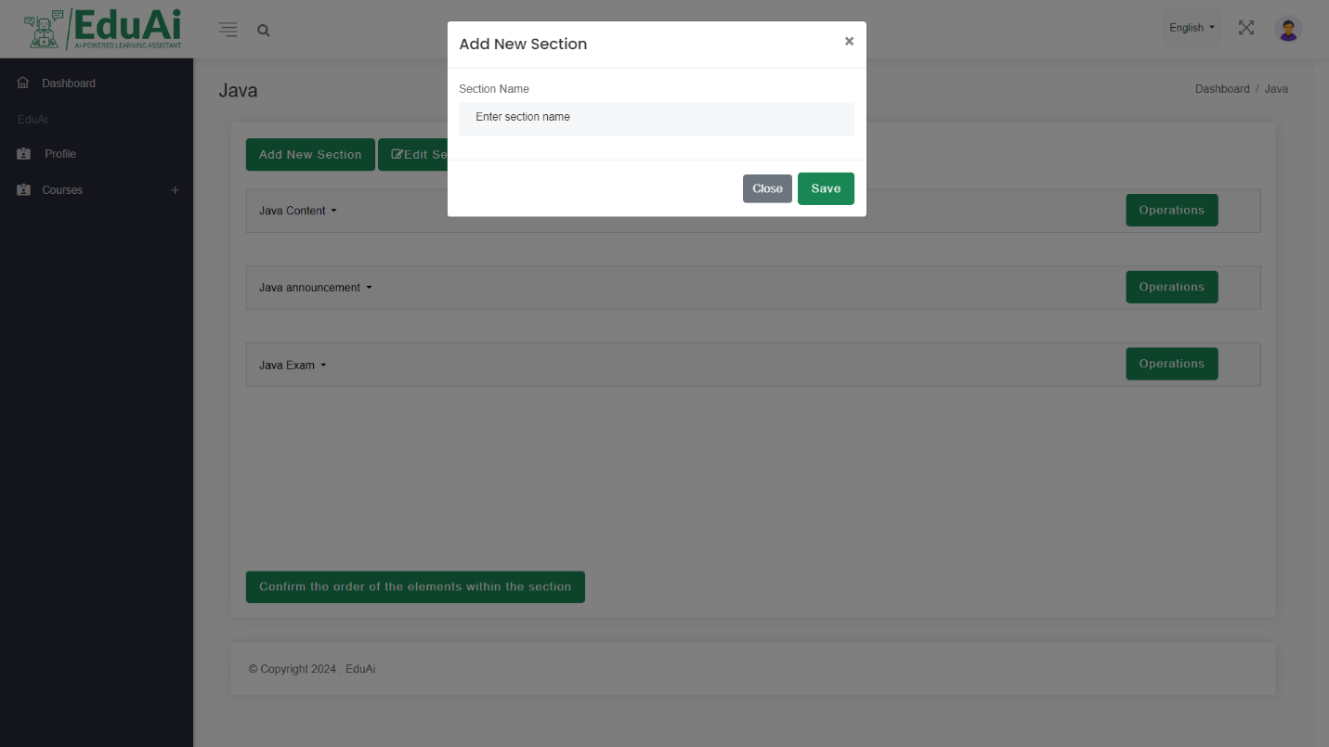

Add section box enter section name then click save or close to cancel

Figure 208: User guide 40

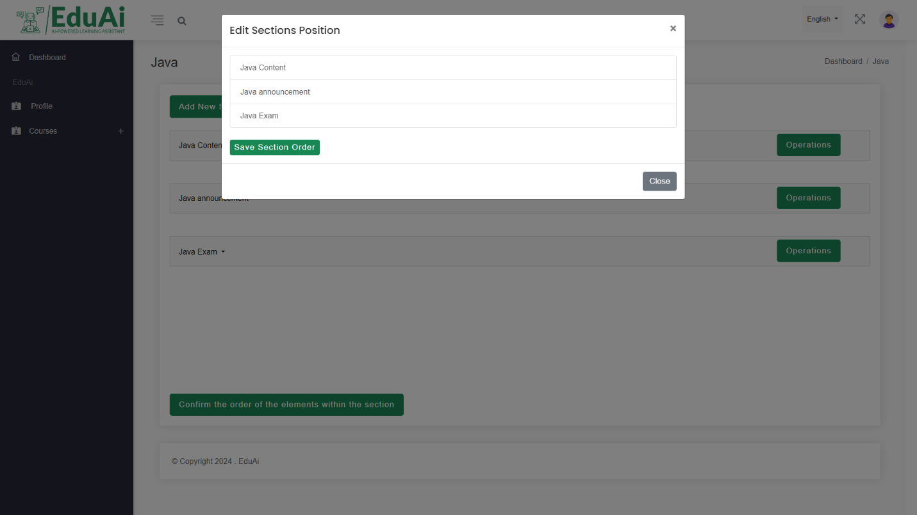

Edit section position box drag and drop the sections in the order you need

Figure 209: User guide 41

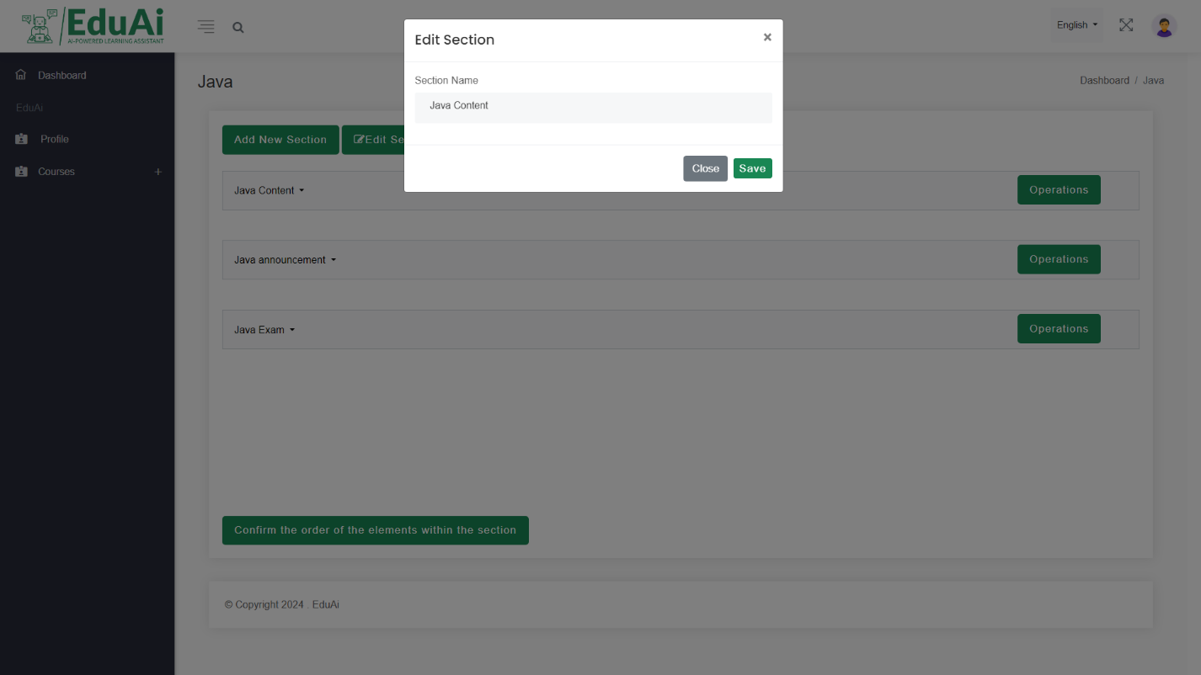

Edit section name box change the section name and click save

Figure 210: User guide 42

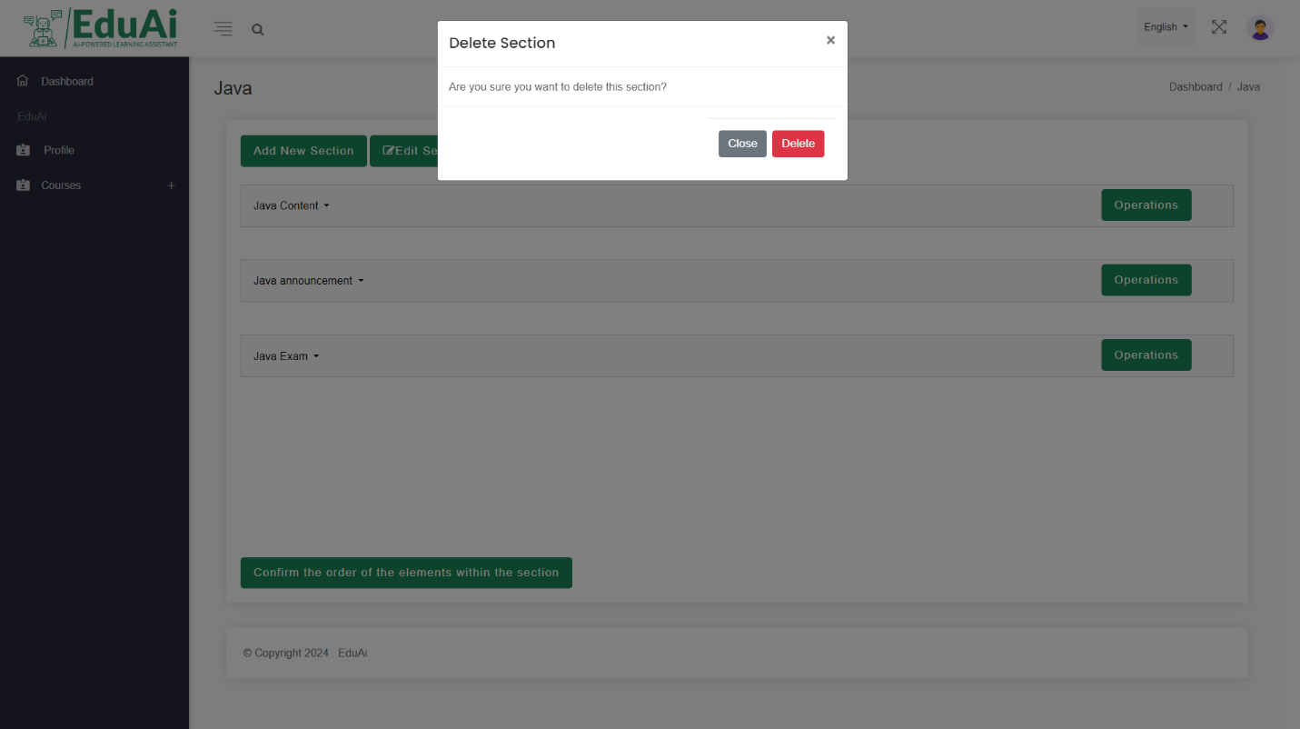

delete section alert box click delete to confirm deletion process

Figure 211: : User guide 43



Adding item choose the best fit one from the list to add your item

Figure 212: User guide 44



Quiz list (add quiz, view quiz list, view result)

Figure 213: User guide 45

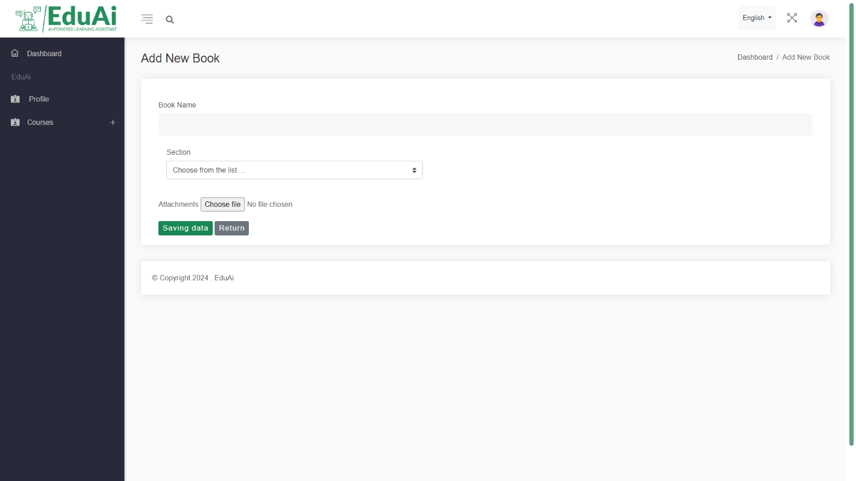

Add new book enter the book name and choose the book then click save

Figure 214: User guide 46

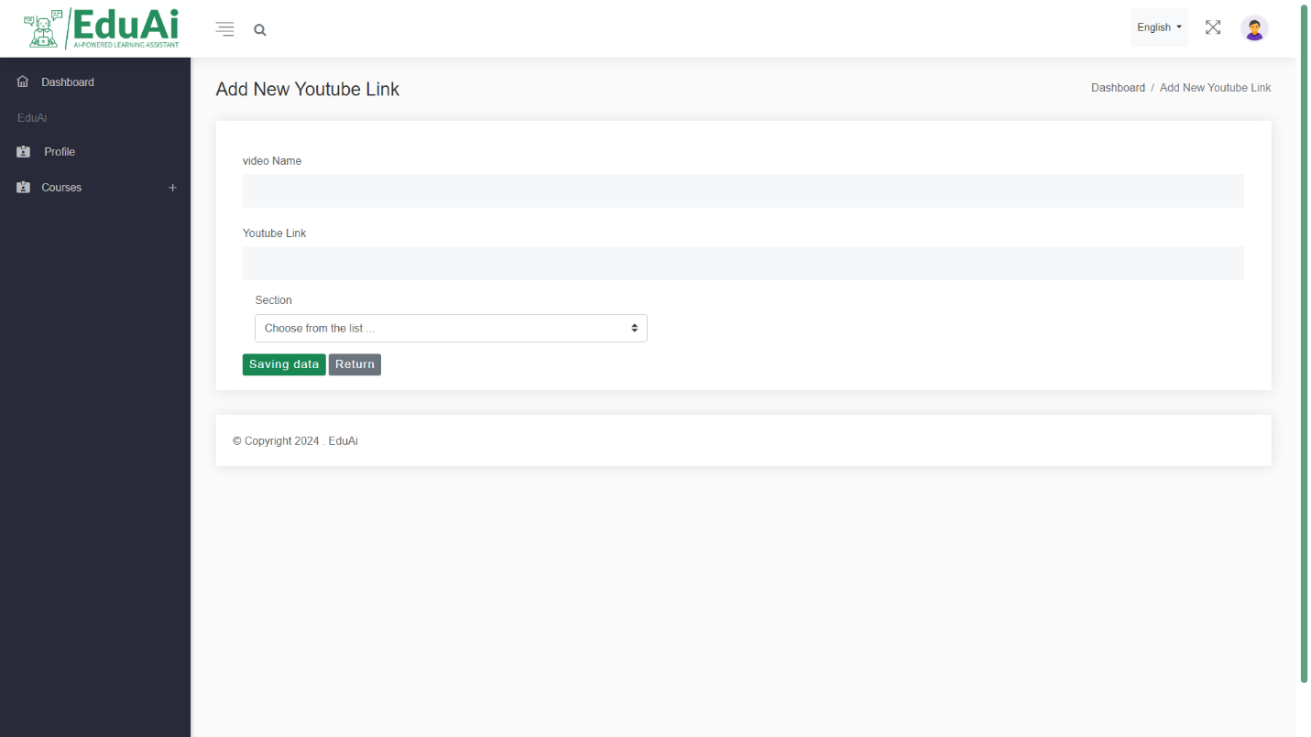

Add new youtube video enter the video name and enter video link then click save

Figure 215: User guide 47

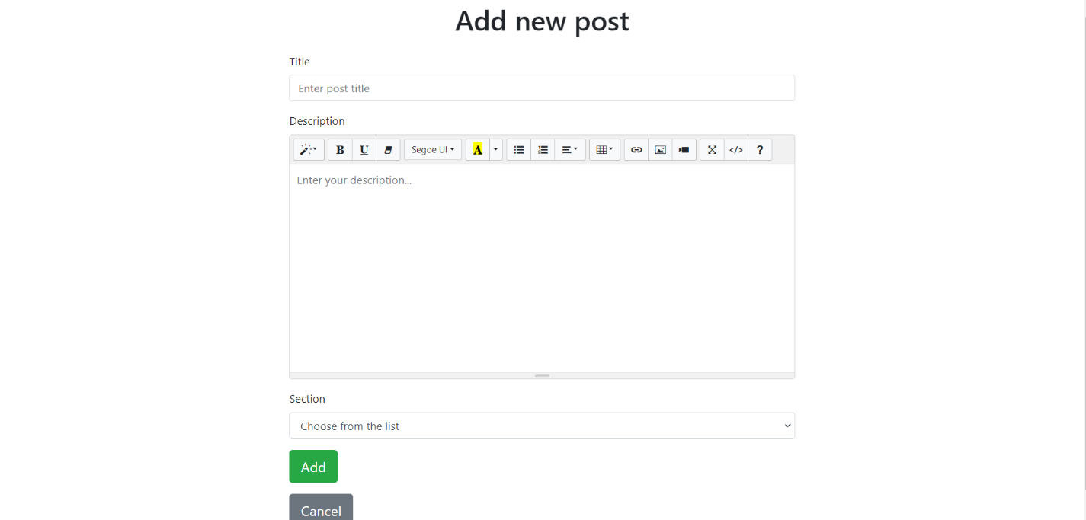

Add new post by entering the title, the content, and the section the post will added in after that click add

Use this bar to format your post text

Figure 216: User guide 48

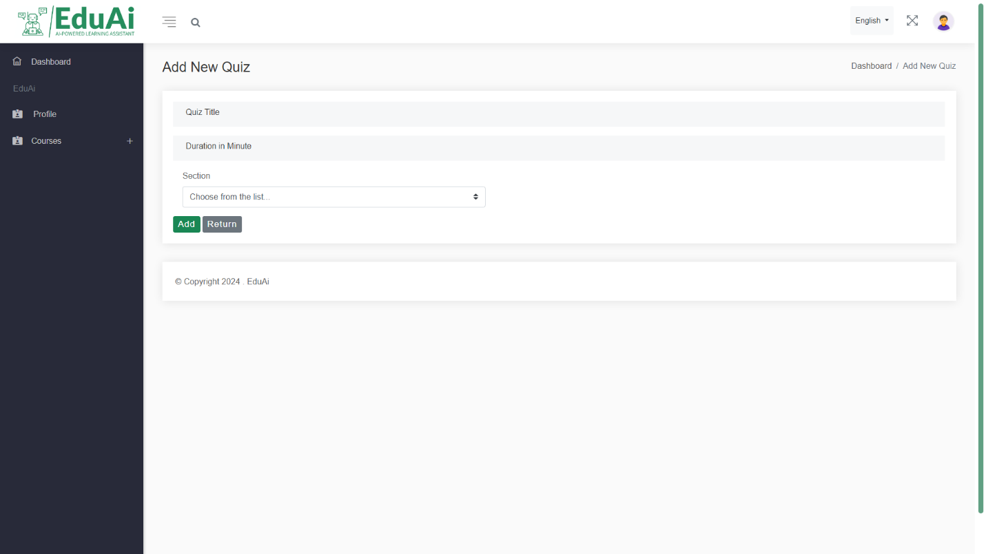

Add new quiz enter the title, duration and in which section the quiz will be then click add

Figure 217: User guide 49

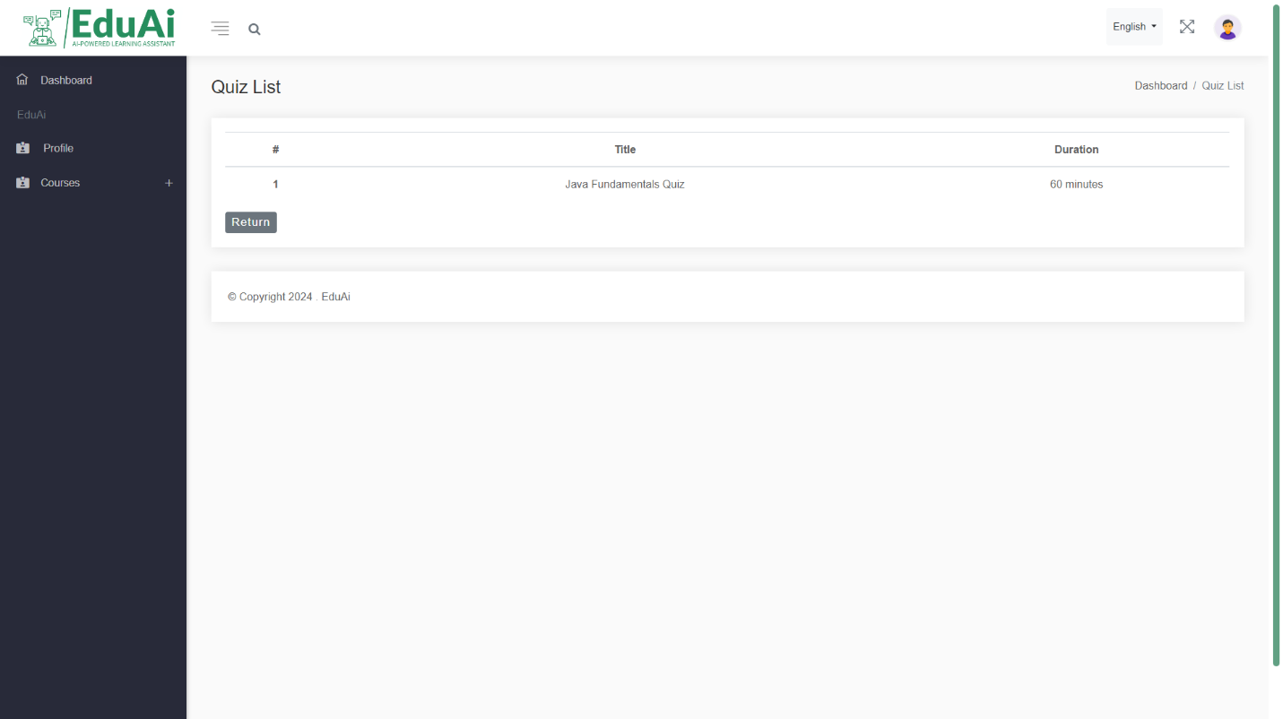

Quiz list here you will see all you quizzes with its duration

Figure 218: User guide 50

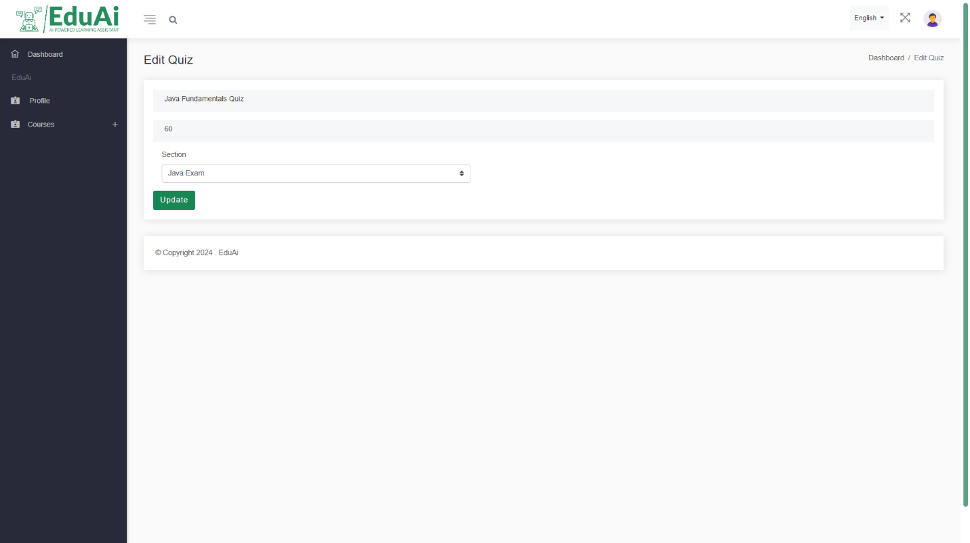

Edit quiz change the data here then click update

Figure 219: User guide 51

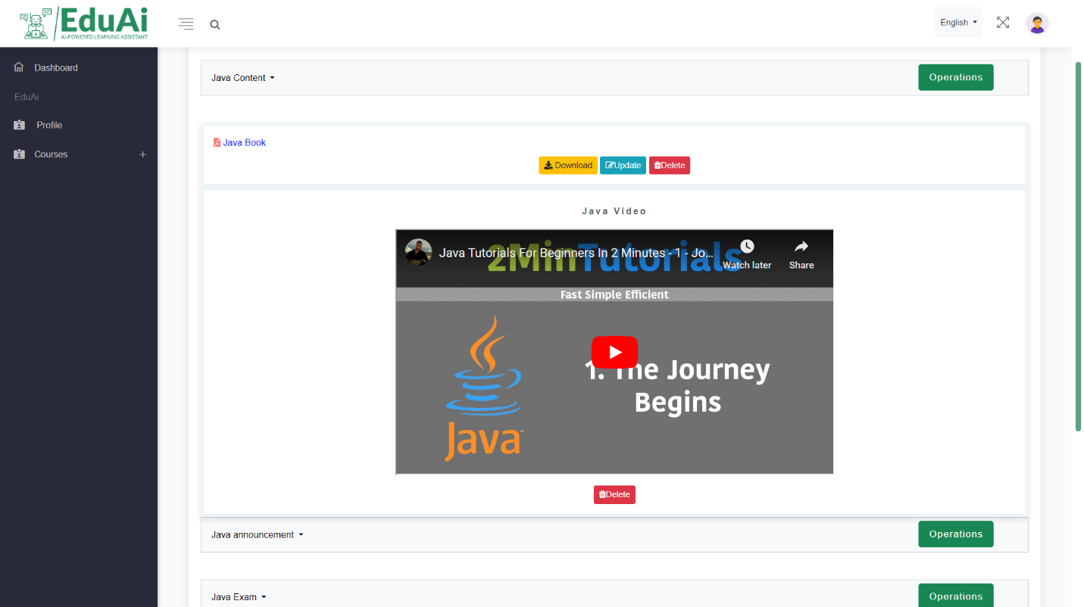

Here you can see book item within a section with delete, update and download button

Here you can see youtube link item within a section with delete button

Figure 220: User guide 52

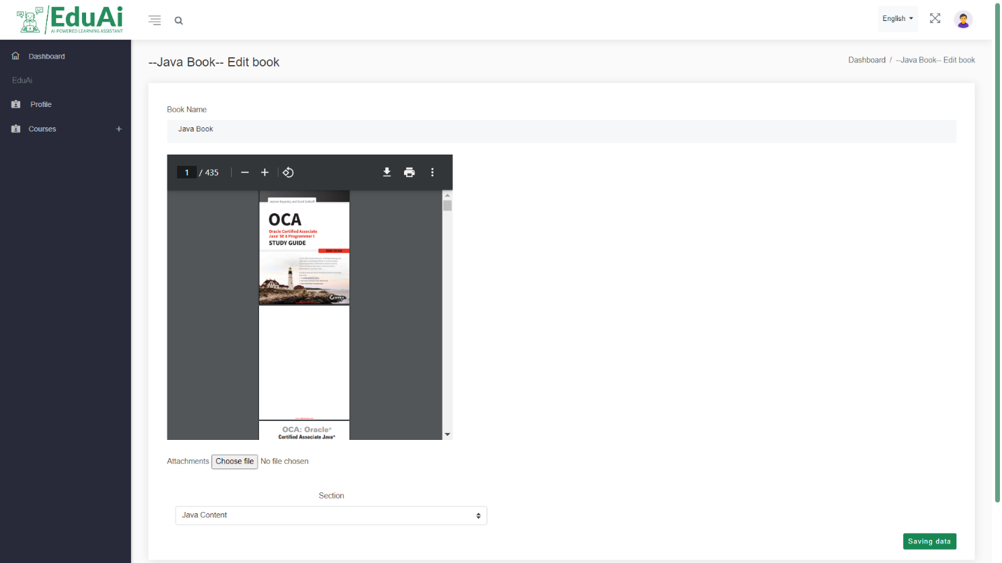

Here you can change the book name or the book itself then click save data in the right corner

Figure 221: User guide 53

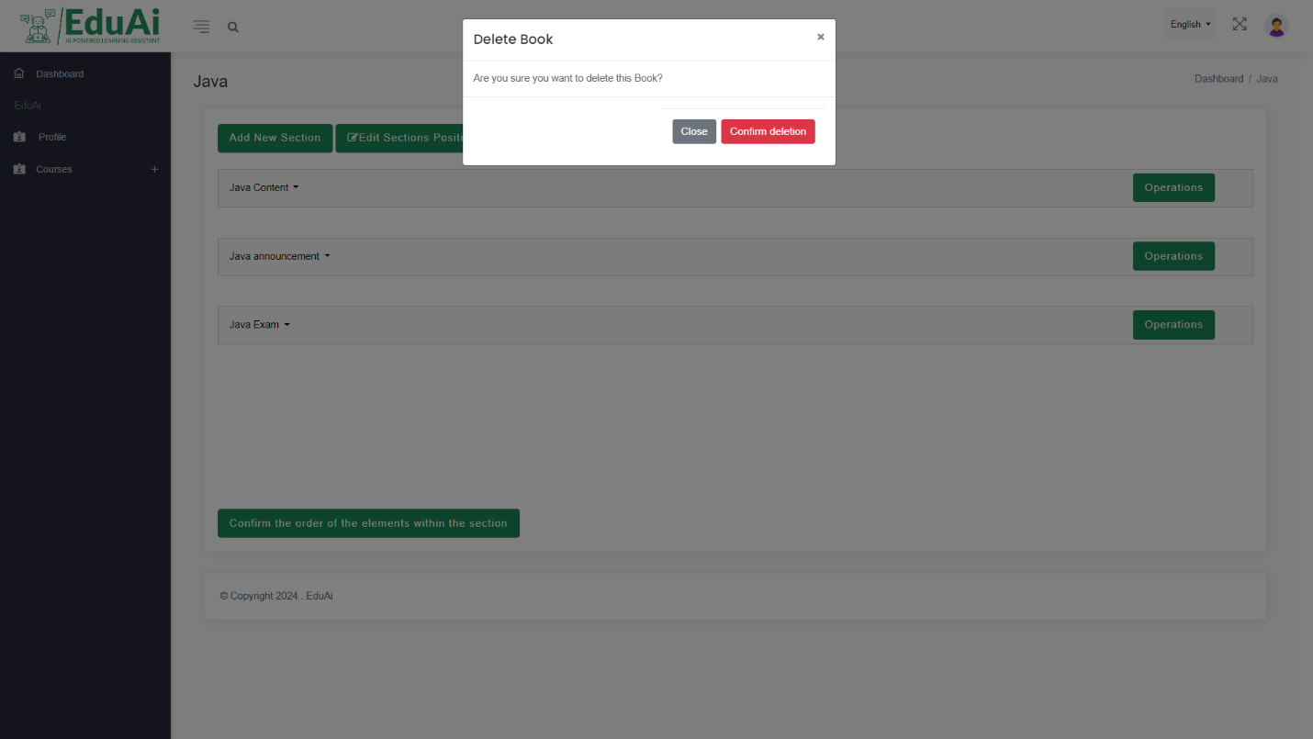

delete book alert box click delete to confirm deletion process

Figure 222: User guide 54



Edit post change the post content here then click update for confirmation

Figure 223: User guide 55



Add question for quiz by entering the question and the options and choosing the correct answer

Here list of all questions you have been added so far

Edit or delete question button

Figure 224: User guide 56



Change specific question date in this fields

Click here after finishing edit

Figure 225: User guide 57



delete question box click delete to confirm or cancel to prevent delete

Figure 226: User guide 58

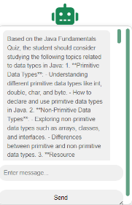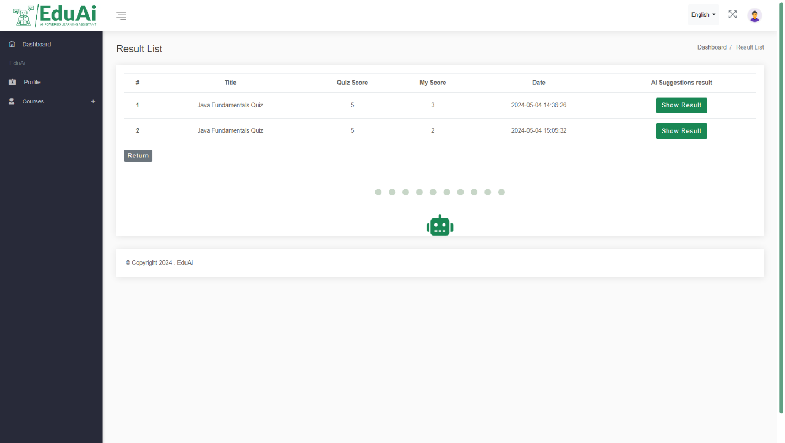



Click here to start chatting

Click here to display the your result

Figure 227: User guide 59

**Chapter seven: Project conclusions and future work**

## **7.1 Conclusions**

* **What We Did:** We made an online learning tool called "EduAI" to help university students learn better.
* **How It Helped:** Our tool had cool stuff like a smart chatbot and tracking how students learn.
* **What People Said:** Students and teachers liked our tool and said it helped them learn more.

## **7.3 Strengths**

* **Made Learning Personal:** Our tool made learning more personal, like having a learning partner just for you.
* **Had Cool Features:** We added useful things like the chatbot and tracking how you learn.
* **People Liked Using It:** Students had more fun learning with our tool and felt more involved.

## **7.3 Weaknesses**

* **Some Tech Problems:** Sometimes our tool had problems working perfectly, like bugs or slow parts.
* **Not Everyone Used It:** Some students didn't use our tool much, so we want to figure out why.
* **Things We Can Improve:** We have identified areas where we can improve, such as making it easier to use or adding more helpful features, like allowing different types of questions in the quiz, not just multiple-choice.

## **7.4 Future Direction**

* We plan to enhance EduAI by adding features such as reading and analyzing the material of the sections and giving suggestions, improving the chatbot's responses, and exploring virtual reality simulations for certain courses.
* In terms of expansion, we aim to partner with more universities and schools, customize EduAI for different educational settings, and translate it into multiple languages for wider accessibility.

## **References**

1-Software Engineering 9th Edition by Ian Sommerville:

<https://engineering.futureuniversity.com/BOOKS%20FOR%20IT/Software-Engineering-9th-Edition-by-Ian-Sommerville.pdf>

2-ChatGPT API documentation:

<https://platform.openai.com/docs/api-reference/introduction>

3-Laravel documentation:

<https://laravel.com/docs/8.x/readme>